Supplementary Materials

Supplementary Table I. Buffer Matrix Ingredients
 | Clinical study | Non-clinical studies
Component | Citrate saline buffer (mg/mL) | Citrate buffer without rHuPH20 (mg/mL) | Citrate buffer with rHuPH20 (mg/mL)
Sodium chloride | 5.8 | 8.77 | 8.77
Polysorbate 80 | 0.4 | 0.3 | 0.3
L-Arginine HCl | 10.5 | – | –
Sodium citrate dihydrate | 2.66 | 2.35 | 2.35
Citric acid anhydrous | 0.17 | 0.385 | 0.385
NaCMC | – | 10 | 10
rHuPH20 | – | – | 2000 U/mL
Methionine | – | 1.49 | 1.49
HCl, hydrogen chloride; NaCMC, sodium carboxymethylcellulose; rHuPH20, recombinant human hyaluronidase PH20.

Supplementary Table II. Device Configurations in Miniature Pig Studies
Device abbreviation | Description | Volume delivered (mL) | Injection depth (mm) | Needle bevel | Target injection duration (s)*
AI2 | Fully automated autoinjector | 2 | 5.5 | 27G | Slow (15 s)  Fast (5 s)
sAI2/5.5 | Semi-automated autoinjector | 2 | 5.5 | 27G | Slow (15 s)  Fast (5 s)
sAI2/7.5 | Semi-automated autoinjector | 2 | 7.5 | 27G | Slow (15 s)  Fast (5 s)
AI1 | Fully automated autoinjector | 1 | 5.5 | 27G | 4−5
PFS1 | Pre-filled syringe | 1 | 12.7† | 27G | 6
PFS2 | Pre-filled syringe | 2 | 12.7† | 27G | 10
AI1, 1-mL auto-injector device; AI2, 2-mL auto-injector device; PFS1, 1-mL pre-filled syringe, PFS2, 2-mL pre-filled syringe; sAI2, semi-automated 2-mL auto-injector device.
*Original target injection durations, which are different from real performance data.
†PFS injection depth is not as precisely controlled as with AIs, as it involves a 45⁰ angle penetration with a 12.7-mm exposed length needle through pinched up skin, unlike vertical penetration of the AI needle without skin pinching.

Supplementary Table III. Device Configurations in Clinical Study
Device abbreviation | Description | Volume delivered (mL) | Injection depth (mm) | Needle bevel | Target injection duration (s)*
AI2 fast | Fully automated autoinjector | 2 | 5.5 | 27G | 5
hAI2 slow† | Fully automated autoinjector | 2 | 5.5 | 27G | 10
PFS2 | Pre-filled syringe | 2 | 12.7‡ | 27G | 10
AI2, 2-mL auto-injector device; hAI2, human 2-mL auto-injector device; PFS2, 2-mL pre-filled syringe.
*Original target injection durations, which are different from real performance data.
†hAI2 slow use a stronger drive spring than the AI2 slow used in the miniature pig studies, hence a shorter injection duration (7 s target instead of 15 s).
‡PFS injection depth is not as precisely controlled as within AIs, as it involves a 45⁰ angle penetration with a 12.7-mm exposed length needle through pinched up skin, unlike vertical penetration of the AI needle without skin pinching up.

Supplementary Table IV. Grading Scales for Non-clinical Miniature Pig Studies for Erythema (a), Swelling Size (b), and Firmness (c)
a)
Scale | Description
0 | No erythema
1 | Very slight erythema (barely perceptible)
2 | Well-defined erythema
3 | Moderate-to-severe erythema
4 | Severe erythema (beet redness) to slight eschar formation

b)
Scale | Description
0 | No swelling
1 | Very slight swelling
2 | Slight swelling
3 | Moderate swelling
4 | Severe swelling

c)
Scale | Description
0 | No perceptible difference in firmness after injection
1 | Very slightly firm (barely perceptible)
2 | Mildly firm
3 | Moderately firm
4 | Very firm

Supplementary Table V. Study Design Treatments for Clinical Evaluation of
2-mL Subcutaneous Injections in Humans
Treatment arm | Injections into the abdomen (sequence randomized)
1 | 1 x PFS2  2 x AI2 fast  1 x hAI2 slow
2 | 1 x PFS2  1 x AI2 fast  2 x hAI2 slow
AI2, 2-mL auto-injector device; hAI2, human 2-mL auto-injector device; PFS2, 2-mL pre-filled syringe.
Duration between the injections was a minimum of 60 min.

Supplementary Fig. 1. Back leakage from 2-mL SC injections in humans by injection device
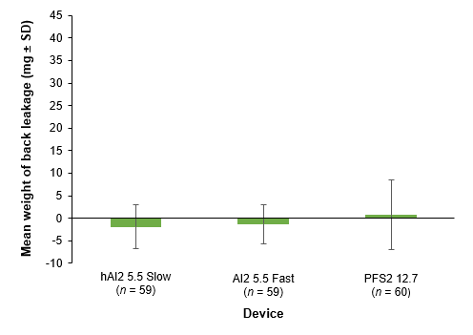
AI2, 2-mL auto-injector device; hAI2, human 2-mL auto-injector device; PFS2, 2-mL pre-filled syringe;
SC, subcutaneous; SD, standard deviation.
Negative values are potentially due to liquid evaporation and are within measurement variability.

