Quantitative chemical profiling of commercial glyceride excipients via ¹H NMR spectroscopy
Isha Saraf¹, Varun Kushwah¹, Hansjoerg Weber², Dattatray Modhave¹, Thean Yeoh³, and Amrit Paudel^{1, 4*}

¹Research Center Pharmaceutical Engineering (RCPE) GmbH, Inffeldgasse 13, 8010 Graz, Austria
²Institute of Organic Chemistry, Graz University of Technology, Stremayrgasse 9A, 8010 Graz
Austria
³Drug Product Design, Pharmatherapeutics Pharmaceutical Sciences, Worldwide Research and Development, Pfizer Inc, Groton, CT, USA
⁴Institute for Process and Particle Engineering, Graz University of Technology, Inffeldgasse 13, 8010 Graz, Austria

*Corresponding author:
E-mail: amrit.paudel@tugraz.at
Tel.: +43 316 873 30912

Supplementary Information
T1 relaxation experiment:
T1-Relaxation experiments were performed using the standard mixture (glycerol, mono-, di-glycerides and their isomers, tri-glycerides and fatty acids) dissolved in 0.6 mL of CDCl₃ containing 1.0 mg of reference standard (tCNB) as per the protocol mentioned in the section 3.1.
T1-Relaxation experiments have been carried out using the inversion-recovery sequence (d1 - 180° pulse - d2 - 90° pulse - acq) and the following parameters: d1 20 s, number of scans 4, d2 as an array of 10 values from 0.0625 - 32 s.
Result and Discussion
The T1 relaxation values obtained were less than 3 secs for all the signals (Figure S1, S2 and S3). Whereas, for the selected signals used for the quantification of chemical composition (equation 2 to 8) of MDGs, the T1 relaxation values were even lower than 2 sec, suggesting application of sufficient relaxation times for the proton (relaxation delay 1.0 s, number of scans 32, acquisition time 2.049 s).
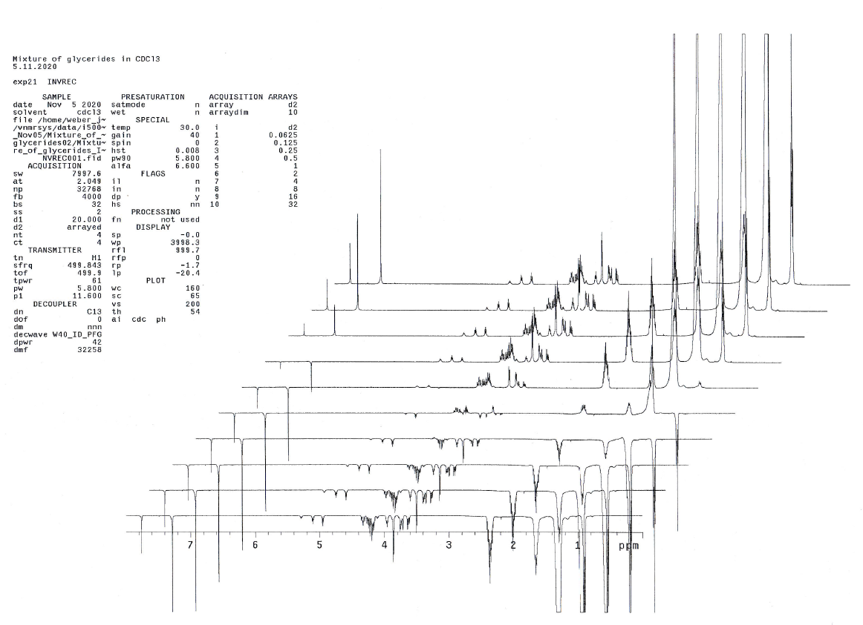
Figure S1: T1 Relaxation experiments using the inversion-recovery sequence
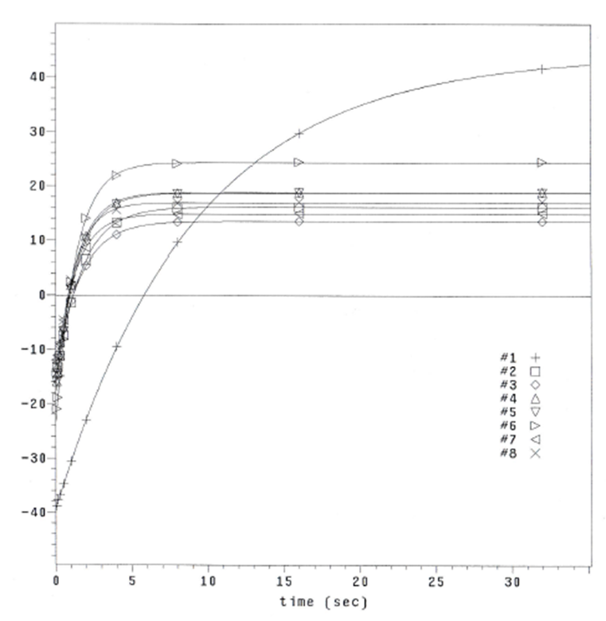
Figure S2: Relaxation curves of samples (8 most intense peak from the Figure S1)
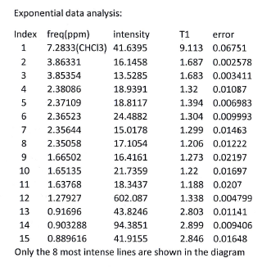
Figure S3: T1 relaxation time value (of 15 most intense signals from Figure S1)

