Supplemental

Poly(vinyl alcohol) cryogel membranes loaded with resveratrol as potential active wound dressings

Anna Górska¹, Anna Krupa¹*, Dorota Majda², Piotr Kulinowski³, Mateusz Kurek¹, Władysław P. Węglarz⁴, Renata Jachowicz¹

Fig. S1. Images taken immediately after combining PVA sols of 8 % with 15 % solution of RSV in: a) PG, b) PEG 200 or after freezing and thawing c) Cremophor RH 40, d) Tween 80, e) Labrasol.

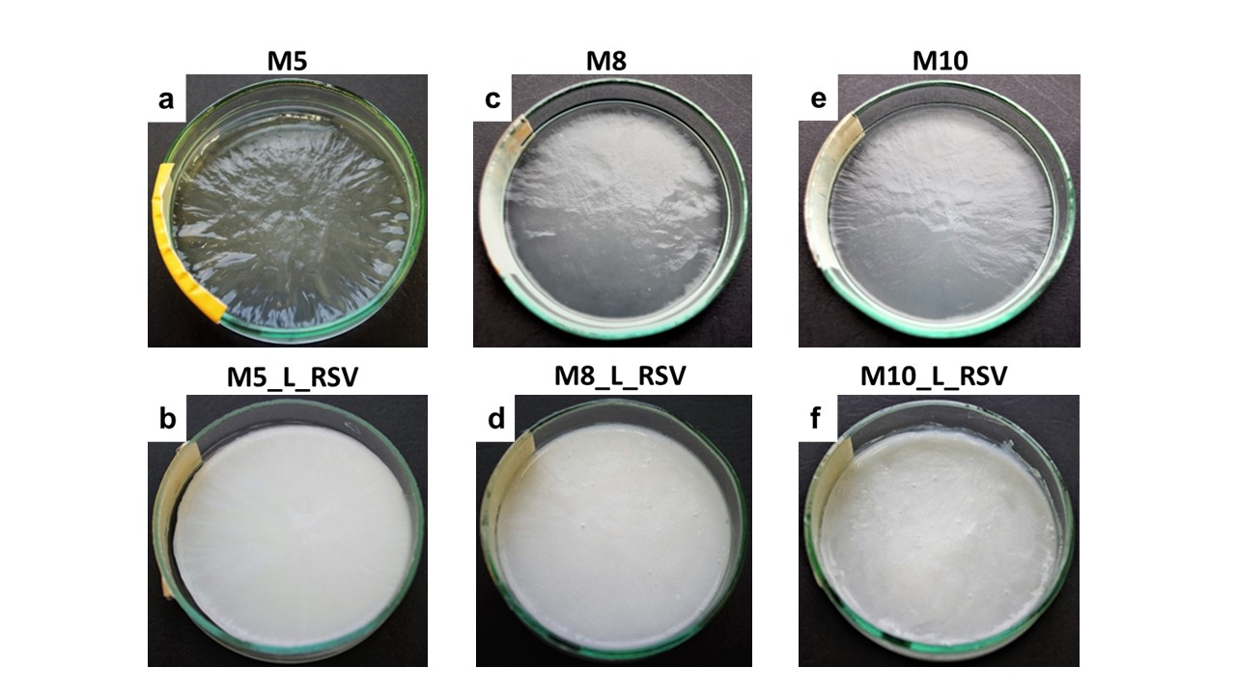

Fig. S2. Images of cryogel membranes (M) recorded after 6FT cycles using digital camera. First row shows placebo cryogels. Second row shows cryogels loaded with trans-resveratrol (RSV). Numbers correspond to percentage of PVA. L-Labrasol.

Fig. S3. Heat flow curves of: (a) raw materials: trans-resveratrol (RSV), polyvinyl alcohol (PVA), propylene glycol (PG), Labrasol (L), stock solution of 15 % RSV in L, sol M8 (PVA & PG), sol M8_L (PVA, PG & L), sol M8_L_RSV (PVA, PG, L & RSV); (b-d) M8, M8_L and M8_L_RSV before and after 6FT cycles.

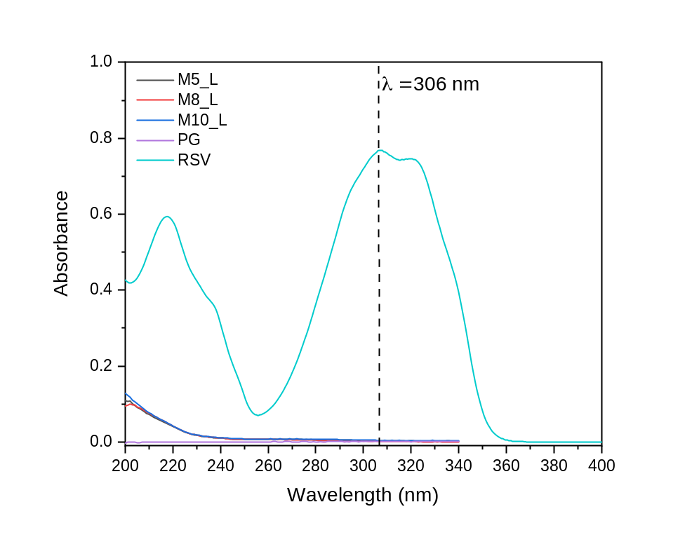
Fig. S4. Specificity of RSV quantification in cryogel membranes using UV spectroscopy.

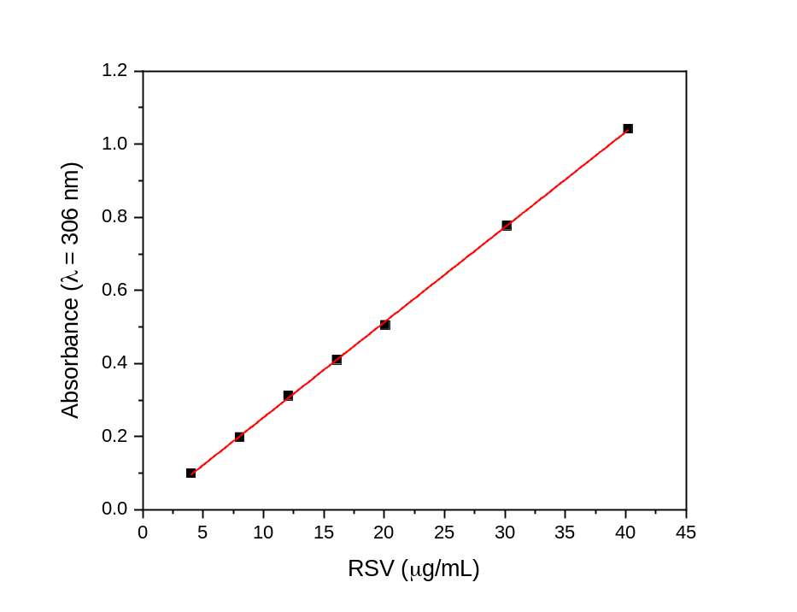
Fig. S5. Calibration curve of RSV in propylene glycol determined at λ = 306 nm (r² = 0.9999).

Tab. SI. Intra- and interday precision of RSV measurements (amber glass).
Samples |  | RSV [μg/mL]
 |  | 0 min | 24 h | 48 h | 72 h | 96 h
A  $\overline{x}$ [μg/mL] = 7.74  SD [μg/mL] = 0.05  RSD [%] = 0.65 | 1 | 7.72 | 7.77 | 7.78 | 7.74 | 7.65
 | 2 | 7.74 | 7.74 | 7.72 | 7.74 | 7.67
 | 3 | 7.74 | 7.87 | 7.73 | 7.75 | 7.68
B  $\overline{x}$ [μg/mL] = 15.98  SD [μg/mL] = 0.04  RSD [%] = 0.25 | 1 | 15.97 | 16.03 | 15.98 | 16.05 | 15.92
 | 2 | 15.95 | 16.03 | 15.98 | 15.99 | 15.95
 | 3 | 15.96 | 15.98 | 15.92 | 16.00 | 16.04
C  $\overline{x}$ [μg/mL] = 30.40  SD [μg/mL] = 0.13  RSD [%] = 0.43 | 1 | 30.22 | 30.23 | 30.39 | 30.65 | 30.54
 | 2 | 30.22 | 30.34 | 30.39 | 30.49 | 30.44
 | 3 | 30.26 | 30.42 | 30.42 | 30.47 | 30.51

