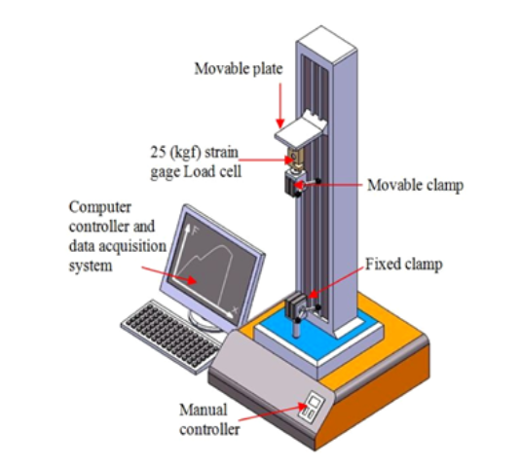
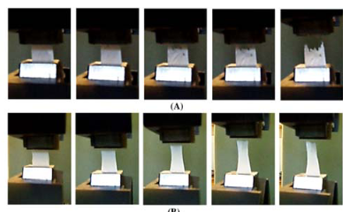
(a)
(b)

Figure S1. (a) The schematic presentation STM-5 tensile machine illustrated by Taghizadeh et al (29) (b) the process of tensile testing reported by Lee and Deng (30).

