Supplementary Material:
Fig. S 1:
Fig. S 1:Osmification of additional oils and excipients.
Micrographs were obtained by SEM imaging using BSE. Theimage sectionsdisplay labrafil M2125 (A), K85EE omega-3-acid ethyl esters (B) squalene (C), olive oil Ph.Eur. grade (D), super refined corn oil (E), super refined cottonseed oil (F), Span 85 Ph.Eur. grade (G) Span 80 Ph.Eur. grade (H) and super refined oleic acid (I). All excipients showed a positive reaction with osmium tetroxide; however, not all samples retained a spherical shape (Fig. S 1H, I).

Method:

All lipids were dispersed as 10% (w/w) in a 1% (w/w) polyvinyl alcohol (PVA) solution, with a total weight of 10 g. The lipids were homogenized using an Ultrathurax IKA T18 Basic (IKA®-Werke GmbH & Co. KG, Staufen, Germany) at 13,000 rpm for 2 minutes. This pre-emulsion was further processed using ultrasound homogenization with a Bandelin Sonopuls HD 2200 homogenizer (BANDELIN electronic GmbH & Co. KG, Berlin, Germany), equipped with an SH 213 G booster horn and a TT13 titanium tip, operated at 50% power in continuous mode for 2 minutes.
The resulting emulsions were diluted 1:1000 and stained with 4% unbuffered osmium tetroxide solution to achieve a final concentration of 1% osmium tetroxide per milliliter. The staining process lasted for at least 48 hours. Samples were analyzed for a positive reaction (e.g., blackening) and evaluated for particle size and shape using an electron microscope
All excipients showed positive reaction with osmium tetroxide but not al samples retained a spherical shape (Fig. S 1H,I).

Fig. S 2:
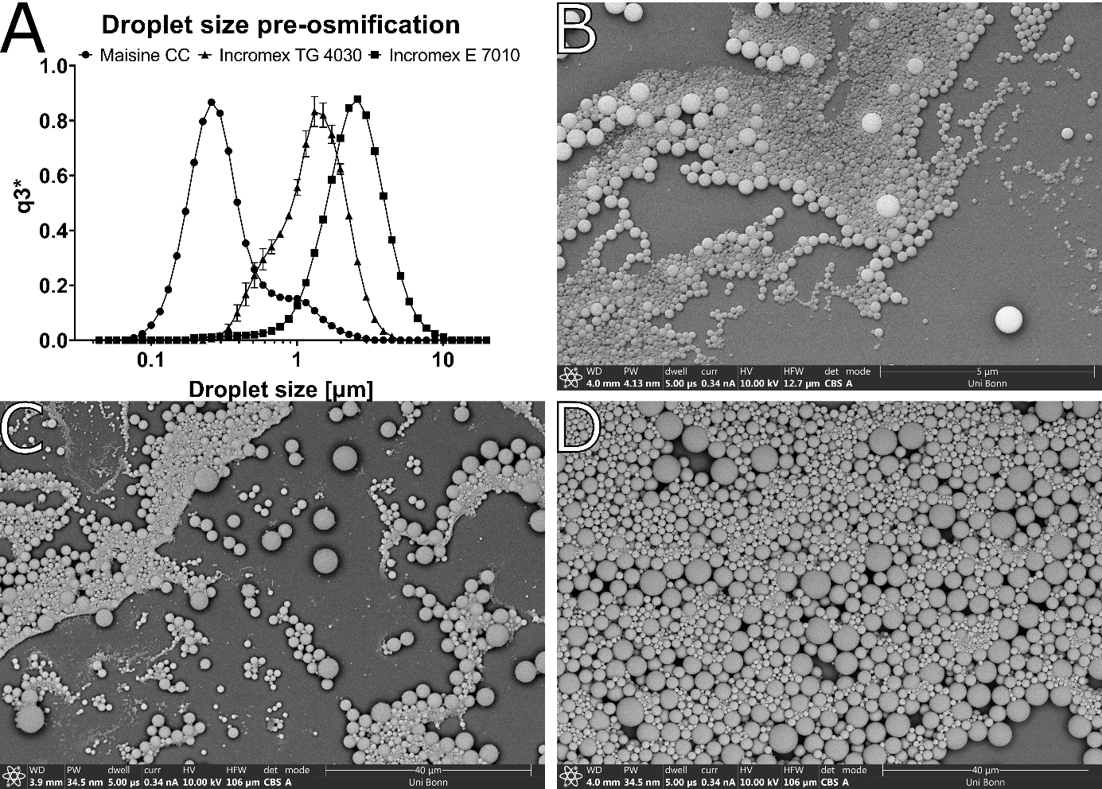
Fig. S 2: Droplet size before and after osmification.
Image section A shows the droplet size distribution of the three oils before osmification, measured by laser diffraction. The following sections show Maisine CC™ (B), Incromex TG 4030™ (C) and Incromex E 7010™ (D) emulsion after osmification as SEM images. Formulation of the oils in 1% PVA resulted in particle size distributions in the sub micrometer range in case for Maisine CC™ and in low micrometer range for the omega 3 based oils Incromex TG 4030™ and Incromex E™ 7010. The coincubation of diluted emulsion with osmium tetroxide resulted in a black precipitate. When observed under SEM the precipitated oil droplets (Figure 1 B-D) show spherical structures within the size range measured by a LA960 laser diffraction device (Horiba, Kyoto, Japan).

Method:

Droplet sizes were analyzed directly after production using a LA 960 laser diffraction device (Horiba, Kyoto, Japan) in a liquid cuvette under stirring. Particle concentrations were adjusted to 85% transmittances. The real refractive index was set to 1.450 and imaginary refractive index was set to 0.000 with the refractive index of the dispersing medium at 1.333 for water. Droplet size distributions were calculated as volumetric distribution.
SEM samples and micrographs were obtained as mentioned under S1

Fig. S 3:

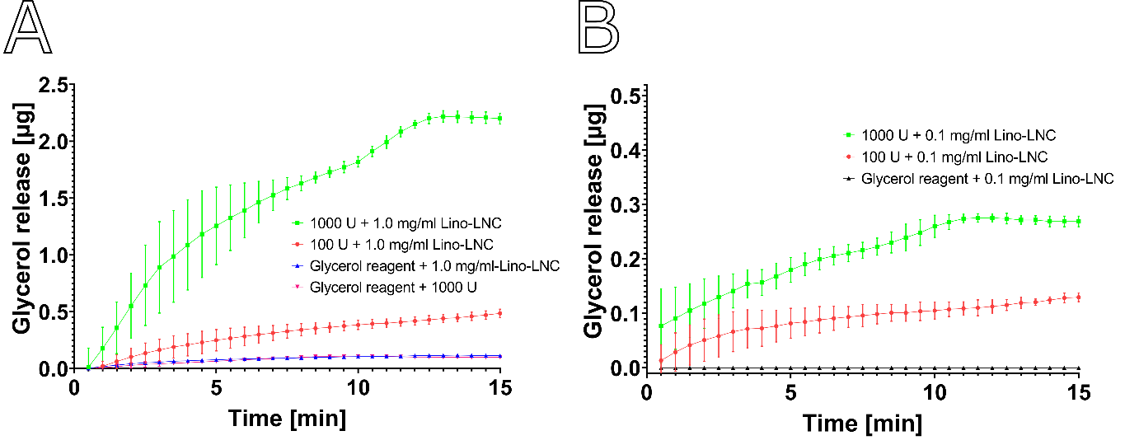Fig. S 3: In vitro digestion of Lino-LNCs by pancreatic lipase
1.0 mg/ml (A) or 0.1 mg/ml (B) Lino-LNC samples were premixed with or without the respective pancreatic lipase concentrations. A 20 µl sample was drawn and added to a 96-well plate containing 100 µl of free glycerol detection reagent. Absorbance measurements at 540 nm, corresponding to the quinoneimine dye formed from released glycerol, were taken after incubation of Lino-LNCs with pancreatic lipase in the presence of the detection reagent. The plate was incubated at 37°C directly in the plate reader for 15 minutes, with absorbance measured every 30 seconds. Lino-LNCs incubated with 1000 U of pancreatic lipase released significantly more glycerol within the time frame compared to LNCs incubated with 100 U (A, B). Control experiments with 1.0 mg/ml Lino-LNC particle sample without lipase or 1000 U of lipase alone showed only minimal absorbance, suggesting negligible glycerol release (A). Additionally, 0.1 mg/ml Lino-LNC particles incubated under similar conditions did not result in measurable absorbance after blank subtraction and are thus displayed as a value of 0 (B). The graphs displayed are corrected by the signal generated by lipase and the particles co incubated in DPBS. Data is presented as mean ± SD (n=3)

Fig. S 4
Fig. S 4: Overview of cellular morphologies of the untreated J774.A1 cell line
The micrographs display BSE images obtained by SEM imaging of HMDS prepared J774.A1 cells. Sections A and B represent small areas of adherend cells. Micrographs C-E represent the 3 morphological types of the cell line ranging from round (C) to elongated (D) to large and flat (E). Especially the elongated cells can stretch over distances of 40 µm. All cells show extensive signs of membrane ruffling (F).

Fig. S 5
Fig. S 5: J774.A1 Cells after treatment with Ω3EE-LNC after 15, 30, 60 and 120 min of incubation.
The micrographs display BSE images obtained by SEM imaging of HMDS prepared J774.A1 cells after incubation of 0.1 mg/ml of Ω3EE-LNC. Image sections display cells after 15 min incubation (A), 30 min incubation (B) 60 min incubation (C) and 120 min incubation (D). LNC uptake could be detected after 15 min, visible as bright spots.

Fig. S 6:
Fig. 6: J774.A1 Cells after treatment with Ω3TG-LNC after 15, 30, 60 and 120 min of incubation.
The micrographs display BSE images obtained by SEM imaging of HMDS prepared J774.A1 cells after incubation of 0.1 mg/ml of Ω3TG-LNC. Visible within the image sections are J774.A1 cells after 15 min incubation (A), 30 min incubation (B) 60 min incubation (C) and 120 min incubation (D). Ω3TG-LNC uptake could be detected after 30 min, visible as bright spots. The imaged cells in the sections occasionally have LNC droplets adhering to the surface, especially the cell in micrograph section D.

Fig. S 7
Fig. S 7: Ultrastructure of lipid droplets after 24-hour incubation using various contrast agents.
Lipid droplets stained with reduced osmium tetroxide and post-staining on the grid show a homogeneous grayish structure (A). Lipid droplets stained with reduced osmium thiocarbohydrazide osmium show a core-shell structure (B,C). The addition of on grid staining did not change the morphology (B) of lipid droplets.
Methods:
Fixation, dehydration, embedding and ultramicrotomy was performed as previously described. Reduced Osmium staining was performed for 90 min using 1,5% ferrocyanide-1% osmium tetroxide. The rOTO staining was performed as described in the method sections. On grid staining was performed using uranyl acetate (Electron microscopy sciences, 1560 Industry Road Hatfield, Pennsylvania, USA) 2 % solution for 25 minutes following 7 minutes 3 % lead citrate.

Fig. S 8
Fig. S 8: Effect of lysosomotropic agents with and without Lino-LNC treatment on viability of J774A.1 cells as determined by MTT assay.
Viability after 24 hours of incubation with chloroquine is shown as a curve in A. Section B shows the effect of lalistat 2 compared with the untreated control after 24 hours. The effect of 0.1 mg/ml Lino-LNC on the viability of cells pre-treated with lalistat 2 and chloroquine after 24 hours is shown as a bar graph in C. Viability was calculated with respect to the untreated control, which was set as 100%. Data is presented as mean ± SD with significance levels: * p < 0.05; ** p < 0.01; *** p < 0.001, **** p < 0.0001 calculated by one way Anova

Abbreviations: Chloroquine (CQ), Lalistat 2 (LAL2), Lipid nanocarrier (LNC)

Method:
The cells were incubated using lalistat 2 or chloroquine at the respective concentrations. To assess the viability influence of the co-treatment, cells were pretreated for 90 min using chloroquine or lalistat 2 and then incubated for 24 hours with 0.1 mg/ml Lino-LNCs.
Cell viability was assessed after three washing steps with Dulbecco’s phosphate-buffered saline (DPBS) using an MTT assay. The assay employed 3-(4,5-dimethylthiazol-2-yl)-2,5-diphenyltetrazolium bromide as the formazan-forming compound [33], with an incubation time of 90 minutes. Colorimetric analysis was conducted using a Perkin Elmer Enspire plate reader (Perkin Elmer, Waltham, Massachusetts, USA) at 560 nm in 100 µL dimethyl sulfoxide (DMSO).

