Supplementary Data

Injectable PLGA-based in situ forming subconjunctival implant for sustained ocular delivery of ketotifen fumarate: Formulation, drug release, and biocompatibility studies
Nur Mita ^{1,2}, Xuejia Kang ^{1,3}, Pengyu Chen³, Oladiran Fasina⁴, Shenise Howard⁵, Anna-Catherine Bowden⁵, Richard J. McMullen Jr.^{5,6}, Amol Suryawanshi⁷, R. Jayachandra Babu ^{1,*}
¹Department of Drug Discovery and Development, Harrison College of Pharmacy, Auburn University, AL 36849, USA
²Faculty of Pharmacy, Mulawarman University, Samarinda, Kalimantan Timur, 75119, Indonesia
³Materials Research and Education Center, Materials Engineering, Department of Mechanical Engineering, Auburn University, Auburn, AL 36849, USA
⁴Department of Biosystems Engineering, Samuel Ginn College of Engineering, Auburn University, Auburn, AL 36849, USA
⁵Department of Clinical Sciences, College of Veterinary Medicine, Auburn University, AL 36849, USA
⁶Equine Department, Vetsuisse Faculty, University of Zurich, 8057 Zurich, Switzerland
⁷Department of Population Health and Pathobiology, College of Veterinary Medicine, North Carolina State University, Raleigh, NC, USA
*Corresponding author
R. Jayachandra Babu: ramapjb@auburn.edu
List of Supplementary Table and Figures
Table S1. The needle dimensions used in the injectability parameters prediction
Figure S1. Comparison of initial burst release at 24 hours for different PLGA concentrations and various release-modifying agents
Figure S2. HPLC chromatogram of ketotifen fumarate (100 μg/mL) compared to the diluent (blank) for baseline assessment
Figure S3. Calibration curve of ketotifen fumarate: Plot of peak area versus concentration (μg/mL) obtained from HPLC analysis

Table S1. The needle dimensions used in the injectability parameters prediction
Needle Dimension | 𝑅n (mm)
19 Gauge | 0.69
20 Gauge | 0.60
21 Gauge | 0.51
25 Gauge | 0.26
27 Gauge | 0.21

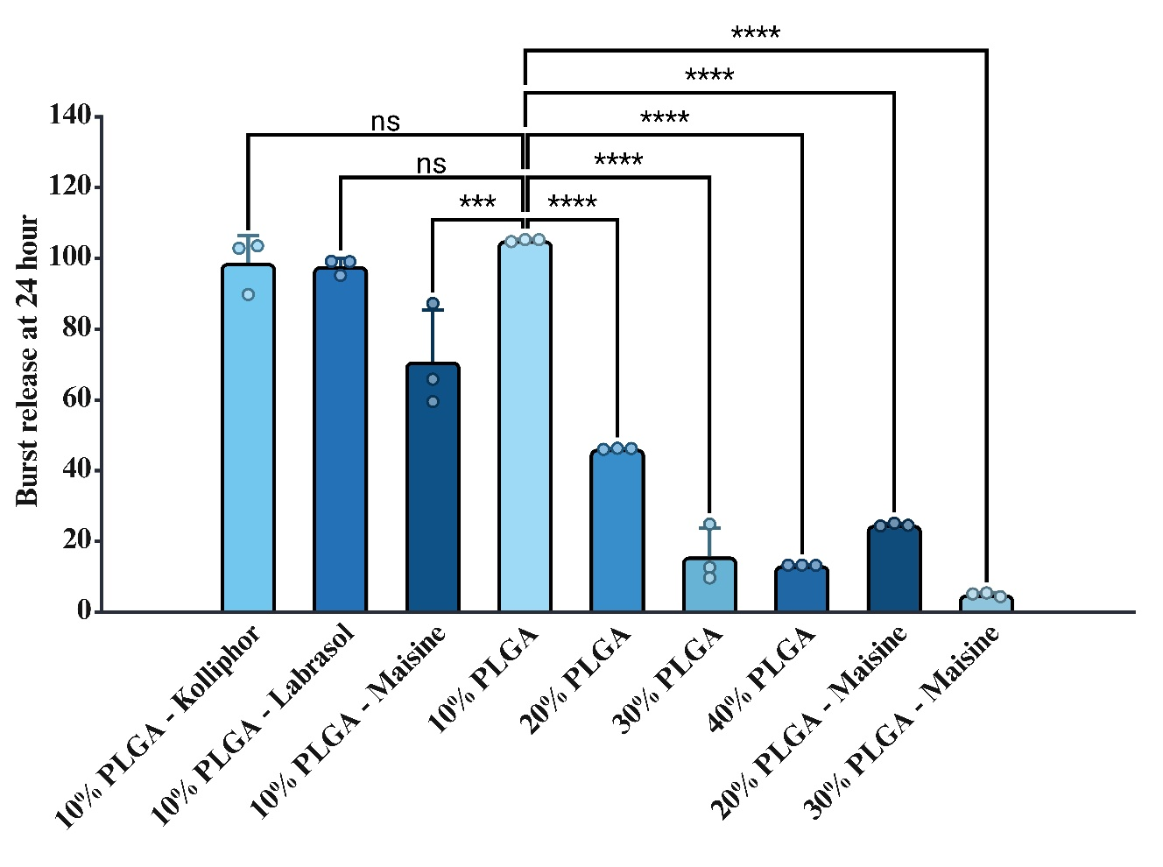
Figure S1. Comparison of initial burst release at 24 hours for different PLGA concentrations and various release-modifying agents
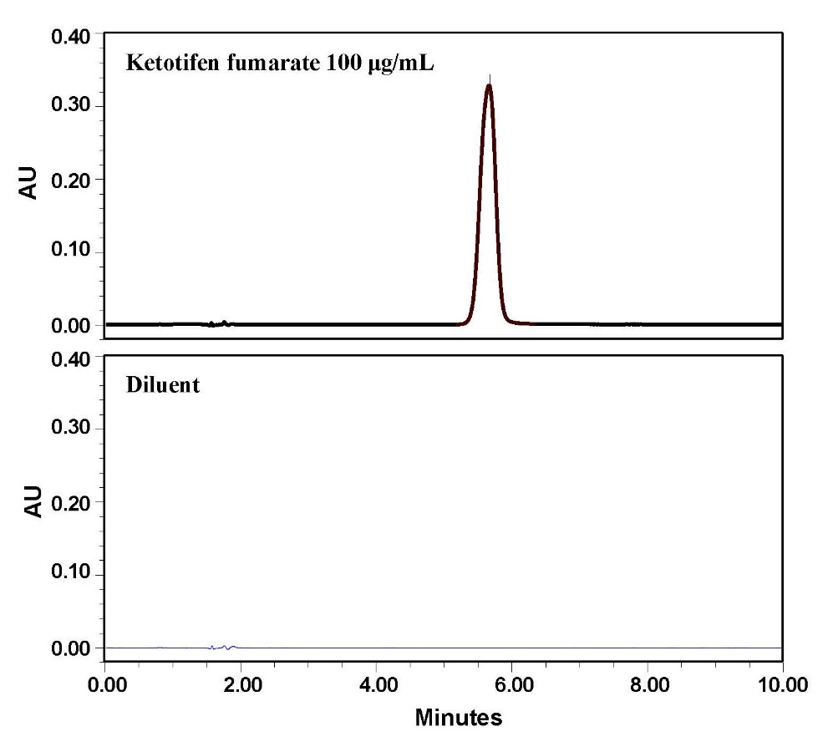
Figure S2. HPLC chromatogram of ketotifen fumarate (100 μg/mL) compared to the diluent (blank) for baseline assessment

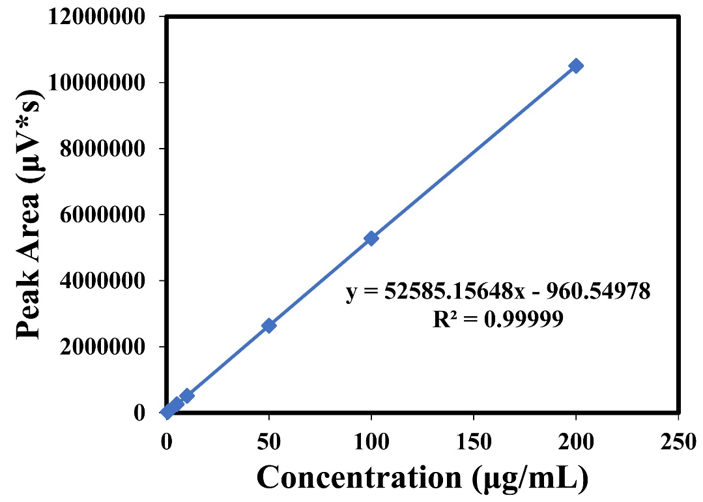
Figure S3. Calibration curve of ketotifen fumarate: Plot of peak area versus concentration (μg/mL) obtained from HPLC analysis

