Supplementary document
Fabrication of Gastroretentive and Extended-Release Famotidine Floating Tablets via Fused Deposition Modeling
Esraa Al Shawakri ª, Eman A. Ashour ª, Rasha M. Elkanayati ª, Mashan Almutairi ^{b}, Sundus Omari ^{c,} Nouf AlShammari ^{a, d}, Michael A Repka ^{a, e, *}

- Department of Pharmaceutics and Drug Delivery, School of Pharmacy, The University of Mississippi, MS, 38677, USA
- Department of Pharmaceutics, College of Pharmacy, University of Hail, Hail, 81442, Saudi Arabia
- Thermo Fischer Scientific, Cincinnati, Ohio 45237
- Department of Pharmaceutics, College of Pharmacy, Northern Border University, Arar 91431, Saudi Arabia
- Pii Center for Pharmaceutical Technology, University of Mississippi, University, MS 38677, USA
eaalshaw@go.olemiss.edu ORCID number: (0009-0004-1981-065X)
rmelkana@go.olemiss.edu ORCID number: (0009-0000-2600-6791)
eashour@olemiss.edu ORCID number: (0000-0001-9013-1327)
m.almutairi@uoh.edu.sa ORCID number: (0000-0003-2774-5128)
sundus.omari@thermofisher.com ORCID number: (0000-0001-6675-1200)
nalshamm@go.olemiss.edu ORCID number: (0009-0004-8697-9260)
marepka@olemiss.edu ORCID number: (0000-0003-2049-4696)

* Corresponding author
Prof. Michael A. Repka
Department of Pharmaceutics and Drug Delivery & Pii Center for Pharmaceutical Technology, School of Pharmacy, University of Mississippi, University, MS 38677, USA
E-mail address: marepka@olemiss.edu

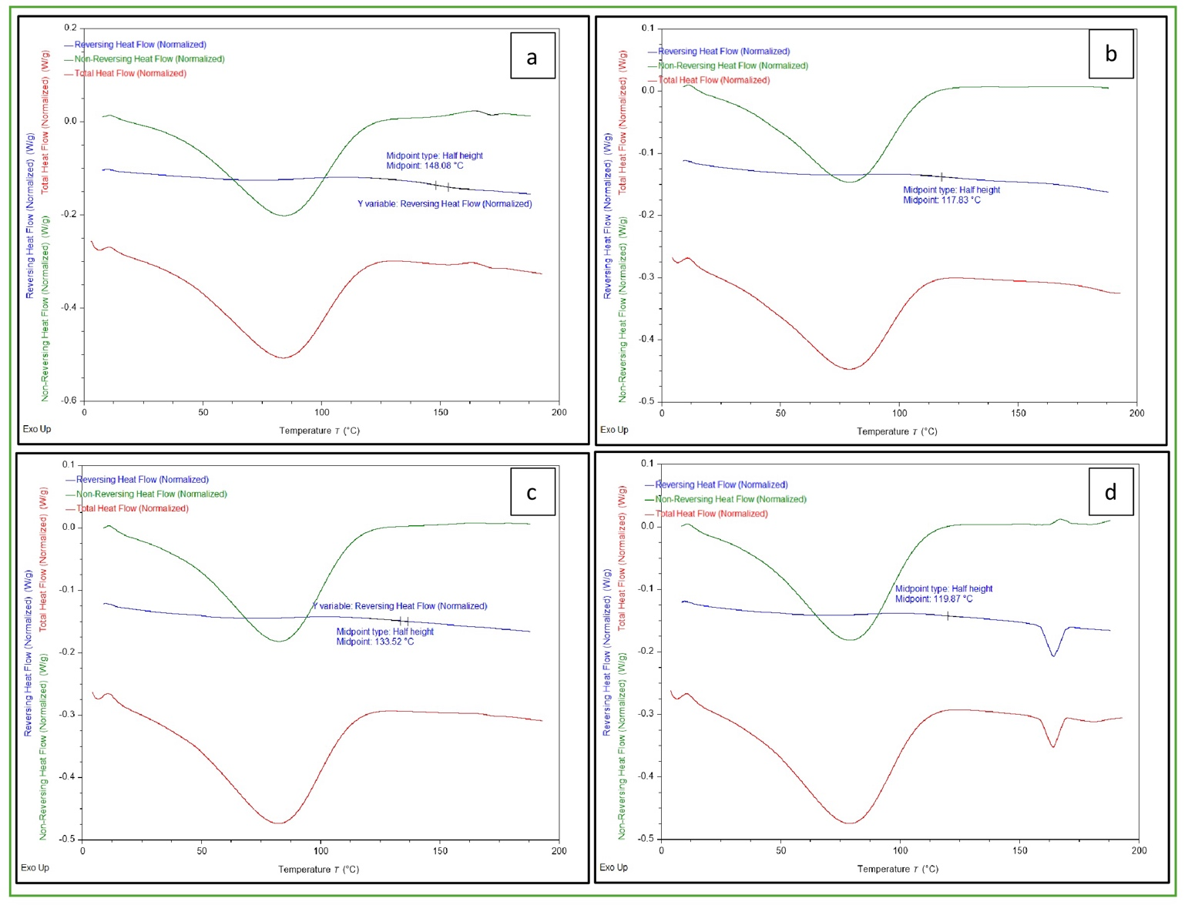

Figure S1. MDSC for (a): HPMC E5, (b): HPLC LF, (c): polymer blend (no drug included), (d): physical mixture (HPLC LF/HPMC E5/famotidine)

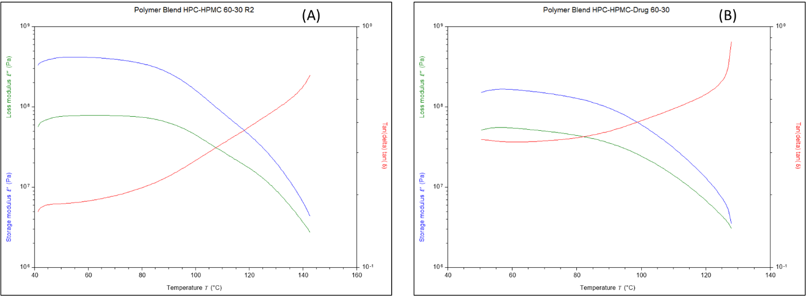

Figure S2. Dynamic mechanical analysis (DMA) thermograms of (A) the polymer blend (HPC LF/HPMC E5, 60:30) and (B) the corresponding physical mixture with famotidine. The glass transition temperature (Tg) was identified at ~120 °C, as indicated by the peak in tan δ (red curve) and confirmed by the drop in storage modulus E′ (blue curve).

Figure S3. Overlay of the heat-cool-heat cycle of 10, 20, and 30% drug load

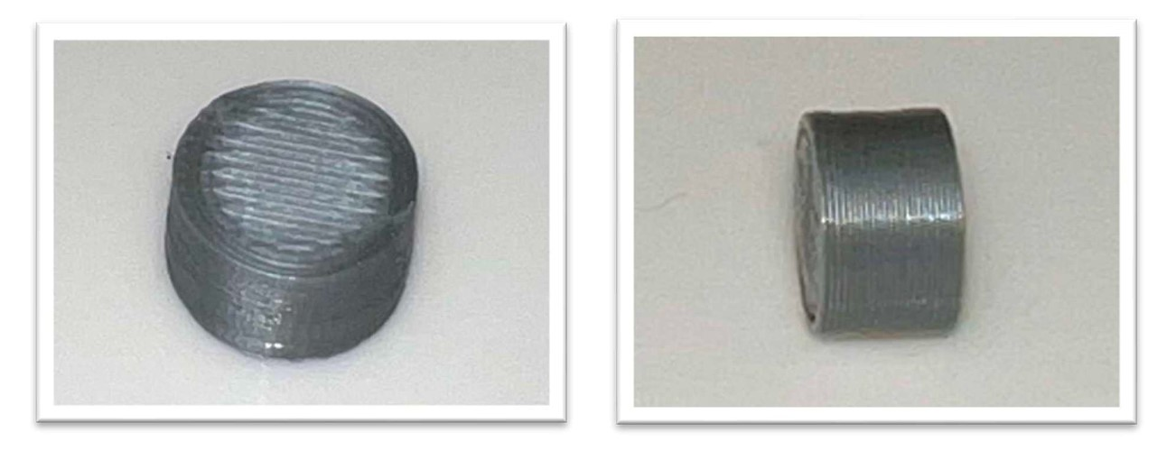

Figure S4. PLA hollow shape 3D printed tablet

