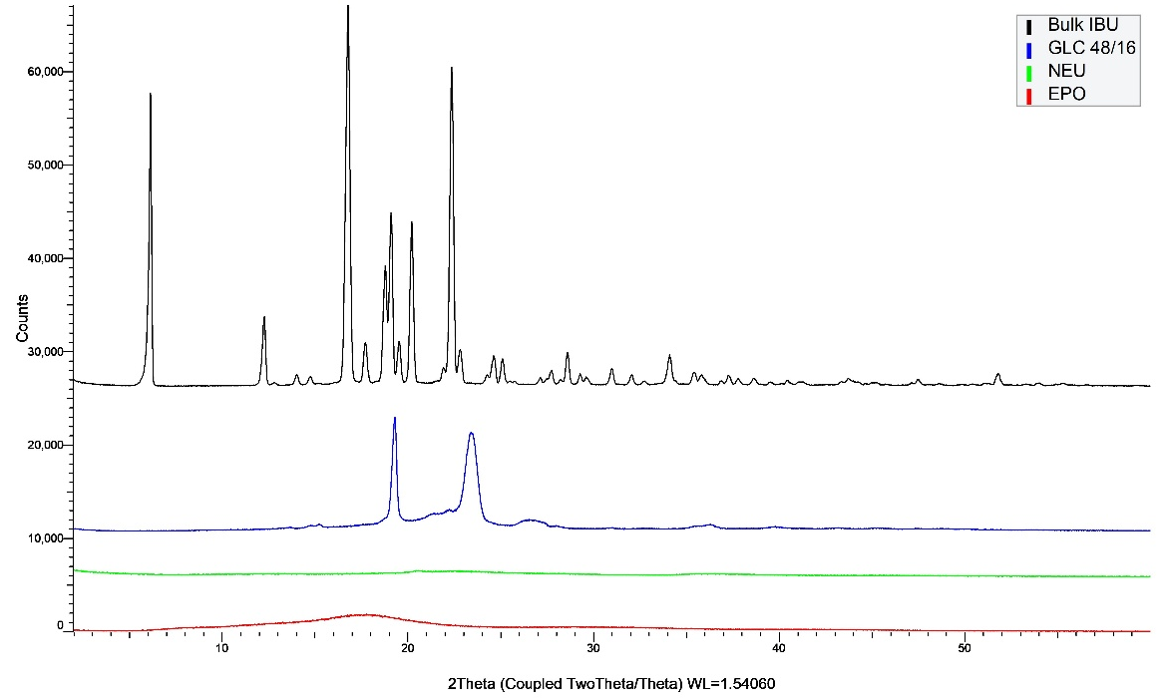
Fig. 1S: XRPD diffractograms of bulk IBU, GLC, NEU and EPO.

Fig. 2S: DSC thermograms of bulk IBU, GLC, NEU and EPO.

Table 1S: Coefficients data for EPO and GLC on crystallinity
Coefficients Table and Models: Crystallinity (%)
Coded Name | Coefficient Value | Coefficient Standard Error | Coefficient  t Statistic | P-Value
Constant | 1.3000 | 0.0058 | -- | --
Eudragit EPO | -1.0000 | 0.0091 | -109.545 | 0.0001
Gelucire 48/16 | -1.3500 | 0.0091 | -147.885 | 0.0001
Eudragit EPO * Gelucire 48/16 | -0.2500 | 0.0091 | -27.386 | 0.0013

Table 2S: Coefficients data for EPO and GLC on particle size
Coefficients Table and Models: Particle size (d₅₀)
Coded Name | Coefficient Value | Coefficient Standard Error | Coefficient  t Statistic | P-Value
Constant | 209.0500 | 4.1633 | -- | --
Eudragit EPO | -928.1950 | 6.5828 | -141.003 | 0.0001
Gelucire 48/16 | -92.3050 | 6.5828 | -14.022 | 0.0050
Eudragit EPO * Gelucire 48/16 | -955.0600 | 6.5828 | -145.084 | 0.0001

Table 3S: Coefficients data for EPO and GLC on dissolution rates
Coefficients Table and Models: Dissolution (45 min)
Coded Name | Coefficient Value | Coefficient Standard Error | Coefficient  t Statistic | P-Value
Constant | 86.00 | 0.58 | -- | --
Eudragit EPO | 15.00 | 0.91 | 16.432 | 0.0037
Gelucire 48/16 | 9.00 | 0.91 | 9.859 | 0.0101
Eudragit EPO * Gelucire 48/16 | 22.00 | 0.91 | 24.100 | 0.0017

