Supplementary information

Comprehensive Stability Assessment of Squalene in a Nanoemulsion Adjuvant and the SpiN-Tec Vaccine: HPLC Quantification, Stress Testing, and Stability Studies

Isabela Pereira Gomes¹, Graziella Gomes Rivelli¹, Flávia Fonseca Bagno¹, Natália Satchiko Hojo-Souza^{1,2}, Ana Luiza Chaves Maia^{1,3}, Liliane Martins dos Santos¹, Bruna Rodrigues Dias Assis¹, Natália Salazar de Castro¹, Wellington Miranda Vargas¹, Rafael Rodrigues de Barros¹, Natália Andrade de Freitas¹, Gisele Assis Castro Goulart^{1,4}, Renan Pedra de Souza^{1,5,6}, Santuza Maria Ribeiro Teixeira^{1,7}, Ana Paula Fernandes^{1,8}, Ricardo Tostes Gazzinelli^{1,6,7}, Eduardo Burgarelli Lages^{1,4}

¹ Centro de Tecnologia de Vacinas, Universidade Federal de Minas Gerais, Belo Horizonte, Brazil
² Laboratório de Biotecnologia e Fisiologia de Infecções Virais, Instituto Oswaldo Cruz, Fundação Oswaldo Cruz, Rio de Janeiro, Brazil
³ Campus Centro-Oeste Dona Lindu, Universidade Federal de São João del-Rei, Divinópolis, Brazil
⁴ Departamento de Produtos Farmacêuticos, Faculdade de Farmácia, Universidade Federal de Minas Gerais, Belo Horizonte, Brazil
⁵ Departamento de Genética, Ecologia e Evolução, Instituto de Ciências Biológicas, Universidade Federal de Minas Gerais, Belo Horizonte, Brazil
⁶ Instituto René Rachou, Fundação Oswaldo Cruz-Minas, Belo Horizonte, Brazil
⁷ Departamento de Bioquímica e Imunologia, Instituto de Ciências Biológicas, Universidade Federal de Minas Gerais, Belo Horizonte, Brazil
⁸ Departamento de Análises Clínicas e Toxicológicas, Faculdade de Farmácia, Universidade Federal de Minas Gerais, Belo Horizonte, Brazil

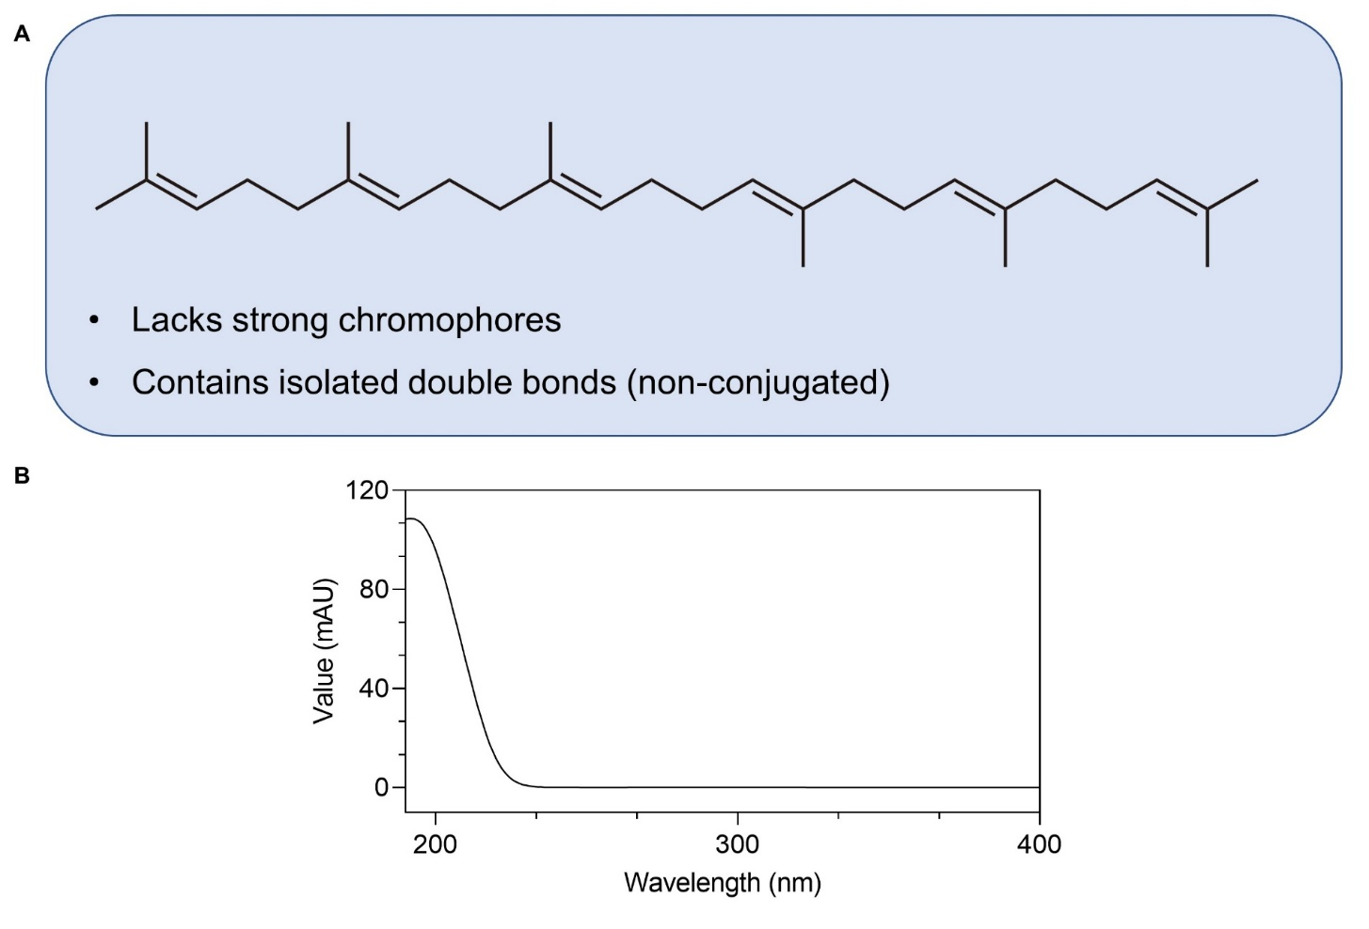
Figure S1. Chemical structure of squalene (A) and its UV absorption spectrum recorded in the 190–400 nm range (B).

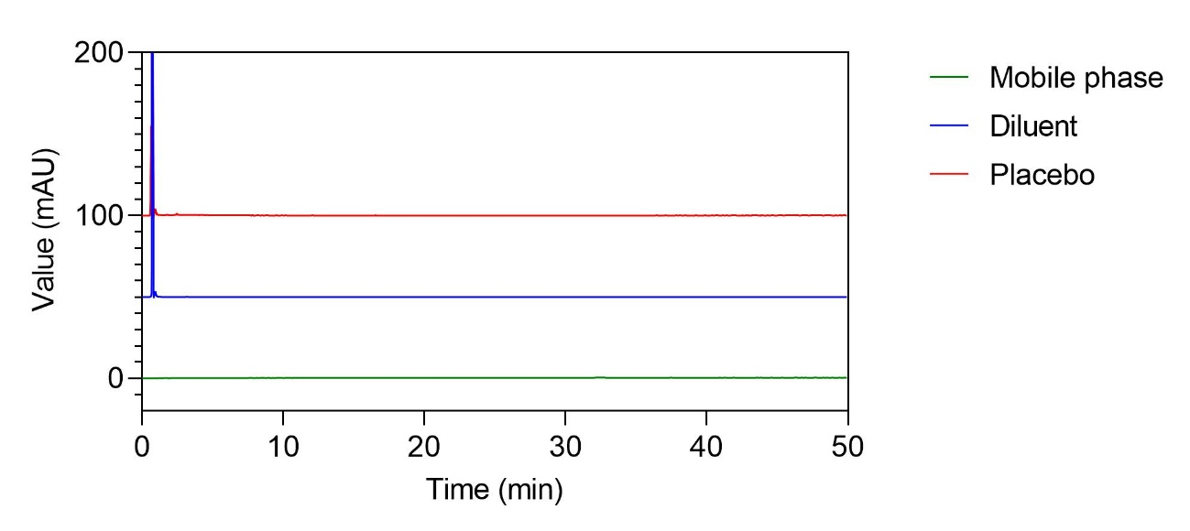
Figure S2. Representative chromatograms of the mobile phase, diluent, and placebo formulation of the SpiN-Tec vaccine, showing no interfering peaks at the retention time of squalene (~42 min).

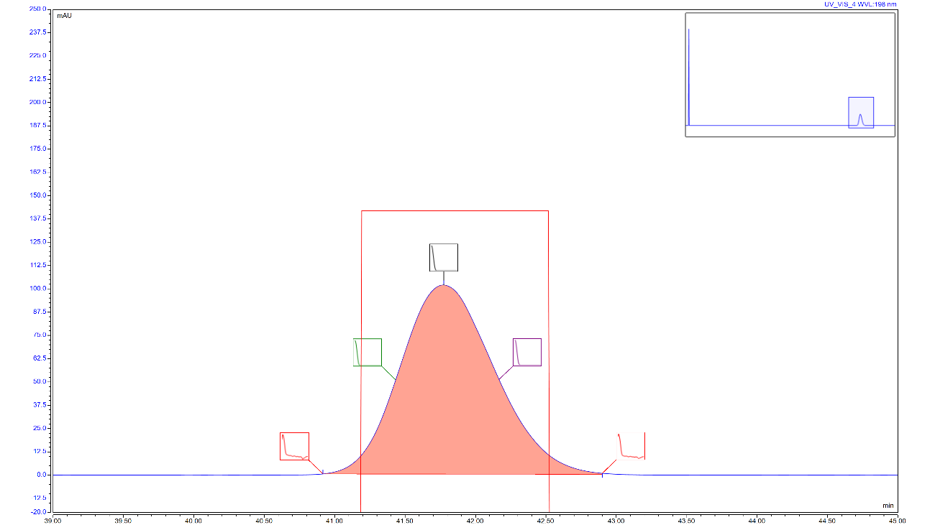
Figure S3. Representative peak purity plot of the squalene reference standard generated by the Chromeleon 7 software. The red box indicates the overlaid peak match factor, while the five small boxes represent spectral thumbnails acquired across the chromatographic peak.

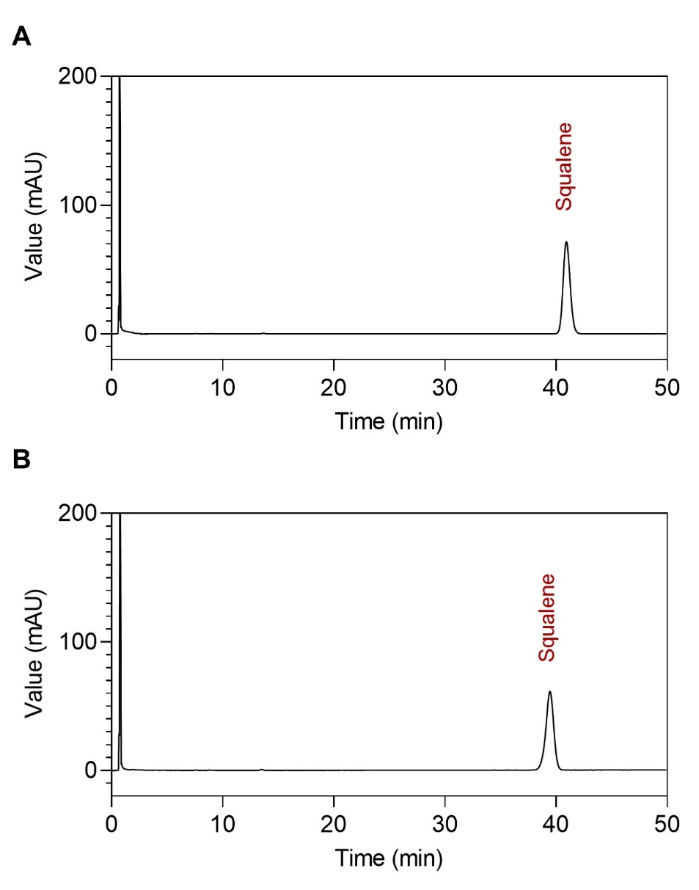
Figure S4. Representative chromatograms of the SpiN-Tec vaccine at the initial time point (A) and after 24 months of long-term storage (B), demonstrating the absence of additional peaks or significant changes in the chromatographic profile.

Table S1. Comprehensive statistical evaluation of CTVad1 physicochemical stability in clear glass vials. Data include mean differences and 95% confidence intervals (CI) relative to T0 under long-term and accelerated storage conditions.
Comparison 0 x 12 months – Long Term stability - CTVad1 clear glass vial
Parameters | Mean difference | Specification range | Initial time | 12 months | 95% CI of Difference | Statistical Significance (p-value)
Particle Size (d.nm) | -2.133 | 140 – 185 nm | 171.2 | 173.3 | -6.187 to 1.920 | p > 0.05 (0.4035)
PDI | -0.001 | Less than 0.3 | 0.073 | 0.075 | -0.025 to 0.023 | p > 0.05 (0.9998)
Zeta Potential (mV) | -1.740 | N/D | -27.71 | -25.97 | -5.200 to 1.720 | p > 0.05 (0.4398)
Squalene content (%) | 4.980 | 85.0 – 110.0 % of the declared content | 101.3 | 96.33 | 1.804 to 8.156 | p < 0.05 (0.0037)
Osmolality (mOsmol/kg) | 0.666 | 30 – 40 mOsm/kg | 37.67 | 37.00 | -0.195 to 1.528 | p > 0.05 (0.1431)
Viscosity (cP) | -0.027 | 1.00 – 1.80 cP | 1.210 | 1.237 | -0.036 to -0.017 | p < 0.05 (0.0001)
Comparison 0 x 6 months – Accelerated stability - CTVad1 clear glass vial
Parameters | Mean difference | Specification range | Initial time | 6 months | 95% CI of Difference | Statistical Significance (p-value)
Particle Size (d.nm) | -3.900 | 140 – 185 nm | 171.2 | 175.1 | -7.599 to -0.2014 | p < 0.05 (0.0410)
PDI | -0.008 | Less than 0.3 | 0.073 | 0.082 | -0.027 to 0.009 | p > 0.05 (0.3638)
Zeta Potential (mV) | 2.587 | N/D | -27.71 | -30.30 | 0.296 to 4.877 | p < 0.05 (0.0313)
Squalene content (%) | -1.423 | 85.0 – 110.0 % of the declared content | 101.3 | 102.7 | -5.409 to 2.563 | p > 0.05 (0.5256)
Osmolality (mOsmol/kg) | -0.333 | 30 – 40 mOsm/kg | 37.67 | 38.00 | -1.435 to 0.7687 | p > 0.05 (0.6180)
Viscosity (cP) | -0.024 | 1.00 – 1.80 cP | 1.210 | 1.234 | -0.028 to -0.019 | p < 0.05 (0.0001)
N/D: (Not Defined): The specification limit for zeta potential was not defined in this study.

Table S2. Comprehensive statistical evaluation of CTVad1 physicochemical stability in amber glass vials. Data include mean differences and 95% confidence intervals (CI) relative to T0 under long-term and accelerated storage conditions.
Comparison 0 x 12 months – Long Term stability - CTVad1 amber glass vial
Parameters | Mean difference | Specification range | Initial time | 12 months | 95% CI of Difference | Statistical Significance (p-value)
Particle Size (d.nm) | 1.600 | 140 – 185 nm | 174.7 | 173.1 | -2.383 to 5.583 | p > 0.05 (0.6159)
PDI | 0.166 | Less than 0.3 | 0.237 | 0.071 | -0.118 to 0.451 | p > 0.05 (0.3235)
Zeta Potential (mV) | 0.330 | N/D | -28.03 | -28.36 | -3.789 to 4.449 | p > 0.05 (0.9976)
Squalene content (%) | 6.680 | 85.0 – 110.0 % of the declared content | 101.1 | 94.45 | 3.396 to 9.964 | p < 0.05 (0.0005)
Osmolality (mOsmol/kg) | 0.666 | 30 – 40 mOsm/kg | 37.67 | 37.00 | -0.826 to 2.159 | p > 0.05 (0.5347)
Viscosity (cP) | -0.040 | 1.00 – 1.80 cP | 1.198 | 1.239 | -0.068 to -0.013 | p < 0.05 (0.0056)
Comparison 0 x 6 months – Accelerated stability - CTVad1 amber glass vial
Parameters | Mean difference | Specification range | Initial time | 6 months | 95% CI of Difference | Statistical Significance (p-value)
Particle Size (d.nm) | -1.033 | 140 – 185 nm | 174.7 | 175.7 | -4.521 to 2.454 | p > 0.05 (0.6288)
PDI | 0.177 | Less than 0.3 | 0.237 | 0.060 | -0.185 to 0.540 | p > 0.05 (0.3388)
Zeta Potential (mV) | 4.147 | N/D | -28.03 | -32.17 | 1.266 to 7.027 | p < 0.05 (0.0111)
Squalene content (%) | -2.413 | 85.0 – 110.0 % of the declared content | 101.1 | 103.5 | -7.523 to 2.697 | p > 0.05 (0.3585)
Osmolality (mOsmol/kg) | 0.666 | 30 – 40 mOsm/kg | 37.67 | 37.00 | -0.435 to 1.769 | p > 0.05 (0.2214)
Viscosity (cP) | -0.033 | 1.00 – 1.80 cP | 1.198 | 1.232 | -0.064 to -0.0027 | p < 0.05 (0.0361)
N/D: (Not Defined): The specification limit for zeta potential was not defined in this study.

Table S3. Comprehensive statistical evaluation of SpiN-Tec physicochemical stability in clear glass vials. Data include mean differences and 95% confidence intervals (CI) relative to T0 under long-term storage conditions.
Comparison 0 x 24 months – Long Term stability – SpiN-Tec clear glass vial
Parameters | Mean difference | Specification range | Initial time | 24 months | 95% CI of Difference | Statistical Significance (p-value)
Particle Size (d.nm) | 6.700 | 165 – 245 nm | 227.4 | 220.7 | -2.61 to 16.02 | p > 0.05 (0.2098)
PDI | -0.026 | Less than 0.3 | 0.073 | 0.100 | -0.063 to 0.010 | p > 0.05 (0.2249)
Zeta Potential (mV) | 2.430 | Less than –30 mV | -32.55 | -34.98 | -0.875 to 5.736 | p > 0.05 (0.1946)
Squalene content (%) | 3.047 | 80.0 – 110.0 % of the declared content | 90.57 | 87.52 | 0.020 to 6.073 | p < 0.05 (0.0482)$
Osmolality (mOsmol/kg) | 52.67 | 900 – 1500 mOsm/kg | 1063 | 1011 | -21.32 to 126.70 | p > 0.05 (0.2171)
Viscosity (cP) | -0.009 | 1.00 – 1.80 cP | 1.321 | 1.330 | -0.014 to -0.0045 | p < 0.05 (0.0003)$
Specific biological activity | -800.0 | Between 1.5 × 10³ and 9.5 × 10³ U/mg for the anti-N and anti-RBD antibodies | 3 × 10^{3#} | 4 × 10^{3#} | -2480 to 879.9 | p > 0.05 (0.4739)
Immunogenicity | 241000 | Total IgG antibody titers ≥ 10² after the first dose and ≥ 10³ after the second dose | 5.8 × 10^{6*} | 3.4 × 10^{6*} | -638211 to 1120211 | p > 0.05 (0.8603)
$ n=3. Statistical analysis performed via One-way ANOVA followed by Dunnett’s post-hoc test. The isolated statistical differences observed in two specific points (p < 0.05) do not invalidate the overall product stability. These occurrences are punctual and lack decisive weight when considering the complete dataset and the high precision of the analytical methods. Crucially, all parameters remain strictly within the predefined pharmaceutical acceptance criteria and the 95% Confidence Intervals (CI), confirming the long-term robustness of the formulation.
# mean anti-N and anti-RBD ; * mean 1st and 2nd dose

