PLGA–Phospholipid Hybrid Oleogel In Situ Forming Implant for Sustained 30-Day Co-Delivery of Donepezil and Memantine
Baljinder Singh¹, Weranga Rajapaksha¹, Haripriya Koppisetti¹, Deepa Nakmode¹, Yunmei Song¹, Sanjay Garg^{1*}
¹Centre for Pharmaceutical Innovation (CPI), School of Pharmacy and Biomedical Science, College of Health, Adelaide University, Adelaide, SA, Australia
Corresponding Author- Sanjay.garg@adelaide.edu.au

Supplementary Table 1: Formulation screening matrix summarizing the effects of lipid type, PLGA composition, oils, solvents, and additives on implant formation, in vitro release behaviour, and physical stability. The table outlines the systematic optimization process used to identify the final DM00PG‑M13 formulation.
Component Category | Ingredient | Conc  (%w/w) | Implant Formation | In vitro Release | Stability
Lipoid Type | Lipoid- S100 | 10–80% | Yes | BR → CR (conc-dependent) | Stable
Lipoid Type | Lipoid- E80 | 10–80% | Weak gel | BR | Unstable (colour change after 1 month)
PLGA Type | PLGA 50:50 | 2.5–30% | Yes | CR | Stable
PLGA Type | PLGA 75:25 | 2.5–30% | Yes | Very slow CR | Stable
PLGA Type | PLGA 85:15 | 2.5–30% | Yes | Very slow CR | Stable
PLGA Type | 50:50 + 75:25 | 2.5–30% | Yes | Very slow CR | Stable
PLGA Type | 50:50 + 85:15 | 2.5–30% | No | – | Phase separation
PLGA Type | 50:50 + 75:25 + 85:15 | 2.5–30% | No | – | Phase separation
Oils | Captex 300 | 10–70% | Yes | BR | Stable
Oils | Captex 355 | 10–70% | Yes | BR → CR | Stable
Oils | Sesame oil | 10–70% | Yes | CR | Stable
Oils | Castor oil | 10–70% | Yes | Very slow CR | Stable
Oils | Captex 300 + Sesame | 10–70% | Yes | Very slow CR | Stable
Oils | Captex 355 + Sesame | 10–70% | Yes | Very slow CR | Stable
Oils | Captex 300 + Castor | 10–70% | Yes (became viscous after 1 week) | – | Unstable
Oils | Captex 355 + Castor | 10–70% | Yes (became viscous after 1 week) | – | Unstable
Oils | Captex 355 + Sesame + Castor | 10–70% | No | – | Unstable
Polymers | Poloxamer 407 | 2–10% | Yes | BR | Phase separation (2 weeks)
Polymers | Ethyl cellulose | 2–10% | Yes | BR | Stable
Polymers | Poloxamer 407 + EC | 2–10% | No | – | –
Solvents | Ethanol | 6–30% | Yes | Initial BR | Stable
Solvents | PEG 400 | 5–10% | Yes | Initial BR | Stable
Solvents | DMSO | 5–10% | Yes | Very slow CR | Stable
Solvents | NMP | 10–30% | Yes | CR | Stable
Solvents | Benzyl alcohol (BA) | 10–20% | Yes | BR | Stable
Solvents | DMSO + BA | 30–60% | Yes | BR | Stable
Solvents | DMSO + Ethanol | 30–60% | Yes | BR | Stable
Solvents | DMSO + BB | 30–60% | Yes | BR (memantine) | Stable
Solvents | PEG 400 + Triacetin + BA | 30–60% | No | – | Phase separation (24 h)
Solvents | BB + BA + Ethanol | 30–60% | No | – | Phase separation (24 h)
Solvents | PEG 400 + BA + BB | 30–60% | No | – | Phase separation (24 h)
Solvents | NMP + BB | 30–60% | Yes | BR | Stable
Solvents | GF + Triacetin + Ethanol | 30–60% | Yes | BR | Stable
Solvents | BB + Ethanol | 30–60% | No | – | Phase separation (24 h)
Solvents | Triacetin + Ethanol + PEG 400 | 30–60% | No | – | Phase separation (24 h)
Solvents | Triacetin + Ethanol | 30–60% | Yes | – | Too viscous
Solvents | NMP + GF | 30–60% | No | – | Phase separation (24 h)
Solvents | GF + Ethanol | 30–60% | No | – | Phase separation (24 h)
Solvents | NMP + GF + Ethanol | 30–60% | No | – | Phase separation (24 h)
Other Additives | Tween (varied) | 0.3–1% | Yes | BR | –
Other Additives | IPM | 5% | No | – | Phase separation (24 h)
Other Additives | Stearic acid | 3–5% | No | – | Phase separation
Other Additives | Cholesterol | 3% | No | – | Phase separation
BR- Burst release; CR-controlled release.
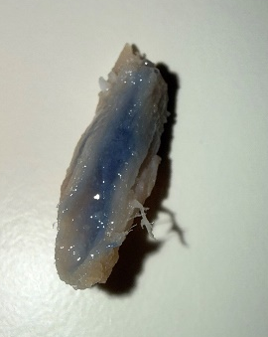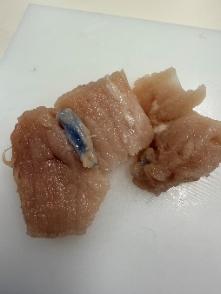
Supplementary Fig 2: Visual confirmation of cohesive in situ depot formation (highlighted with blue dye) within the porcine muscle tissue immediately following intramuscular delivery.

