APPENDICES

Patterns of clinical response with talimogene laherparepvec (T-VEC) in patients with melanoma treated in the OPTiM Phase III clinical trial.

Robert H.I. Andtbacka, MD, CM, FACS FRCSC,¹ Merrick Ross, MD,² Igor Puzanov, MD, MSI, FACP,³ Mohammed Milhem. MD,⁴ Frances Collichio, MD,⁵ Keith A. Delman, MD, FACS,⁶ Thomas Amatruda, MD,⁷ Jonathan S. Zager, MD, FACS,⁸ Lee Cranmer, MD, PhD,⁹ Eddy Hsueh, MD,¹⁰ Lisa Chen, PhD,¹¹ Mark Shilkrut, MD, PhD,¹¹ Howard L. Kaufman, MD, FACS¹²

¹University of Utah, Huntsman Cancer Institute, Salt Lake City, UT; ²University of Texas M. D. Anderson Cancer Center, Houston, TX; ³Vanderbilt University Medical Center, Nashville, TN; ⁴University of Iowa Hospitals & Clinics, Iowa City, IA; ⁵University of North Carolina, Chapel Hill, NC; ⁶Emory University, Atlanta, GA ⁷Minnesota Oncology, Fridley, MN; ⁸Moffitt Cancer Center, Tampa, FL; ⁹University of Washington School of Medicine, Seattle, WA; ¹⁰Saint Louis University Cancer Center, St. Louis, MO; ¹¹Amgen Inc., Thousand Oaks, CA; ¹²Rutgers Cancer Institute of New Jersey, Rutgers, NJ
Appendix 1 online
Baseline Demographics and Clinical Characteristics of Patients in the T-VEC Arm in OPTiM
Characteristic | Patients With Durable Response |  |  | Intent to treat  N=295ª
Characteristic | All  N=48 | Without PPR  N=25 | With PPR  N=23 | Intent to treat  N=295ª
Median (range) age, years | 70 (38-91) | 74 (40-91) | 63 (38-86) | 63 (22-94)
Age — no. (%)
<65 years | 22 (46) | 9 (36) | 13 (57) | 152 (52)
≥65 years | 26 (54) | 16 (64) | 10 (43) | 143 (48)
Sex — no. (%)
Men | 29 (60) | 16 (64) | 13 (57) | 173 (59)
Women | 19 (40) | 9 (36) | 10 (43) | 122 (41)
Disease stage — no. (%)^{b,c}
IIIB | 10 (21) | 5 (20) | 5 (22) | 22 (8)
IIIC | 19 (40) | 9 (36) | 10 (44) | 66 (22)
IVM1a | 12 (25) | 7 (28) | 5 (22) | 75 (25)
IVM1b | 2 (4) | 1 (4) | 1 (4) | 64 (22)
IVM1c | 5 (10) | 3 (12) | 2 (9) | 67 (23)
LDH — no. (%)^{b}
≤ULN | 44 (92) | 23 (92) | 21 (91) | 266 (90)
>ULN | 0 (0) | 0 (0) | 0 (0) | 15 (5)
Line of therapy — no. (%)^{d}
First line | 33 (69) | 18 (72) | 15 (65) | 138 (47)
Second or greater | 15 (31) | 7 (28) | 8 (35) | 157 (53)
ECOG performance status — no. (%)^{b}
0 | 38 (79) | 18 (72) | 20 (87) | 209 (71)
1 | 10 (21) | 7 (28) | 3 (13) | 82 (28)
Anatomic location of original disease — no. (%)^{b,e}
Scalp, face, neck | 21 (44) | 10 (40) | 11 (48) | 59 (20)
Trunk^{f} | 11 (23) | 6 (24) | 5 (22) | 72 (24)
Hand, arm | 2 (4) | 0 (0) | 2 (9) | 35 (12)
Leg, foot | 13 (27) | 7 (28) | 6 (26) | 107 (36)
Plantar/subungual | 1 (2) | 1 (4) | 0 (0) | 5 (2)
Other | 0 (0) | 0 (0) | 0 (0) | 21 (7)
BRAF status — no. (%)
Mutated | 5 (10) | 1 (4) | 4 (17) | 46 (16)
Wild-type | 5 (10) | 3 (12) | 2 (9) | 45 (15)
Unknown/ Missing | 38 (79) | 21 (84) | 17 (74) | 204 (69)
HSV-1 serostatus — no. (%)^{b}
Negative | 13 (27) | 5 (20) | 8 (35) | 97 (33)
Positive | 31 (65) | 19 (76) | 12 (52) | 175 (59)

PPR, Progression prior to response; ECOG, Eastern Cooperative Oncology Group; LDH, lactate dehydrogenase; ULN, upper limit of normal.

ª 4 patients did not receive T-VEC; ^{b} may have patients with unknown or missing data; ^{c} per CRF (case report form); ^{d} per IVRS (interactive voice response system); ^{e} the categories are not mutually exclusive; ^{f} chest, back, abdomen, pelvis.

Appendix 2 online
A. Distribution of All Baseline and New Measurable Lesions in the T-VEC Arm.
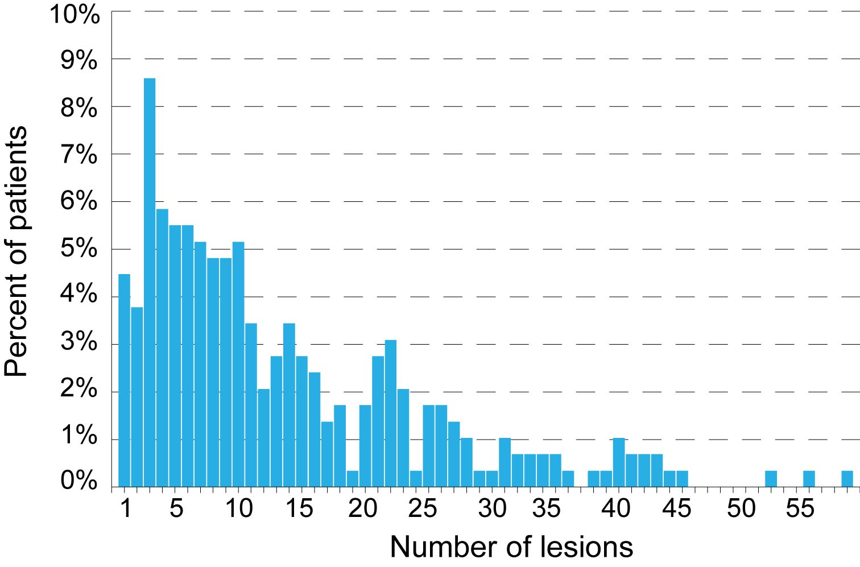

B. Distribution of Injected Lesions Per Patient in the T-VEC Arm.
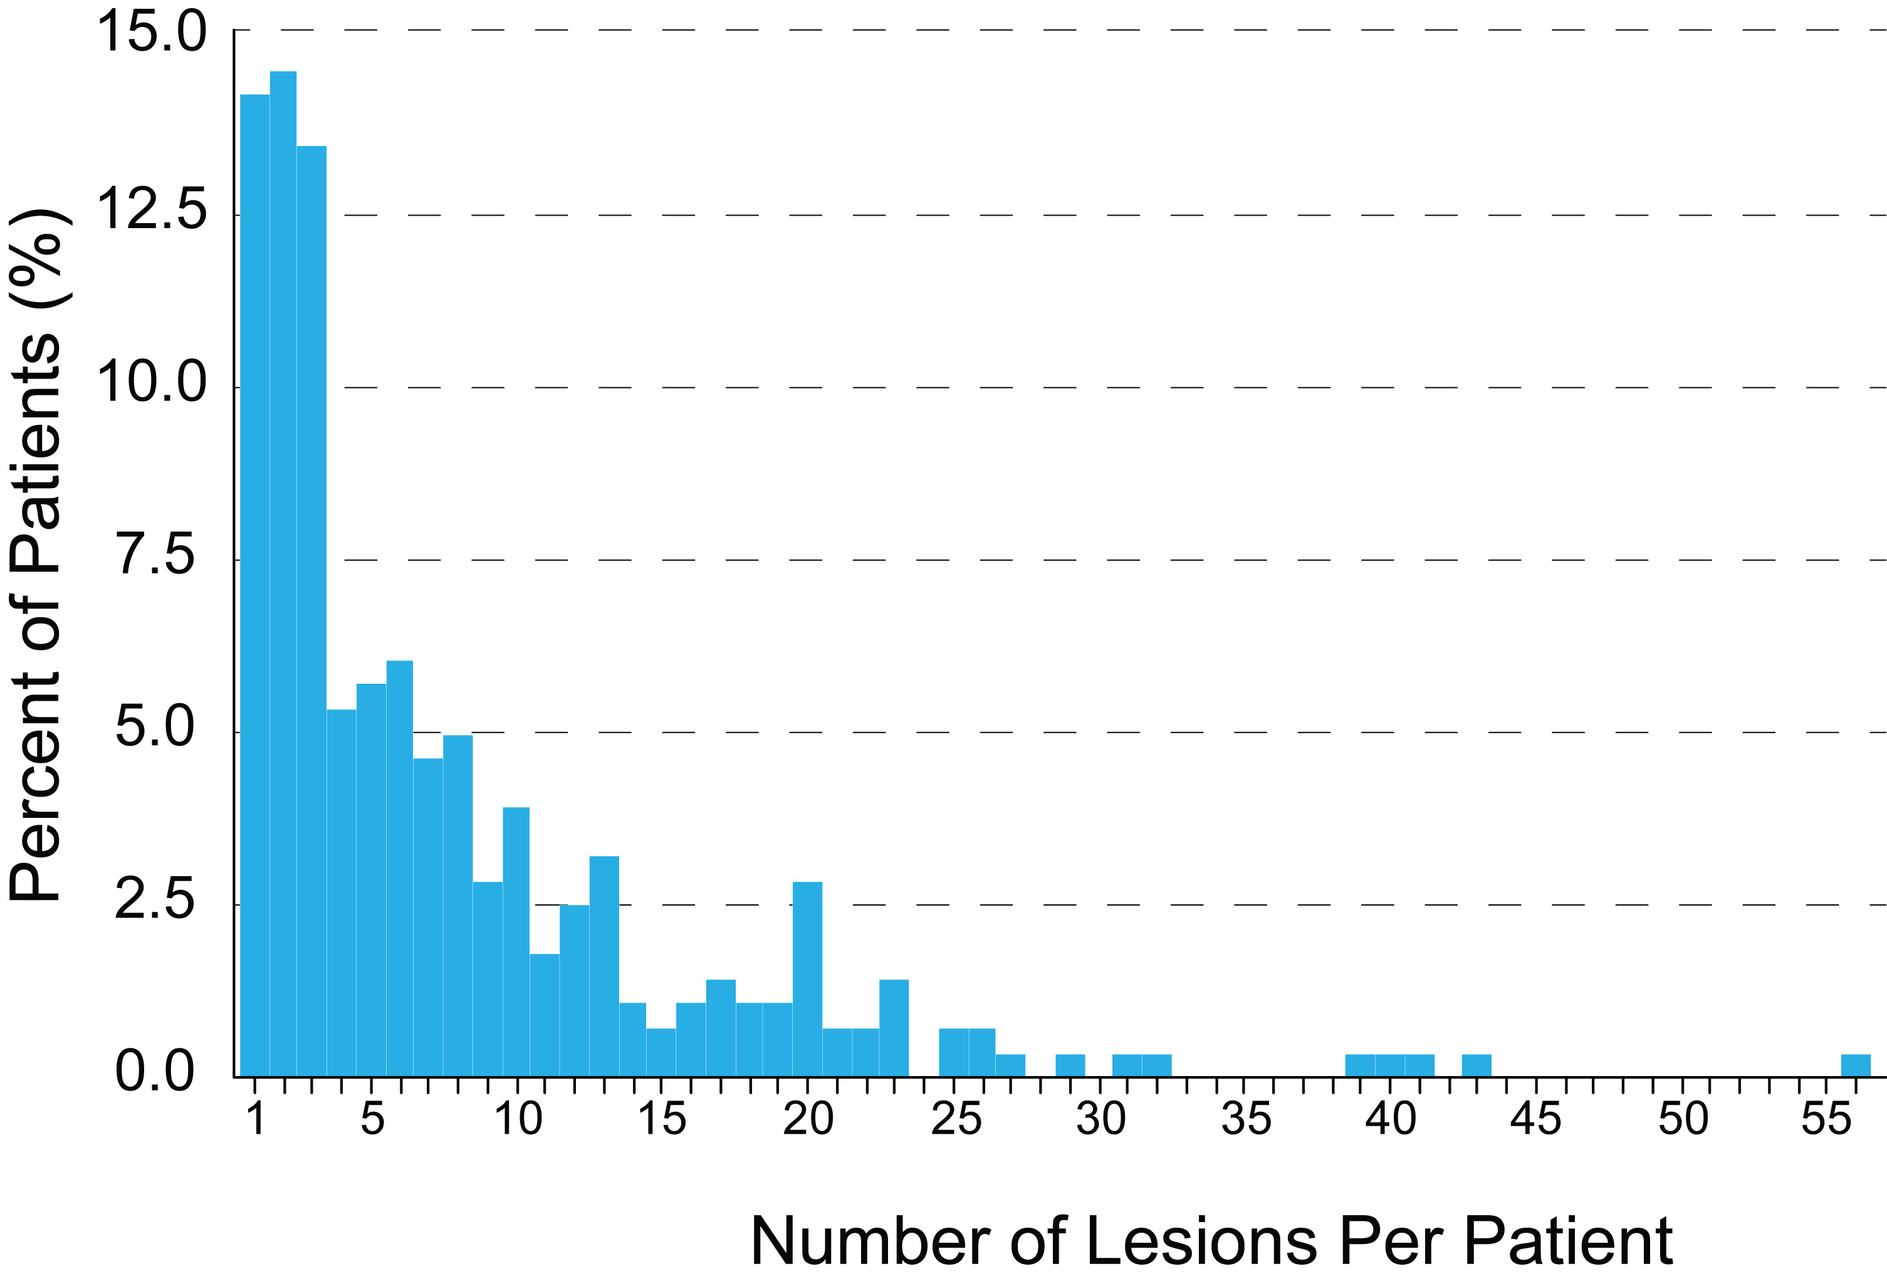

Appendix 3 online
Time-to-response of groups of responding lesions from baseline. For each plot, boxes represent lower and upper quartiles, the line represents the median, the diamond represents the mean, the whiskers represent boundaries of 1.5X below and above the lower and upper quartiles, respectively, and the open circles data points that are outside of the boundaries.

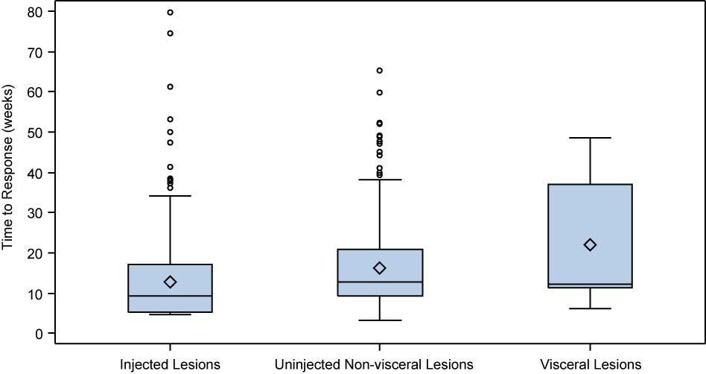
Appendix 4 online
Decrease in size of individual injected lesions, total tumor area of injected lesions in a patient-level analysis, and overall response in corresponding patients.

Injected lesionsª (N=2116) |  | Patients with injected lesions^{b} (N=277)
Decrease in size of injected lesions |  | Patients with a decrease in total tumor area of injected lesions |  | Overall response^{c}
≥50% | 1361 (64%) | ≥50% | 102 (37%) | Overall response | 90 32%)
100% | 995 (47%) | 100% | 45 (16%) | Complete response | 42 (15%)

ª Lesions with at least 2 measurements recorded at two separate time points.
^{b} Patients with ≥1 lesion(s) with at least 2 measurements recorded at two separate time points.
^{c} Assessed by the investigators with modified WHO criteria (best overall response of all measurable tumors; overall response = complete + partial response). Partial response was defined as achieving a 50% or greater reduction in the sum of the products of the perpendicular diameters of all measurable tumors at the time of assessment as compared to the sum of the products of the perpendicular diameters of all measurable tumors at baseline.
Appendix 5 online
Response of individual uninjected non-visceral lesions by proximity to lesions injected with T-VEC. Lesions located in the same body site as injected lesions and lesions located in the different body site from injected lesions are shown. Vertical axis depicts change in individual tumor lesions size (products of the two largest perpendicular diameters) from baseline. Investigators assigned cutaneous, subcutaneous, and superficial nodal tumor lesions to 42-body sites grid defined by anatomical area (head; lower or upper arm; thigh; lower leg; foot dorsum or soles; upper, middle, and lower quadrants of the trunk) and side (front or back; left or right; top and side of head). Visceral lesions or deep lying nodal lesions (eg associated with visceral organs) were not assigned to the body site grid.

Among 981 uninjected, non-visceral evaluable lesions, 294 (30.0%) were located in the same body site as injected lesions, 306 (31.2%) were located in a different body site and 381 (38.8%) lesions had an unknown body site. Among 294 lesions located in the same body site as injected lesions, 159 (54.1%) decreased in size by ≥50% and 107 (36.4%) resolved completely. Among 306 uninjected, non-visceral lesions located in a different body site of injected lesions, 77 (25.2%) decreased in size by ≥50% and 39 (12.7%) resolved completely.

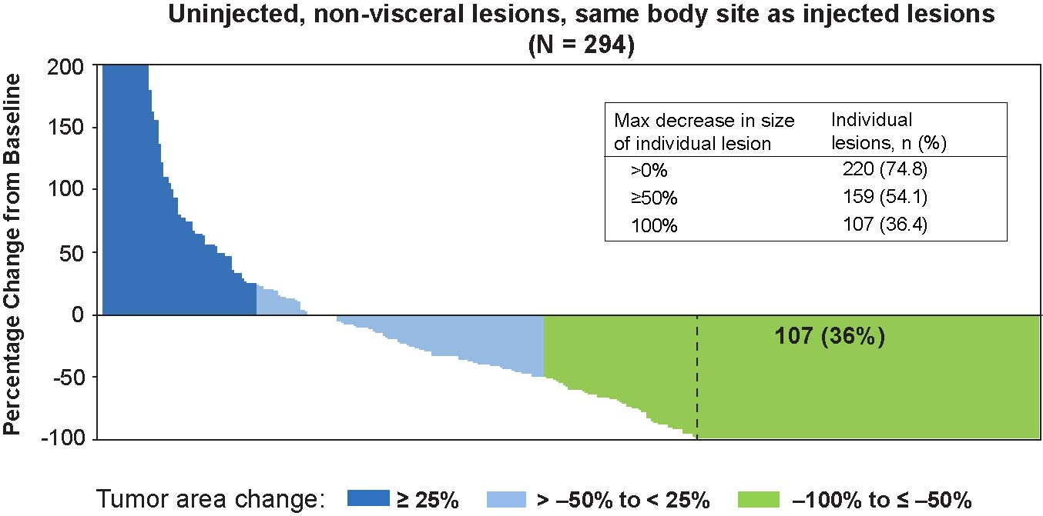

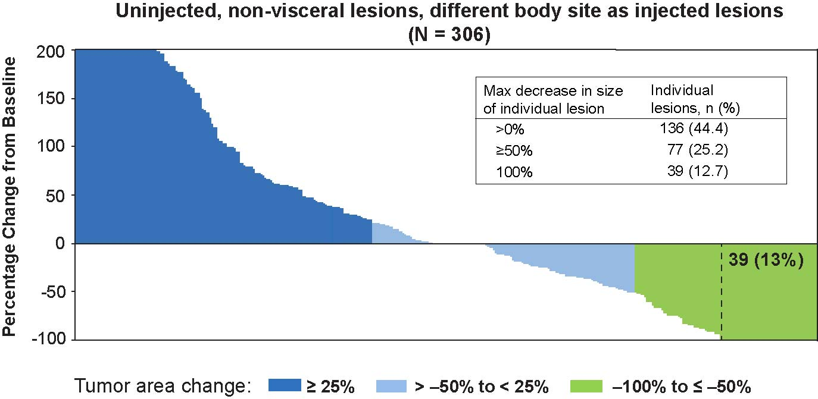
Appendix 6 online
Decrease in size of individual uninjected non-visceral lesions, total tumor area of injected lesions in a patient-level analysis, and overall response in corresponding patients.
Uninjected non-visceral lesionsª (N=981) |  | Patients with uninjected non-visceral lesions^{b} (N=177)
Decrease in size of uninjected non-visceral lesions |  | Patients with a decrease in total tumor area of uninjected non-visceral lesions |  | Overall response^{c}
≥50% | 331 (34%) | ≥50% | 37 (21%) | Overall response | 31 (18%)
100% | 212 (22%) | 100% | 24 (14%) | Complete response | 11 (6%)

ª Lesions with at least 2 measurements recorded at two separate time points.
^{b} Patients with ≥1 lesion(s) with at least 2 measurements recorded at two separate time points.
^{c} Assessed by the investigators with modified WHO criteria (best overall response of all measurable tumors; overall response = complete + partial response). Partial response was defined as achieving a 50% or greater reduction in the sum of the products of the perpendicular diameters of all measurable tumors at the time of assessment as compared to the sum of the products of the perpendicular diameters of all measurable tumors at baseline.

Appendix 7 online
Decrease in size of individual visceral lesions, total tumor area of visceral lesions in a patient-level analysis, and overall response in corresponding patients.
Visceral lesionsª (N=177) |  | Patients with visceral lesions^{b} (N=79)
Decrease in size of visceral lesions |  | Patients with a decrease in total tumor area of visceral lesions |  | Overall response^{c}
≥50% | 27 (15%) | ≥50% | 8 (10%) | Overall response | 11 (14%)
100% | 16 (9%) | 100% | 5 (6%) | Complete response | 2 (3%)

ª Lesions with at least 2 measurements recorded at two separate time points.
^{b} Patients with ≥1 lesion(s) with at least 2 measurements recorded at two separate time points.
^{c} Assessed by the investigators with modified WHO criteria (best overall response of all measurable tumors; overall response = complete + partial response). Partial response was defined as achieving a 50% or greater reduction in the sum of the products of the perpendicular diameters of all measurable tumors at the time of assessment as compared to the sum of the products of the perpendicular diameters of all measurable tumors at baseline.

Appendix 8 online
Kaplan-Meier plots of overall survival of patients with durable response (DR) and progression prior to response (PPR) versus patients with DR and without a PPR. Overall survival was calculated from the date of randomization to the date of death or last date when a patient was known to be alive. NE, not estimable.
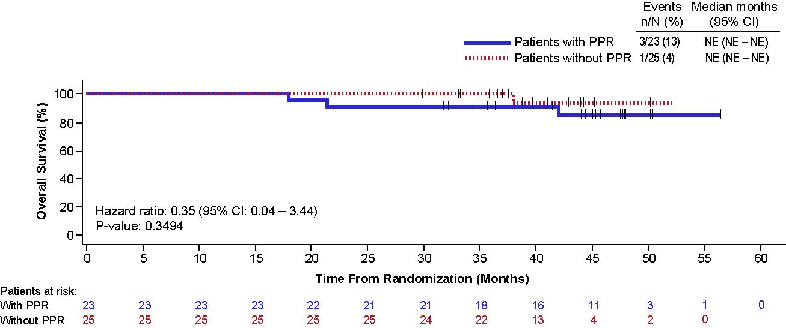

Appendix 9 online
Patient without progression prior to response (PPR) and durable response (DR) onset ≤6 months. The patient had newly diagnosed stage IVM1a melanoma with right axillary, retropectoral and infraclavicular (not shown) nodal metastases that were injected (axillary and retropectoral) with T-VEC under ultrasound guidance (arrows). Partial response was recorded on week 13 after the start of treatment and continued until the end of the study with DR duration of 59 weeks. All responses are per External Assessment Committee. Titles above each photography are weeks on study.

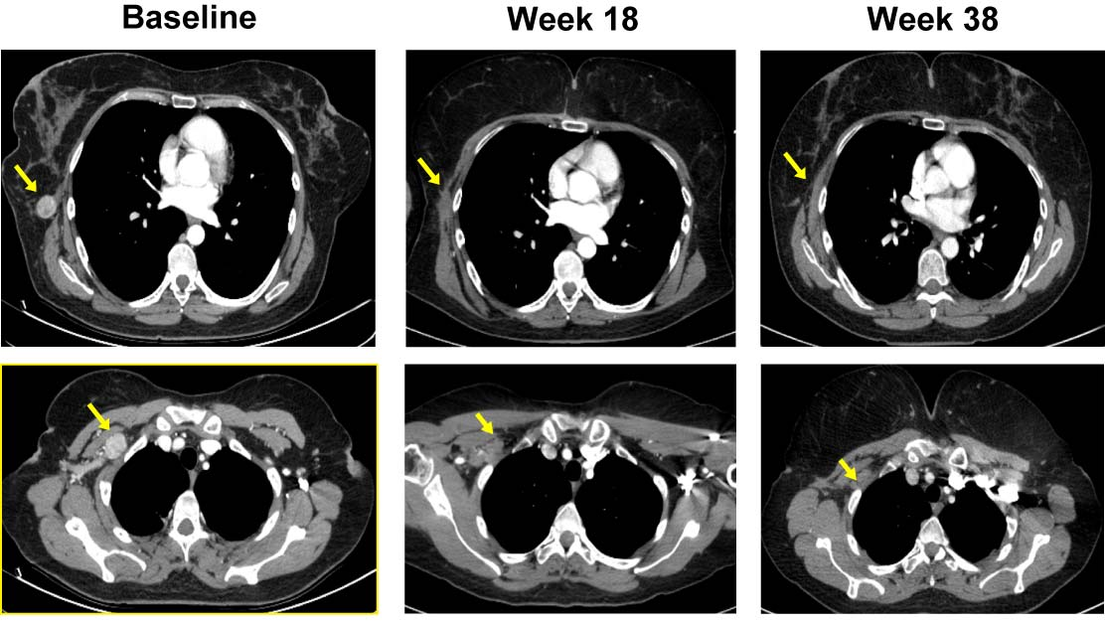
Appendix 10 online
Patient with progression prior to response (PPR) due to new lesions. The patient had recurrent stage IVM1a melanoma with multiple cutaneous metastases (15 measurable lesions and aggregates of lesions) and only three of the lesions at baseline (L1, L2 and L5) were injected with T-VEC. A new cutaneous lesion (yellow asterisk and arrow) appeared on week 17 after the start of treatment and was injected with T-VEC at 18 weeks. Partial response was recorded on week 37 after the start of treatment and all lesions, including the new lesion, resolved by week 50. The patient remained in complete response (confirmed by biopsy) until the end of the study with durable response duration of 41 weeks. All responses are per External Assessment Committee (EAC). Titles above each photography are weeks on study. Green arrows are marks of EAC.

