Table S1. Description of the clinical trials enrolling patients included in the study
Trial name |  | Time of enrolment | Patients | Treatment | Inclusion criteria
PACT-9  Pancreatic AdenoCarcinoma Trials-9; Clinical- Trials.gov ID: NCT00966706 | open, single institution, randomized phase II trial | July 2005 - September 2008 | pathologically proven stage III–IV pancreatic adenocarcinoma [26], and at least one measurable lesion according to RECIST criteria | PEXG / PDXG | Chemotherapy-naive  18–70 years and KPS>60 or 71–75 years and KPS>80  Adequate bone marrow (absolute neutrophil count (ANC) ≥1,500 cells/mm3; platelet count ≥100,000 cells/mm3; and hemoglobin ≥10 g/dl); kidney (serum creatinine ≤1.5 mg/ dl); and liver function (serum total bilirubin ≤1.5 mg/dl and serum transaminases ≤3 times the upper limit of laboratory normal).
ClinicalTrials.gov number, NCT01730222 | single-arm phase 1 study | December 2012 - April 2014 | pathologic diagnosis of unresectable or borderline resectable pancreatic adenocarcinoma, without distant metastases | PAXG regimen | Chemo-naive  18–75 years  KPS>70  Adequate bone marrow (leucocytes ≥3500mm⁻³, absolute neutrophil count ≥1500mm⁻³; platelet count ≥100 000mm⁻³; haemoglobin ≥10 g dl⁻¹), liver (total bilirubin ≤2mg dl⁻¹;  aspartate aminotransferase and alanine aminotransferase ≤3X upper limit of normal) and kidney function (serum creatinine ≤1.5mg dl⁻¹)  Ability to swallow and absorb oral medications
PACT-15 trial, ClinicalTrials.gov, number NCT01150630 | randomised, open-label, multicenter, phase 2–3 trial | October 2010 - May 2015 | pathologically  confirmed  pancreatic ductal adenocarcinoma  clinical stage I–II according to the 2010 TNM classification | PEXG / PEFG | Chemo-naive  18–75 years  KPS>60  Resectable disease defined as the absence of invasion of superior mesenteric artery or vein, portal vein, coeliac artery, or hepatic artery;  Adequate bone marrow (white blood cells ≥3500 cells per µL, neutrophils ≥1500 cells per µL, platelets ≥100 000 per µL, and haemoglobin ≥10 g/dL), liver (alanine aminotransferase and aspartate aminotransferase ≤3 upper limit of normal [ULN]), and kidney function (serum creatinine ≤1·5 mg/dL).  The enrolment of patients without a confirmed pathological diagnosis was allowed only when there had been at least one attempt at fine needle aspiration with a negative outcome, and imaging and clinical history were strongly suggestive for the diagnosis of adenocarcinoma
NCT01730222 | open-label, single institution, randomised phase II trial | April 2014 -February 2016 | locally advanced or borderline resectable PDAC according to NCCN criteria and as T3 or T4 according to Union for International Cancer Control (UICC)-TNM classification; | PAXG/AG | 18–75 years  KPS was ≥70  Chemo and radio naïve  Adequate bone marrow (GB ≥ 3500/mm3; neutrophils ≥ 1500/ mm3; platelets ≥ 100,000/mm3; haemoglobin ≥10 g/dl), liver (total bilirubin ≤2 mg/dL; SGOT e SGPT ≤3 UNL) and kidney function (serum creatinine ≤1.5 mg/dL).
Abbreviations: PEXG= cisplatin, epirubicin, capecitabine, gemcitabine; PDGX=cisplatin, docetaxel, capecitabine, gemcitabine; PAXG= cisplatin, nab-paclitaxel, capecitabine, gemcitabine.

Table S2. Description of the morphological parameters assessed
Parameter | Description | Score
Grade |  | 0: G2  1: G3  (G1 were excluded because of the small number of samples)
Nodes |  | 0: N0  1: N1  2: N2
Resection margin |  | 0: R0  1: R1
Dispersion | Distribution of residual tumor cells in the tumor bed | 0: single mass without dispersion  1: sparse foci in adjacent samples  2: sparse foci in distant samples
Stroma to neoplasia ratio | Quantitative relationship between stroma and cellular neoplasia | 0 (Stroma poor): neoplasia ≥ stroma  1 (Stroma rich): stroma > neoplasia
Vascular invasion |  | 0: Absent  1: Present
Vascular wall alterations | Subintimal thickening, undulation of the inner elastic lamina, non- neoplastic thrombosis of the lumen and changes to the muscular wall | 0: Absent  1: Present
Perineural invasion |  | 0: Absent  1: Present
Duodenal invasion |  | 0: Absent  1: Present
Hyaline fibrosis | Dense fibrotic connective tissue composed of collagen fibers interspersed with few cells | 0: Absent  1: Present
Keloid-like reaction | Scar-like fibrotic tissue composed of acellular thick collagen fibers | 0: Absent  1: Present
Cellular stroma |  | 0: Absent  1: Present
Calcification |  | 0: Absent  1: Present
Necrosis |  | 0: Absent  1: Focally present  2: Diffusely present
Regressive changes | Cytological alterations of carcinoma cells (nuclei hyperchromasia, cytoplasmic vacuolization) | 0: Absent  1: Focally present  2: Diffusely present
Granulocytes |  | 0: Absent  1: Present
Lymphocytes |  | 0: Absent  1: Present
Macrophages |  | 0: Absent  1: Present
TLS |  | 0: Absent  1: Present
Mucin |  | 0: Absent  1: Present
PanIN/IPMN |  | 0: Absent  1: Low grade  2: High-grade
Lymph node ratio | $$\frac{N positive lymph nodes}{N lymph nodes sampled}$$ | 0 to 1

Table S3. Morphological features of histological specimens of patients with resectable PDAC of either neoadjuvant or surgical group.
Characteristic | Neoadjuvant (resectable only) | Upfront-surgery | p- value¹
 | N (%) | N (%)
Grade^
G2 | 12 (70.6) | 13 (37.1)
G3 | 5 (29.4) | 22 (62.9) | 0.038
Nodes
pN0 | 10 (55.6) | 9 (25)
pN1 | 3 (16.7) | 13 (36.1)
pN2 | 5 (27.8) | 14 (38.9) | 0.07
Dispersion
Absent | 4 (22.2) | 31 (86.1)
Present | 14 (77.8) | 5 (13.9) | <0.0001
Stroma/Neoplasia Ratio
Neoplasia ≥ Stroma | 5 (27.8) | 30 (83.3)
Stroma > Neoplasia | 13 (72.2) | 6 (16.7) | <0.0001
Vascular invasion
Absent | 7 (38.9) | 7 (19.4)
Present | 11 (61.1) | 29 (80.6) | 0.18
Granulocytes
Absent | 11 (61.1) | 11 (30.6)
Present | 7 (38.9) | 25 (69.4) | 0.042
Hyaline fibrosis
Absent | 6 (33.3) | 25 (69.4)
Present | 12 (66.7) | 11 (30.6) | 0.018
Necrosis
Absent | 18 (100) | 21 (58.3)
Present | 0 (0) | 15 (41.7) | 0.0009
Vascular wall alterations
Absent | 1 (5.6) | 7 (19.4)
Present | 17 (94.4) | 29 (80.6) | 0.24
Stromal calcification
Absent | 16 (88.9) | 36 (100)
Present | 2 (11.1) | 0 (0) | 0.1
Regressive changes
Absent | 6 (33.3) | 33 (92)
Focal | 7 (38.9) | 3 (8)
Diffuse | 5 (27.8) | 0 (0) | <0.0001
Cellular stroma
Absent | 16 (88.9) | 20 (55.6)
Present | 2 (11.1) | 16 (44.4) | 0.016
PanIN/IPMN
Absent | 3 (16.7) | 4 (11.1)
Present | 15 (83.3) | 32 (88.9) | 0.67
TLS
Absent | 17 (94.4) | 32 (88.9)
Present | 1 (5.6) | 4 (11.1) | 0.65
Macrophages
Absent | 12 (72.2) | 26 (72.2)
Present | 6 (27.8) | 10 (27.8) | 0.75
Perineural invasion
Absent | 7 (38.9) | 6 (16.7)
Present | 11 (61.1) | 30 (83.3) | 0.096
Lymphocytes
Absent | 7 (38.9) | 16 (44.4)
Present | 11 (61.1) | 20 (55.6) | 0.29
Duodenal invasion*
Absent | 9 (60) | 13 (40)
Present | 6 (40) | 20 (60) | 0.22
Mucin
Absent | 14 (77.8) | 32 (88.9)
Present | 4 (22.2) | 4 (11.1) | 0.41
Resection margin
R0 | 12 (66.7) | 11 (30.6)
R1 | 6 (33.3) | 25 (69.4) | 0.018
Keloid stromal reaction
Absent | 4 (22.2) | 22 (61.1)
Present | 14 (77.8) | 14 (38.9) | 0.009
¹, Fisher’s exact test, P<0.05. ^, G1 were excluded from the analysis. *, not evaluated for distal pancreatectomy specimens. Abbreviations: PanIN=pancreatic intraepithelial neoplasia; IPMN=intraductal papillary mucinous neoplasm; TLS=tertiary lymphoid structure.

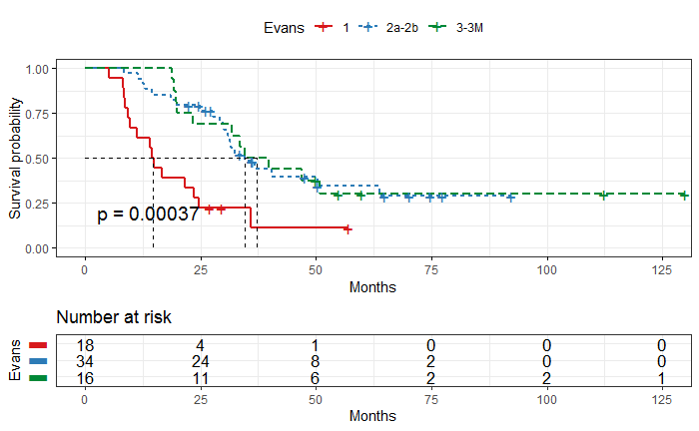
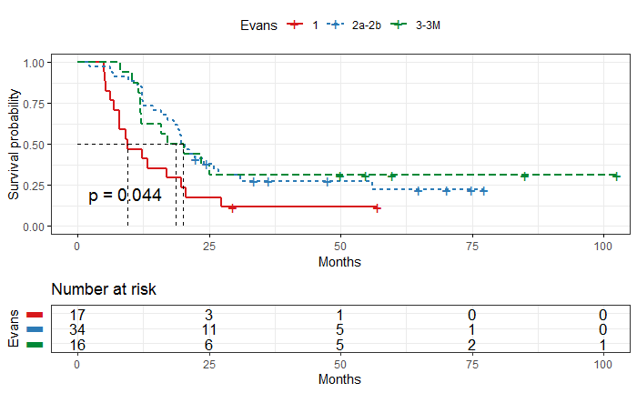
B
A
Figure S1. A. OS prediction after resection stratified by Evans’ score. B. DFS prediction after resection stratified by Evans’ score.
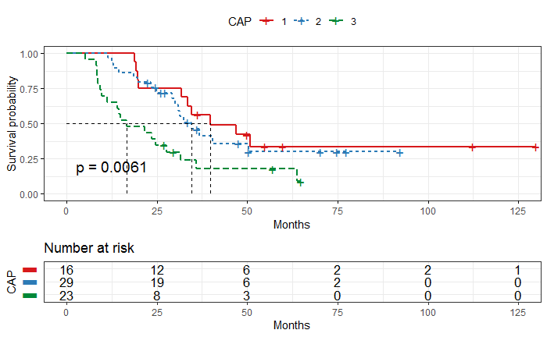
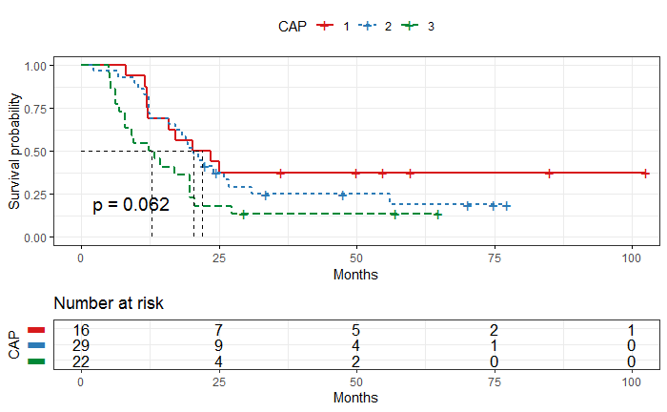
B
A
Figure S2. A. OS prediction after resection stratified by CAP score. B. DFS prediction after resection stratified by CAP score. Abbreviations: CAP=College of American Pathologists

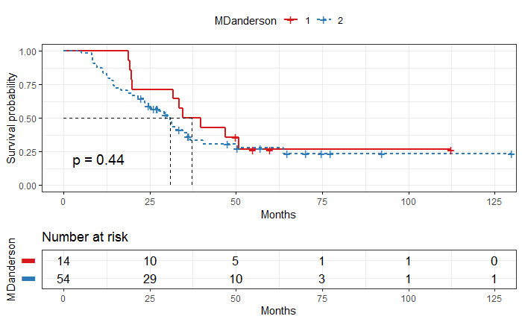
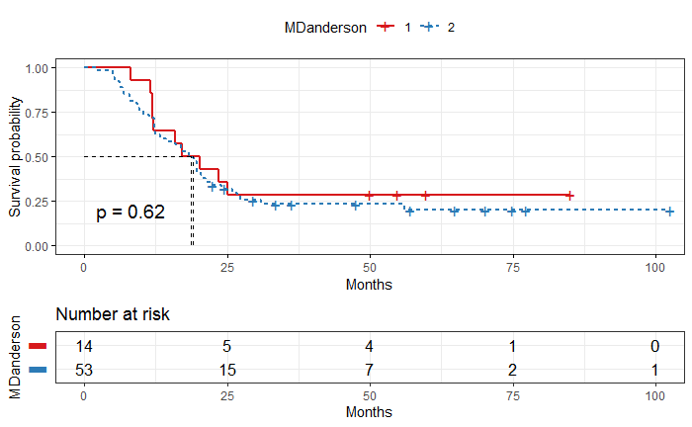
B
A
Figure S3. A. OS prediction after resection stratified by MD Anderson score. B. DFS prediction after resection stratified by MD Anderson score.

