SUPPLEMENTAL DIGITAL CONTENT 2. SCATTER PLOT OF PREOPERATIVE CYCLES OF FOLFIRINOX AND ADJUVANT CHEMOTHERAPY
A.
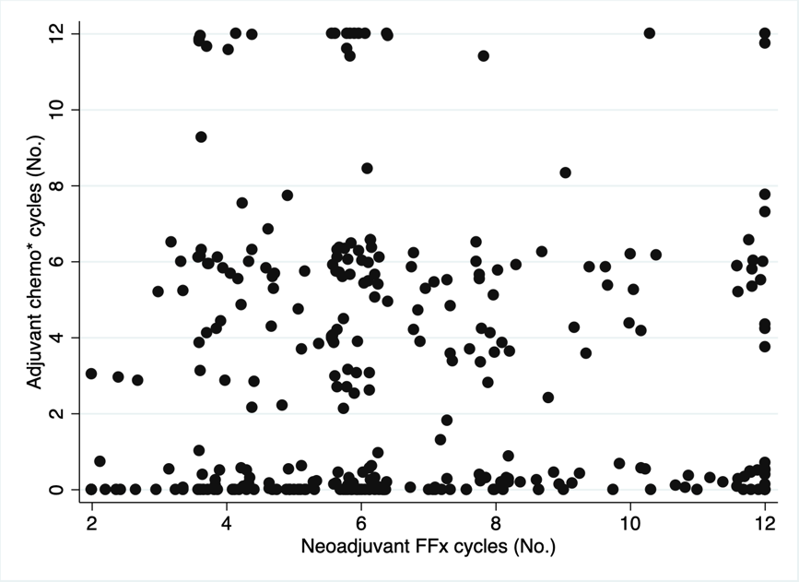
B.
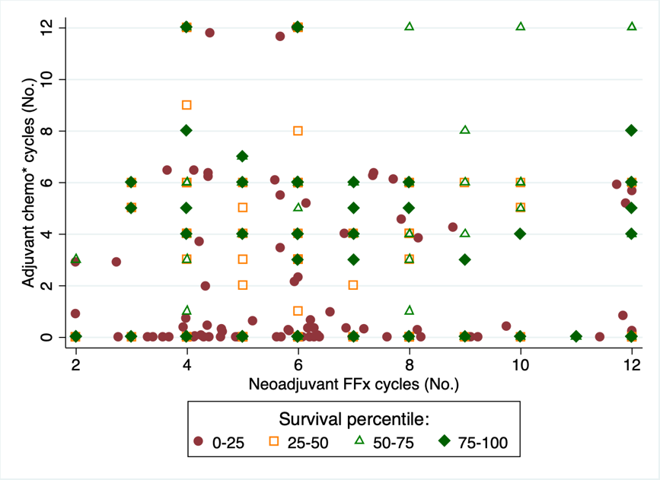
CAPTION: Scatter plot of neoadjuvant and adjuvant chemotherapy cycles for (A) individual patients included in the study and (B) grouped by survival percentile. The number of chemotherapy cycles were truncated at 12. Abbreviations: FFx, FOLFIRINOX; No., number. *Any chemotherapy regimen, including non-FOLFIRINOX agents.

