SUPPLEMENTAL DIGITAL CONTENT 3. SURVIVAL FROM DATE OF SURGERY

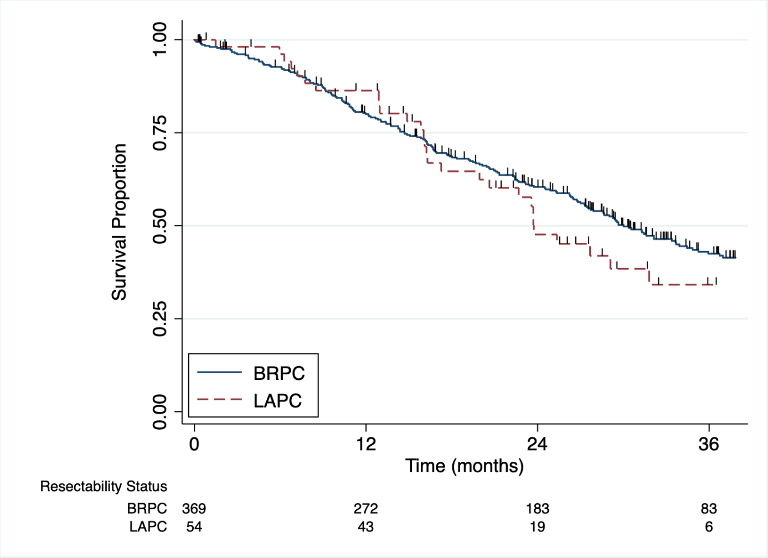

CAPTION: Unadjusted Kaplan-Meier survival curves from date of surgery, stratified by resectability status after preoperative FOLFIRINOX chemotherapy. Median survival was 30 (95%CI: 27-34) months for BRPC and 24 (95%CI: 17-32) months for LAPC (P = 0.412). Abbreviations: BRPC, borderline resectable pancreatic cancer; LAPC, locally advanced pancreatic cancer.

