SUPPLEMENTAL DIGITAL CONTENT 4. TIME TO RECURRENCE
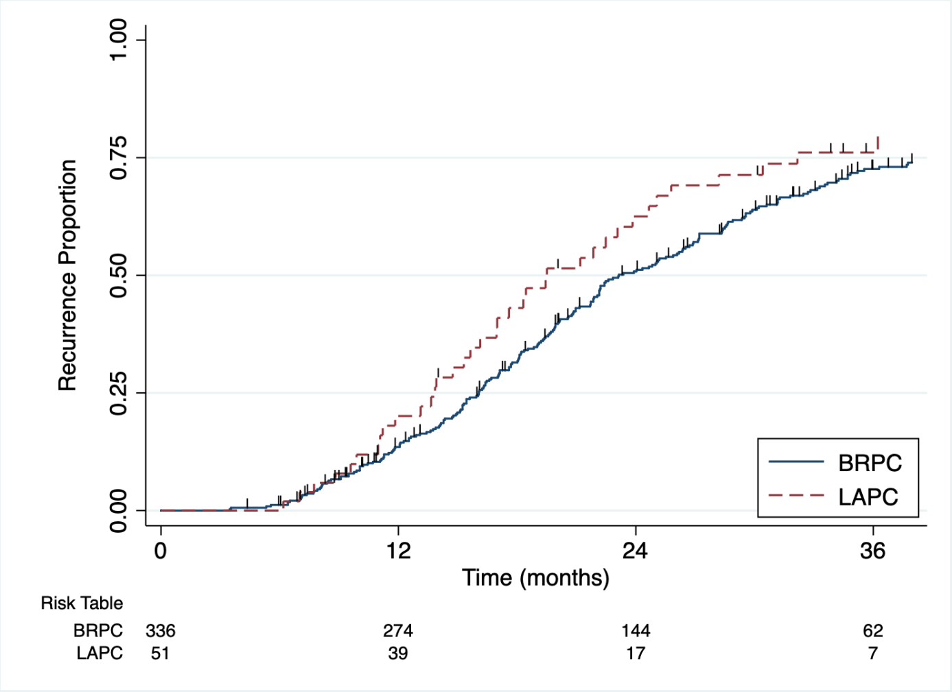
CAPTION: Time to recurrence, either local or distant, in 387 patients with a recorded recurrence event status. Median time to recurrence was 23 (95%CI: 22-26) months for BRPC and 20 (95%CI: 16-25) months for LAPC (P = 0.119). Abbreviations: BRPC, borderline resectable pancreatic cancer; LAPC, locally-advanced pancreatic cancer.

