Supplementary Figure S1: Kaplan-Meier curves showing distant metastasis-free survival stratified by a) sentinel node status; b) AJCC N-Stage (N3 subgroup not shown); c) AJCC Stage III subgroup (IIID subgroup not shown); d) ECS status; e) sentinel node status in the pT4b subgroup
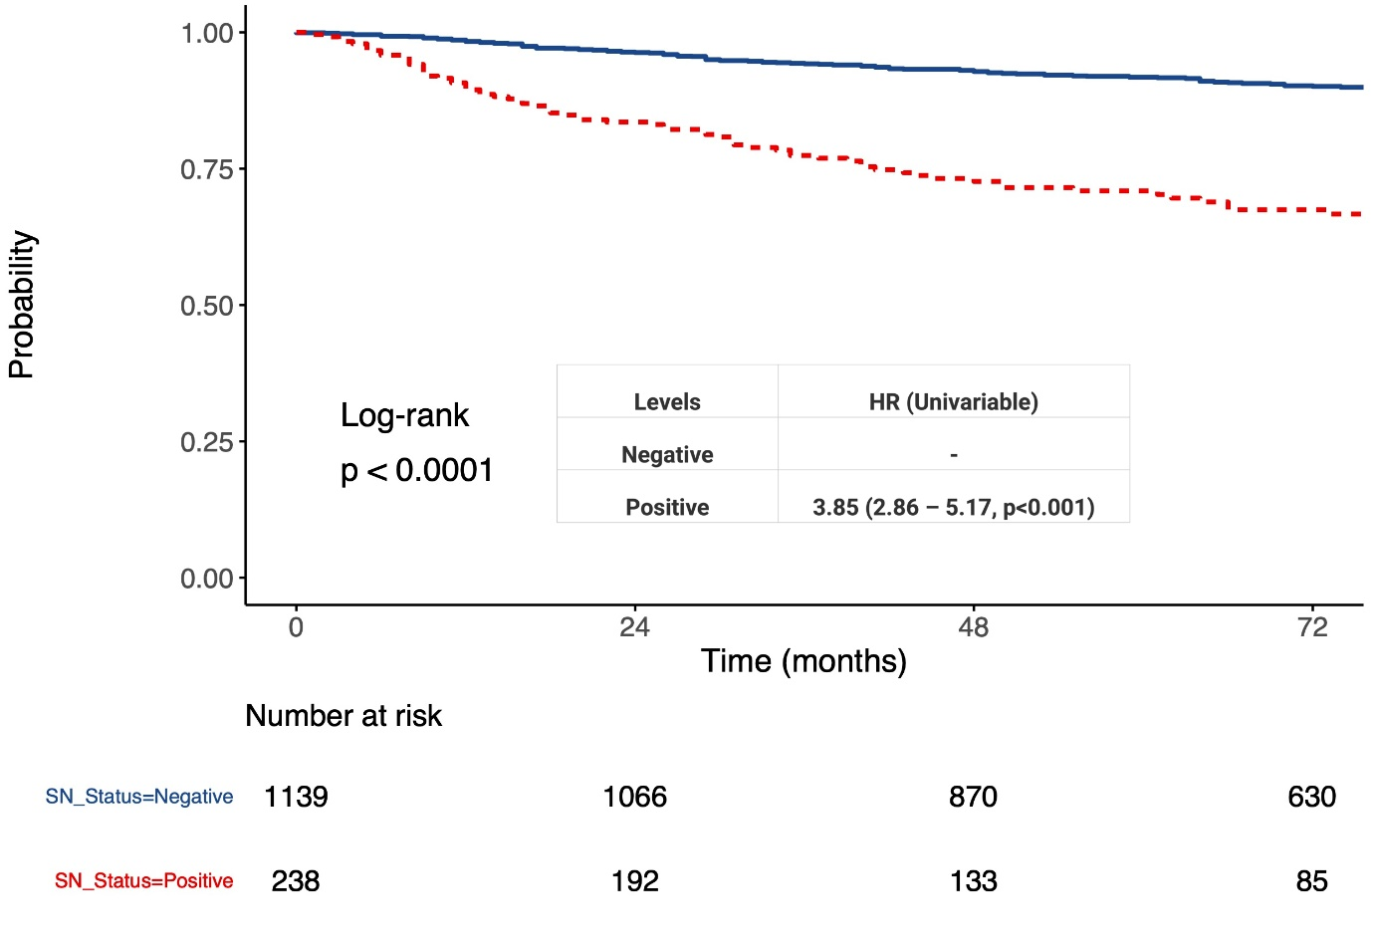
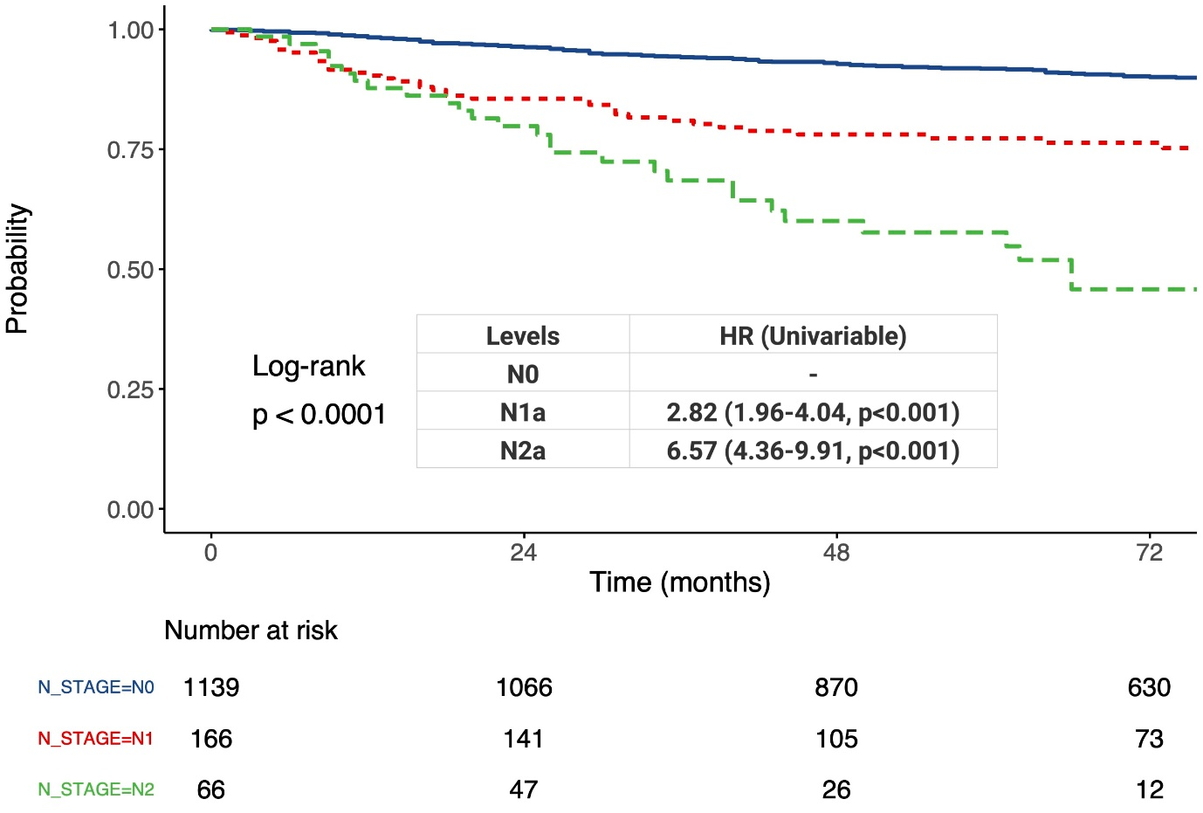
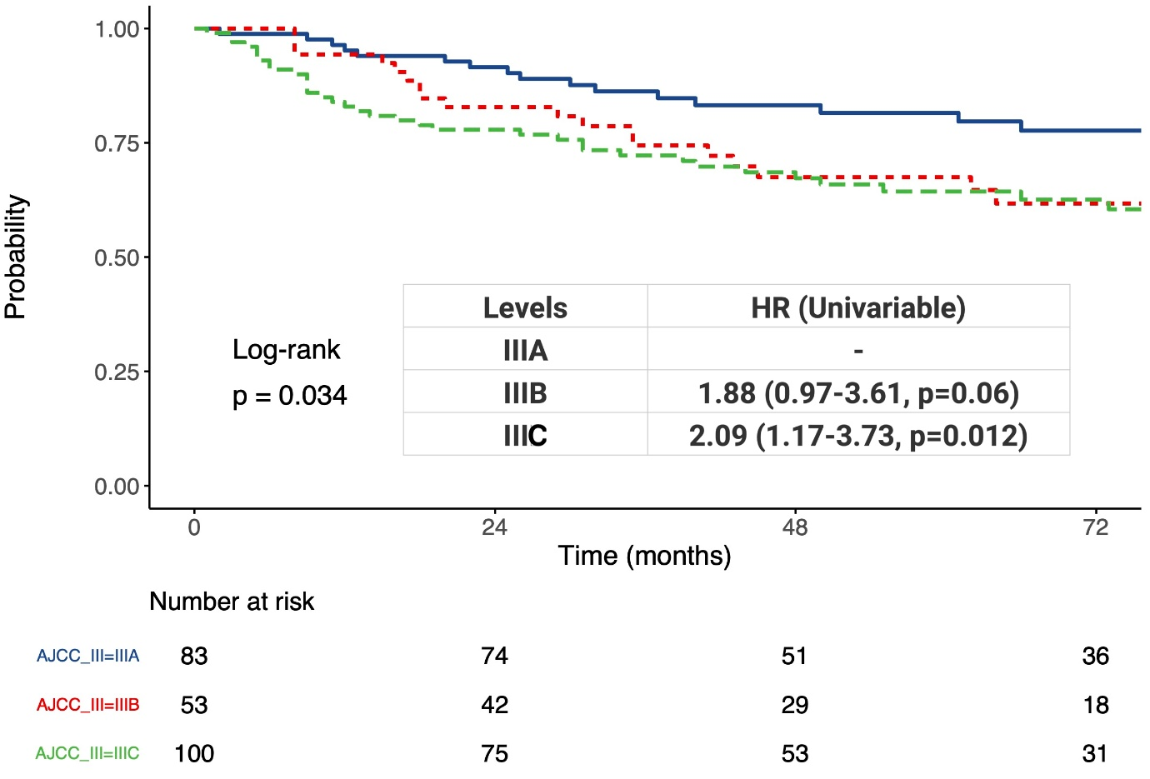
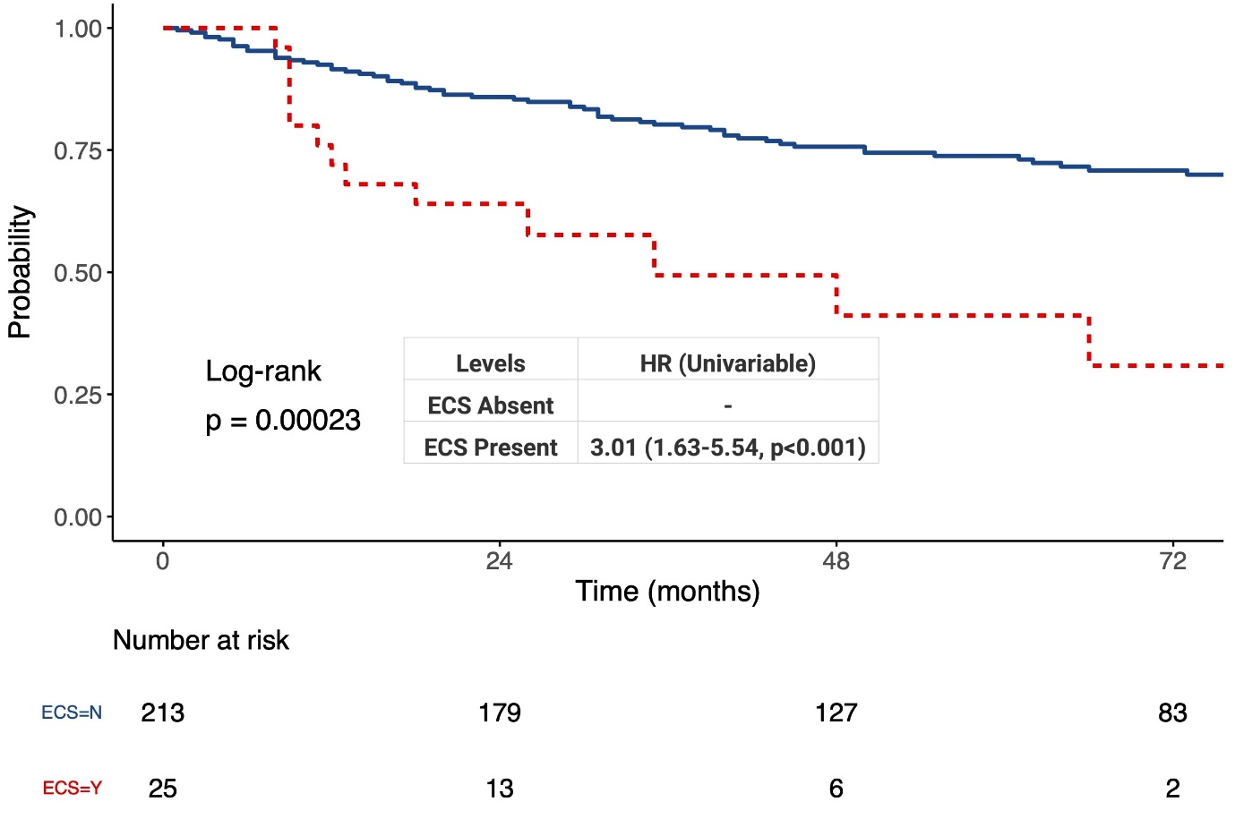
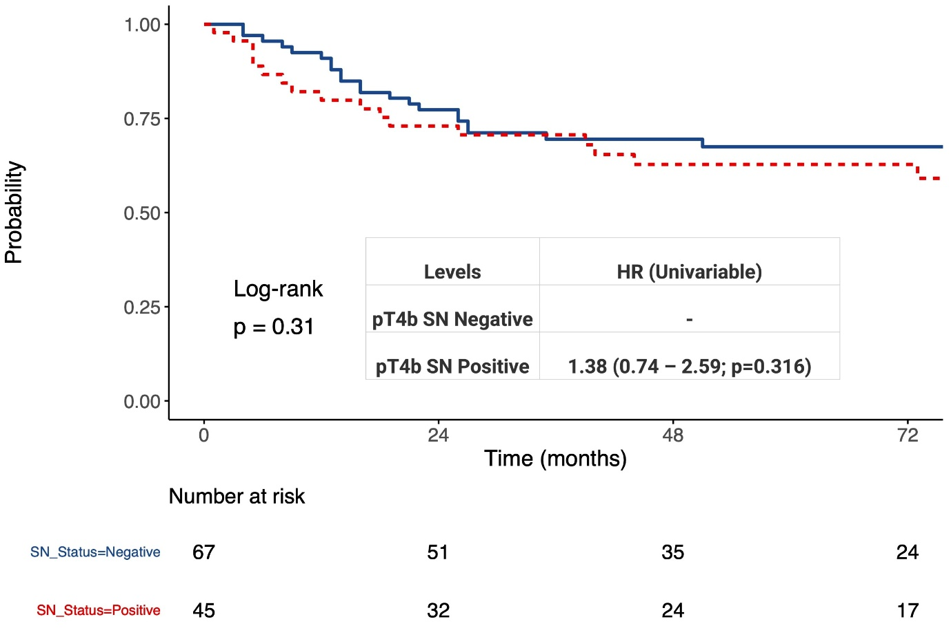

Supplementary Figure S2: Kaplan-Meier curves showing overall survival stratified by a) sentinel node status; b) AJCC N-Stage (N3 subgroup not shown); c) AJCC Stage III subgroup (IIID subgroup not shown); d) ECS status; e) sentinel node status in the pT4b subgroup
