Supplementary Figure 1. Endoscopic injection of the tracer
A This figure shows an endoscopic resection scar of 4cm in length between 12 and 4 o’clock, fully regenerated with neosquamous epithelium after a piecemeal multiband mucosectomy for a poorly differentiated high-risk T1a cancer with no lymphovascular invasion. B After endoscopic injection of saline in the submucosal layer of four quadrants around the resection scar, a 0.5cc of the hybrid tracer was injected in each saline collection (total 2cc).

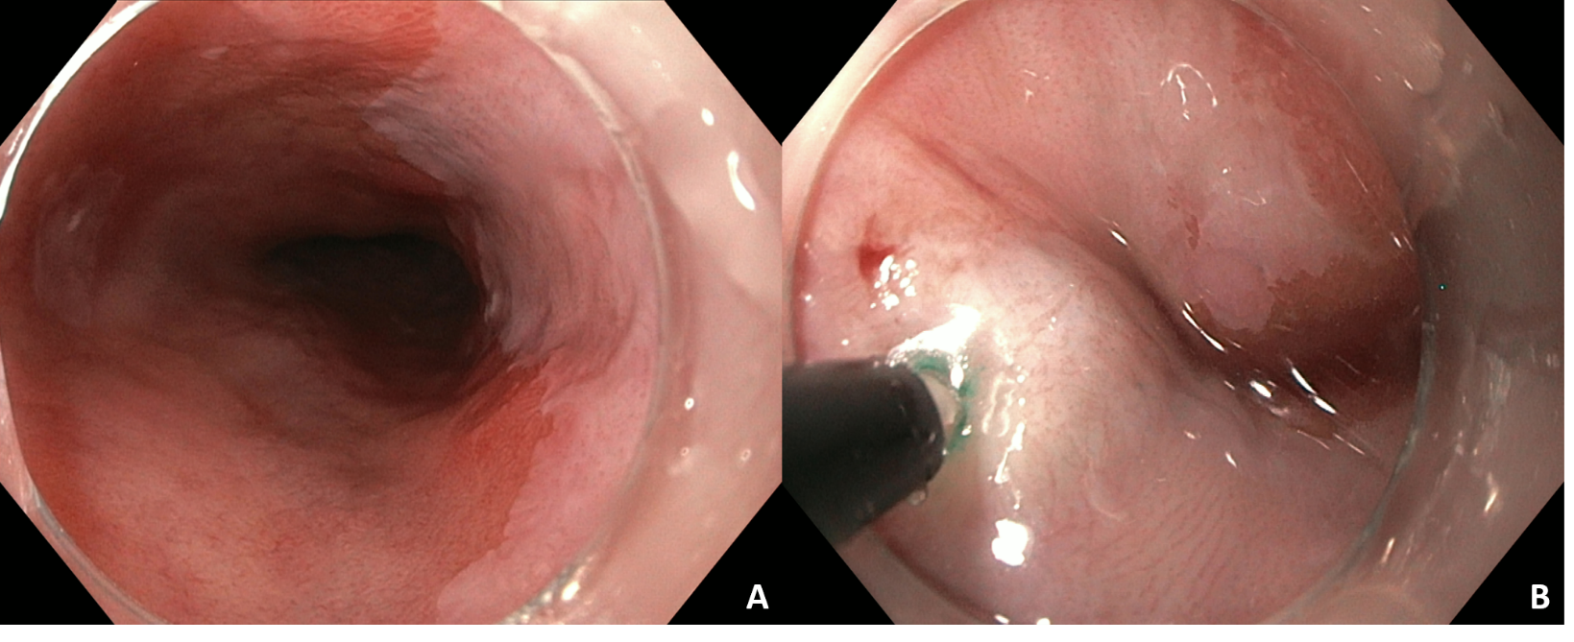

Supplementary Figure 2. Patient flow chart
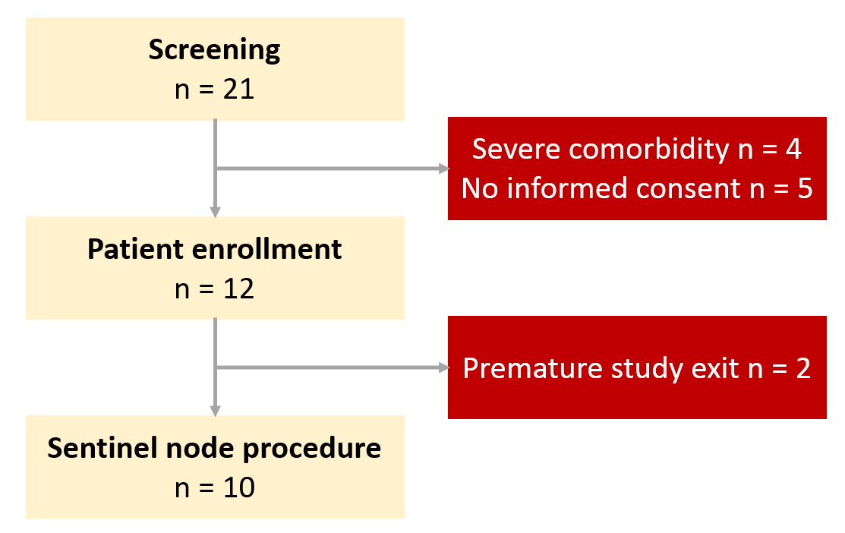
Twenty-one potential candidates were screened for study eligibility, of which 12 patients were enrolled. Ten patients eventually underwent sentinel node navigated surgery, after two patients were excluded prematurely due to a lack of operating room capacity during the COVID-19 pandemic (n=1) and newly diagnosed comorbidity precluding surgery (n=1).

Supplementary Figure 3. Preoperative scans of patient with tumor positive sentinel node at celiac trunk
A Lymphoscintigraphy showed the injection site of the hybrid tracer and multiple sentinel nodes in the thoracic and abdominal compartment. B As shown by the SPECT-CT, one sentinel node was located in the lymph node station at the celiac trunk. C The transverse plane of the SPECT-CT shows the near proximity of the sentinel node to the gastrohepatic ligament. D This sentinel node with a diameter of 4mm on the low-dose CT (red circle) contained a metastasis of 2.2mm.
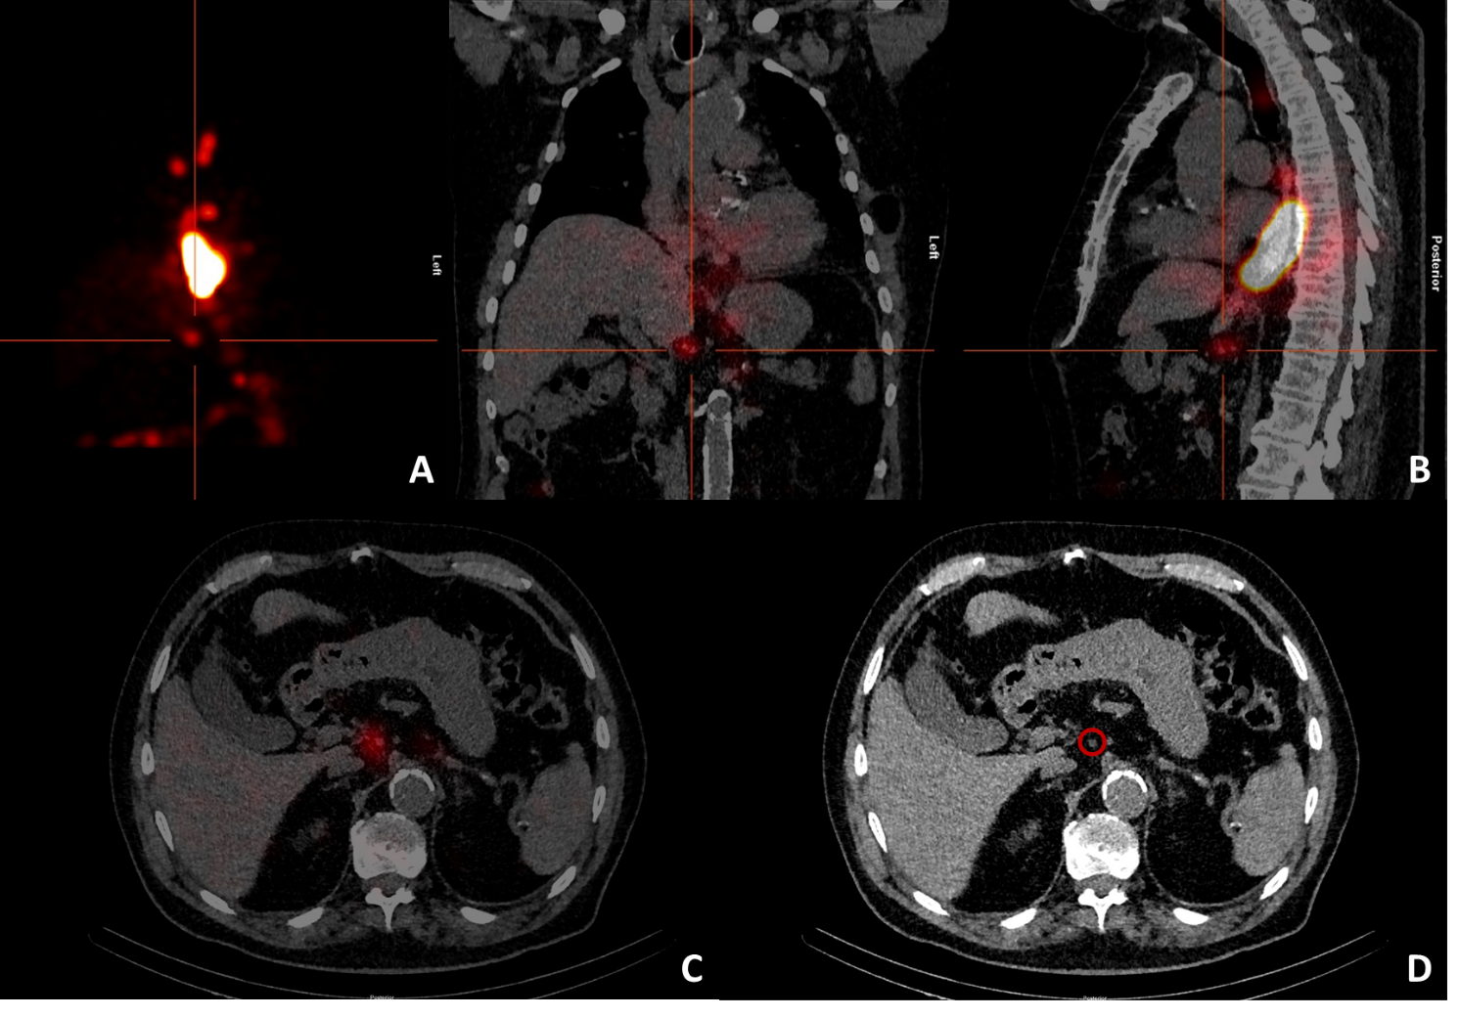

Supplementary Figure 4. Preoperative scans of patient with tumor positive sentinel node at diaphragmatic crus
A Lymphoscintigraphy showed the injection site of the hybrid tracer and a sentinel node in the abdominal compartment. B As shown by the SPECT-CT, this sentinel node was located in the lymph node station at the diaphragm. C The transverse plane of the SPECT-CT shows the near proximity of the sentinel node to the aorta. D This sentinel node with a diameter of 6mm on the low-dose CT (red circle) contained a micrometastasis of 1.5mm.

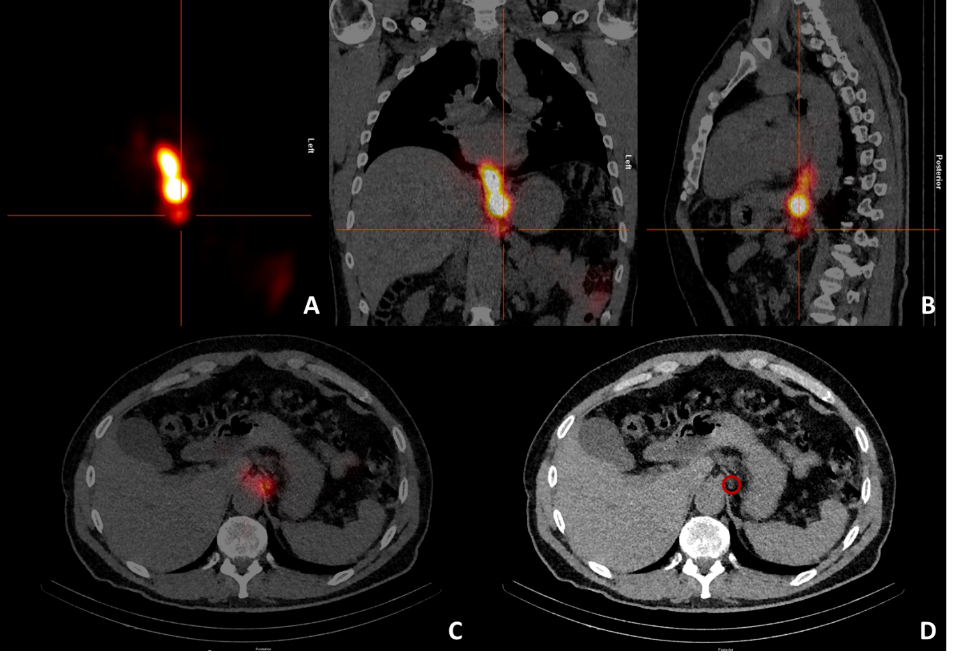

Supplementary Table 1. Details of the pre- and postoperative esophageal and gastric function tests
Patient | High-resolution manometry¹ |  | Gastric emptying test²
 | Preoperative | Postoperative | Preoperative | Postoperative
1 | Absent contractility | Absent contractility | 35 | 38
2 | Ineffective esophageal motility | 'Absent contractility | 15 | 35
3 | Ineffective esophageal motility | Ineffective esophageal motility | 26 | 12
4 | Ineffective esophageal motility | Ineffective esophageal motility | 10 | 33
5 | Absent contractility | Absent contractility | 3 | 4
6 | Absent contractility | Absent contractility | 14 | 24
7 | Ineffective esophageal motility | Ineffective esophageal motility | 38 | 47
8 | Ineffective esophageal motility | Ineffective esophageal motility | 9 | 9
9 | Normal | Normal | 36 | 3
10 | Normal | Normal | 7 | 16
¹Diagnosis according to the Chicago classification.
²Percentage retention after 2 hours (normal <45%).

