Supplemental Figure 1 - Cluster distribution at 3 and 12 months after surgery
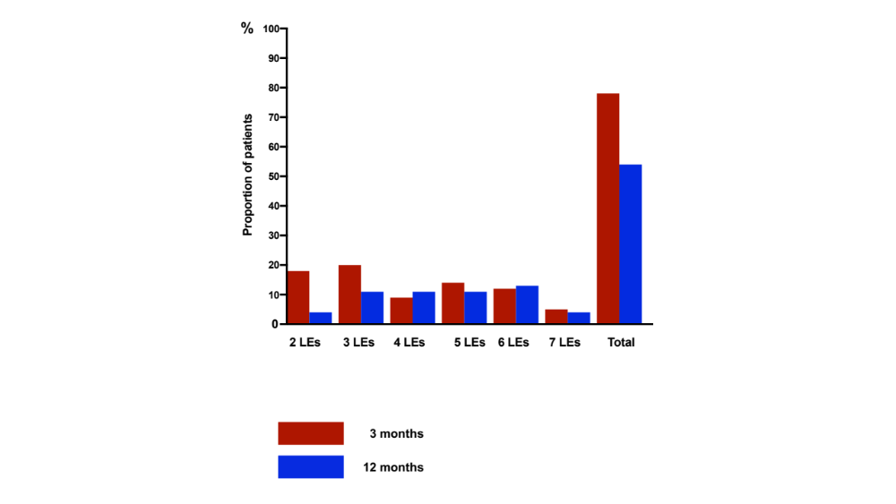

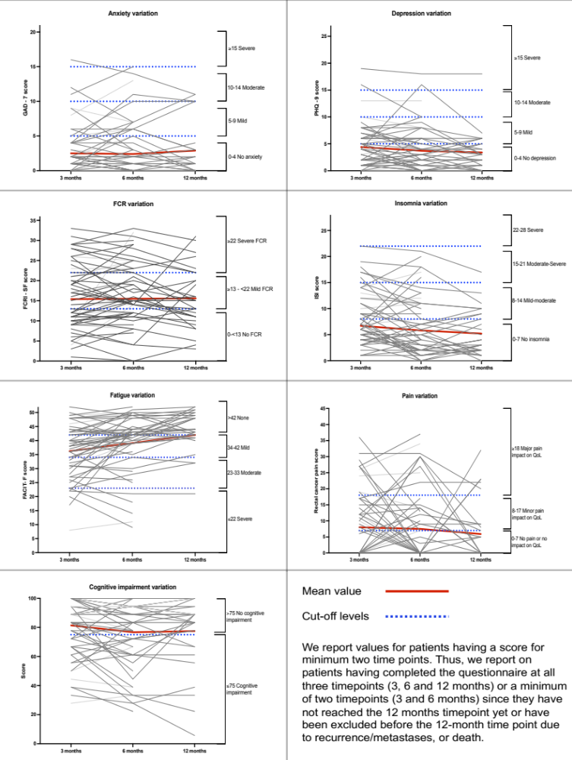
Supplemental Figure 2 - Within-patient variation and between-patient variation for scores

