Supplemental Figure 1: Patterns of Recurrence

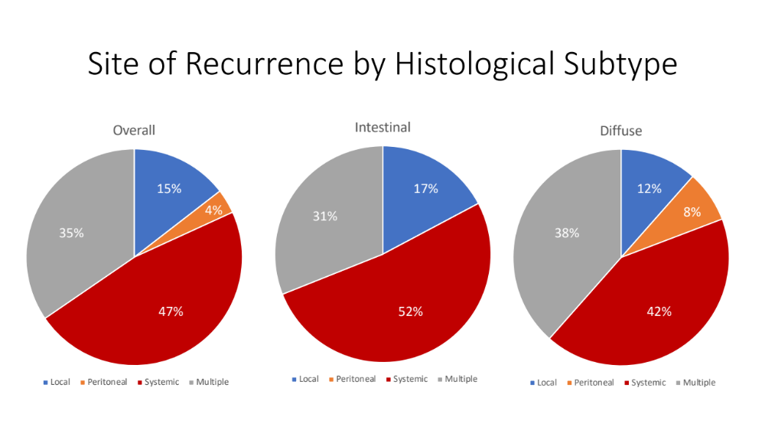

Supplemental Figure 2: Multivariable Cox-Regression Analysis for Time to Progression

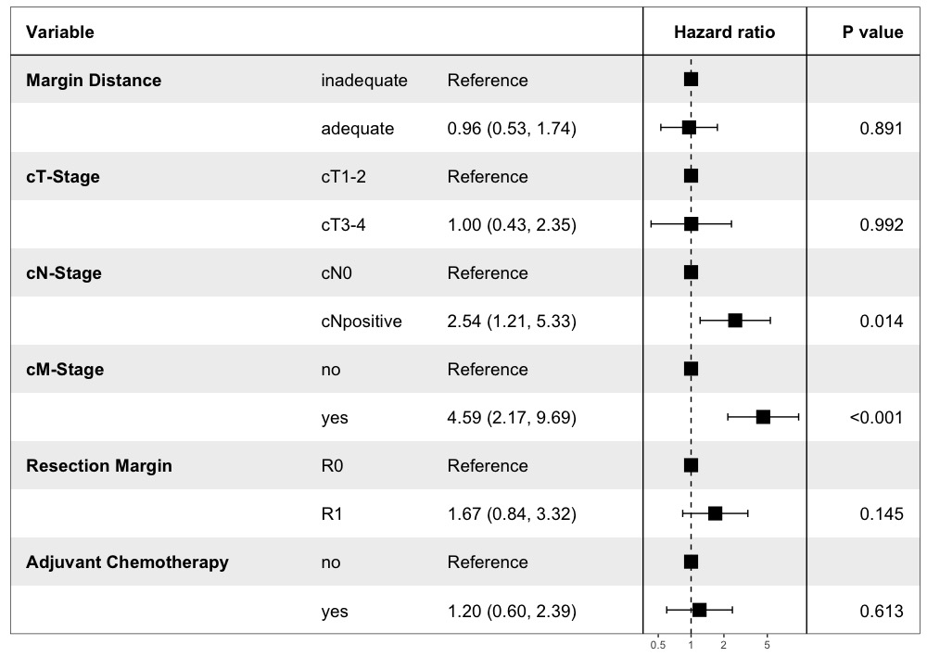
Supplementary Table 1: Subtype Comparisons | intestinal, N = 95¹ | mixed, N = 29¹ | diffuse, N = 52¹ | p-value²
ASA |  |  |  | 0.023
1/2 | 38 (40%) | 13 (45%) | 33 (63%)
3/4 | 57 (60%) | 16 (55%) | 19 (37%)
Age | 68.80 (11.07) | 63.97 (12.61) | 58.12 (12.49) | <0.001
Sex (female) | 33 (35%) | 12 (41%) | 20 (38%) | 0.781
Grade |  |  |  | <0.001
well-moderate | 52 (61%) | 6 (21%) | 0 (0%)
poor | 33 (39%) | 22 (79%) | 51 (100%)
Unknown | 10 | 1 | 1
cT-Stage |  |  |  | 0.735
cT1 | 11 (12%) | 2 (7.1%) | 7 (14%)
cT2 | 26 (29%) | 9 (32%) | 15 (31%)
cT3 | 43 (48%) | 16 (57%) | 20 (41%)
cT4 | 9 (10%) | 1 (3.6%) | 7 (14%)
Unknown | 6 | 1 | 3
cN-Stage |  |  |  | 0.564
cN0 | 44 (47%) | 17 (59%) | 24 (49%)
cNpositive | 49 (53%) | 12 (41%) | 25 (51%)
Unknown | 2 | 0 | 3
Neoadjuvant Treatment | 38 (40%) | 10 (34%) | 18 (35%) | 0.759
Complication | 8 (8.4%) | 5 (17%) | 4 (7.7%) | 0.318
Anastomotic Leakage | 4 (4.2%) | 1 (3.6%) | 1 (1.9%) | 0.86
Unknown | 0 | 1 | 0
Lymph Nodes Resected | 28.88 (13.46) | 25.97 (12.89) | 25.79 (10.29) | 0.36
Proximal Margin Distance | 4.91 (2.83) | 4.98 (2.92) | 5.73 (3.01) | 0.223
pT-Stage |  |  |  | 0.191
pT0-1 | 31 (40%) | 5 (22%) | 14 (31%)
pT2 | 0 (0%) | 0 (0%) | 0 (0%)
pT3 | 37 (48%) | 15 (65%) | 20 (44%)
pT4 | 9 (12%) | 3 (13%) | 11 (24%)
Unknown | 18 | 6 | 7
pN-Stage |  |  |  | 0.92
pN0 | 44 (46%) | 13 (45%) | 24 (46%)
pN1 | 13 (14%) | 5 (17%) | 10 (19%)
pN2 | 17 (18%) | 3 (10%) | 7 (13%)
pN3 | 21 (22%) | 8 (28%) | 11 (21%)
pM | 7 (7.4%) | 2 (6.9%) | 7 (13%) | 0.394
Lymph Node Ratio | 0.15 (0.22) | 0.15 (0.23) | 0.16 (0.25) | 0.973
Resection Margin |  |  |  | 0.011
R0 | 87 (92%) | 24 (83%) | 38 (73%)
R1 | 8 (8.4%) | 5 (17%) | 14 (27%)
Regression |  |  |  | 0.505
1 | 2 (5.4%) | 0 (0%) | 1 (5.6%)
2 | 8 (22%) | 1 (10%) | 3 (17%)
3 | 8 (22%) | 6 (60%) | 6 (33%)
4 | 19 (51%) | 3 (30%) | 8 (44%)
Unknown | 58 | 19 | 34
Adjuvant Tx | 41 (46%) | 12 (44%) | 26 (50%) | 0.865
Unknown | 6 | 2 | 0
Recurrence | 30 (32%) | 9 (31%) | 20 (38%) | 0.667
Site of Recurrence |  |  |  | 0.148
local | 5 (17%) | 1 (13%) | 2 (11%)
multiple | 9 (31%) | 1 (13%) | 9 (50%)
peritoneal | 0 (0%) | 0 (0%) | 2 (11%)
systemic | 15 (52%) | 6 (75%) | 5 (28%)

Supplementary Table 2: Intestinal Subtype | Adequate, N = 47¹ | Inadequate, N = 48¹ | p-value²
ASA |  |  | 0.18
1/2 | 22 (47%) | 16 (33%)
3/4 | 25 (53%) | 32 (67%)
Age | 68.91 (10.75) | 68.69 (11.49) | 0.92
Sex |  |  | 0.568
male | 32 (68%) | 30 (63%)
female | 15 (32%) | 18 (38%)
Grade |  |  | 0.393
well-moderate | 27 (66%) | 25 (57%)
poor | 14 (34%) | 19 (43%)
Unknown | 6 | 4
cT-Stage |  |  | 0.373
cT1 | 3 (7.0%) | 8 (17%)
cT2 | 12 (28%) | 14 (30%)
cT3 | 22 (51%) | 21 (46%)
cT4 | 6 (14%) | 3 (6.5%)
Unknown | 4 | 2
cN-Stage |  |  | 0.464
cN0 | 20 (43%) | 24 (51%)
cNpositive | 26 (57%) | 23 (49%)
Unknown | 1 | 1
Neoadjuvant Treatment | 20 (43%) | 18 (38%) | 0.615
Complication | 5 (11%) | 3 (6.3%) | 0.486
Anastomotic Leakage | 2 (4.3%) | 2 (4.2%) | >0.999
Lymph Nodes Resected | 29.32 (10.71) | 28.46 (15.80) | 0.148
Proximal Margin Distance | 7.13 (2.24) | 2.74 (1.17) | <0.001
pT-Stage |  |  | 0.274
pT0-1 | 15 (38%) | 16 (43%)
pT2 | 0 (0%) | 0 (0%)
pT3 | 18 (45%) | 19 (51%)
pT4 | 7 (18%) | 2 (5.4%)
Unknown | 7 | 11
pN-Stage |  |  | 0.436
pN0 | 22 (47%) | 22 (46%)
pN1 | 6 (13%) | 7 (15%)
pN2 | 6 (13%) | 11 (23%)
pN3 | 13 (28%) | 8 (17%)
pM | 3 (6.4%) | 4 (8.3%) | >0.999
Lymph Node Ratio | 0.17 (0.24) | 0.13 (0.19) | 0.885
Resection Margin |  |  | >0.999
R0 | 43 (91%) | 44 (92%)
R1 | 4 (8.5%) | 4 (8.3%)
Regression |  |  | 0.826
1 | 1 (5.0%) | 1 (5.9%)
2 | 5 (25%) | 3 (18%)
3 | 3 (15%) | 5 (29%)
4 | 11 (55%) | 8 (47%)
Unknown | 27 | 31
Adjuvant Tx | 24 (56%) | 17 (37%) | 0.075
Unknown | 4 | 2
Recurrence | 18 (38%) | 12 (25%) | 0.163
Site of Recurrence |  |  | 0.112
local | 5 (29%) | 0 (0%)
multiple | 4 (24%) | 5 (42%)
systemic | 8 (47%) | 7 (58%)

Supplementary Table 3: Mixed and Diffuse Types | Adequate, N = 231 | Inadequate, N = 581 | p-value2
Signetgroup |  |  | 0.31
mixed | 6 (26%) | 23 (40%)
diffuse | 17 (74%) | 35 (60%)
ASA |  |  | 0.641
1/2 | 14 (61%) | 32 (55%)
3/4 | 9 (39%) | 26 (45%)
Age | 61.39 (14.06) | 59.74 (12.32) | 0.479
Sex (female) | 6 (26%) | 26 (45%) | 0.12
Grade |  |  | 0.178
well-moderate | 0 (0%) | 6 (11%)
poor | 22 (100%) | 51 (89%)
Unknown | 1 | 1
cT-Stage |  |  | 0.087
cT1 | 5 (23%) | 4 (7.3%)
cT2 | 9 (41%) | 15 (27%)
cT3 | 7 (32%) | 29 (53%)
cT4 | 1 (4.5%) | 7 (13%)
Unknown | 1 | 3
cN-Stage |  |  | 0.025
cN0 | 16 (73%) | 25 (45%)
cNpositive | 6 (27%) | 31 (55%)
Unknown | 1 | 2
Neoadjuvant Treatment | 4 (17%) | 24 (41%) | 0.041
Complication | 4 (17%) | 5 (8.6%) | 0.265
Anastomotic Leakage | 1 (4.5%) | 1 (1.7%) | 0.477
Lymph Nodes Resected | 24.83 (9.72) | 26.26 (11.80) | 0.645
Proximal Margin Distance | 9.20 (1.46) | 3.98 (1.94) | <0.001
pT-Stage |  |  | 0.037
pT0-1 | 10 (50%) | 9 (19%)
pT2 | 0 (0%) | 0 (0%)
pT3 | 7 (35%) | 28 (58%)
pT4 | 3 (15%) | 11 (23%)
Unknown | 3 | 10
pN-Stage |  |  | 0.067
pN0 | 16 (70%) | 21 (36%)
pN1 | 3 (13%) | 12 (21%)
pN2 | 1 (4.3%) | 9 (16%)
pN3 | 3 (13%) | 16 (28%)
pM | 0 (0%) | 9 (16%) | 0.054
Lymph Node Ratio | 0.07 (0.17) | 0.19 (0.25) | 0.007
Resection Margin (R1) | 1 (4.3%) | 18 (31%) | 0.011
Regression |  |  | 0.294
1 | 0 (0%) | 1 (4.2%)
2 | 2 (50%) | 2 (8.3%)
3 | 1 (25%) | 11 (46%)
4 | 1 (25%) | 10 (42%)
Unknown | 19 | 34
Adjuvant Tx | 6 (26%) | 32 (57%) | 0.012
Unknown | 0 | 2
Recurrence | 2 (8.7%) | 27 (47%) | 0.001
Site of Recurrence |  |  | 0.003
local | 0 (0%) | 3 (13%)
multiple | 0 (0%) | 10 (42%)
peritoneal | 2 (100%) | 0 (0%)
systemic | 0 (0%) | 11 (46%)

Supplemental Text 1: Subgroup Analysis Node Negative

In nodal negative and non-metastatic patients, 38 out of 80 (47.5%) had an adequate PMD. Except from complication rates (16% vs. 2.4%, p=0.049), there were no significant differences in clinicopathological characteristics between the cohorts with adequate versus inadequate PMD. Estimated 5-year survival was 79% and 81% for adequate and inadequate resection margin distance with no difference in OS (medians not reached, p=0.683) and TTP (medians not reached, p=0.251).

Supplemental Text 2: Subgroup Analysis Node Positive
Twenty-nine out of 70 (41.4%) nodal positive patients without distant metastatic disease had an adequate PMD. Significant differences in clinicopathological characteristics between the cohorts with adequate and inadequate PMD was only observed for histologic subtypes (intestinal 76% vs. 43%, p=0.016). Again, no significant differences were observed for median OS (adequate PMD: 94.8 months vs. inadequate PMD; 131.4 months, p=0.658) or median TTP (28.8 vs. 124.9 months, p=0.470).

Supplemental Text 3: Subgroup Analysis R0
In patients with negative resection margins, 65 out of 149 (43.6%) had an adequate PMD. No significant differences were found in clinicopathological characteristics. Estimated 5-year survival was 66% for patients with an adequate PMD and 69% with an inadequate PMD with no differences in OS (medians not reached, p=0.708) and TTP (medians not reached, p=0.541). The same effects as in the main analysis were also observed in patients with intestinal type cancer and R0 resections (mOS both not reached, p=0.514, mTTP both not reached, p=0.300, estimated 5-year survival adequate PMD 54% vs. inadequate PMD 69%). An association to improved disease specific survival was also observed in R0 resected patients with diffuse subtype (mTTP adequate PMD not reached vs. inadequate PMD 125 months, p=0.005), however, the difference in OS did not reach statistical significancy (mOS, not reached vs. 131.0 months, p=0.062 estimated 5-year survival 85% vs. 69%).

