Supplemental digital content (SDC)

Table 1. Preoperative regimens in the NACT and the NACRT group.

Treatment Group | Regimen | N. of patients | %
NACT | Fluoruracil, leucovorin, oxaliplatin, docetaxel | 216 | 77.7
NACT | Folinic acid, fluoruracil, oxaliplatin | 18 | 6.5
NACT | Cisplatin, fluoruracil  OR  Cisplatin, capecitabine | 17 | 6.1
NACT | Epirubicin, cisplatin, fluoruracil  OR  Epirubicin, cisplatin, capecitabine | 13 | 4.7
NACT | Docetaxel, cisplatin, fluoruracil | 12 | 4.3
NACT | Epirubicin, capecitabine, oxaliplatin | 2 | 0.7
NACRT | Carboplatin, paclitaxel | 156 | 54.7
NACRT | Docetaxel, cisplatin, fluoruracil | 68 | 23.9
NACRT | Cisplatin, fluoruracil | 43 | 15.1
NACRT | Folinic acid, fluoruracil, oxaliplatin | 10 | 3.5
NACRT | Epirubicin, capecitabine, oxaliplatin | 8 | 2.8
NACT: neoadjuvant chemotherapy; NACRT: neoadjuvant chemoradiotherapy.

Table 2. Incidence of node metastases by TRG grade.

 | NACT (N=278) |  | NACRT (N=285) |  | All (N=563)
 | N0 | N+ | N0 | N+ | N0 | N+
TRG 1 | 31 (11.1) | 2 (0.7) | 71 (24.9) | 13 (4.6) | 102 (18.1) | 15 (2.7)
TRG 2 | 32 (11.5) | 19 (6.8) | 44 (15.4) | 18 (6.3) | 76 (13.5) | 37 (6.6)
TRG 3 | 24 (8.6) | 37 (13.3) | 42 (14.7) | 38 (13.3) | 66 (11.7) | 75 (13.3)
TRG 4 o 5 | 36 (12.9) | 97 (34.9) | 21 (7.4) | 38 (13.3) | 57 (10.1) | 135 (23.9)
 | p < 0.0001 |  | p < 0.0001 |  | p < 0.0001

NACT: neoadjuvant chemotherapy. NACRT: neoadjuvant chemoradiotherapy.

Table 3. Details of the pathological findings on the specimens.

 | NACT  (n= 278) | NACRT  (n= 285) | p
ypT (8^ed AJCC)  0  1  2  3  4 | 33 (11.9)  36 (12.9)  49 (17.6)  145 (52.2)  15 (5.4) | 84 (29.5)  34 (11.9)  61 (21.4)  104 (36.5)  2 (0.7) | < 0.0001
ypN (8^ed AJCC)  0  1  2  3 | 123 (44.2)  58 (20.9)  46 (16.5)  51 (18.3) | 178 (62.5)  61 (21.4)  29 (10.2)  17 (6) | < 0.0001
ypTNM (8^ed AJCC)  1  2  3  4 | 84 (30.2)  36 (12.9)  102 (36.7)  56 (20.1) | 131 (46)  46 (16.1)  90 (31.6)  18 (6.3) | < 0.0001
Perineural invasion | 117 (42.1) | 69 (24.2) | < 0.0001
Lymphovascular invasion | 120 (43.2) | 72 (25.3) | < 0.0001
TRG (Mandard)  1  2  3  4 o 5 | 33 (11.9)  51 (18.3)  61 (21.9)  133 (47.8) | 84 (29.5)  62 (21.8)  80 (28.1)  59 (20.7) | < 0.0001
pCR | 31 (11.1) | 71 (24.9) | < 0.0001
NACT: neoadjuvant chemotherapy; NACRT: neoadjuvant chemoradiotherapy;
pCR: pathological complete response.

Table 4. Univariate and multivariate analysis of factors associated with 5y OS.

 | Univariate analysis |  | Multivariate analysis
Variable | Odds Ratio (95%CI) | p | Odds Ratio (95%CI) | p
pN0 (ref) vs pN+ | 3.87 (2.70-5.54) | <0.01 | 2.91 (1.98-4.27) | <0.01
TRG 1-2 (ref) vs TRG 3-5 | 3.40 (2.33-4.96) | <0.01 | 2.31 (1.54-3.47) | <0.01
NACRT (ref) vs NACT | 1.26 (0.89-1.76) | 0.19
NACT: neoadjuvant chemotherapy; NACRT: neoadjuvant chemoradiotherapy;
CI: confidence interval; ref: reference

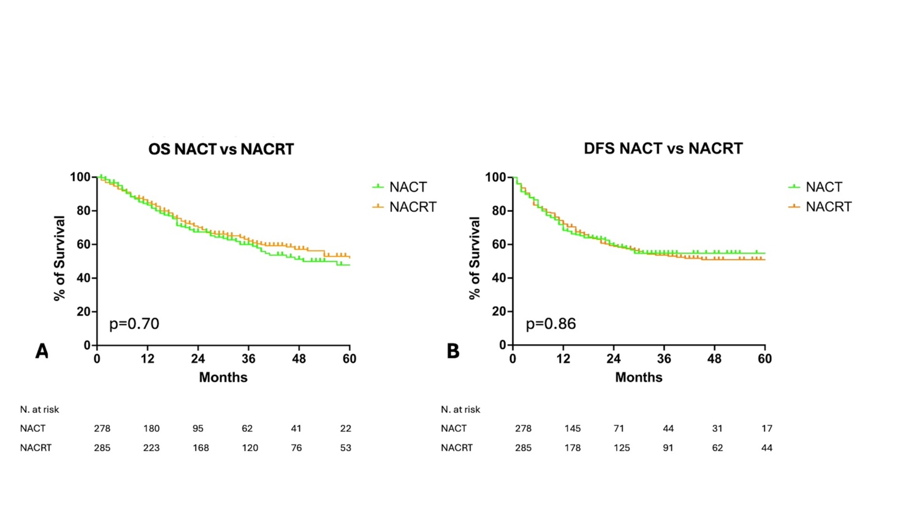
Figure 1. Kaplan-Meier survival curve comparing 5y OS (A) and 5y DFS (B) of patients after NACT and NACRT.

OS: overall survival; DFS: disease-free survival; NACT: neoadjuvant chemotherapy; NACRT: neoadjuvant chemoradiotherapy;

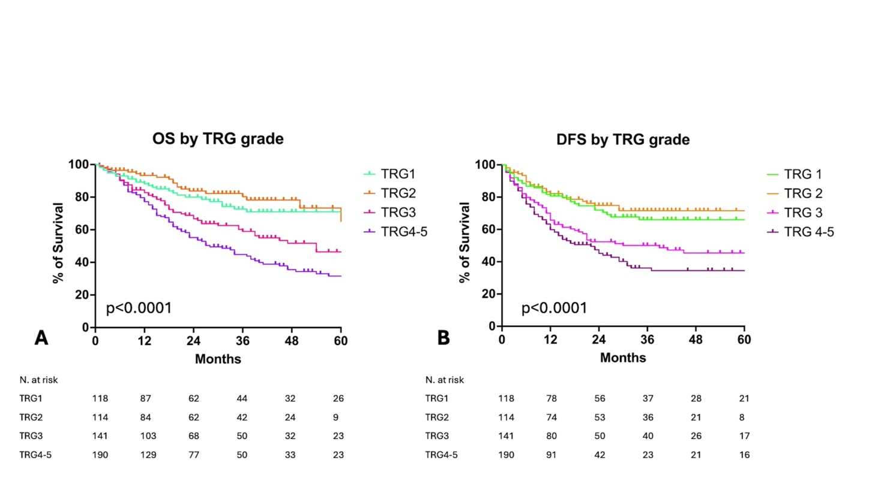
Figure 2. Kaplan-Meier survival curves comparing 5y OS (A) and 5y DFS (B) by TRG grade of the whole population.

OS: overall survival; DFS: disease-free survival; NACT: neoadjuvant chemotherapy; NACRT: neoadjuvant chemoradiotherapy;

