Supplementary Figure 1. Correlation Between Tumor Burden Score (TBS) and AFP Levels at Preoperative and Postoperative Time Points (6 and 12 Months)
This figure illustrates the relationship between Tumor Burden Score (TBS) and log-transformed AFP levels at three time points: preoperatively, 6 months postoperatively, and 12 months postoperatively. The blue line represents AFP levels at the preoperative time point, the orange line shows AFP levels at 6 months postoperatively, and the green line depicts AFP levels at 12 months postoperatively. Shaded areas around each line indicate the 95% confidence intervals. Spearman correlation coefficients and corresponding p-values are provided to assess the strength and significance of the correlation at each time point. 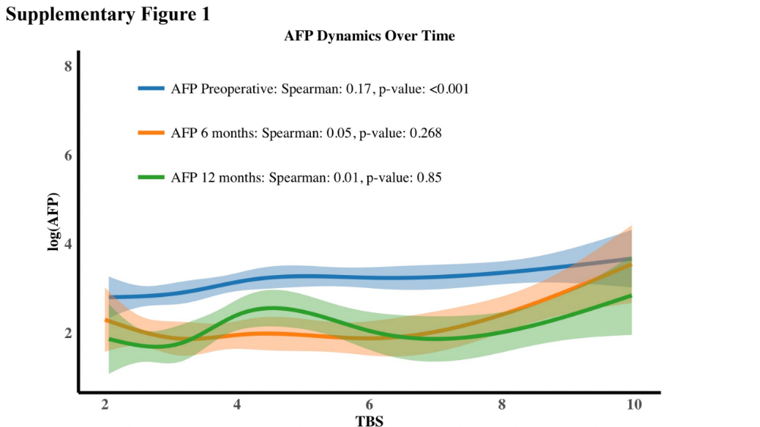
Supplementary Figure 2. Example Use of the Online Real-time Time-varying RFS Prediction Calculator for HCC Patients Based on AFP Levels
This figure demonstrates the use of an online calculator for predicting recurrence-free survival (RFS) in hepatocellular carcinoma (HCC) patients, based on AFP levels and other clinical data.
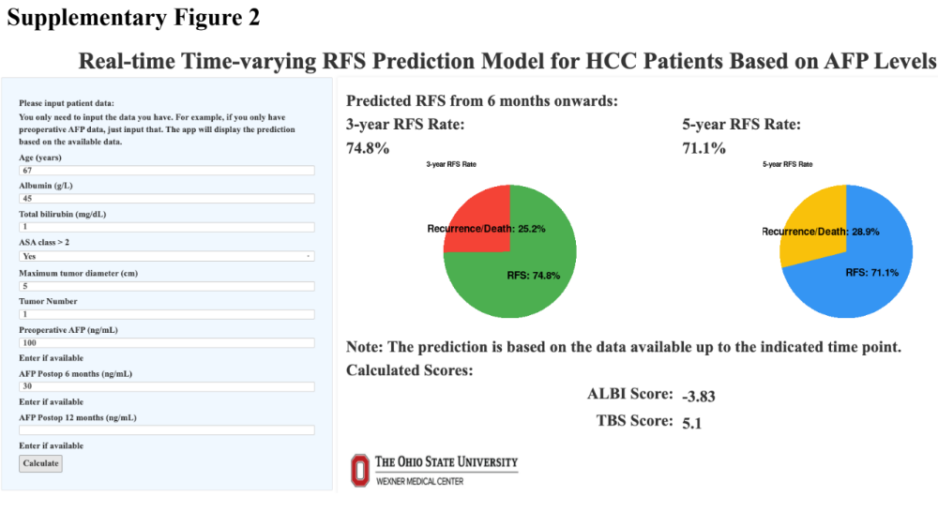

Supplementary Table 1: Predictors of Recurrence-Free Survival in Cox Proportional Hazard Model: Univariate and Multivariate Analysis
 | Univariate |  | Multivariable
Variable | HR (95% CI) | p-value | HR (95% CI) | p-value
Age | 1.005 (0.999 – 1.011) | 0.134 | 1.009 (1.002 – 1.017) | 0.019
Male, Yes | 1.058 (0.896 – 1.249) | 0.508 | 1.194 (0.960 – 1.485) | 0.111
ASA class>2, Yes | 1.059 (0.919 – 1.221) | 0.428 | 1.130 (0.940 – 1.359) | 0.194
BMI, kg/m² | 0.986 (0.970 – 1.002) | 0.095 | 0.993 (0.973 – 1.013) | 0.498
Log AFP | 1.074 (1.049 – 1.100) | <0.001 | 1.052 (1.021 – 1.084) | <0.001
TBS | 1.053 (1.039 – 1.068) | <0.001 | 1.049 (1.031 – 1.068) | <0.001
ALBI score | 1.057 (1.006 – 1.111) | 0.029 | 1.433 (1.207 – 1.701) | <0.001
Abbreviations. AFP: α-Fetoprotein, ALBI: Albumin-Bilirubin, ASA: American Society of Anesthesiologists, BMI: Body Mass Index, CI: Confidence interval, HR: Hazard Ratio, TBS: Tumor Burden Score.

