Supplementary Figure 1. Comparison of staging laparoscopy, neoadjuvant chemotherapy, adjuvant chemotherapy and perioperative chemotherapy implementation for particular countries.

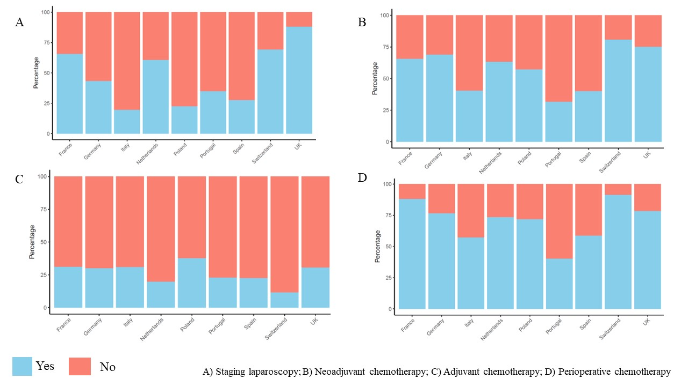

Supplementary Figure 2. Map of European Participant Countries comparing staging laparoscopy and chemotherapy administration.

