Supplemental Digital Content 3
Cumulative incidence of regional nodal recurrence and competing events in a cohort of 15 784 cN0 patients staged with SLNB with no SN metastases
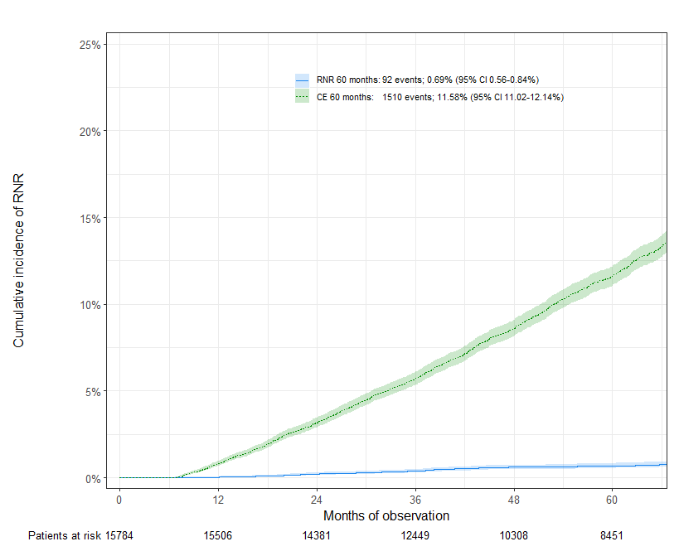
Abbreviations: SLNB: sentinel lymph node biopsy, RNR: regional nodal relapse, CE: competing event, CI: confidence interval

