Supplemental Digital Content 4
Cumulated incidence of 1602 first events* occurring in cN0 ypN0 patients within 5 years of follow-up
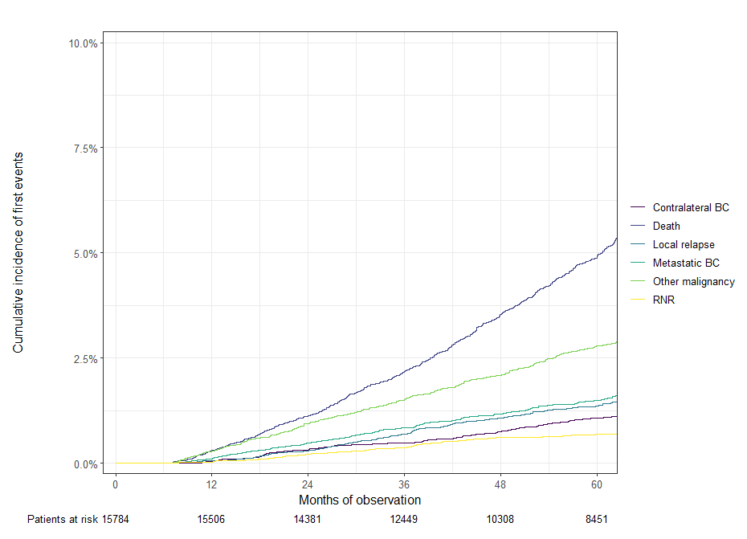
*Among patients with RNR (n = 92), isolated RNR occurred in 48 patients, RNR with local relapse in 15 patients and RNR with synchronous metastatic breast cancer in 29 patients.

