Supplementary Tables and Figures
Supplementary Figure 1: Strobe Diagram
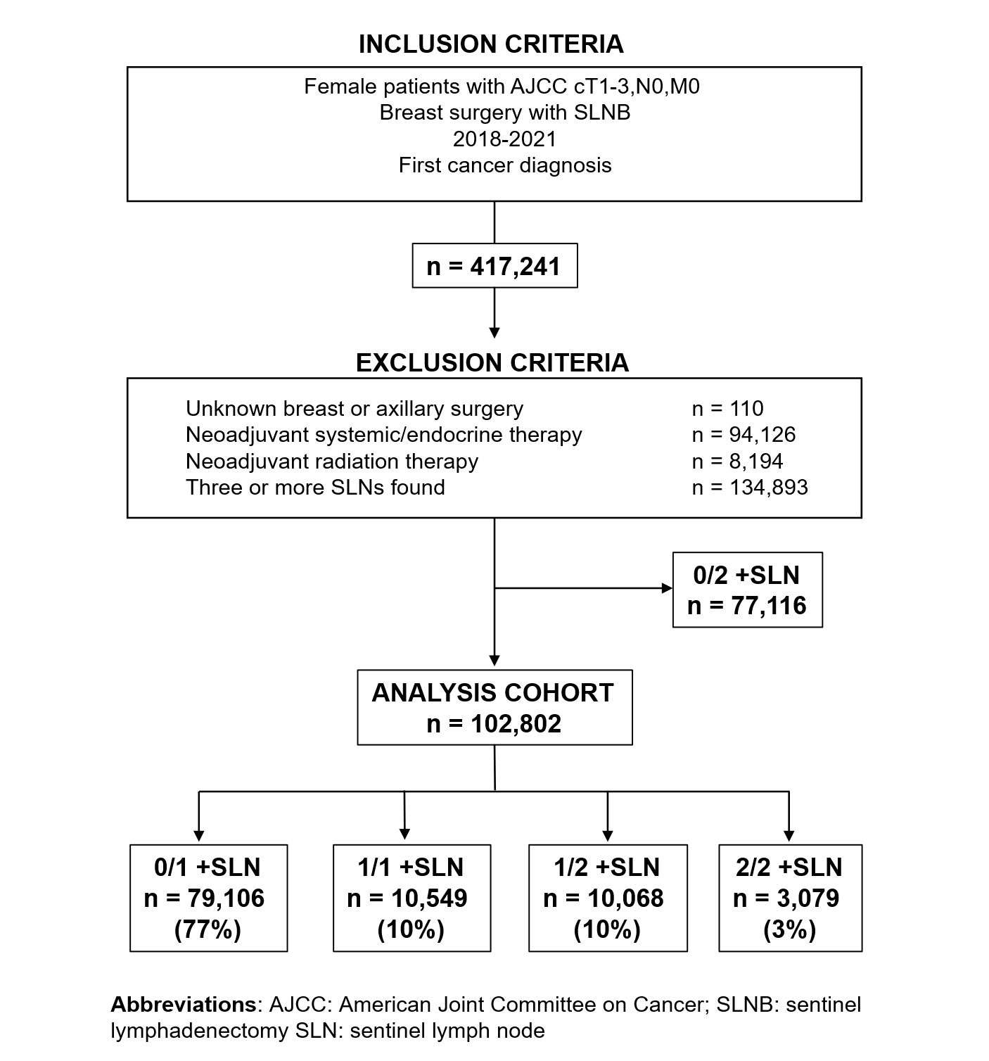

Supplementary Table 1: Adjuvant therapies among pN+ patients with triple negative breast cancer
 | 1/1 |  |  | 1/2 |  |  | 2/2 |  |  | p1 | p2
 | No ALND | ALND | p | No ALND | ALND | p | No ALND | ALND | p | p1 | p2
n | 268 | 117 |  | 306 | 86 |  | 77 | 42
Chemotherapy |  |  | 0.61 |  |  | 0.37 |  |  | 0.65 | 0.48 | 0.67
No/Unknown | 51 (19.0) | 20 (17.1) |  | 56 (18.3) | 19 (22.1) |  | 16 (20.8) | 11 (26.2)
Yes | 217 (81.0) | 97 (82.9) |  | 250 (81.7) | 66 (76.7) |  | 61 (79.2) | 31 (73.8)
Radiation - all patients |  |  | 0.001 |  |  | 0.06 |  |  | 0.51 | 0.21 | 0.003
No/Unknown | 61 (22.7) | 52 (37.6) |  | 89 (29.1) | 34 (39.6) |  | 21 (27.1) | 13 (31.0)
Yes | 207 (77.2) | 73 (62.4) |  | 217 (70.9) | 52 (60.5) |  | 56 (72.7) | 29 (69.1)
Radiation - mastectomy patients |  |  | 0.40 |  |  | 0.27 |  |  | 0.93 | 0.06 | 0.13
No/Unknown | 28 (43.1) | 29 (36.7) |  | 47 (59.5) | 29 (49.2) |  | 10 (38.5) | 12 (42.9)
Yes | 33 (50.8) | 46 (58.2) |  | 32 (40.5) | 29 (49.2) |  | 14 (53.9) | 16 (57.1)
Radiation - lumpectomy patients |  |  | 0.54 |  |  | 0.67 |  |  | 0.83 | 0.002 | 0.66
No | 27 (13.3) | * |  | 38 (16.7) | * |  | * | *
Yes - breast only | 51 (25.1) | * |  | 62 (27.3) | 8 (29.6) |  | * | *
Yes - breast and LNs* | 102 (50.3) | 15 (39.5) |  | 112 (49.3) | 12 (44.4) |  | 23 (45.1) | *
Yes - other | * | * |  | * | * |  | 10 (19.6) | *
Unknown | * | * |  | * | * |  | * | *

Data are expressed as n (%) unless otherwise specified
ALND: axillary lymph node dissection; LNs: lymph nodes
*Results suppressed: NCDB does not permit aggregate results for cell sizes < 10

Supplementary Table 2: Adjuvant therapies among pN+ patients with HER2+ breast cancer
 | 1/1 |  |  | 1/2 |  |  | 2/2 |  |  | p1 | p2
 | No ALND | ALND | p | No ALND | ALND | p | No ALND | ALND | p | p1 | p2
n | 249 | 115 |  | 255 | 74 |  | 66 | 47
Chemotherapy |  |  | 0.70 |  |  | 0.60 |  |  | 0.04 | 0.76 | 0.43
No/Unknown | 104 (41.8) | 46 (40.0) |  | 98 (38.5) | 30 (40.5) |  | 29 (43.9) | 12 (25.5)
Yes | 145 (58.2) | 69 (60.0) |  | 157 (61.6) | 44 (59.5) |  | 37 (56.1) | 35 (74.5)
Radiation - all patients |  |  | 0.07 |  |  | 0.16 |  |  | 0.63 | 0.75 | 0.02
No/Unknown | 90 (36.1) | 53 (46.1) |  | 89 (34.9) | 31 (41.9) |  | 21 (31.8) | 17 (36.2)
Yes | 159 (63.9) | 62 (53.9) |  | 166 (65.1) | 43 (58.1) |  | 45 (68.2) | 30 (63.8)
Radiation - mastectomy patients |  |  | 0.73 |  |  | 0.56 |  |  | 0.68 | 0.2212 | 0.31
No/Unknown | 49 (57.0) | 42 (54.6) |  | 43 (58.2) | 27 (51.9) |  | 10 (45.5) | 16 (40.0)
Yes | 37 (43.0) | 35 (45.5) |  | 31 (41.9) | 25 (48.1) |  | 12 (54.6) | 24 (60.0)
Radiation - lumpectomy patients |  |  | 0.21 |  |  | 0.70 |  |  | 0.51 | 0.96 | 0.59
No | 34 (20.9) | * |  | 39 (21.6) | * |  | 11 (25.0) | *
Yes - breast only | 39 (23.9) | * |  | 50 (27.6) | * |  | 11 (25.0) | *
Yes - breast and LNs* | 77 (47.2) | 13 (34.2) |  | 74 (40.9) | 12 (54.6) |  | 19 (43.2) | *
Yes - other | * | * |  | * | * |  | * | *
Unknown | * | * |  | * | * |  | * | *

Data are expressed as n (%) unless otherwise specified
HER2: human epidermal growth factor 2; ALND: axillary lymph node dissection; LNs: lymph nodes
*Results suppressed: NCDB does not permit aggregate results for cell sizes < 10

Supplementary Table 3: Adjuvant therapies among pN+ patients with HR+/HER2- breast cancer
 | 1/1 |  |  | 1/2 |  |  | 2/2 |  |  | p1 | p2
 | No ALND | ALND | p | No ALND | ALND | p | No ALND | ALND | p | p1 | p2
n | 7021 | 2443 |  | 7327 | 1655 |  | 1616 | 1147
Recurrence Score
Not performed | 2888 (41.13) | 1415 (57.92) | <0.001 | 2947 (40.22) | 829 (50.09) | <0.001 | 834 (51.61) | 809 (70.53) | <0.001 | <0.001 | <0.001
Performed | 4133 (58.87) | 1028 (42.08) | <0.001 | 4380 (59.78) | 826 (49.91) | <0.001 | 782 (48.39) | 338 (29.47) | <0.001 | <0.001 | <0.001
Mean ± S.D. | 16.32 ± 9.08 | 16.73 ± 9.45 | 0.2100 | 16.25 ± 8.94 | 17.10 ± 10.02 | 0.03 | 15.97 ± 8.25 | 16.84 ± 10.00 | 0.17 | 0.86 | 0.01
Chemotherapy |  |  | <0.001 |  |  | <0.001 |  |  | <0.001 | <0.001 | <0.001
No/Unknown | 5085 (72.4) | 1280 (52.4) |  | 5235 (71.4) | 953 (57.6) |  | 945 (58.5) | 398 (34.7)
Yes | 1936 (27.57) | 1163 (47.61) |  | 2092 (28.55) | 702 (42.42) |  | 671 (41.52) | 749 (65.30)
Endocrine therapy |  |  | 0.01 |  |  | 0.10 |  |  | 0.82 | 0.01 | 0.001
No | 548 (7.81) | 234 (9.58) |  | 534 (7.29) | 139 (8.40) |  | 148 (9.16) | 102 (8.89)
Yes | 6366 (90.67) | 2164 (88.58) |  | 6690 (91.31) | 1481 (89.49) |  | 1435 (88.80) | 1019 (88.84)
Unknown | 107 (1.52) | 45 (1.84) |  | 103 (1.41) | 35 (2.11) |  | 33 (2.04) | 26 (2.27)
Radiation - all patients |  |  | <0.001 |  |  | <0.001 |  |  | <0.001 | <0.001 | <0.001
No | 1060 (15.10) | 785 (32.13) |  | 1179 (16.09) | 548 (33.11) |  | 192 (11.88) | 229 (19.97)
Yes | 5869 (83.59) | 1614 (66.07) |  | 6046 (82.52) | 1080 (65.26) |  | 1390 (86.01) | 901 (78.55)
Unknown | 92 (1.31) | 44 (1.80) |  | 102 (1.39) | 27 (1.63) |  | 34 (2.10) | 17 (1.48)
Radiation - mastectomy patients |  |  | 0.13 |  |  | 0.05 |  |  | 0.19 | <0.001 | 0.19
No | 687 (38.92) | 709 (41.49) |  | 822 (39.48) | 503 (44.67) |  | 106 (21.07) | 201 (24.51)
Yes | 1045 (59.21) | 970 (56.76) |  | 1220 (58.60) | 603 (53.55) |  | 382 (75.94) | 606 (73.90)
Unknown | 33 (1.87) | 30 (1.76) |  | 40 (1.92) | 20 (1.78) |  | 15 (2.98) | 13 (1.59)
Radiation - lumpectomy patients |  |  | <0.001 |  |  | 0.07 |  |  | 0.01 | <0.001 | <0.001
No | 373 (7.10) | 76 (10.35) |  | 357 (6.81) | 45 (8.51) |  | 86 (7.73) | 28 (8.56)
Yes - breast only | 1992 (37.90) | 229 (31.20) |  | 2050 (39.08) | 178 (33.65) |  | 282 (25.34) | 58 (17.74)
Yes - breast and LNs | 2561 (48.73) | 360 (49.05) |  | 2517 (47.99) | 266 (50.28) |  | 660 (59.30) | 207 (63.30)
Yes - other | 232 (4.41) | 48 (6.54) |  | 228 (4.35) | 28 (5.29) |  | 56 (5.03) | *
Unknown | 98 (1.86) | 21 (2.86) |  | 93 (1.77) | 12 (2.27) |  | 29 (2.61) | *

Data are expressed as n (%) unless otherwise specified
HR: hormone receptor; HER2: human epidermal growth factor 2; ALND: axillary lymph node dissection; LNs: lymph nodes
*Results suppressed: NCDB does not permit aggregate results for cell sizes < 10

