Supplemental Online Figures

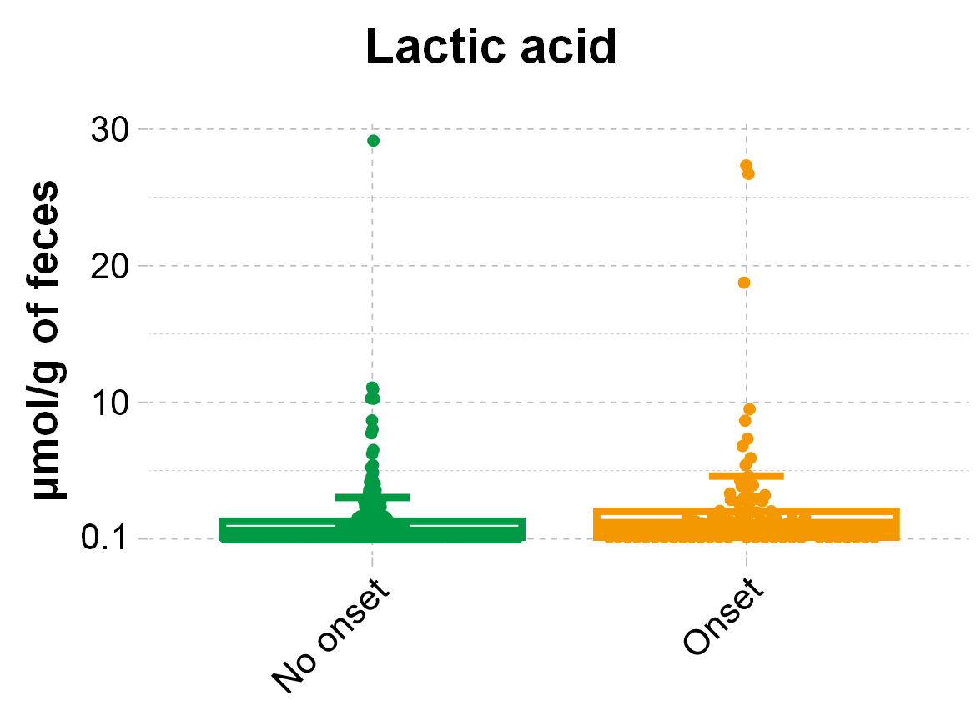
Supplemental Figure S1. Comparison of preoperative fecal lactic acid levels in patients with and without postoperative infectious complications.

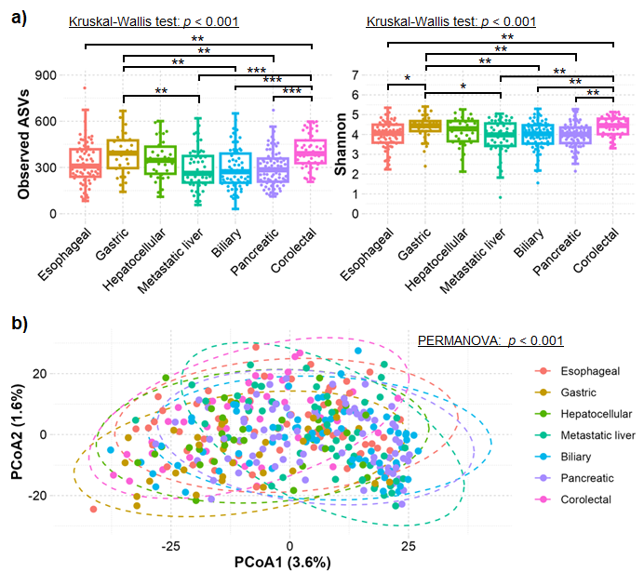
Supplemental Figure S2. Comparison of gut microbiota diversity among cancer types. (a) Alpha diversity and (b) beta diversity based on the Aitchison distance were compared among patients according to cancer type. For alpha diversity, p-values were estimated using the Kruskal–Wallis and post-hoc Dunn tests. For beta diversity, p-values were estimated using pairwise permutational analysis of variance (PERMANOVA).

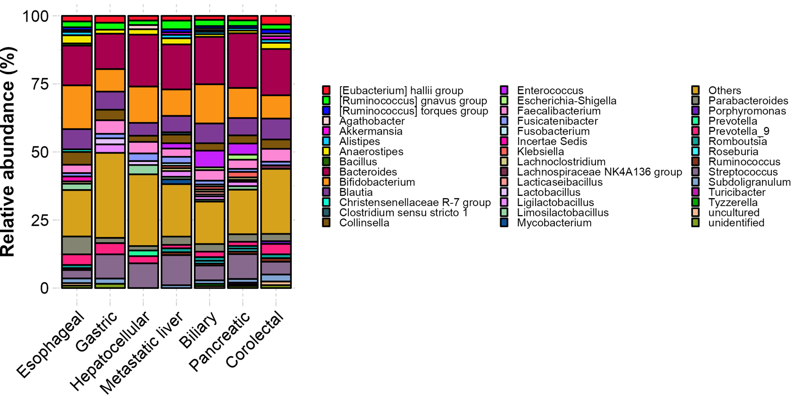
Supplemental Figure S3. Comparison of the gut microbiota among different cancer types. The abundance of the gut microbiota at the genus level was compared among patients according to the cancer type.

