Database | Time span | Search strategy
MEDLINE | 1946 to 10th March 2025 | 1 Tum?r deposit*.mp.  2 (extranodal adj2 deposit*).mp.  3 (extramural adj2 deposit*).mp.  4 1 or 2 or 3  5 exp Extranodal Extension  6 4 or 5  7 Magnetic Resonance Imaging  8 MRI.mp.  9 mrTD.mp.  10 7 or 8 or 9  11 overall survival.mp.  12 disease free survival.mp.  13 local recurr*nce.mp.  14 distant metastas*s.mp.  15 11 or 12 or 13 or 14  16 exp Colorectal Neoplasms/  17 colorectal cancer.mp.  18 bowel cancer.mp.  19 rectal cancer.mp.  20 16 or 17 or 18 or 19  21 6 and 10 and 15 and 20
EMBASE (OvidSP) | 1947 to 10th March 2025 | 1 Tumo?r deposit*.mp.  2 (extranodal adj2 deposit*).mp  3 (extramural adj2 deposit*).mp.  4 1 or 2 or 3  5 MRI.mp.  6 mrTD.mp.  7 magnetic resonance imaging.mp.  8 6 or 7 or 8  9 Overall survival.mp.  10 disease free survival.mp.  11 local recurr*nce.mp.  12 distant metastas*s.mp.  13 9 or 10 or 11 or 12  14 rectum tumor/ or rectum carcinoma/ or colorectal cancer/ or colon carcinoma/ or rectum cancer/  15 bowel cancer.mp.  16 14 or 15  17 4 and 8 and 13 and 16
Scopus | January 1950 to April 2020 | ( rectal AND cancer ) OR ( bowel AND cancer ) OR ( colorectal AND cancer ) AND ( distant AND metastas*s ) OR ( local AND recurr*nce ) OR ( disease AND free AND survival ) ( overall AND survival ) AND ( magnetic AND resonance AND imaging ) OR ( MRI ) OR ( mrTD ) AND ( extramural W/2 deposit* ) OR ( extranodal W/2 deposit* ) OR ( tumour AND deposit )
Table S1: Detailed Search Strategy

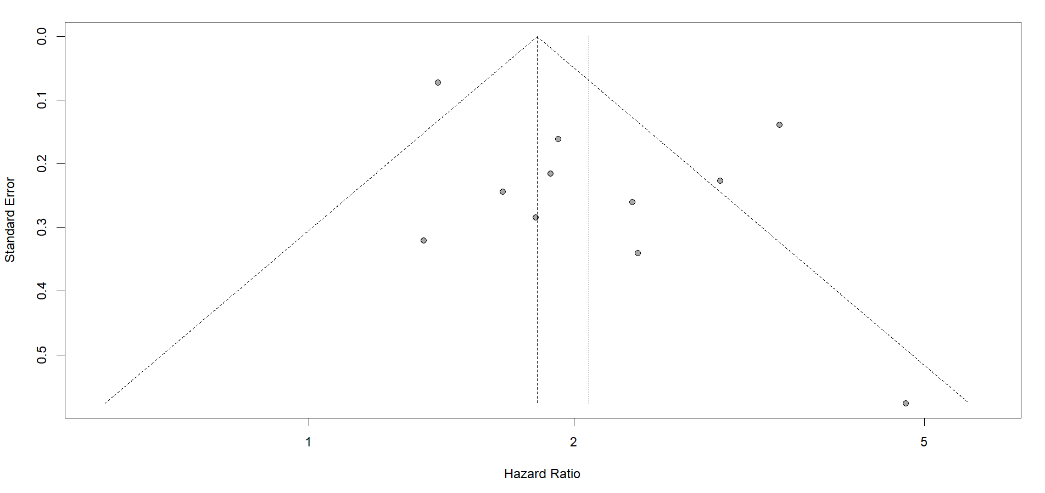
Figure S1: Funnel plot assessing publication bias for the 11 included studies in the meta-analysis. Eggers test: t = 1.70, df = 9, p-value = 0.1234

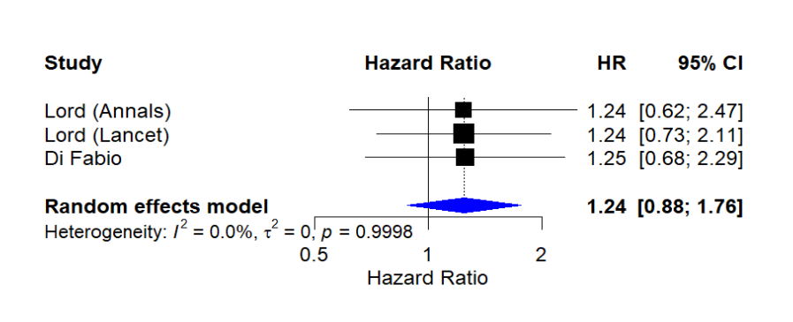
Figure S2: Forest plot showing pooled Hazard ratio (HR) for MRI detected T3-4 vs T2. Prognostic measure is Overall Survival (OS). P=0.21.

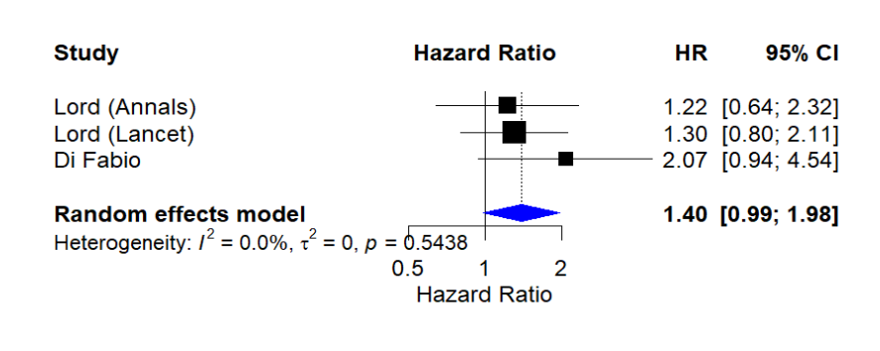
Figure S3: Forest plot showing pooled Hazard ratio (HR) for MRI detected T3-4 vs T2. Prognostic measure is Disease Free Survival (DFS). P=0.21.

