Table of content | Page
Figure S1: Histogram of predictions for complete clinical response | 2
Table S1: Members of the SANO study group | 3

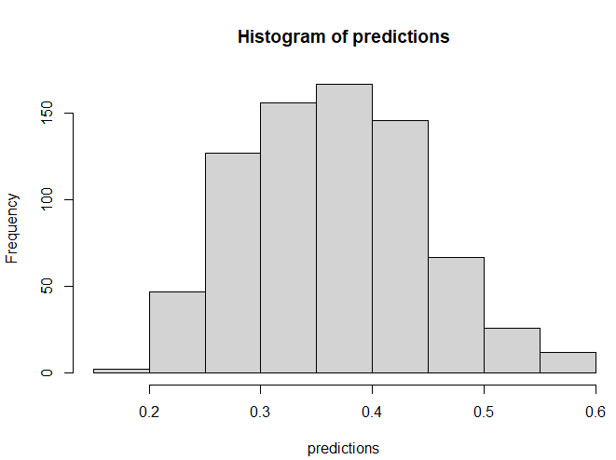
Figure S1 - Predictions of complete clinical response (CCR) for 750 patients who underwent nCRT X-axis: predicted probabilities of CCR , Y-axis: number of patients, corresponding to each range of predicted probabilities.

Table S1: Members of the SANO study group, besides the authors who are indicated on the title page
Name | Department | Centre
Manon C.W. Spaander | Gastroenterology | Erasmus MC – University medical centre
Arjun D. Koch | Gastroenterology | Erasmus MC – University medical centre
Suzan Nikkessen | Gastroenterology | Erasmus MC – University medical centre
Ate van der Gaast | Medical oncology | Erasmus MC – University medical centre
Roelf Valkema | Nuclear medicine | Erasmus MC – University medical centre
Michail Doukas | Pathology | Erasmus MC – University medical centre
Lindsey Oudijk | Pathology | Erasmus MC – University medical centre
Roy S. Dwarkasing | Radiology | Erasmus MC – University medical centre
Joost J. Nuyttens | Radiotherapy | Erasmus MC – University medical centre
Berend van der Wilk | Surgery | Erasmus MC – University medical centre
Ben Eyck | Surgery | Erasmus MC – University medical centre
Bo Jan Noordman | Surgery | Erasmus MC – University medical centre
Maartje Valkema | Surgery | Erasmus MC – University medical centre
Pieter C. van der Sluis | Surgery | Erasmus MC – University medical centre
Tanya M. Bisseling | Gastroenterology | Radboud University Medical Centre
Geert J. Bulte | Gastroenterology | Radboud University Medical Centre
Peter D. Siersema | Gastroenterology | Radboud University Medical Centre
Harm Westdorp | Medical oncology | Radboud University Medical Centre
Erik H. Aarntzen | Nuclear medicine | Radboud University Medical Centre
Chella S. van der Post | Pathology | Radboud University Medical Centre
Maartje C. van Rijk | Radiology | Radboud University Medical Centre
Pètra M. Braam | Radiotherapy | Radboud University Medical Centre
Heidi Rütten | Radiotherapy | Radboud University Medical Centre
Marcel Verheij | Radiotherapy | Radboud University Medical Centre
Camiel Rosman | Surgery | Radboud University Medical Centre
Bastiaan Klarenbeek | Surgery | Radboud University Medical Centre
Serge J. Zweers | Gastroenterology | Maasstad Hospital
Lieke Hol | Gastroenterology | Maasstad Hospital
I. Lisanne Holster | Gastroenterology | Maasstad Hospital
Ewout F.W. Courrech Staal | Radiology | Maasstad Hospital
Karen E. Hamoen | Pathology | Maasstad Hospital
Trudy Rapmund | Surgery | Maasstad Hospital
Erwin van der Harst | Surgery | Maasstad Hospital
Andries van der Linden | Gastroenterology | Ziekenhuisgroep Twente Hospital
Huseyin Aktas | Gastroenterology | Ziekenhuisgroep Twente Hospital
Polat Dura | Gastroenterology | Ziekenhuisgroep Twente Hospital
Ronald Hoekstra | Medical oncology | Ziekenhuisgroep Twente Hospital
Ali Agool | Nuclear medicine | Ziekenhuisgroep Twente Hospital
Joop van Baarlen | Pathology | Ziekenhuisgroep Twente Hospital
Ellen M. Hendriksen | Radiotherapy | Ziekenhuisgroep Twente Hospital
Henk Jan Mantel | Surgery | Ziekenhuisgroep Twente Hospital
Marc van Det | Surgery | Ziekenhuisgroep Twente Hospital
Rutger Quispel | Gastroenterology | Reinier de Graaf Gasthuis
Sana A. Mulder | Gastroenterology | Reinier de Graaf Gasthuis
Arjan J. Verschoor | Medical oncology | Reinier de Graaf Gasthuis
Marc R.J. ten Broek | Nuclear medicine | Reinier de Graaf Gasthuis
René J. Dallinga | Radiology | Reinier de Graaf Gasthuis
Karen J. Neelis | Radiotherapy | Reinier de Graaf Gasthuis
Erlinde de Graaf | Surgery | Reinier de Graaf Gasthuis
Stijn van Esser | Surgery | Reinier de Graaf Gasthuis
Jolanda M. van Dieren | Gastroenterology | The Netherlands Cancer Institute
Thomas R. de Wijkerslooth | Gastroenterology | The Netherlands Cancer Institute
Marieke A. Vollebergh | Medical oncology | The Netherlands Cancer Institute
Emilia C. Owers | Nuclear medicine | The Netherlands Cancer Institute
Annemarieke Bartels-Rutten | Radiology | The Netherlands Cancer Institute
Liudmila L. Kodach | Pathology | The Netherlands Cancer Institute
Francine E.M. Voncken | Radiotherapy | The Netherlands Cancer Institute
Yvonne Hilhorst | Surgery and gastroenterology | The Netherlands Cancer Institute
Marjolein Warmerdam | Surgery and gastroenterology | The Netherlands Cancer Institute
Sietske Corporaal | Gastroenterology | Medical Centre Leeuwarden
Edward Fiets | Medical oncology | Medical Centre Leeuwarden
Marco B. Polée | Medical oncology | Medical Centre Leeuwarden
Anne Marij G. van Burg | Nuclear medicine | Medical Centre Leeuwarden
Judith Nieken | Pathology | Medical Centre Leeuwarden
Rinze Wolf | Radiology | Medical Centre Leeuwarden
Vera Oppedijk | Radiotherapy | Medical Centre Leeuwarden
Marloes Emous | Surgery | Medical Centre Leeuwarden
Daniel A. Hess | Surgery | Medical Centre Leeuwarden
Eva Kouw | Gastroenterology | Gelre Hospital
Willemien Erkelens | Gastroenterology | Gelre Hospital
S. Cathrien S. Tromp – van Driel | Medical oncology | Gelre Hospital
Marc D. Zuijdwijk | Nuclear medicine | Gelre Hospital
H. Doornewaard | Pathology | Gelre Hospital
Karin Muller | Radiotherapy | Gelre Hospital, Radiotherapiegroep Deventer
Peter van Duijvendijk | Surgery | Gelre Hospital
Eelco B. Wassenaar | Surgery | Gelre Hospital
Wouter L. Curvers | Gastroenterology | Catharina Hospital
Geert-Jan Creemers | Medical oncology | Catharina Hospital
Mark J. Roef | Nuclear medicine | Catharina Hospital
Ineke van Lijnschoten | Pathology | Catharina Hospital
Joost Nederend | Radiology | Catharina Hospital
Maurice J.C. van der Sangen | Radiotherapy | Catharina Hospital
Tom C.G. Budiharto | Radiotherapy | Catharina Hospital
Fanny F.B.M. Heesakkers | Surgery | Catharina Hospital
Misha D. Luyer | Surgery | Catharina Hospital
Liekele E. Oostenbrug | Gastroenterology | Zuyderland Medical Centre
Fabienne A.R.M. Warmerdam | Medical oncology | Zuyderland Medical Centre
Wendy Schreurs | Nuclear medicine | Zuyderland Medical Centre
Bart de Vries | Pathology | Zuyderland Medical Centre
Roy F.A. Vliegen | Radiology | Zuyderland Medical Centre
Jeroen Buijsen | Radiotherapy | Zuyderland Medical Centre
Ilse Stohr | Surgery | Zuyderland Medical Centre
Eric H.J. Belgers | Surgery | Zuyderland Medical Centre
Jolein van der Kraan | Gastroenterology | Leiden University Medical Centre
Marije Slingerland | Medical oncology | Leiden University Medical Centre
Richard Raghoo | Nuclear medicine | Leiden University Medical Centre
A. Stijn L.P. Crobach | Pathology | Leiden University Medical Centre
Aart J. van der Molen | Radiology | Leiden University Medical Centre
Susan J.C.L.M. Quix | Surgery | Leiden University Medical Centre
Wobbe O. de Steur | Surgery | Leiden University Medical Centre
Wouter L. Hazen | Gastroenterology | Elisabeth Tweesteden Hospital
Laurens V. Beerepoot | Medical oncology | Elisabeth Tweesteden Hospital
David E. Ploeg | Pathology | Elisabeth Tweesteden Hospital
Tom Rozema | Radiotherapy | Elisabeth Tweesteden Hospital
Ilse A.C. Vermeltfoort | Nuclear medicine | Elisabeth Tweesteden Hospital
Walther Jansen | Surgery | Elisabeth Tweesteden Hospital

