Supplements
Overall
(N=163)
Years since breast cancer diagnosis, median (IQR) | 9.00 (IQR 7.0 - 13.0)
Affected breast
Right | 77 (47.2%)
Left | 81 (49.7%)
Bilateral | 5 (3.1%)
T - stage
Tis | 1 (0.6%)
T0 | 1 (0.6%)
T1 | 57 (35.0%)
T2 | 77 (47.2%)
T3 | 23 (14.1%)
T4 | 4 (2.5%)
N - stage
N0 | 28 (17.2%)
N1 | 67 (41.1%)
N2 | 46 (28.2%)
N3 | 21 (12.9%)
N4 | 1 (0.6%)
M - stage
M0 | 135 (82.8%)
M1 | 1 (0.6%)
Mx | 27 (16.6%)
Primary tumor location, n (%)
Upper outer quadrant | 107 (65.6%)
Upper inner quadrant | 24 (14.7%)
Lower inner quadrant | 9 (5.5%)
Centrally behind nipple | 5 (3.1%)
Multifocal | 17 (10.4%)
Unknown | 1 (0.6%)
Primary tumor diameter (mm), median (IQR) | 23.0 (IQR 15.0 - 35.0)
ER pos (≥10%), n (%) | 110 (67.5%)
Her2Neu pos (IHC 3+ or amplification), n (%) | 28 (17.2%)
Germline DNA mutations, n (%)
BRCA1 | 8 (4.9%)
BRCA2 | 2 (1.2%)
CHEK21100delC | 1 (0.6%)
No DNA mutations | 152 (93.3%)
Breast surgery (yes), n (%) | 162 (99.4%)
Type of breast surgery
Mastectomy | 97 (59.9%)
Lumpectomy | 65 (40.1%)
ALND (total), n (%) | 146 (89.6%)
SLNB (total), n (%) | 58 (35.6%)
Lymph nodes removed, median (IQR) | 14.0 (IQR 9.0 - 20.5)
Reconstructive surgery
Primary reconstructive surgery | 21 (12.9%)
Secondary reconstructive surgery | 60 (36.8%)
No reconstructive surgery | 82 (50.3%)
Chemotherapy (yes), n (%) | 147 (90.2%)
Adjuvant/Neoadjuvant
Adjuvant | 95 (64.6%)
Neoadjuvant | 51 (34.7%)
Neoadjuvant and adjuvant | 1 (0.7%)
Chemotherapy sessions, median (IQR) | 6.0 (IQR 5.5 - 8.0)
Type of chemotherapy, n (%)
Anthracycline and taxane based schedules | 103 (70.1%)
Solely anthracycline based agents | 39 (26.5%)
Solely taxane based agents | 5 (3.4%)
Taxane-based chemotherapy (yes), n (%) | 108 (66.3%)
Platinum-based chemotherapy (yes), n (%) | 8 (4.9%)
Antihormonal therapy (yes), n (%) | 110 (67.5%)
Anti-HER2 targeted therapy (yes), n (%) | 19 (11.6%)
PARP inhibitor targeted therapy (yes), n (%) | 3 (13.1%)
CDK4/6 inhibitor therapy (yes), n (%) | 1 (4.3%)
Radiotherapy (yes), n (%) | 143 (87.7%)
Irradiation site / Targeted regions
Breast | 29 (20.3%)
Breast and axillary lymph nodes | 30 (20.9%)
Chest wall | 31 (21.7%)
Chest wall and axillary lymph nodes | 52 (36.4%)
Periclavicular lymph nodes and axillary lymph nodes | 1 (0.7%)
Regional nodal irradiation (RNI), (yes) n (%) | 83 (58%)
Radiation therapy boost (yes), n (%) | 45 (31.5%)
Total radiation dosage (Gy), median (IQR) | 50.0 Gy (IQR 40.0-55.9)
Number of radiotherapy sessions, median (IQR) | 25.0 (IQR 15.0-25.0)

Supplementary Table 1: Oncological characteristics and treatment history of patients with breast cancer-related lymphedema (BCRL).

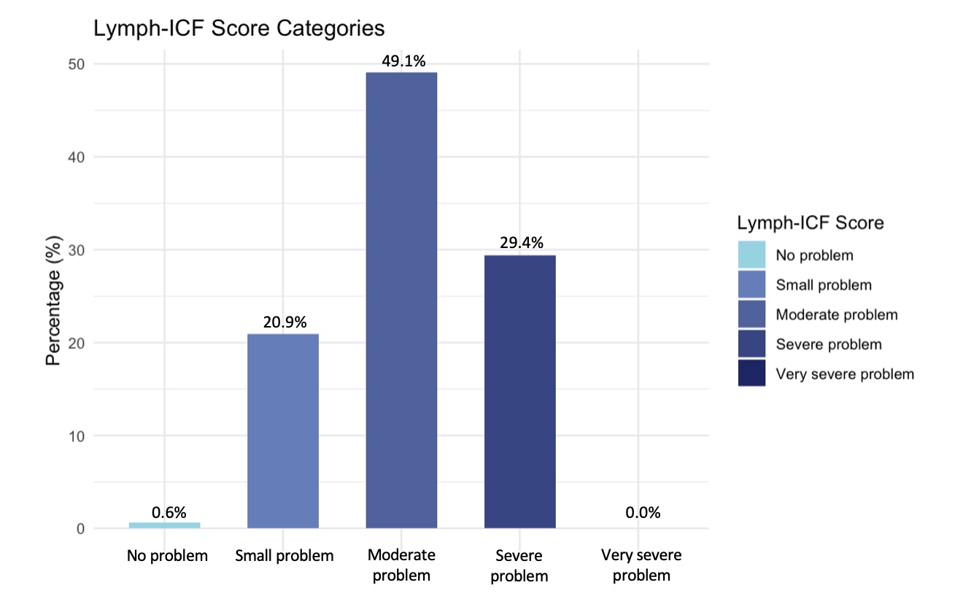
Supplementary Figure 1: Lymph-ICF categories based on total score.

