List of supplemental digital content
- Figure 1: Flowchart inclusion and exclusion criteria
- Table 1: Five-year locoregional recurrence rate per subtype, stratified by complication group
- Figure 2: Cumulative incidence of locoregional recurrence, stratified by complication group in absence of R1 resections
- Figure 3: One year conditional overall survival plot, stratified per complication group
Supplementary digital content Figure 1: Flowchart inclusion and exclusion criteria
Anastomotic leakage
n=394 (4.9%)
Snapshot colon cancer cohort
n=9,523
Included patients
n=7,983
No complications
n=5,744 (72.0%)
Any other surgical complication
n=944 (11.8%)
Non-surgical complication only
n=901 (11.3%)
Appendiceal tumor (n=74)
R2-resection (n=63)
Synchronous metastases (n=1,205)
Unknown synchronous metastases (n=19)
Mortality ≤30 days (n=149)
pT0 (n=30)
Supplementary digital content Table 1: Five-year locoregional recurrence rate per subtype, stratified by complication group
 | Overall  N = 7,983 | No complications  N = 5,744 | Anastomotic leakage  N = 394 | Any other surgical complication  N = 944 | Non-surgical complication only  N = 901
Tumor bed recurrence | 1.2% | 1.1% | 1.6% | 2.2% | 1.1%
Peritoneal recurrence | 3.9% | 3.3% | 6.7% | 5.5% | 5.1%
Omental recurrence | 0.1% | 0.1% | - | 0.5% | -
Ovarian/adnexal recurrence | 0.4% | 0.4% | 0.7% | 0.4% | 0.5%
Abdominal wall recurrence | 1.1% | 1.0% | 2.6% | 0.8% | 1.3%
Anastomotic recurrence | 1.6% | 1.6% | 2.4% | 1.3% | 1.6%
Regional LN recurrence | 1.1% | 0.9% | 1.5% | 1.6% | 1.8%
Para-iliac recurrence | 0.7% | 0.7% | 1.2% | 0.3% | 1.2%
NOS recurrence | 0.2% | 0.1% | - | 0.6% | 0.4%

Supplementary digital content Figure 2: Cumulative incidence of locoregional recurrence, stratified by complication group in absence of R1 resections
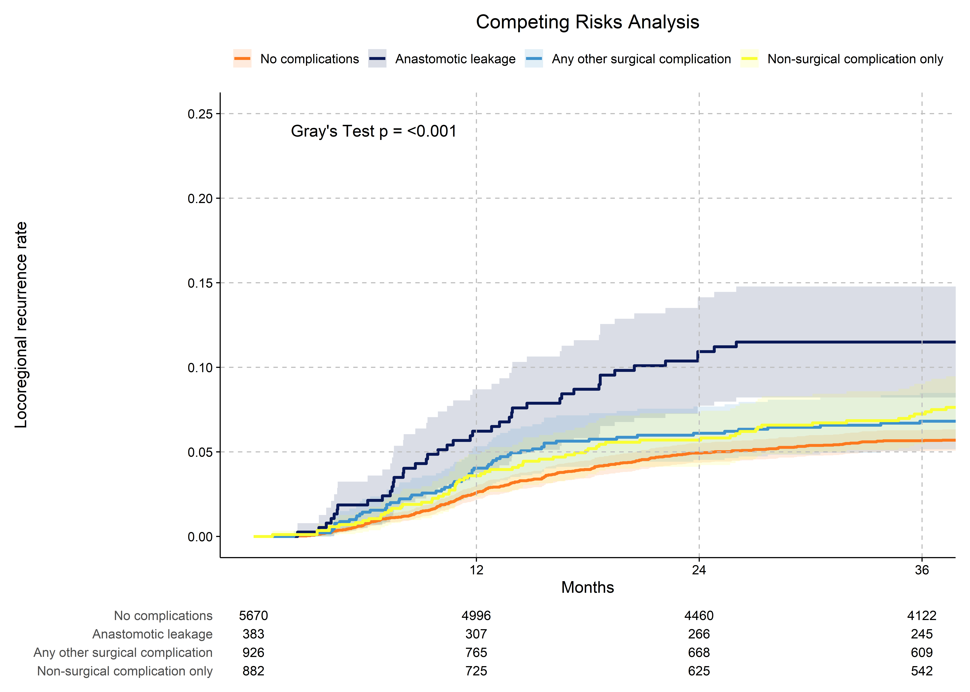
Supplementary digital content Figure 3: One year conditional overall survival plot, stratified per complication group
