Supplementary Figures:
Supplementary Figure 1: pathology confirmed ovarian metastasis at the time of CRS among reproductive aged women with appendiceal cancer: Stratified by tumor histology (n=47)
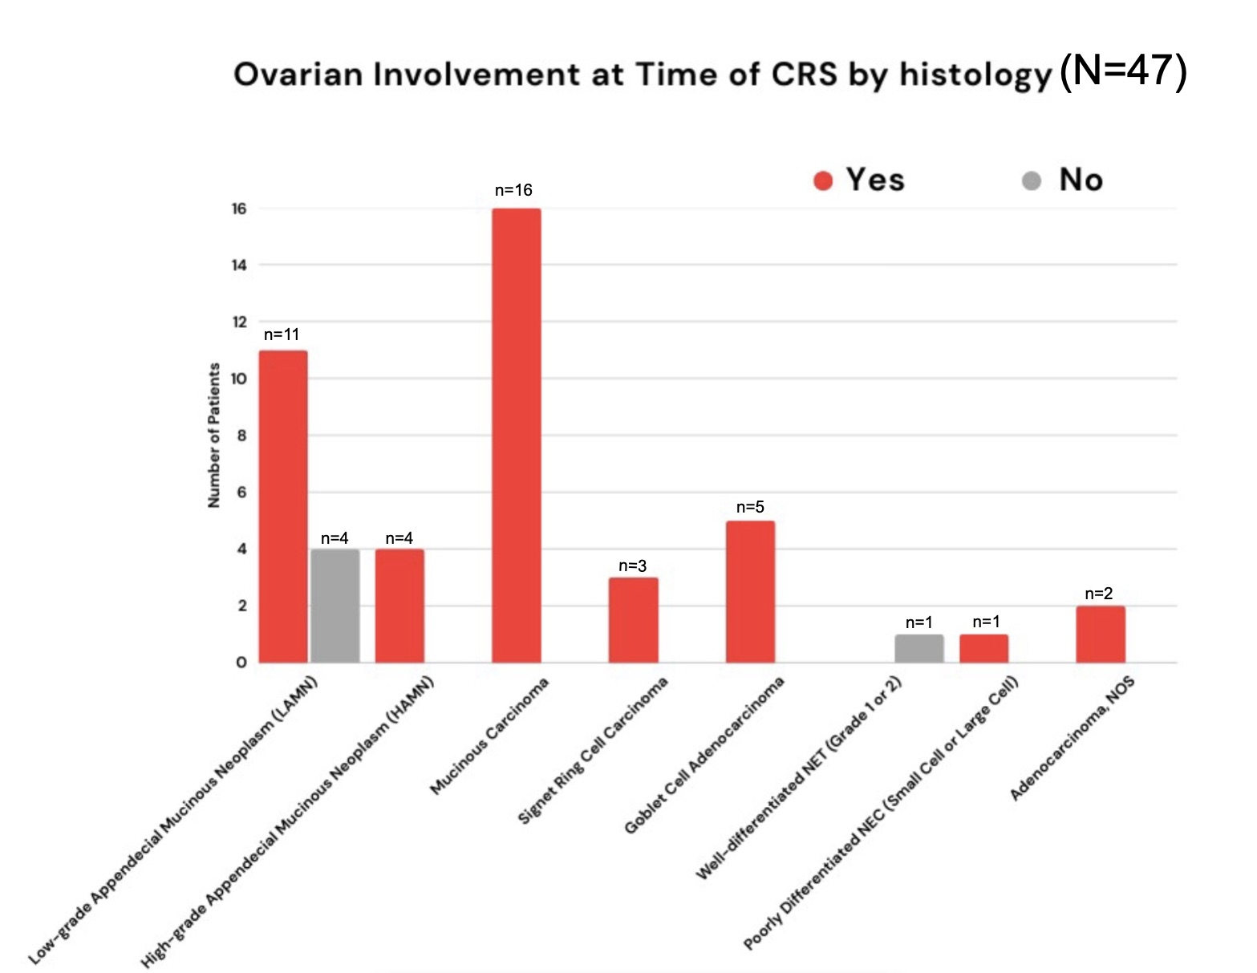

Supplementary Figure 2: Pathology confirmed ovarian metastasis at the time of CRS among reproductive aged women with appendiceal cancer: Stratified by tumor stage (n=47)
