Supplementary Figure S1. Timing of liver-confined and extrahepatic recurrence according to resection margin status
Smoothed cause-specific hazard functions are shown for liver-confined recurrence and recurrence involving any extrahepatic site, stratified by resection margin status. Blue lines indicate R0 margin and red lines indicate R1 margin; shaded bands indicate 95% confidence intervals. Time was measured from liver resection. This exploratory analysis complements Figure 2 by visualizing recurrence timing.
Abbreviations: R0, microscopically negative margin; R1, microscopically positive margin.

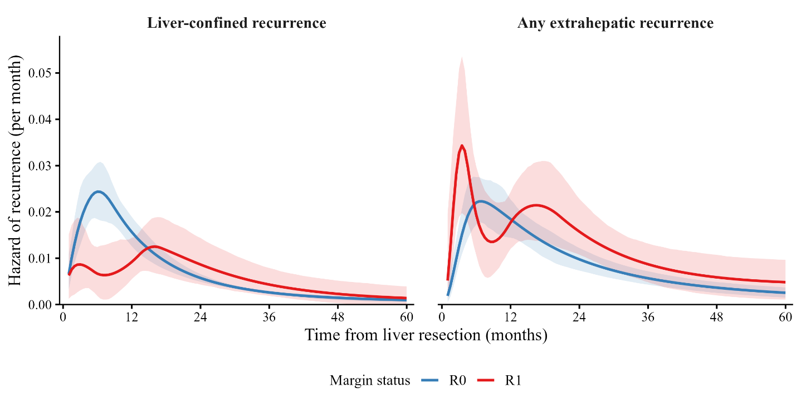

Supplementary Figure S2. Estimated 2-year probability of first-recurrence patterns according to modified tumor burden score and resection margin status
Heatmaps show the model-estimated 2-year probability of each first-recurrence pattern according to modified tumor burden score, stratified by resection margin status. Color intensity indicates the estimated probability of recurrence. This descriptive visualization was used to examine variation in recurrence patterns across tumor-burden strata.
Abbreviations: mTBS, modified tumor burden score; R0, microscopically negative margin; R1, microscopically positive margin.
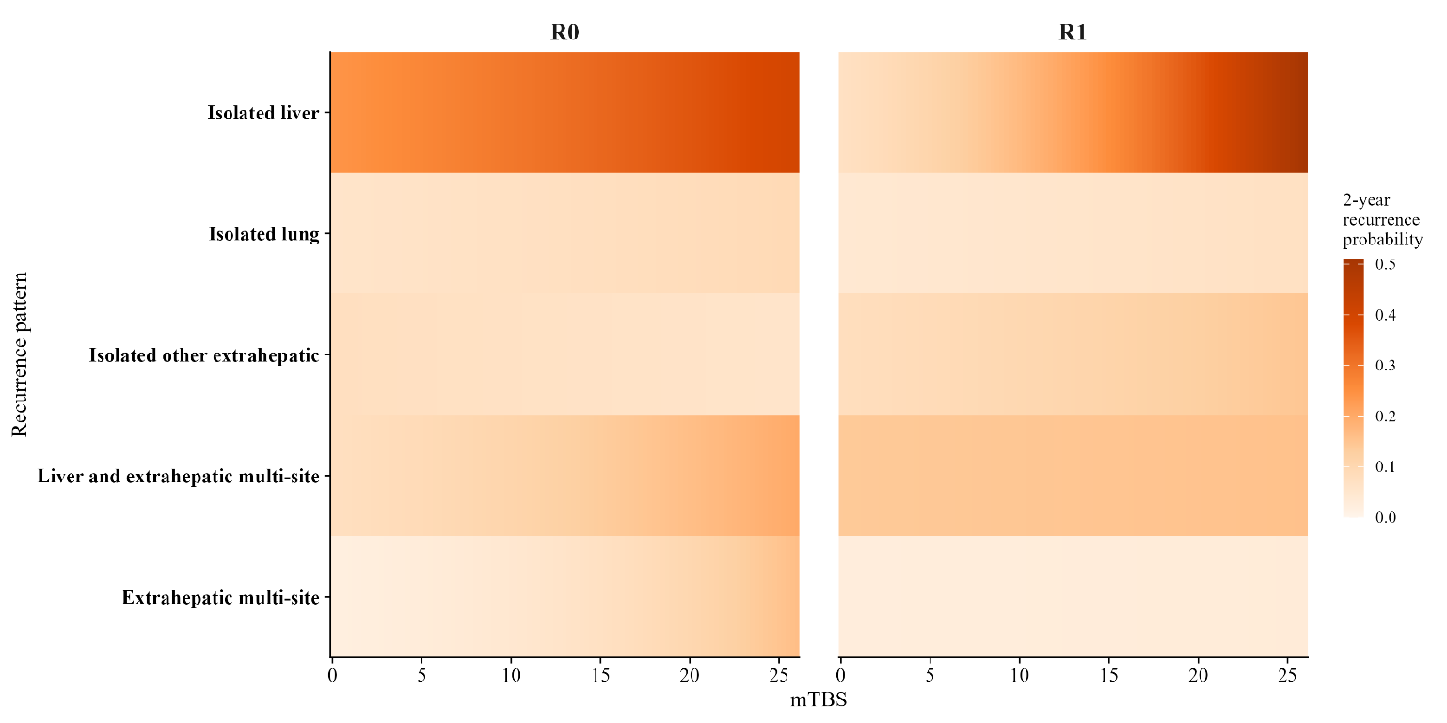

Supplementary Table S1. Univariable Cox regression of candidate predictors across survival endpoints
Variable | OS HR (95%CI) | p value | RFS HR (95%CI) | p value | DFS HR (95%CI) | p value
Positive margin (R1 vs R0) | 1.60 (1.04–2.46) | 0.033 | 1.40 (1.06–1.84) | 0.018 | 1.46 (1.13–1.89) | 0.004
Age 60–69 (vs <60) | 1.10 (0.89–1.37) | 0.374 | 0.85 (0.71–1.03) | 0.104 | 0.93 (0.78–1.10) | 0.387
Age ≥70 (vs <60) | 1.61 (1.26–2.05) | <0.001 | 0.74 (0.59–0.92) | 0.008 | 0.98 (0.80–1.19) | 0.824
Female sex | 1.12 (0.93–1.36) | 0.239 | 1.04 (0.88–1.24) | 0.625 | 1.04 (0.89–1.21) | 0.629
ASA class >2 | 1.11 (0.88–1.42) | 0.382 | 0.93 (0.75–1.17) | 0.551 | 1.04 (0.85–1.27) | 0.696
Surgery 2011–2023 | 1.33 (1.06–1.66) | 0.012 | 1.18 (0.97–1.44) | 0.103 | 1.32 (1.10–1.58) | 0.003
Right primary location (vs left) | 1.29 (1.02–1.64) | 0.036 | 0.94 (0.76–1.16) | 0.542 | 0.96 (0.80–1.16) | 0.697
Rectal primary location (vs left) | 1.31 (1.05–1.64) | 0.016 | 1.08 (0.89–1.32) | 0.431 | 1.14 (0.95–1.36) | 0.152
AJCC T3–T4 | 0.96 (0.63–1.47) | 0.860 | 1.39 (1.04–1.87) | 0.027 | 1.48 (1.14–1.93) | 0.003
AJCC N1 (vs N0) | 1.54 (1.17–2.03) | 0.002 | 1.28 (1.02–1.62) | 0.037 | 1.31 (1.07–1.62) | 0.011
AJCC N2 (vs N0) | 1.70 (1.25–2.30) | <0.001 | 1.81 (1.39–2.35) | <0.001 | 1.71 (1.35–2.17) | <0.001
Node-positive primary | 1.42 (1.14–1.75) | 0.001 | 1.44 (1.19–1.74) | <0.001 | 1.38 (1.17–1.64) | <0.001
Synchronous presentation | 1.13 (0.93–1.37) | 0.231 | 1.33 (1.12–1.58) | 0.001 | 1.27 (1.09–1.49) | 0.002
Number of CRLM 2–3 (vs 1) | 1.22 (0.98–1.51) | 0.076 | 1.32 (1.08–1.60) | 0.006 | 1.35 (1.14–1.61) | <0.001
Number of CRLM ≥4 (vs 1) | 2.12 (1.64–2.74) | <0.001 | 2.33 (1.87–2.90) | <0.001 | 2.25 (1.84–2.76) | <0.001
Largest CRLM size ≥5 cm (vs <3 cm) | 1.17 (0.92–1.48) | 0.197 | 1.21 (0.98–1.50) | 0.082 | 1.17 (0.97–1.42) | 0.108
Bilobar disease | 1.31 (1.07–1.61) | 0.008 | 1.66 (1.39–1.98) | <0.001 | 1.67 (1.43–1.96) | <0.001
mTBS medium (vs low) | 1.31 (1.07–1.60) | 0.008 | 1.56 (1.30–1.86) | <0.001 | 1.49 (1.27–1.75) | <0.001
mTBS high (vs low) | 1.96 (1.42–2.72) | <0.001 | 2.48 (1.89–3.27) | <0.001 | 2.34 (1.82–3.02) | <0.001
Major hepatectomy | 1.12 (0.88–1.44) | 0.356 | 0.99 (0.80–1.24) | 0.948 | 1.02 (0.84–1.24) | 0.809
Severe complication, CD ≥III | 1.69 (1.29–2.21) | <0.001 | 0.98 (0.75–1.28) | 0.906 | 1.22 (0.98–1.53) | 0.080
Neoadjuvant chemotherapy | 1.47 (1.17–1.85) | 0.001 | 1.59 (1.30–1.94) | <0.001 | 1.48 (1.24–1.77) | <0.001
Postoperative chemotherapy | 0.73 (0.56–0.96) | 0.023 | 0.99 (0.79–1.22) | 0.898 | 0.81 (0.66–0.99) | 0.036
Abbreviations: AJCC, American Joint Committee on Cancer; ASA, American Society of Anesthesiologists; CD, Clavien–Dindo; CI, confidence interval; CRLM, colorectal liver metastasis; DFS, disease-free survival; HR, hazard ratio; mTBS, modified tumor burden score; OS, overall survival; RFS, recurrence-free survival.
Hazard ratios were estimated using separate univariable Cox models stratified by institution.

Supplementary Table S2. Sequential adjustment of the association between R1 margin status and survival outcomes in the common complete-case cohort
Model | OS HR  (95%CI) | p value | RFS HR  (95%CI) | p value | DFS HR  (95%CI) | p value
Model 0: crude | 1.41  (0.88–2.28) | 0.154 | 1.22  (0.92–1.63) | 0.173 | 1.28  (0.98–1.68) | 0.070
Model 1: age, sex, era, primary location | 1.46  (0.91–2.34) | 0.120 | 1.23  (0.93–1.65) | 0.152 | 1.30  (0.99–1.71) | 0.056
Model 2: Model 1 + nodal status | 1.35  (0.84–2.18) | 0.213 | 1.16  (0.87–1.55) | 0.315 | 1.23  (0.94–1.62) | 0.136
Model 3: Model 2 + mTBS and synchronous presentation | 1.24  (0.77–2.00) | 0.373 | 1.08  (0.81–1.44) | 0.614 | 1.15  (0.87–1.51) | 0.325
Model 4: Model 3 + neoadjuvant chemotherapy | 1.26  (0.78–2.03) | 0.341 | 1.11  (0.83–1.48) | 0.499 | 1.17  (0.89–1.54) | 0.256
Abbreviations: CI, confidence interval; DFS, disease-free survival; HR, hazard ratio; mTBS, modified tumor burden score; OS, overall survival; R0, microscopically negative margin; R1, microscopically positive margin; RFS, recurrence-free survival.
Hazard ratios are for R1 versus R0. Cox models were stratified by institution. To distinguish covariate adjustment from differences in the patients analyzed, all models were fit in the same complete-case cohort of 862 patients.

Supplementary Table S3. Sensitivity analyses of the association between R1 margin status and survival
Panel A. Disease-free survival hazard ratio (R1 vs R0) across clinically defined covariate-entry orders in the common complete-case cohort (n=862)
Order of covariate domains added after clinical adjustment |  | After the first domain | After the second domain |  | Fully adjusted (Model 4)
Nodal status → tumor burden → neoadjuvant chemotherapy |  | 1.23 (0.94–1.62) | 1.15 (0.87–1.51) |  | 1.17 (0.89–1.54)
Tumor burden → nodal status → neoadjuvant chemotherapy |  | 1.21 (0.92–1.58) | 1.15 (0.87–1.51) |  | 1.17 (0.89–1.54)
Neoadjuvant chemotherapy → nodal status → tumor burden |  | 1.33 (1.01–1.74) | 1.26 (0.96–1.65) |  | 1.17 (0.89–1.54)
Panel B. Fully adjusted estimates after multiple imputation of missing covariates (m=30; n=1,060)
Endpoint | HR (95%CI) |  |  | p value
DFS | 1.34 (1.03–1.74) |  |  | 0.027
OS | 1.41 (0.91–2.17) |  |  | 0.122
RFS | 1.29 (0.98–1.71) |  |  | 0.073
Abbreviations: CI, confidence interval; DFS, disease-free survival; HR, hazard ratio; OS, overall survival; R0, microscopically negative margin; R1, microscopically positive margin; RFS, recurrence-free survival.
Values are hazard ratios (95% CIs) for R1 versus R0 from Cox models stratified by institution. In Panel A, Model 0 was unadjusted (HR 1.28, 95%CI 0.98–1.68) and Model 1 included age, sex, year of surgery, and primary tumor location (HR 1.30, 95%CI 0.99–1.71) for all covariate-entry orders; tumor burden comprised the modified tumor burden score and synchronous presentation, and the fully adjusted model (Model 4) included all specified covariates simultaneously and was the primary inferential model. In Panel B, missing covariates were imputed by chained equations under a missing-at-random assumption, with the event indicator and the Nelson–Aalen cumulative hazard included as predictors, and estimates were pooled across 30 imputed datasets using Rubin's rules. There was no evidence of problematic multicollinearity in the fully adjusted model (maximum generalized variance inflation factor adjusted for degrees of freedom, 1.06).

Supplementary Table S4. Recurrence at the resection margin according to resection margin status
Group | R0 | R1
Patients who recurred with a recorded recurrence site | 60/396 (15.2%) | 9/133 (6.8%)
Abbreviations: R0, microscopically negative margin; R1, microscopically positive margin.
Values are the number of patients with recurrence recorded at the resection margin over the number of patients who developed recurrence and had recorded recurrence-site data (%). First-recurrence sites were recorded using an imaging-based classification that separately identified recurrence at the resection margin from other intrahepatic recurrence. Given the small number of margin-site events and possible variation in ascertainment across centers, the findings should be interpreted conservatively.

Supplementary Table S5. Exploratory KRAS-restricted analysis
Endpoint | KRAS-known cohort | KRAS-adjusted model | KRAS mutated vs wild-type
 | R1 vs R0 margin, HR (95%CI) | R1 vs R0 margin, HR (95%CI) | HR (95%CI)
DFS | 0.99 (0.71–1.38) | 0.99 (0.71–1.38) | 1.09 (0.80–1.47)
OS | 1.05 (0.59–1.88) | 1.11 (0.62–1.99) | 1.47 (0.95–2.26)
RFS | 0.90 (0.64–1.28) | 0.90 (0.63–1.27) | 1.18 (0.86–1.61)
Abbreviations: CI, confidence interval; DFS, disease-free survival; HR, hazard ratio; KRAS, Kirsten rat sarcoma viral oncogene homolog; OS, overall survival; R0, microscopically negative margin; R1, microscopically positive margin; RFS, recurrence-free survival.
Models were restricted to patients with available KRAS status and stratified by institution.

