APPENDIX

Distinct SARS-CoV-2 sensing pathways in pDCs driving TLR7-antiviral vs. TLR2-immunopathological responses in COVID-19

Authors: Renée M. van der Sluis^{1,2}, Lamin B. Cham^{3,4}, Albert Gris-Oliver^{2†}, Kristine R. Gammelgaard^{2†}, Jesper G. Pedersen^{2†}, Manja Idorn², Ulvi Ahmadov², Sabina Sanches Hernandez², Ena Cémalovic^{2,5,6}, Stine H. Godsk², Jacob Thyrsted², Jesper D. Gunst³, Silke D. Nielsen², Janni J. Jørgensen², Tobias Wang Bjerg², Anders Laustsen², Line S. Reinert², David Olagnier², Rasmus O. Bak^{1,2}, Mads Kjolby^{7,8}, Christian K. Holm², Martin Tolstrup^{3,4}, Søren R. Paludan¹, Lasse S. Kristensen², Ole S. Søgaard^{3,4}, Martin R. Jakobsen^{2*}

Correspondence to: mrj@biomed.au.dk

Table of content:
Appendix Figure S1: Generating pDCs from stem cells…………………………………………...2
Appendix Figure S2: pDCs are not a reservoir for SARS-CoV-2 replication……………………...3
Appendix Figure S3: Reactome Pathway Analysis for donor D^{high}………………………………...4
Appendix Figure S4: Reactome Pathway Analysis for donor D^{low}………………………………...5
Appendix Figure S5: Validation of MyD88^{KO} pDCs……………………………………………...6
Appendix Figure S6: Validation of TRIF^{KO} and RIG-I^{KO} pDCs…………………………………...7
Appendix Figure S7: TLR3 is not involved in SARS-CoV-2 mediated type I IFNα………………9
Appendix Figure S8: TLR8 is not involved in SARS-CoV-2 mediated type I IFNα……………...10
Appendix Figure S9: Inhibition of IRAK4 decreases SARS-CoV-2-induced……………………11
Appendix Figure S10: Validation of TLR1^{KO}, TLR2^{KO} and TLR6^{KO} pDCs……………………...12

Appendix Figure S1. Generating pDCs from stem cells. A: CD34+ hematopoietic stem and progenitor cells (CD34+ stem cell) are isolated from human umbilical cord blood and undergo a 14-21 day differentiation period. PDCs are enriched using negative magnetic selection and primed for maturation with IFNbeta (IFNβ) and IFNgamma (IFNγ) for 1-3 days. Each donor is phenotypically (B) and functionally (C) evaluated. B: Overview of the flow cytometric gating strategy to determine the pDCs’ phenotype characterized by being Lineage and CD11c negative and positive for CD123 and CD304. Shown are unstained (top) and stained (bottom) pDCs, while gates were set using fluorescent minus one controls. C: Functional evaluation of pDCs, characterized by producing type I IFNα in response to 24 hrs of stimulation with TLR7 (2.5 μg/mL R837) or TLR9 (2.5 μg/mL CpG-A) agonist, as measured by ELISA (n=6). Illustration was created with BioRender.com.
Appendix Figure S2. Plasmacytoid DCs are not a reservoir for SARS-CoV-2 replication. To assess whether SARS-CoV-2 replicates in pDCs, HSPC-pDCs were mock treated (mock) or exposed to increasing SARS-CoV-2 titers (MOI of 0.01, 0.1 or 1). Supernatants (A) and cells (B) were collected at different time intervals, as indicated, and viral outgrowth in supernatant (A) and intracellular viral amplification (B) was analyzed using the limiting dilution assay and qPCR, respectively. Virus in cell culture supernatant was normalized to viral titers at the 24 hr time point. To confirm that the utilized assays detected SARS-CoV-2 replication, air liquid interface (ALI) epithelial cell cultures were used as a control for productive infection of SARS-CoV-2 (0.5 MOI) and viral outgrowth (C) as well as intracellular SARS-CoV-2 amplification (D). ACE2 expression was measured on pDC and VeroE6 TMPRSS2 by flow cytometry (E). Quantification of ACE2 (F) and TMPRSS2 (G) mRNA in pDC and epithelial cells (not detectable was set to 0). Bars represent mean values, symbols represent individual pDC donors (n=3-4).

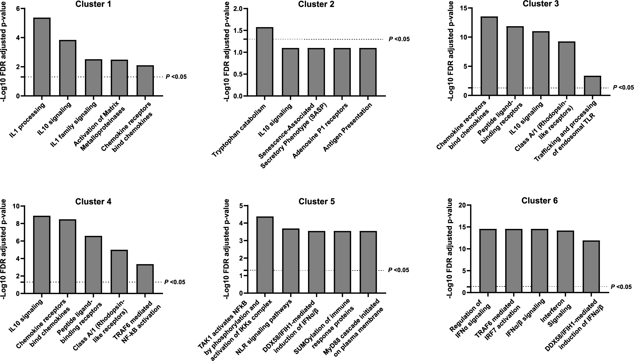

Appendix Figure S3 Reactome Pathway Analysis for donor D^{high}. Histograms illustrating the five most significant pathways and the associated False Discovery Rate (FDR) corrected P-values for the gene clusters derived from the unsupervised hierarchical clustering analysis displayed in Fig 4C for D^{high}. Reactome uses the Binomial Test to assess the probability that the overlap between the query and the pathways has occurred by chance and the FDR is calculated using the Benjamini-Hochberg approach. Dotted lines indicate statistical significance. Antigen representation: Folding, assembly and peptide loading of class I MHC.

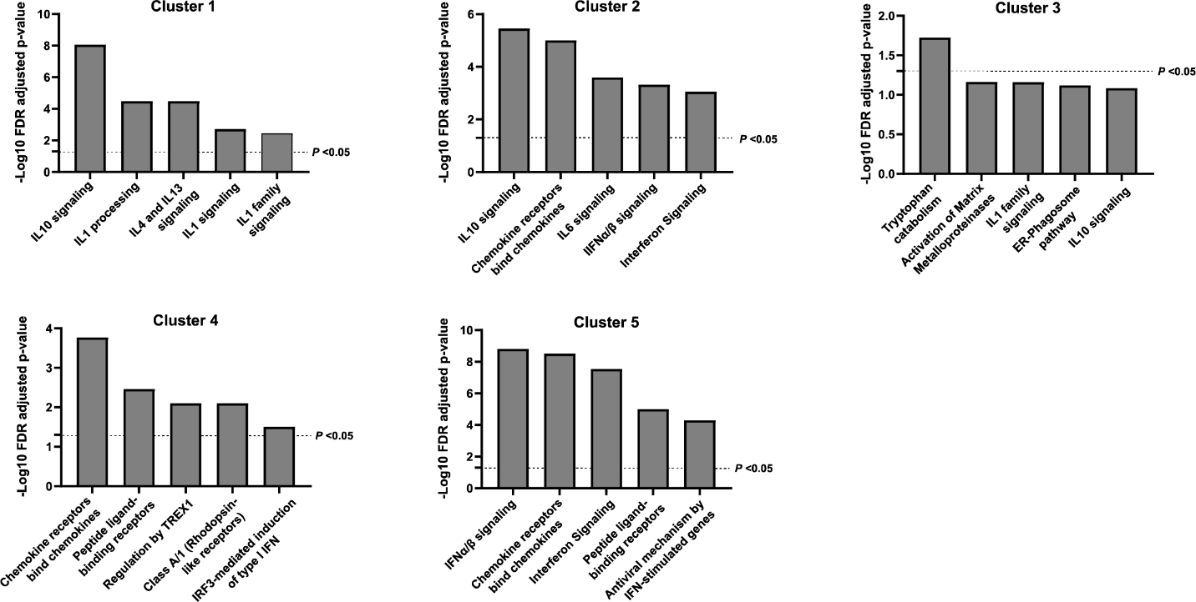

Appendix Figure S4. Reactome Pathway Analysis for donor D^{low}. Histograms illustrating the five most significant pathways and the associated False Discovery Rate (FDR) corrected P-values for the gene clusters derived from the unsupervised hierarchical clustering analysis displayed in Fig 4D for D^{low}. Reactome uses the Binomial Test to assess the probability that the overlap between the query and the pathways has occurred by chance and the FDR is calculated using the Benjamini-Hochberg approach. Dotted lines indicate statistical significance.

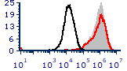
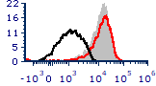
A
C
E
D
F
B
counts
CD304-BV421
CD123-PE
counts
KO US
KO stained
AAVS1 KO stained

Appendix Figure S5. Validation of MyD88^{KO} pDCs. MyD88^{KO} pDCs were functionally evaluated by stimulating the cells with TLR7 (2.5 µg/mL R837, blue) or TLR3 (800 ng/mL poly(I:C), pink) agonist and collecting supernatant 24 hrs after stimulation to quantify IFNα (A), IFNλ1 (B), TNFα (C), CXCL10 (D) and IL-6 (E) protein concentrations. MyD88^{KO} pDC were phenotypically evaluated for expression of the pDC markers CD123 and CD304, and compared to unstained (US) MyD88^{KO} pDCs and stained HSPC-pDC-AAVS1^{KO} (F). Bars represent mean values and equal symbols represent equal donors (n=4).

Appendix Figure S6. Validation of TRIF^{KO} and RIG-I^{KO} pDCs. Knock out efficiency was evaluated at the protein level by western blot analysis (A) for MyD88 (top panel), TRIF (middle panel) and RIG-I (bottom panel), and by genomic sequencing and ICE analysis to assess the frequency of insertion and deletions (indels) at the targeted sites (B). The TRIF antibody functionality was confirmed with THP-1 cell lysates (data not shown), yet we were unable to detect TRIF protein in donor B. Additionally, pDC^{KO} cells were evaluated functionally by stimulating the cells with TLR7 (2.5 µg/mL R837, blue) or TLR3 (800 ng/mL poly(I:C), pink) agonist and collecting supernatant after 24 hrs to quantify IFNα (C), IFNλ1 (D) and IL-6 (E) protein concentrations. pDC^{KO} were phenotypically evaluated for expression of the pDC markers CD123 and CD304, and compared to unstained (US) KO cells and stained control AAVS1^{KO} pDC (F). Bars represent mean values and equal symbols represent equal donors (n=2, donor A is represented by the circle and Donor B by the square symbol). AAVS1 control in panel A and B are reused from figure S5A and B.

Appendix Figure S7. TLR3 is not involved in SARS-CoV-2 mediated type I IFNα production by pDCs. Using CRISPR/Cas9, TLR3 knock-out (KO) and AAVS1^{KO} (control) pDCs were generated and cellular DNA was sequenced for ICE analysis (A). For functional evaluation, the KO pDCs were stimulated with TLR7 (2.5 μg/mL R837, blue) or TLR3 (800 ng/mL poly(I:C), pink) agonist, supernatant was collected after 24 hrs and analyzed for CXCL10 protein expression by ELISA (B). Phenotypic evaluation of pDC^{KO} by flow cytometry (C). Histograms showing the expression of pDC markers CD123 and CD304, as compared to unstained KO pDCs and stained AAVS1^{KO} control pDCs. AAVS1^{KO} and TLR3^{KO} pDCs were either mock treated (mock) or exposed to SARS-CoV-2 (SARS-2, 1 MOI), supernatants were collected at indicated time points and analyzed for type I IFNα (D) and CXCL10 (E) proteins. Bars represent mean values and equal symbols represent equal donors (n=2).

Appendix Figure S8. TLR8 is not involved in SARS-CoV-2 mediated type I IFNα production by pDCs. To determine if the intracellular RNA sensor TLR8 can detect SARS-CoV-2 and induce cytokine production, TLR8^{KO} and TLR7+8^{KO} pDCs were generated and inference of CRISPR Edits was analyzed by sequencing (A). To functionally evaluate the KOs, AAVS1^{KO}, TLR7^{KO}, TLR8^{KO} and TLR7+8^{KO} pDCs were either left untreated (mock, grey) or stimulated with TLR3 (800 ng/mL poly(I:C), pink), TLR7 (2.5 μg/mL R837, blue) or TLR7/8 (2.5 μg/mL R848, red) agonist, supernatant was collected after 24 hrs and analyzed for CXCL10 protein expression by ELISA (B). TLR8^{KO} and TLR7+8^{KO} pDC were either mock treated or exposed to SARS-CoV-2 (1 MOI) and cell culture supernatants were analyzed for type I IFNα (C) and CXCL10 (D) protein production at indicated time points. To investigate TLR8-driven IL-6 production, AAVS1^{KO}, TLR7^{KO}, TLR8^{KO} and TLR7+8^{KO} pDCs were either treated with the different TLR agonist (E) or SARS-CoV-2 (F) and IL-6 was quantified in cell culture supernatant after 24 hrs (E) or at indicated time points (F) by ELISA. Bars represent mean values and equal symbols represent equal donors (n=2).

Appendix Figure S9. Inhibition of IRAK4 decreases SARS-CoV-2-induced production of type I IFNα and CXCL10 but not IL-6 by pDCs. PDC were exposed to SARS-CoV-2 (0.5 MOI) in the absence or presence of an IRAK4 inhibitor (10 μM), and 24 hrs after virus exposure cell culture supernatants were harvest and analyzed for secretion of type I IFNα (A), CXCL10 (B) and IL-6 (C) proteins. Cells were also analyzed for viability by flow cytometry (D). Bars represent mean values and equal symbols represent equal donors (n=4). Statistical significance was determined using the ratio paired student T test. *<p0.05, **<p0.01.

Appendix Figure S10. Validation of TLR1^{KO}, TLR2^{KO} and TLR6^{KO} pDCs. A: Phenotypic evaluation of pDC^{KO} by flow cytometry. Histograms showing the expression of pDC markers CD123 and CD304, as compared to unstained KO pDCs and stained AAVS1^{KO} control pDCs. B: KO pDCs were evaluated by genomic sequencing followed by inference of CRISPR edits (ICE) analysis to assess the frequency of insertions and deletions (indels) at the target site. C: Functional evaluation the TLR1^{KO} and TLR6^{KO} pDCs by stimulating with TLR2/6 (5 ng/mL Pam2CSK4, yellow) or TLR1/2 (50 ng/mL Pam3CSK4, orange). Supernatant was collected after 24 hrs and analyzed for IL-6 protein expression by ELISA. D: TLR2 forms heterodimers with TLR1 and TLR6, and thus AAVS1^{KO}, TLR1^{KO} and TLR6^{KO} pDCs were either mock treated (grey), exposed to SARS-CoV-2 (0.5 MOI) or TLR7/8 agonist (2.5 μg/mL R848, red) and IL-6 protein concentrations were quantified in cell culture supernatant after 24 hrs. Bars represent mean values and equal symbols represent equal donors (n=2).

