Mohanraj et al. 2019
Dataset EV3
MIA40 deletion mutant allele sequence analysis.
Sequence alignment between wild type MIA40 (WT_WT) and MIA40 mutant allele PCR product (WT_Del)
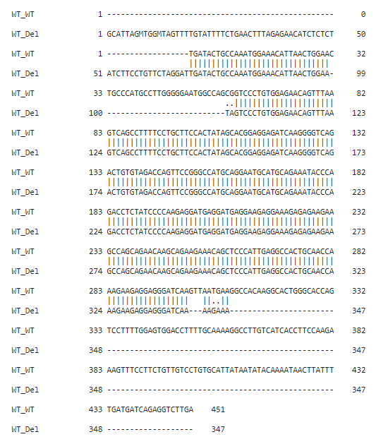

Deleted fragment in one allele of HEK MIA40 WT/Del⁵³⁻⁶⁰ cells: CTG CCC ATG CCT TGG GGG AAT GGC CAG
Two base substitution in one allele of HEK MIA40 WT/Del⁵³⁻⁶⁰ cells: CG TA

