Attenuation of clinical and immunological outcomes during SARS-CoV-2 infection by ivermectin

Guilherme Dias de Melo¹, Françoise Lazarini², Florence Larrous¹, Lena Feige¹, Etienne Kornobis^{3,4}, Sylvain Levallois⁵, Agnès Marchio⁶, Lauriane Kergoat¹, David Hardy⁷, Thomas Cokelaer^{3,4}, Pascal Pineau⁶, Marc Lecuit^{5,8}, Pierre-Marie Lledo², Jean-Pierre Changeux⁹, Hervé Bourhy^{1*}

Appendix

Table of contents

Figures
- Appendix Figure S1. Virologic aspects in the nasal turbinates and in the lungs at 4 days post-infection of SARS-CoV-2-infected hamsters with and without ivermectin treatment.

Tables
- Appendix Table S1. Primer sequences used for qPCR in the golden hamster tissues.
- Appendix Table S2. Primer and probes sequences used for ddPCR in the golden hamster lung.

References
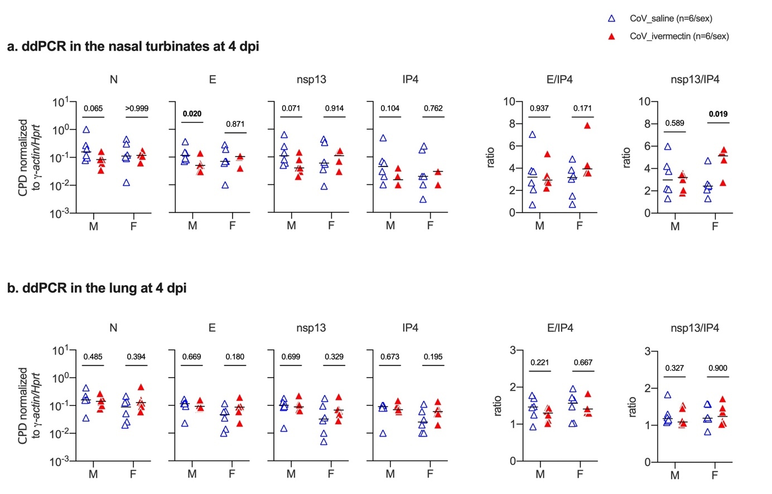
Appendix Figure S1 | Virologic aspects in the nasal turbinates and in the lungs at 4 days post-infection of SARS-CoV-2-infected hamsters with and without ivermectin treatment. ab, viral gene expression of N (nucleocapsid), E (envelope), nsp13 (non-structural protein 13), IP4 (RdRp, RNA-dependent RNA polymerase), and E/IP4 and nsp13/IP4 ratios determined by digital droplet PCR (ddPCR) in the nasal turbinates (a) and in the lungs (b) at 4 dpi. Data are expressed as CPD (copy per droplet) normalized to γ−actin and Hprt reference genes relative expression. n=6/group (except nasal turbinates from female CoV_ivermectin, where n=4). The p value is indicated in bold when significant at a 0.05 threshold. Mann-Whitney test. Horizontal lines indicate the medians. M: male hamsters; F: female hamsters. Data were obtained from two independent experiments for each sex.

Appendix Table S1 | Primer sequences used for qPCR in the golden hamster tissues.
Gene | Primer sequence (5' – 3') |  | Reference
ha-γ-actin | For | ACAGAGAGAAGATGACGCAGATAAT | (Ribeiro-Romão et al., 2016)
ha-γ-actin | Rev | GCCTGAATGGCCACGTACA | (Ribeiro-Romão et al., 2016)
ha-Hprt | For | TGCGGATGATATCTCAACTTTAACTG | (Zivcec et al., 2011)
ha-Hprt | Rev | AAAGGAAAGCAAAGTTTGTATTGTCA | (Zivcec et al., 2011)
ha-actinB | For | GGCCAGGTCATCACCATT | (Boudewijns et al., 2020)
ha-actinB | Rev | GAGTTGAATGTAGTTTCGTGGATG | (Boudewijns et al., 2020)
ha-Il-6 | For | GGACAATGACTATGTGTTGTTAGAA | (Ribeiro-Romão et al., 2016)
ha-Il-6 | Rev | AGG CAA ATT TCC CAA TTG TAT CCA | (Ribeiro-Romão et al., 2016)
ha-Il-10 | For | GGTTGCCAAACCTTATCAGAAATG | (Ribeiro-Romão et al., 2016)
ha-Il-10 | Rev | TTCACCTGTTCCACAGCCTTG | (Ribeiro-Romão et al., 2016)
ha-Il-1β | For | GGCTGATGCTCCCATTCG | (Zivcec et al., 2011)
ha-Il-1β | Rev | CACGAGGCATTTCTGTTGTTCA | (Zivcec et al., 2011)
ha-Tnf-α | For | TGAGCCATCGTGCCAATG | (Ribeiro-Romão et al., 2016)
ha-Tnf-α | Rev | AGCCCGTCTGCTGGTATCAC | (Ribeiro-Romão et al., 2016)
ha-Ifn-β | For | ACCCTAAAGGAAGTGCCAG | (Gowen et al., 2015)
ha-Ifn-β | Rev | CCAGCTGCCAGTAATAGCTC | (Gowen et al., 2015)
ha-Ifn-γ | For | TGTTGCTCTGCCTCACTCAGG | (Ribeiro-Romão et al., 2016)
ha-Ifn-γ | Rev | AAGACGAGGTCCCCTCCATTC | (Ribeiro-Romão et al., 2016)
ha-Cxcl10 | For | GCCATTCATCCACAGTTGACA | (Zivcec et al., 2011)
ha-Cxcl10 | Rev | CATGGTGCTGACAGTGGAGTCT | (Zivcec et al., 2011)
ha-Ccl5 | For | ACTGCCTCGTGTTCACATCA | (Schountz et al., 2019)
ha-Ccl5 | Rev | CCCACTTCTTCTTTGGGTTG | (Schountz et al., 2019)
ha-Tnfaip3 | For | TGGAAAGCCAGAAGAAGCTC | ENSMAUG00000019454§
ha-Tnfaip3 | Rev | ATGAGGCAGTTTCCATCACC | ENSMAUG00000019454§
ha-Casp3 | For | AAGCCATGGTGATGAAGGAG | ENSMAUG00000004837
ha-Casp3 | Rev | TCATGTCATCTTCGGTTCCA | ENSMAUG00000004837
ha-Plcb1 | For | ACCCATGGATTCACCATGAC | ENSMAUG00000015228
ha-Plcb1 | Rev | GAATGCACACTCTGCAATGG | ENSMAUG00000015228
ha-Chrna7 | For | TCCCTCCAGGCATATTCAAG | ENSMAUG00000005544
ha-Chrna7 | Rev | TCCCATGAGATCCCACTCTC | ENSMAUG00000005544
ha-Chrnb4 | For | CTGAACAAAACCCGCTACAAC | ENSMAUG00000012409
ha-Chrnb4 | Rev | TCTCGCTCATTCACACTGATG | ENSMAUG00000012409
ha-Adra1d | For | TCTTCGTCCTTTGCTGGTTC | ENSMAUG00000009086
ha-Adra1d | Rev | GCCAGAAGATGACCTTGAAGAC | ENSMAUG00000009086
ha-Grind2 | For | AAATCCATCTGGCTGCTCTG | ENSMAUG00000015271
ha-Grind2 | Rev | GAAAGATGACGGCGAAGAAG | ENSMAUG00000015271
ha-Pik3r5 | For | CTGCAAACCCTGGAAAACTC | ENSMAUG00000020086
ha-Pik3r5 | Rev | TGTCAAAGCTGTCCTGGTTC | ENSMAUG00000020086
ha-Igf1r | For | ATCAGAAAGTACGCGGATGG | ENSMAUG00000010750
ha-Igf1r | Rev | CTTCTCGGCTTCAGTTTTGG | ENSMAUG00000010750
ha- Ifn-λ | For | CCCACCAGATGCAAAGGATT | (Boudewijns et al., 2020)
ha- Ifn-λ | Rev | CTTGAGCAGCCACTCTTCTATG | (Boudewijns et al., 2020)
ha- Mx2 | For | CCAGTAATGTGGACATTGCC | (Ribeiro-Romão et al., 2016)
ha- Mx2 | Rev | CATCAACGACCTTGTCTTCAGTA | (Ribeiro-Romão et al., 2016)
ha-Wnt11 | For | TACGCATGAGTTCCAGGTTG | ENSMAUG00000008427
ha-Wnt11 | Rev | TGTGCTATGGCATCAAGTGG | ENSMAUG00000008427
ha-Sfrp4 | For | TGTTACGAGTGGCGATCAAG | ENSMAUG00000018868
ha-Sfrp4 | Rev | TTGTGGGGTTTTCTGTGCAG | ENSMAUG00000018868
ha-Epha2 | For | ACAAGGCAGAAGGTGATTGG | ENSMAUG00000009598
ha-Epha2 | Rev | CAGCTTTCAGCGTCTTGATG | ENSMAUG00000009598
ha-Hgf | For | GCTGGAGCTGAAAAGATTGG | ENSMAUG00000007722
ha-Hgf | Rev | TCGGACGAAAATACCAGGAC | ENSMAUG00000007722
ha-Il-2 | For | CATCTTCCAAGTGAAAGCTTTTGCT | (Ribeiro-Romão et al., 2016)
ha-Il-2 | Rev | CCAGTGCCTGGAAGAAGAACTT | (Ribeiro-Romão et al., 2016)
ha-Il-2ra | For | AAAGCAAGCTACACCTAACCC | (Ribeiro-Romão et al., 2016)
ha-Il-2ra | Rev | GCCTTGTATCCTTGAATGCG | (Ribeiro-Romão et al., 2016)
ha-Tgf-β | For | GGCTACCACGCCAACTTCTG | (Ribeiro-Romão et al., 2016)
ha-Tgf-β | Rev | GAGGGCAAGGACCTTACTGTACTG | (Ribeiro-Romão et al., 2016)
ha-Gabbr1 | For | AAAGATCAACGACCACAGGG | ENSDARG00000016667
ha-Gabbr1 | Rev | GGTGACAGGAGCAGTGATAAGAG | ENSDARG00000016667
ha-Prkg1 | For | ATCGAGGTTATGCCAAGCTG | ENSMAUG00000009610
ha-Prkg1 | Rev | TGGAGTCCCACAAAAAGTCC | ENSMAUG00000009610
ha-Gnai1 | For | ACCAGGGTGAAAACAACAGG | ENSMAUG00000000903
ha-Gnai1 | Rev | CCCTTCAAAGCAGTGAATCC | ENSMAUG00000000903
ha-Grid1 | For | TGGCTTCTTCCCTGGATATG | ENSMAUG00000003072
ha-Grid1 | Rev | TGTCATCATTGAGGCTCAGG | ENSMAUG00000003072
ha-Krt4 | For | ACATCAATGCCCTGAGGAAG | ENSMAUG00000018774
ha-Krt4 | Rev | CAGCTGTGCGCTTGTTAATC | ENSMAUG00000018774
ha-Wnt3a | For | AATGGTGTCTCGGGAGTTTG | ENSMAUG00000021475
ha-Wnt3a | Rev | GTTGTTGTGACGGTTCATGG | ENSMAUG00000021475
ha-Creb5 | For | ATCAGAAAGTACGCGGATGG | ENSMAUG00000008771
ha-Creb5 | Rev | CTTCTCGGCTTCAGTTTTGG | ENSMAUG00000008771
ha-Ager | For | CCCTCGAACACAGTCTCCAT | ENSMAUG00000001006
ha-Ager | Rev | CACAGCTGTAGATGCCCTCA | ENSMAUG00000001006
ha-Fos | For | AATGGTGAAGACCGTGTCAG | ENSMAUG00000019419
ha-Fos | Rev | TCCTTTCCCTTCGGATTCTC | ENSMAUG00000019419
§ Designed by this paper, based on the Ensembl gene number, available at <www.ensembl.org>

Appendix Table S2 | Primer and probes sequences used for ddPCR in the golden hamster lung.
Gene | Primer sequence (5' – 3') |  | Concentration  (nM) | Reference
N | For | GGGGAACTTCTCCTGCTA | 900 | (Suo et al., 2020)
N | Rev | CAGACATTTTGCTCTCAA | 900 | (Suo et al., 2020)
N | Probe | FAM-TTGCTGCTGCTTGACAGATT-IBFQ | 250 | (Suo et al., 2020)
IP4 | For | GGTAACTGGTATGATTTCG | 900 | (WHO, 2020)
IP4 | Rev | CTGGTCAAGGTTAATATAGG | 900 | (WHO, 2020)
IP4 | Probe | HEX-TCATACAAACCACGCCAGG-IBFQ | 300 | (WHO, 2020)
E | For | ACAGGTACGTTAATAGTTAATAGCGT | 200 | (Corman et al., 2020)
E | Rev | ATATTGCAGCAGTACGCACACA | 200 | (Corman et al., 2020)
E | Probe | FAM-ACACTAGCCATCCTTACTGCGCTTCG-IBFQ | 150 | (Corman et al., 2020)
nsp13 | For | TAAGGGCACACTAGAACCAG | 900 | this paper
nsp13 | Rev | ACAATTTCAGCAGGACAACG | 900 | this paper
nsp13 | Probe | HEX-AGGTCCAGACATGTTCCTCGGAA-IBFQ | 250 | this paper

REFERENCES

Boudewijns R, Thibaut HJ, Kaptein SJF, Li R, Vergote V, Seldeslachts L, Van Weyenbergh J, De Keyzer C, Bervoets L, Sharma S et al. (2020) STAT2 signaling restricts viral dissemination but drives severe pneumonia in SARS-CoV-2 infected hamsters. Nature Commun 11: 5838-5838
Corman VM, Landt O, Kaiser M, Molenkamp R, Meijer A, Chu DK, Bleicker T, Brünink S, Schneider J, Schmidt ML et al. (2020) Detection of 2019 novel coronavirus (2019-nCoV) by real-time RT-PCR. Euro Surveill 25: 2000045
Gowen BB, Westover JB, Sefing EJ, Bailey KW, Nishiyama S, Wandersee L, Scharton D, Jung K-H, Ikegami T (2015) MP-12 virus containing the clone 13 deletion in the NSs gene prevents lethal disease when administered after Rift Valley fever virus infection in hamsters. Front Microbiol 6
Ribeiro-Romão RP, Saavedra AF, Da-Cruz AM, Pinto EF, Moreira OC (2016) Development of real-time PCR assays for evaluation of immune response and parasite load in golden hamster (Mesocricetus auratus) infected by Leishmania (Viannia) braziliensis. Parasit Vectors 9: 361-361
Schountz T, Campbell C, Wagner K, Rovnak J, Martellaro C, DeBuysscher BL, Feldmann H, Prescott J (2019) Differential Innate Immune Responses Elicited by Nipah Virus and Cedar Virus Correlate with Disparate In Vivo Pathogenesis in Hamsters. Viruses 11: 291
Suo T, Liu X, Feng J, Guo M, Hu W, Guo D, Ullah H, Yang Y, Zhang Q, Wang X et al. (2020) ddPCR: a more accurate tool for SARS-CoV-2 detection in low viral load specimens. Emerging Microbes & Infections 9: 1259-1268
WHO (2020) Protocol: Real-time RT-PCR assays for the detection of SARS-CoV-2. Institut Pasteur, Paris. https://www.who.int/docs/default-source/coronaviruse/real-time-rt-pcr-assays-for-the-detection-of-sars-cov-2-institut-pasteur-paris.pdf?sfvrsn=3662fcb6_2
Zivcec M, Safronetz D, Haddock E, Feldmann H, Ebihara H (2011) Validation of assays to monitor immune responses in the Syrian golden hamster (Mesocricetus auratus). J Immunol Methods 368: 24-35

