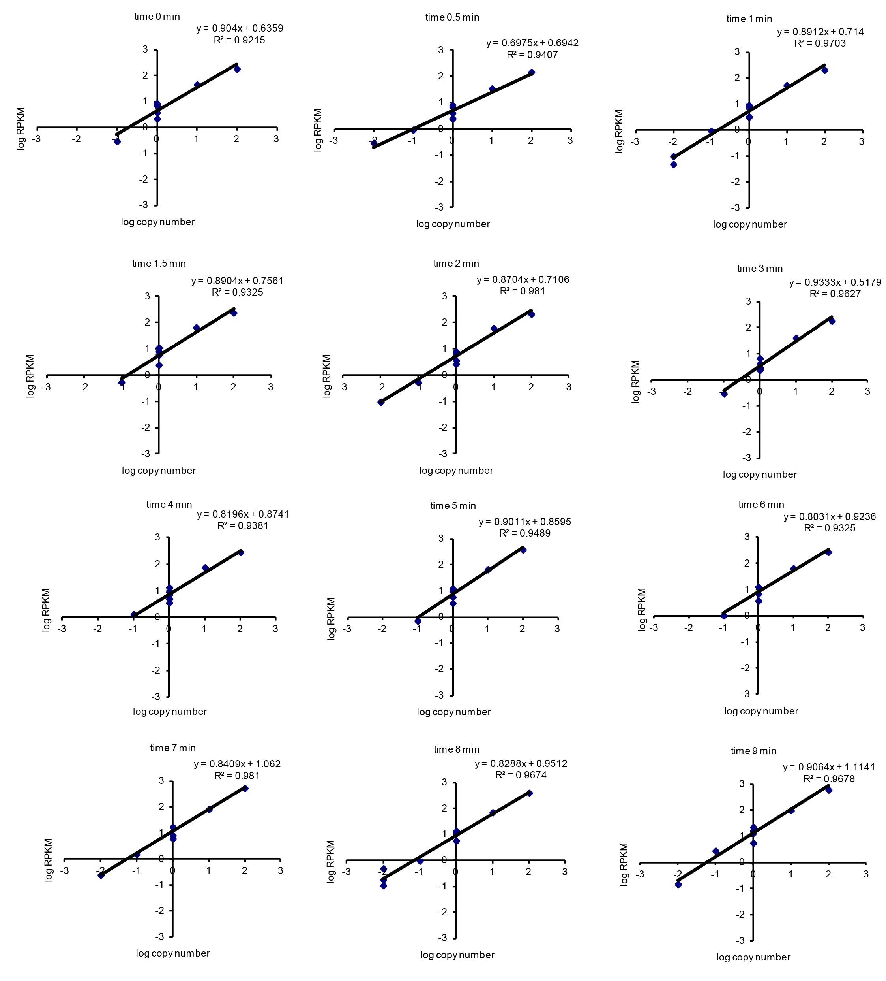

Supplementary Figure S1. Spike-In RNAs confirm linear correspondence between number of sequencing reads and amount of RNA in samples. The RPKM of each 300nt bin within the spike-in RNAs correspond to the number of RNAs added to the sample at each time point.

