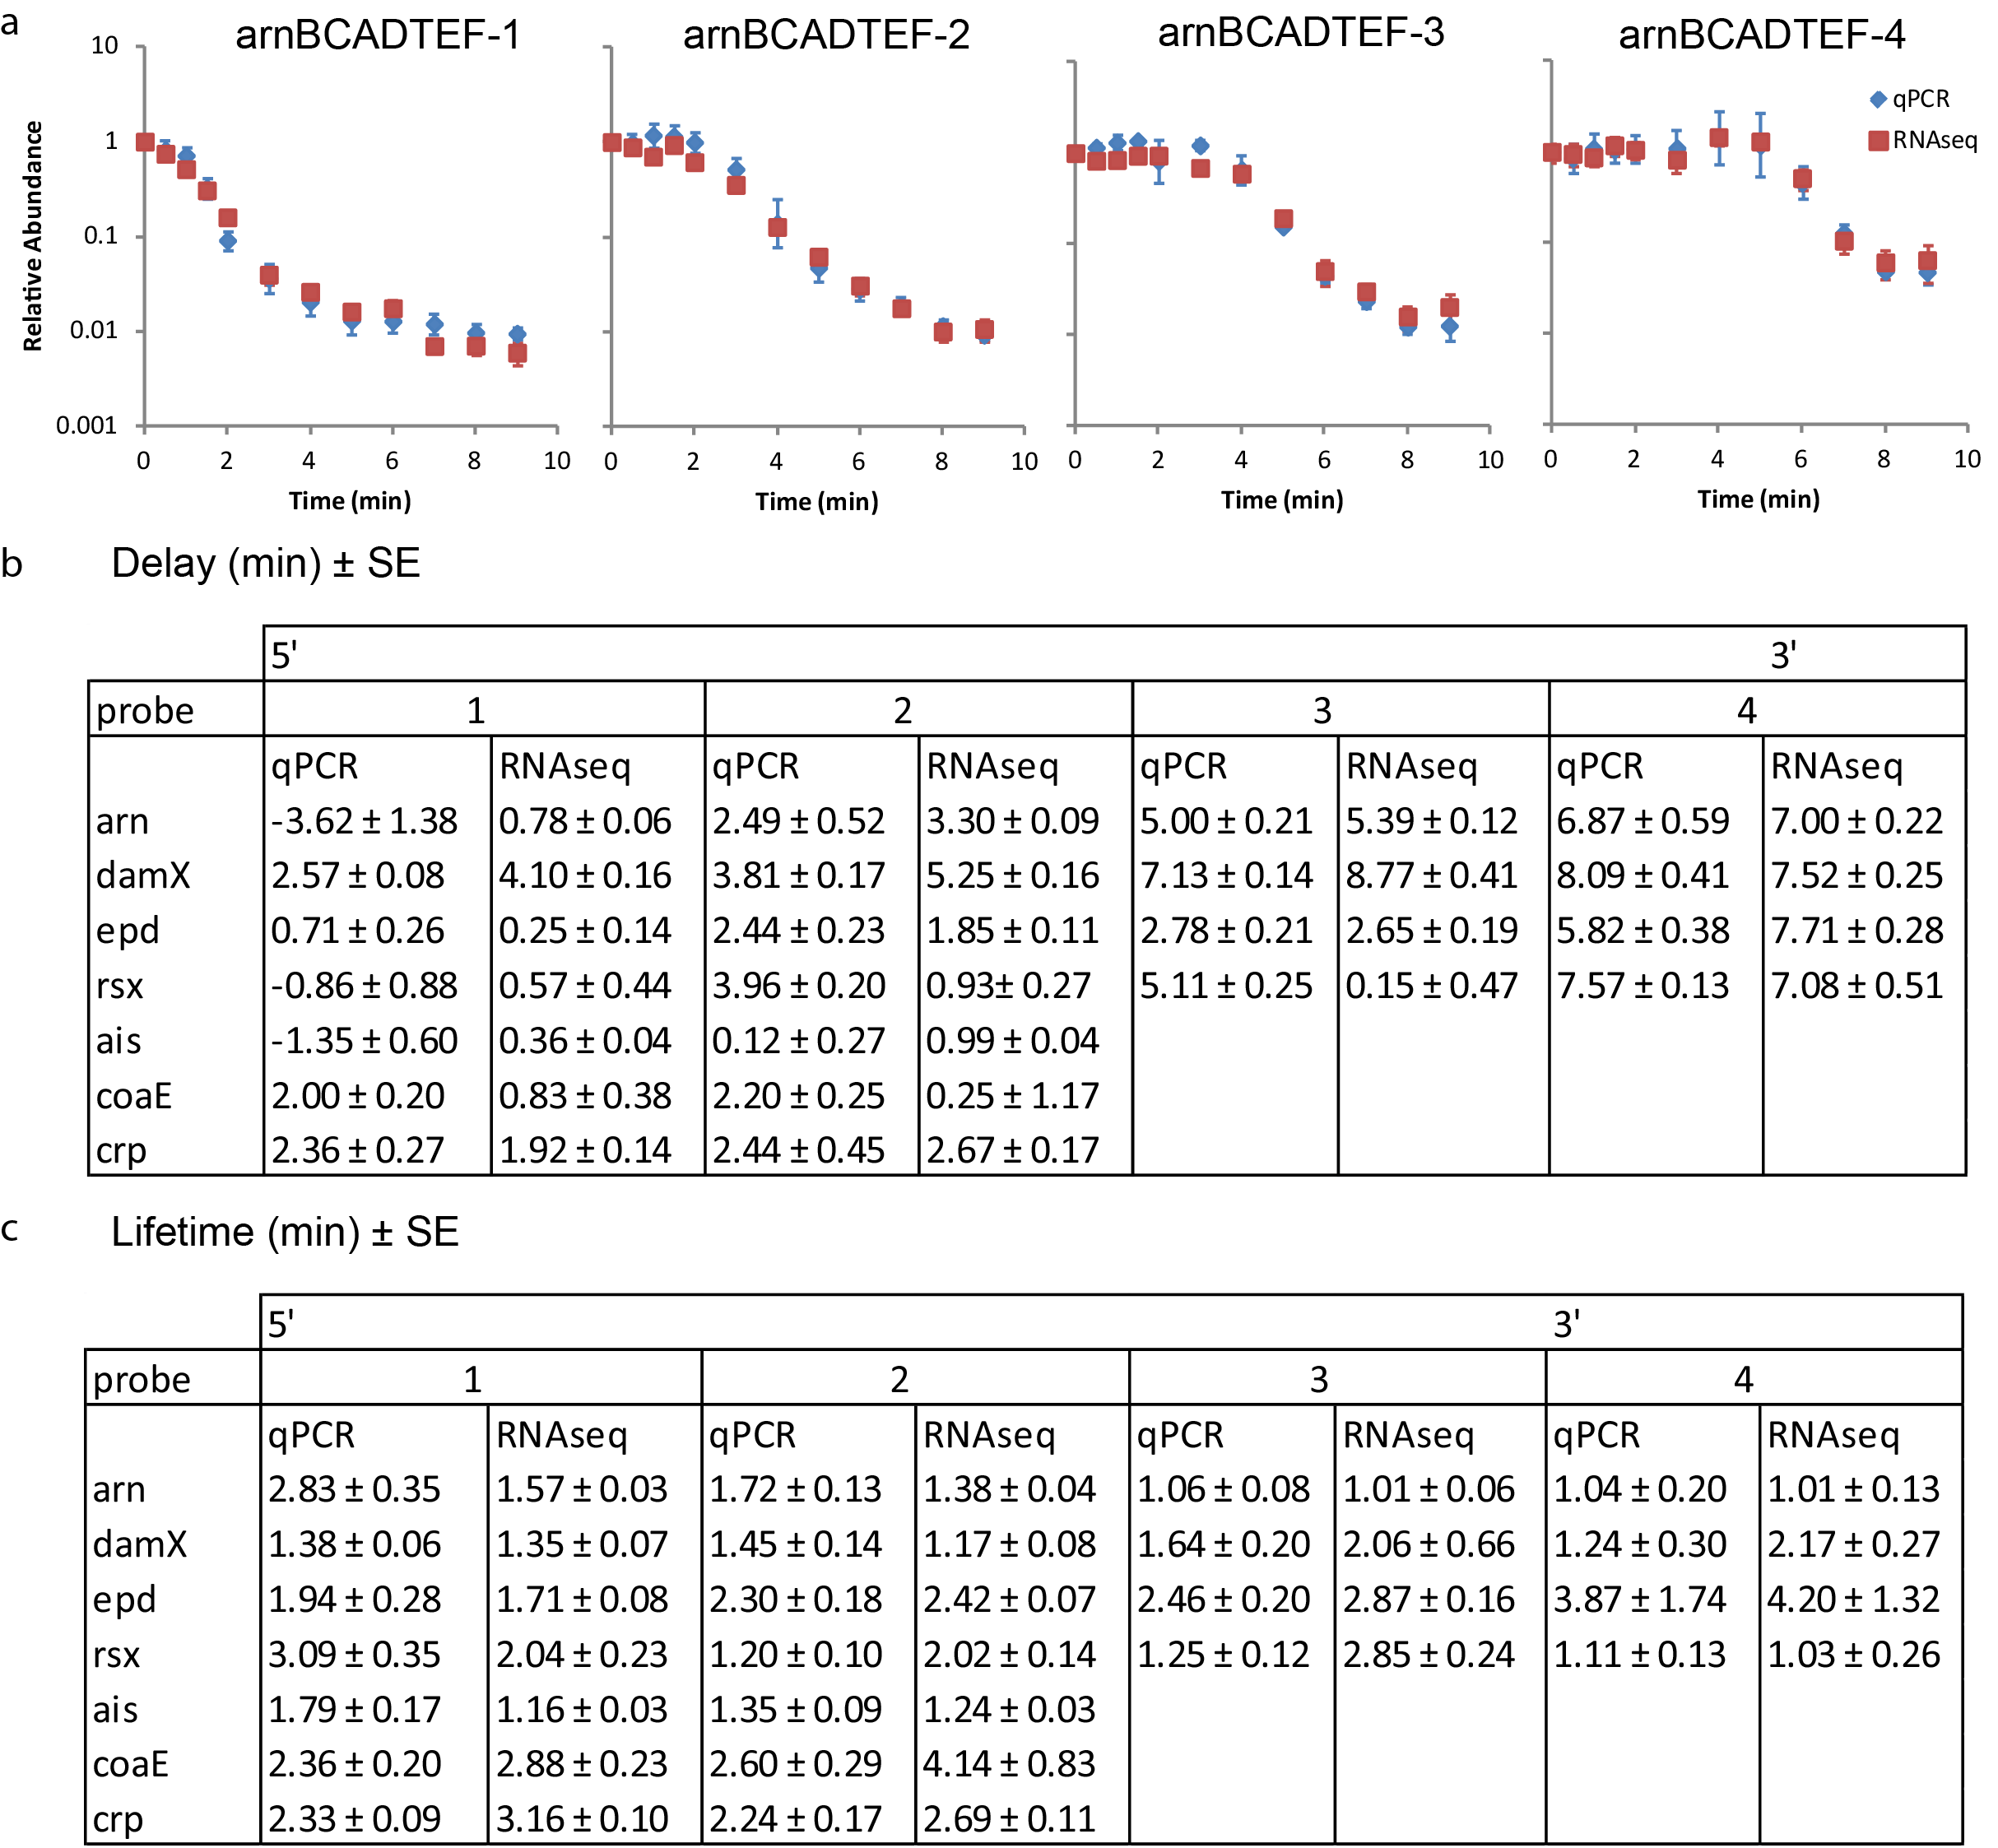

Supplementary Figure S2: Exponential E.coli RNA-seq data is confirmed by qPCR measurements. (a) Degradation traces of regions in a representative operon, arnBCADTEF, measured by qPCR and RNA-seq are similar. (b and c) Summary of fitting data from qPCR and RNA-seq degradation traces of selected transcription units. (b) The delay time fitted from qPCR and RNA-seq data are not significantly different (p = 0.77, paired Student t test) (c) The lifetimes fitted from qPCR and RNA-seq data are not significantly different ( p = 0.26, paired Student t test).

