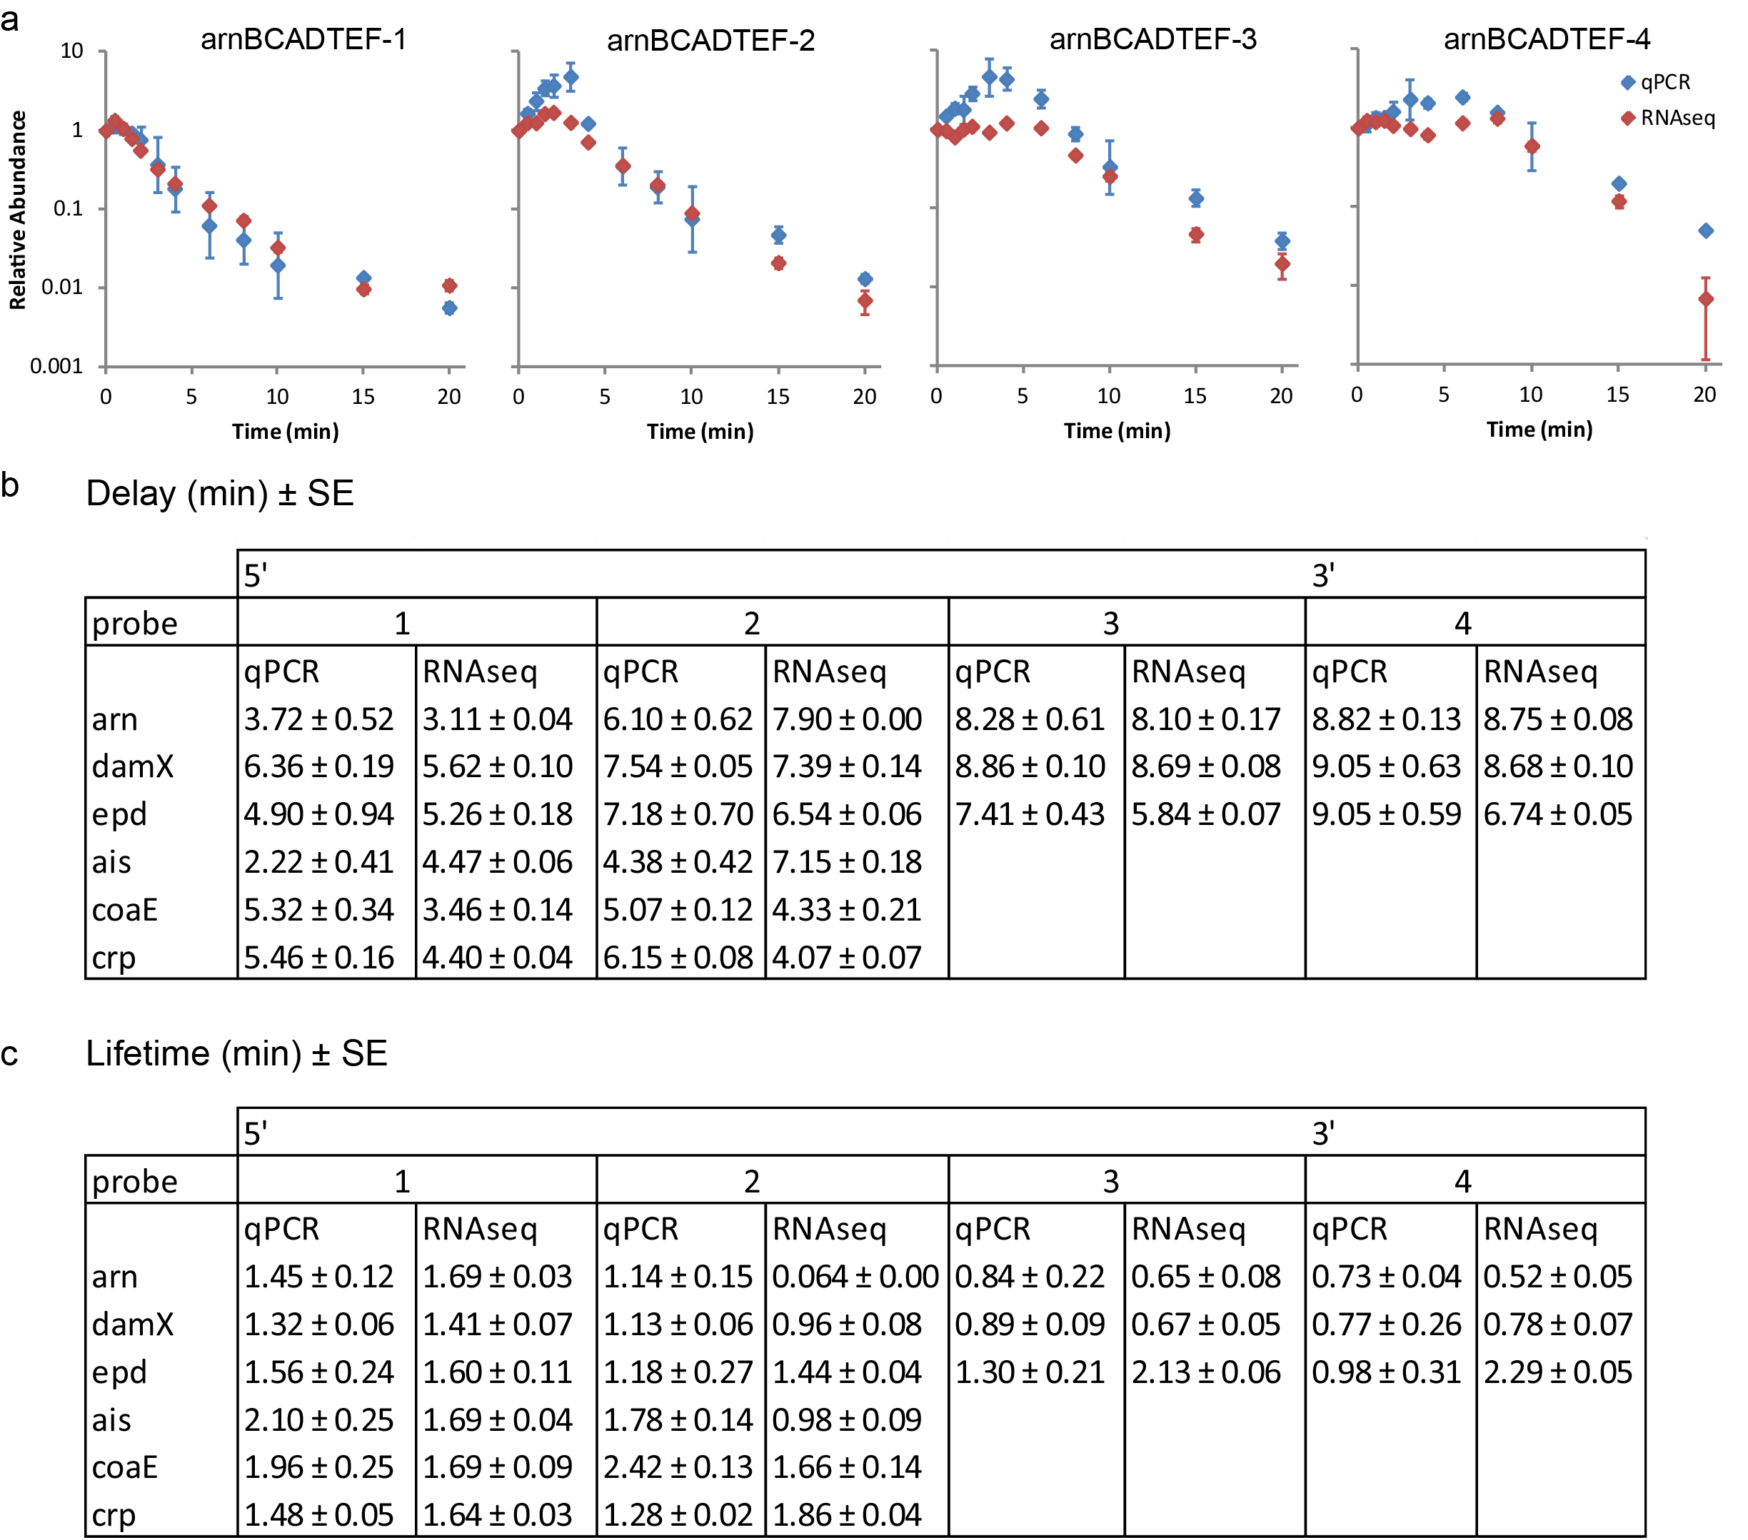

Supplementary Figure S3: Stationary phase E.coli RNA-seq data is confirmed by qPCR measurements. (a) Degradation traces of regions in a representative operon, arnBCADTEF, measured by qPCR and RNA-seq are similar. (b and c) Summary of fitting data from qPCR and RNA-seq degradation traces of selected transcription units. (b) The delay time fitted from qPCR and RNA-seq data are not significantly different (p = 0.38, paired Student t test). (c) The lifetimes fitted from qPCR and RNA-seq data are not significantly different (p = 0.81, paired Student t test).

