Structure and composition of grain boundaries and their impact on functional properties of energy materials – Supplementary information

Oana Cojocaru-Mirédin^{1,}*, Elisa Wade¹, Yuan Yu², Jian Luo^{3,4}*

¹Department of Sustainable Systems Engineering (INATECH), University of Freiburg, Emmy-Noether-Straße 2, 79110 Freiburg, Germany
² Institute of Physics (IA), RWTH Aachen University, 52056 Aachen, Germany
³AiisoYufeng Li Family Department of Chemical and Nano Engineering, University of California San Diego, La Jolla, CA 92093, USA
⁴Program in Materials Science and Engineering, University of California San Diego, La Jolla, CA 92093, USA

Corresponding authors*: oana.cojocaru-miredin@inatech.uni-freiburg.de ; jluo@alum.mit.edu

Figure S1 shows a selection of atomic structures of several Σ9 GBs, both symmetric and asymmetric, in multicrystalline Si^{1–3}. The structures were investigated using HAADF- and BF-STEM. The intermediate region between the grains is notably larger than in the previous Σ3 GBs, best visible in 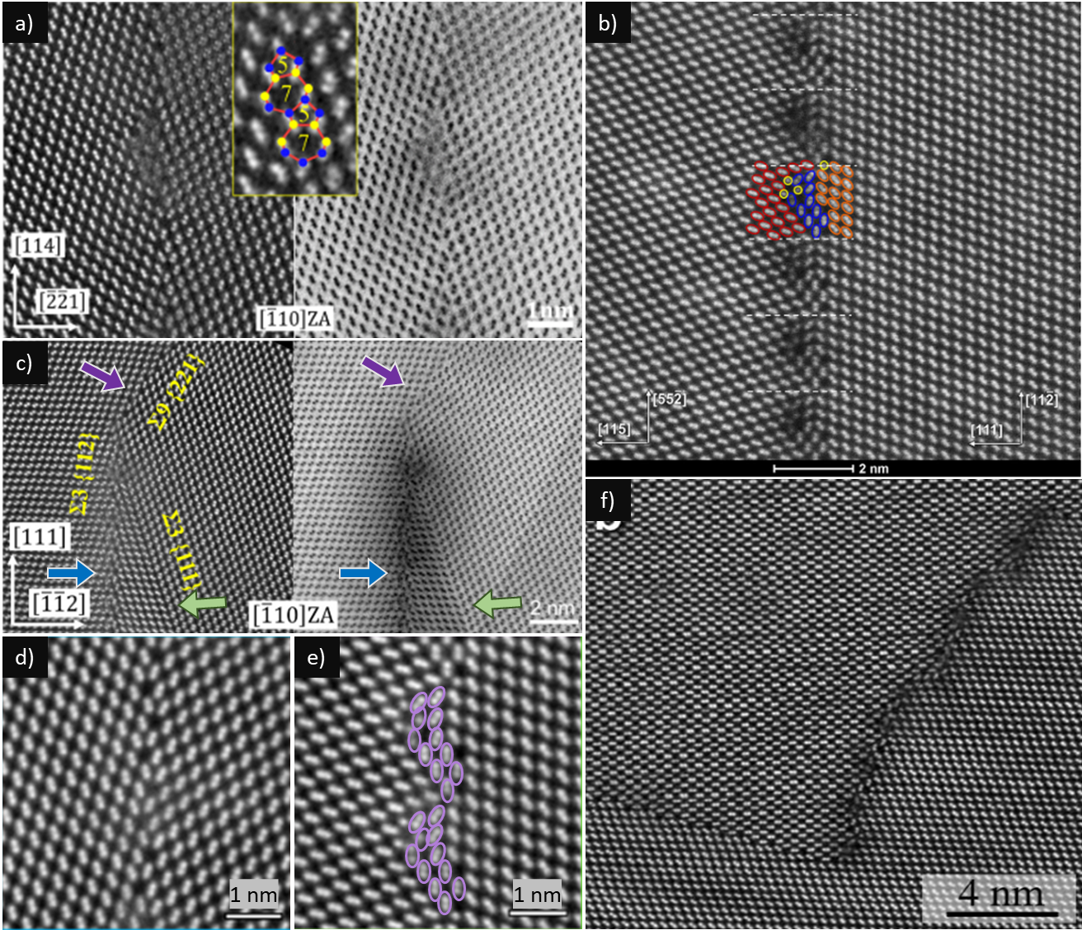Figure S1b, e and f, where entire sections of atoms cannot be attributed to a specific grain. As demonstrated for Σ3 GBs, the intermediate atoms repeat periodically, best emphasized in Figure S1b, where Stoffers² highlighted the periodic sequence in an asymmetric Σ9(111|115) GB segment, and Figure S1e, where the intermediate atoms are marked in purple. Figure S1 also includes more symmetric Σ9 segments, where the intermediate region is not as large, yet still of a similar periodicity.
Figure S1: Atomic structures of several Σ9 GBs in silicon. Some intermediate atoms not clearly attributed to either grain are highlighted in (b) and (e). (a) High-resolution HAADF-STEM (left) and BF-STEM (right) images of a Σ9 {221} GB in multicrystalline Si¹. (b) High-resolution HAADF-STEM image of the asymmetric Σ9(111|115) GB segment in multicrystalline Si². (c) HAADF-STEM (left side) and BF-STEM (right side) image of a GB triple junction of two Σ3 and one Σ9 GBs in multicrystalline Si¹. (d-e) High-resolution HAADF images of symmetric Σ9 (221), and asymmetric (111)|(115) GBs, respectively, in multicrystalline Si.³ (f) HAADF-STEM-image of Σ9 interface consisting of {122} and incoherent {114} facets². Panels (b) and (f) are adapted from ref ² with permission. Panel (a) and (c) License status to be confirmed. Panels (d,e) are reproduced with permission from ACS, License No. 6098071124638.

1. M. G. Tsoutsouva, P. E. Vullum, K. Adamczyk, M. Di Sabatino, G. Stokkan, J Appl Phys. 127, 125109 (2020).
2. A. Stoffers, thesis, RWTH Aachen (2017).
3. B. Haas, T. M. Boland, C. Elsässer, A. K. Singh, K. March, J. Barthel, C. T. Koch, P. Rez, Nano Lett. 23, 5975–5980 (2023).

