Table I Summary of nanoindentation Surface Free Energy results on all analyzed samples.
Sample | Pull-off force  (µN) | SFE - JKR  (mJ/m²) | SFE - DMT (mJ/m²)
Mica | 29 ± 3 | 77 ± 15 | 62 ± 7
Bare germanium | 21 ± 2 | 42 ± 8 | 24 ± 5
Silanized germanium | 3.5 ± 0.6 | 1.55 ± 0.34 | 0.9 ± 0.2
Patterned germanium | 0.47 ± 0.2 | 0.023 ± 0.016 | 0.013 ± 0.009
Patterned and silanized germanium | 0.2 ± 0.1 | 0.0039 ± 0.0025 | 0.0022 ± 0.0014
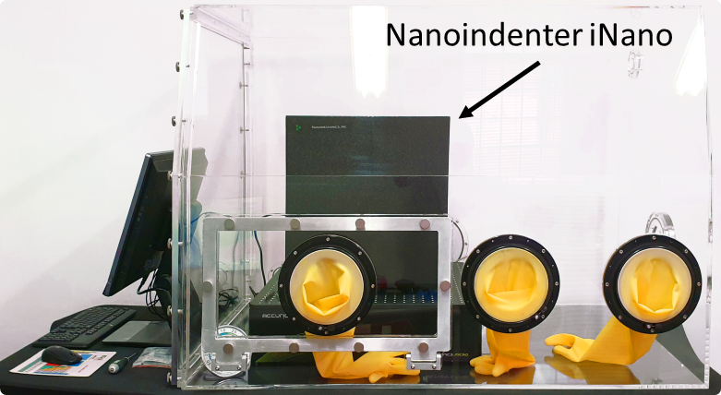
Figure I Environmentally controlled glove-box system for the Nanoindenter.

