Supporting Information

Single- or Double A-Site Cations in A₃Bi₂I₉ Bismuth Perovskites – What is the suitable choice?
Feray Ünlü¹, Ashish Kulkarni², Khan Lê¹, Christoph Bohr¹, Andrea Bliesener³, Seren Dilara Öz¹, Ajay Kumar Jena⁴, Yoichi Ando³, Tsutomu Miyasaka⁴, Thomas Kirchartz^{2,5}, and Sanjay Mathur¹*

¹ Department for Chemistry, Institute for Inorganic Chemistry, University of Cologne, Greinstr. 6, 50939 Cologne, Germany.
²IEK5-Photovoltaics, Forschungszentrum Jülich, 52425 Jülich, Germany
³ Physics Institute II, University of Cologne, Zülpicher Str. 77, 50937 Cologne, Germany
⁴Graduate School of Engineering, Toin University of Yokohama, Aoba, Yokohama 225-8503, Japan
⁵Faculty of Engineering and CENIDE, University of Duisburg-Essen, Carl-Benz-Str. 199, 47057 Duisburg, Germany

Corresponding author: sanjay.mathur@uni-koeln.de

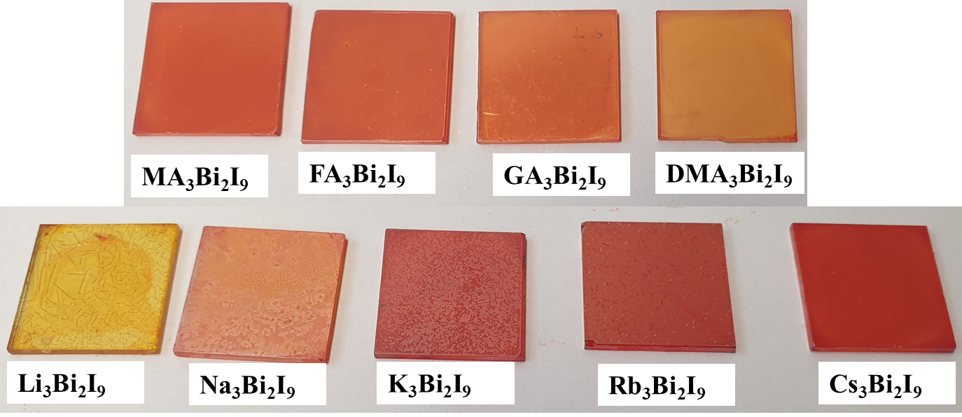
Figure S 1: Taken photographs of the various organic-inorganic and all-inorganic bismuth iodide thin films, spin-coated on FTO/TiO₂ substrates.

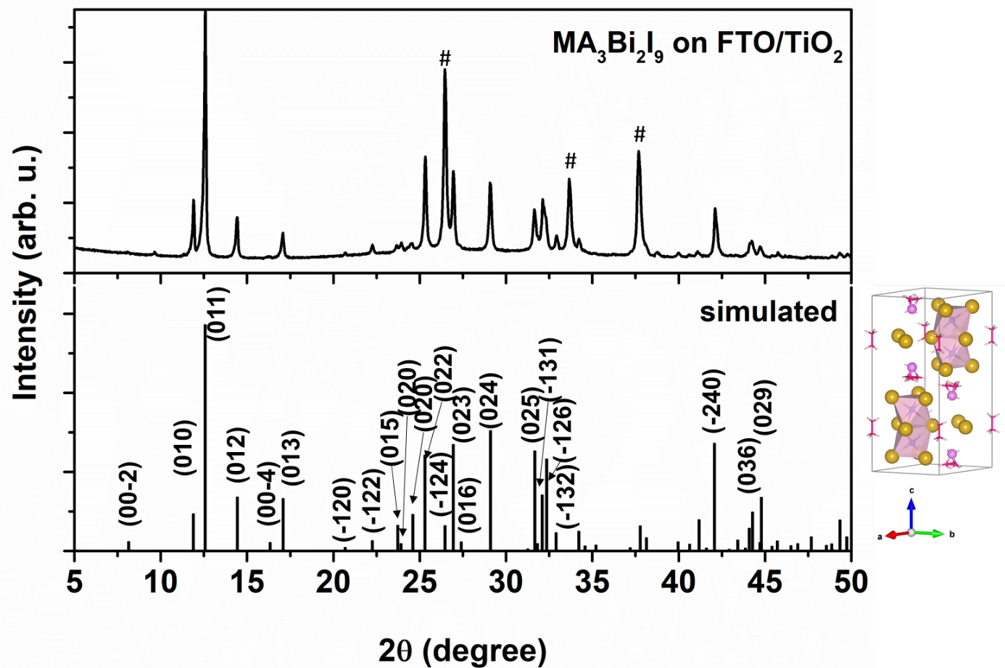
Figure S 2: XRD pattern of MA₃Bi₂I₉ thin film on mesoporous TiO₂, coated on FTO substrate (peaks labeled as # belong to FTO/TiO₂), compared to the simulated pattern from cif data of Eckhardt et al.¹

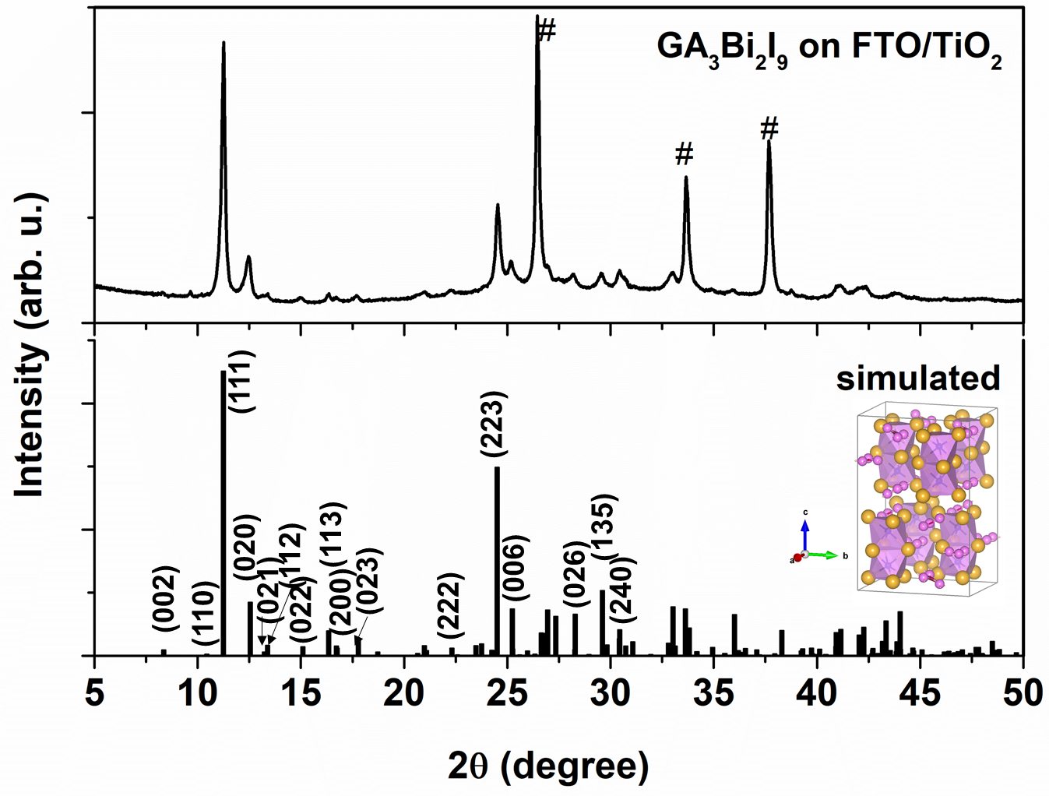
Figure S 3: XRD pattern of GA₃Bi₂I₉ on FTO/TiO₂ substrate (peaks labeled as # belong to FTO/TiO₂), compared with simulated pattern from cif data of Szklarz et al. ²

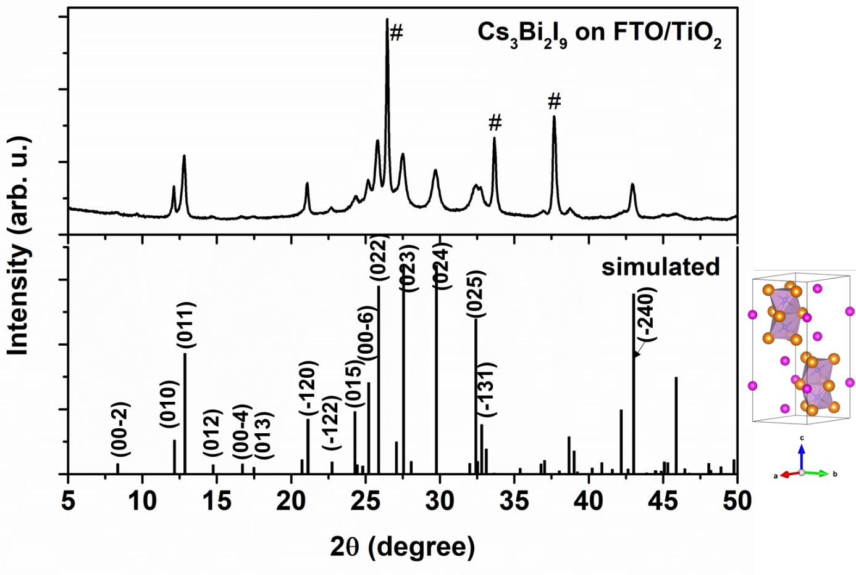
Figure S 4: XRD pattern of Cs₃Bi₂I₉ thin film on mesoporous TiO₂, coated on FTO substrate (peaks labeled as # belong to FTO/TiO₂), compared to the simulated pattern from cif data of Chabot and Parthé.³

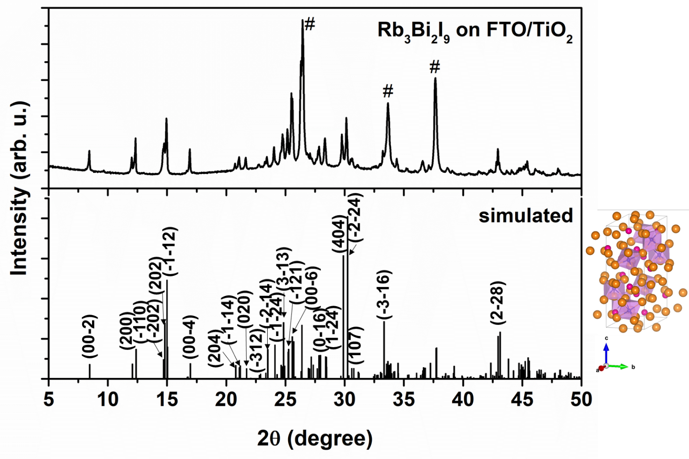
Figure S 5: XRD pattern of Rb₃Bi₂I₉ thin film on mesoporous TiO₂, coated on FTO substrate (peaks labeled as # belong to FTO/TiO₂), compared to the simulated pattern from cif data of Lehner et al.⁴

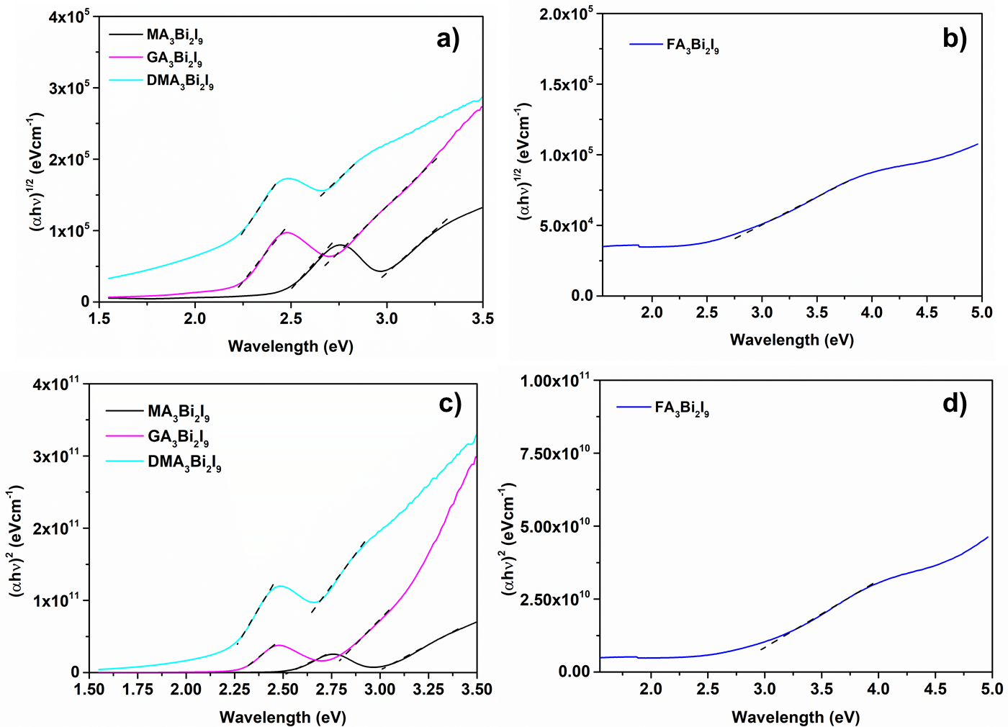
Figure S6: Tauc plots for indirect band gap determination of organic-inorganic bismuth iodide thin films (a-b) and Tauc plots for direct band gap determination of organic-inorganic bismuth iodide thin films (c-d). The first absorption edge belongs to the excitonic absorption and the second edge was taken as optical band gap.

Table S1: Extrapolated band gaps for organic-inorganic bismuth iodide thin films from the Tauc plots in Figure S5.
 | Direct band gap (eV) |  | Indirect band gap (eV)
 | excitonic | optical | excitonic | optical
MA₃Bi₂I₉ | 2.5 | 2.9 | 2.4 | 2.8
FA₃Bi₂I₉ | -- | 2.6 | -- | 1.7
GA₃Bi₂I₉ | 2.3 | 2.7 | 2.2 | 2.5
DMA₃Bi₂I₉ | 2.2 | 2.4 | 2.0 | 2.1

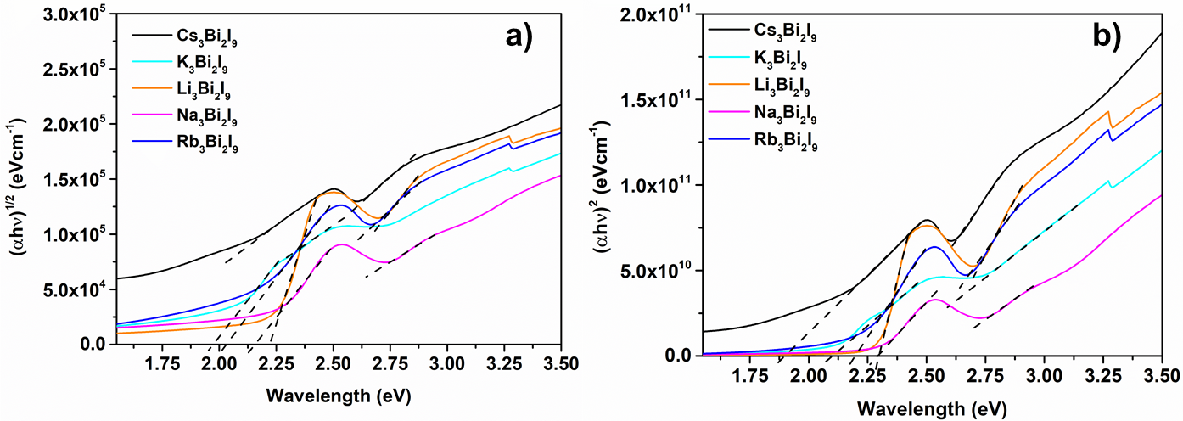
Figure S7: a) Tauc plots for indirect band gap determination of all-inorganic bismuth iodide thin films. b) Tauc plots for direct band gap determination of all-inorganic bismuth iodide thin films.

Table S2: Extrapolated band gaps for all-inorganic bismuth iodide thin films from the Tauc plots in Figure S6.

 | Direct band gap (eV) |  | Indirect band gap (eV)
 | excitonic | optical | excitonic | optical
Cs₃Bi₂I₉ | 1.9 | 2.3 | 1.5 | 1.8
Rb₃Bi₂I₉ | 2.2 | 2.5 | 2.0 | 2.1
K₃Bi₂I₉ | 2.0 | 2.3 | 1.9 | 1.7
Na₃Bi₂I₉ | 2.3 | 2.5 | 2.2 | 2.2
Li₃Bi₂I₉ | 2.3 | 2.5 | 2.2 | 2.3

Figure S 8: J-V curves of a) organic-inorganic and b) all-inorganic bismuth iodide based champion solar cells in forward (solid curves) and reverse (dashed curves) scans.

Table S 3: Open-circuit voltage (V_{OC}), short-circuit current density (J_{SC}), fill factor (FF) and power conversion efficiency (PCE) from the champion solar cell IV curves, with organic-inorganic bismuth iodide thin films in forward and reverse scan.
 | Scan direction | V_{OC} (V) | J_{SC} (mA∙cm⁻²) | FF (%) | PCE (%)
MA₃Bi₂I₉ | forward | 0.65 | 0.54 | 63.0 | 0.22
MA₃Bi₂I₉ | reverse | 0.65 | 0.56 | 56.8 | 0.21
FA₃Bi₂I₉ | forward | 0.51 | 0.090 | 48.2 | 0.02
FA₃Bi₂I₉ | reverse | 0.50 | 0.050 | 90.3 | 0.02
GA₃Bi₂I₉ | forward | 0.52 | 0.036 | 59.4 | 0.011
GA₃Bi₂I₉ | reverse | 0.31 | 0.036 | 51.5 | 0.006
DMA₃Bi₂I₉ | forward | 0.54 | 0.073 | 43.4 | 0.017
 | reverse | 0.53 | 0.065 | 49.2 | 0.017

Table S 4: Open-circuit voltage (V_{OC}), short-circuit current density (J_{SC}), fill factor (FF) and power conversion efficiency (PCE) from the champion solar cell IV curves with all-inorganic bismuth iodide thin films in forward and reverse scan.
 | Scan direction | V_{OC} (V) | J_{SC} (mA∙cm⁻²) | FF (%) | PCE (%)
Cs₃Bi₂I₉ | forward | 0.62 | 0.59 | 48.7 | 0.18
Cs₃Bi₂I₉ | reverse | 0.65 | 0.42 | 86.1 | 0.24
K₃Bi₂I₉ | forward | 0.55 | 0.21 | 86.0 | 0.10
K₃Bi₂I₉ | reverse | 0.52 | 0.32 | 50.2 | 0.08
Rb₃Bi₂I₉ | forward | 0.60 | 0.32 | 51.7 | 0.10
Rb₃Bi₂I₉ | reverse | 0.61 | 0.29 | 61.8 | 0.11
Na₃Bi₂I₉ | forward | 0.45 | 0.41 | 80.5 | 0.15
Na₃Bi₂I₉ | reverse | 0.36 | 0.40 | 41.9 | 0.06

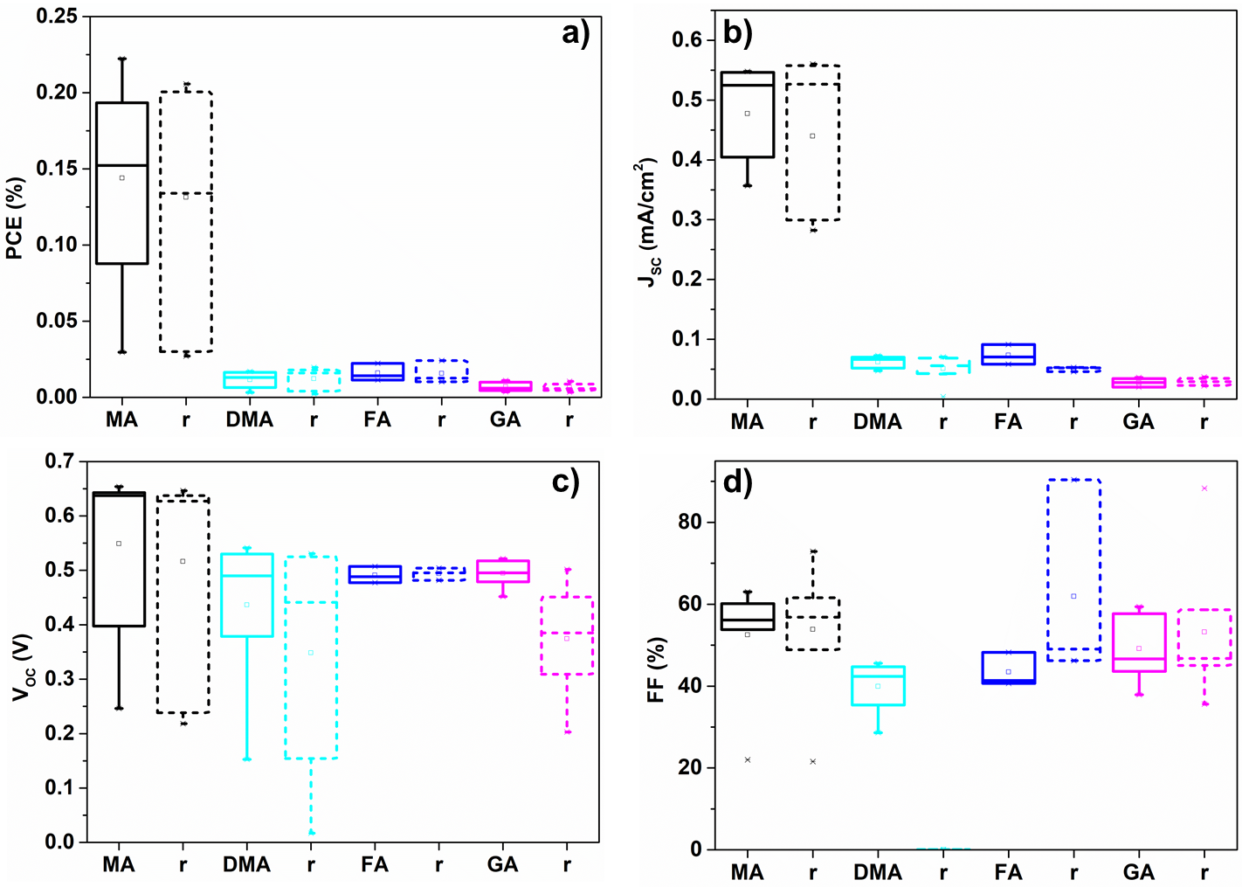
Figure S9: Solar cell parameters for perovskite solar cells (n = 8) using monovalent organic cations MA⁺ (black), DMA⁺ (cyan), FA⁺ (blue) and GA⁺ (magenta) displayed as a) power conversion efficiency (PCE), b) short-circuit current density (J_{SC}) c) open-circuit voltage (V_{OC}) d) fill factor (FF). The parameters were extracted from forward and reverse (dashed) J-V scans and displayed together.
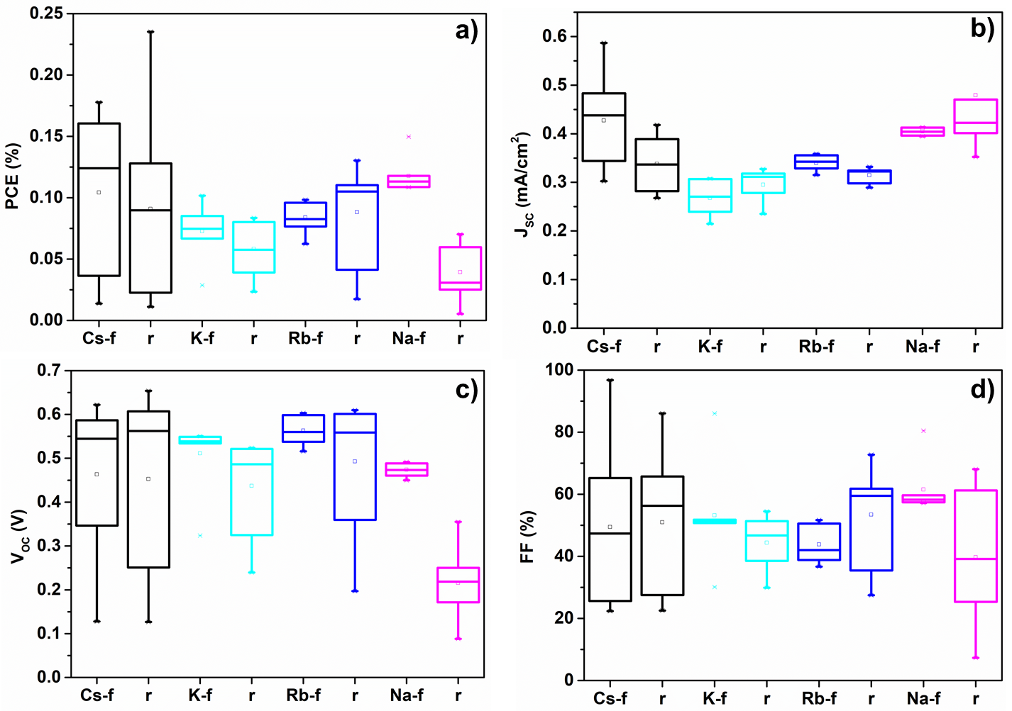

Figure S10: Solar cell parameters for perovskite solar cells (n = 8) using alkali metal cations Cs⁺ (black), K⁺ (cyan), Rb⁺ (blue), Na⁺ (magenta) displayed as a) PCE, b) J_{SC} c) V_{OC} d) FF. The parameters were extracted from forward and reverse (dashed) J-V scans and displayed together.
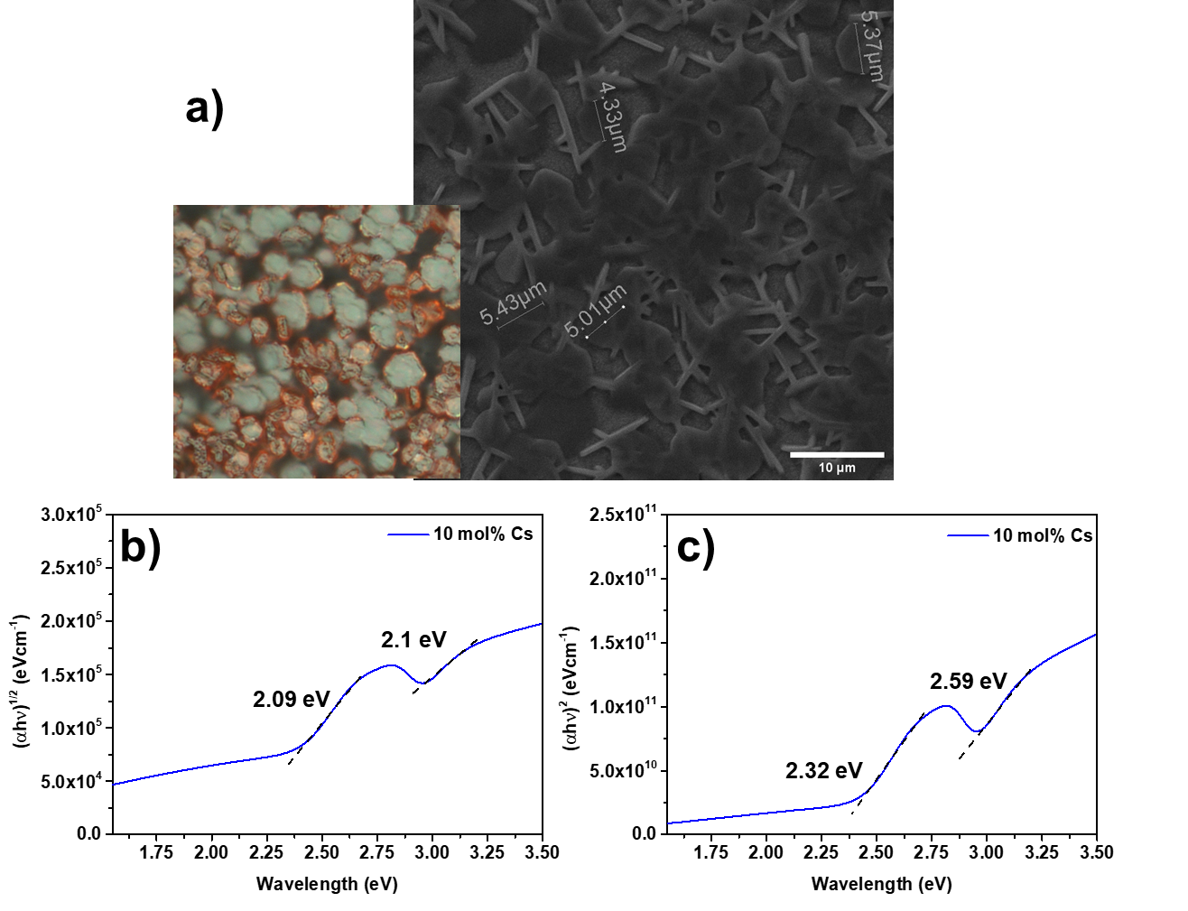
Figure S11: a) Optical and scanning electron microscope image of hexagonal shape perovskite grains on glass, and grain sizes of the 10 mol% Cs doped MA₃Bi₂I₉ perovskites on FTO. b) Tauc plot for indirect band gap determination of the mixed cation bismuth iodide thin film with 10 mol% Cs amount and extrapolated band gap values for each excitonic and optical absorptions. c) Tauc plot for direct band gap determination of Cs/MA bismuth iodide thin film.

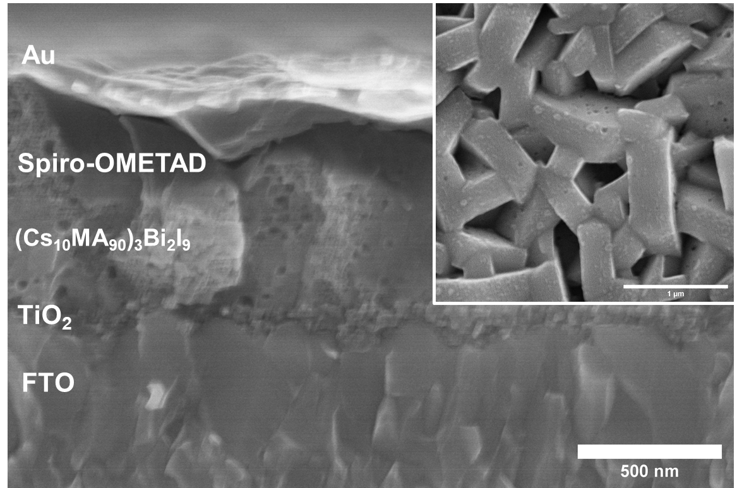
Figure S 12: Cross-section and Top-view SEM (inset scale bar 1 µm) images of double-cation bismuth iodide thin film from 45 wt% precursor solution leading to a capping layer on top of the mesoporous TiO₂. The scale bar is 500 nm.

Figure S 13:Best performing J-V curves of the devices based on MA₃Bi₂I₉ (blue curve) and (Cs₁₀MA₉₀)₃Bi₂I₉ (black curve) sensitized solar cells.

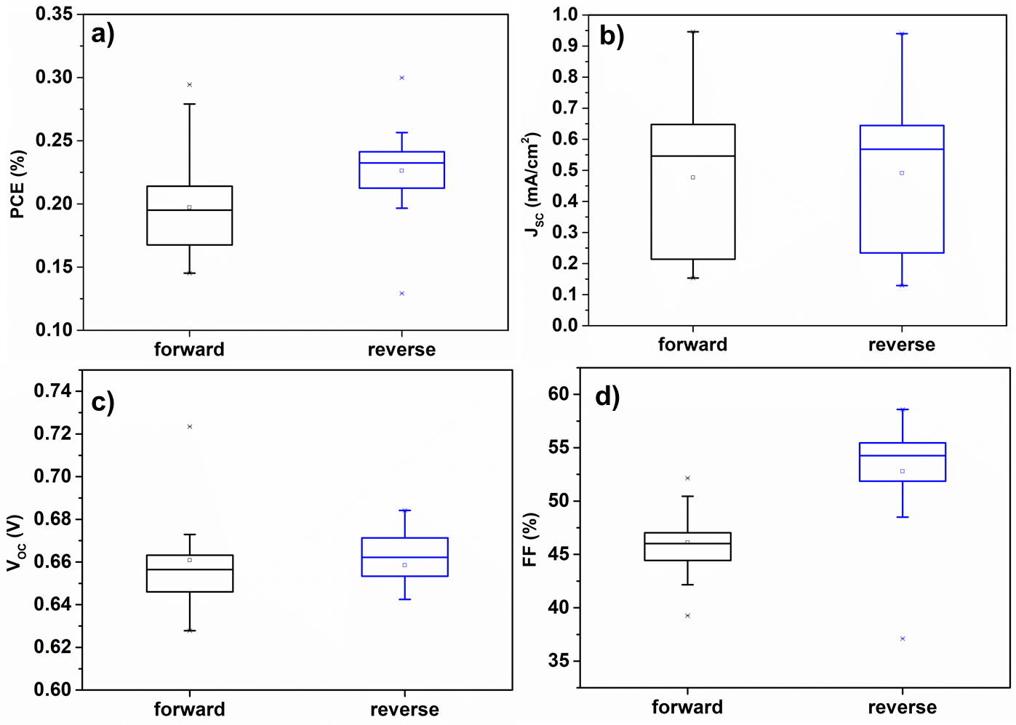
Figure S14: Solar cell parameters for perovskite solar cells (n = 18) using double-cation Cs/MA displayed as a) PCE, b) J_{SC} c) V_{OC} d) FF. The parameters were extracted from forward (black boxes) and reverse (blue boxes) J-V scans and displayed together.

