Supplementary information
High strain rate in situ micropillar compression of a Zr-based metallic glass

Rajaprakash Ramachandramoorthy,^{1,2,**} Fan Yang,³ Daniele Casari,² Moritz Stolpe,⁴ Manish Jain,² Jakob Schwiedrzik,² Johann Michler,² Jamie J. Kruzic⁵ and James P. Best^{1,5,6,**}

¹ Max-Planck-Institut für Eisenforschung GmbH, Max-Planck-Straße 1, 40237 Düsseldorf, Germany
² Laboratory for Mechanics of Materials and Nanostructures, Empa – Swiss Federal Institute for Materials Science and Technology, 3603 Thun, Switzerland
³ Institut für Materialphysik im Weltraum, Deutsches Zentrum für Luft- und Raumfahrt (DLR), 51170 Köln, Germany
⁴ Heraeus Amloy Technologies GmbH, Heraeusstraße 12-14, 63405 Hanau, Germany
⁵ School of Mechanical and Manufacturing Engineering, UNSW Sydney, Sydney NSW 2052, Australia
⁶ Institut für Metallkunde und Materialphysik, RWTH Aachen University, 52056 Aachen, Germany

** Corresponding authors: Dr. Rajaprakash Ramachandramoorthy (r.ram@mpie.de) & Dr. James P. Best (j.best@mpie.de)

Table T1. Overview of micropillar testing geometries.
Sample | Top diameter | Corrected height | Aspect ratio | Taper angle | # pillars
 | µm | µm | - | ° | -
(AMZ4)_{L} | 2.95 ± 0.02 | 7.14 ± 0.10 | 2.32 ± 0.04 | 3.50 ± 0.19 | 21
(AMZ4)_{H} | 2.93 ± 0.02 | 6.74 ± 0.11 | 2.21 ± 0.03 | 3.25 ± 0.30 | 20

Table T2. Summary of sampling rates and load noise at tests conducted at different strain rates.
 | Strain rate (s⁻¹)
 | 5.0 × 10⁻⁴ | 0.05 | 5.82 | 520
Sampling rate (Hz) | 5 | 200 | 50000 | 1.0 × 10⁶
Noise level S.D. (mN) | 0.0016 | 0.0107 | 0.34 | 0.7

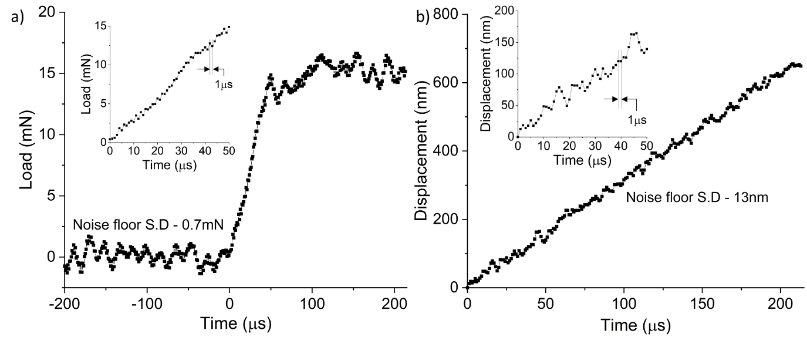
Figure S1. High fidelity raw data captured at a sampling rate of 1 MHz during high-speed BMG micropillar compression that results in a strain rate of ~520 s⁻¹. Raw load versus time data with a noise floor standard deviation of 0.7 mN (a). Raw displacement versus time data with a noise floor standard deviation of 13 nm (b). Both insets show a magnified view of the elastic loading region of ~47.5 µs, highlighting a time interval of 1 µs between sampling points in both load and displacement.

