Synthesis and Behavior of Bulk Iron Nitride Soft Magnets via High Pressure Spark Plasma Sintering – Supplemental Information

Fig. S1. Backscattered electron (BSE) SEM image of the surface of a sintered iron nitride toroid.

Table S1. WDS results collected from the surface of a sintered iron nitride toroid.
Location | Fe (Atomic %) | N (Atomic %)
Grain center | 81.3 | 18.7
Grain boundary | 84.2 | 15.8

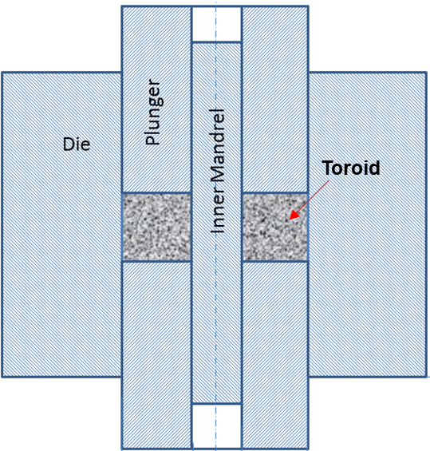

Fig. S2. Schematic of graphite die assembly for the fabrication of iron nitride based toroids using SPS.

