Supplemental material

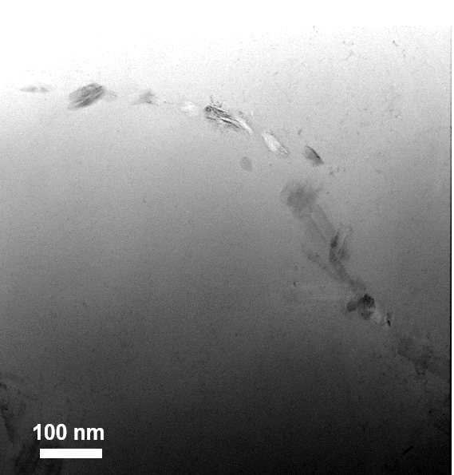  a) | 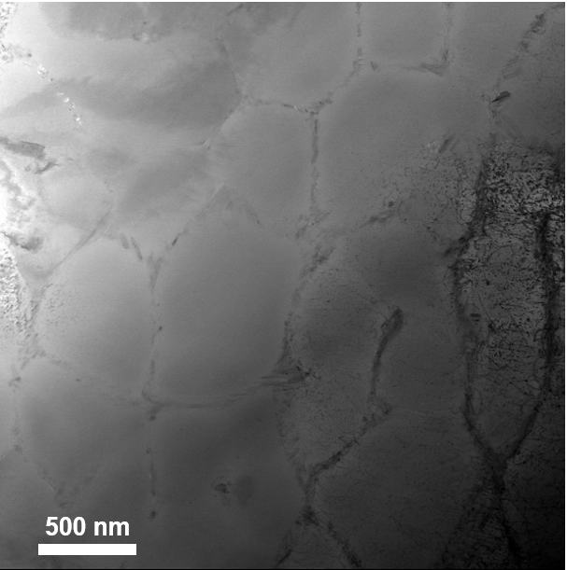  b)
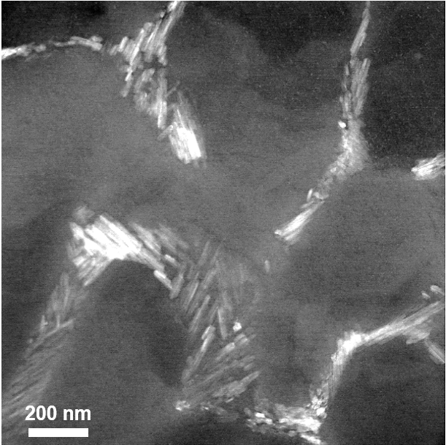
c)

Figure S1. a) and b) Bright-field, and c) dark-field TEM images of the TNZT with 1 wt.% of TiB₂ processed by L-PBF. Figure a) and c) show more details of the TiB formed in the interdendritic region. Figure b) shows a high density of dislocations inside and outside some dendrites.

