Supplementary information
Article title: Al-Mn-Cr-Zr Based Alloys Tailored for Powder Bed Fusion- Laser Based: Alloy Design, Printability, Resulting Microstructure and Alloy Properties
Journal name: Journal of Materials Research
Author names: Bharat Mehta¹, Lars Nyborg¹, Karin Frisk^{1,2}, Eduard Hryha¹
Affiliation:
1: Department of Industrial & Materials Science, Chalmers University of Technology, Göteborg, Sweden
2: Höganäs AB, Höganäs, Sweden
Email address of corresponding author: bharat.mehta@chalmers.se

Supplementary information is provided here, which could not be covered in the main article. It provides more information about the atomised powders, sample preparation and calculation for solid solution strengthening, metastable phase diagrams and resistance to solidification cracking.
Powder size distribution data
All the powders were gas atomised to 20-53 µm specifications. The powders were tested for particle size distribution by laser diffraction using a Mastersizer 3000 from Malvern UK. The measurements were repeated five times. Summary of particle size distribution is available in Table S1 and Figure S1.
Table S1 Particle size distribution for four Al-alloy powder grades
Sample Name | D₁₀ (μm) | D₅₀ (μm) | D₉₀ (μm)
Alloy A | 18.5 | 29.1 | 46.7
Alloy B | 20.4 | 33.4 | 56.1
Alloy C | 18.1 | 28.7 | 47.0
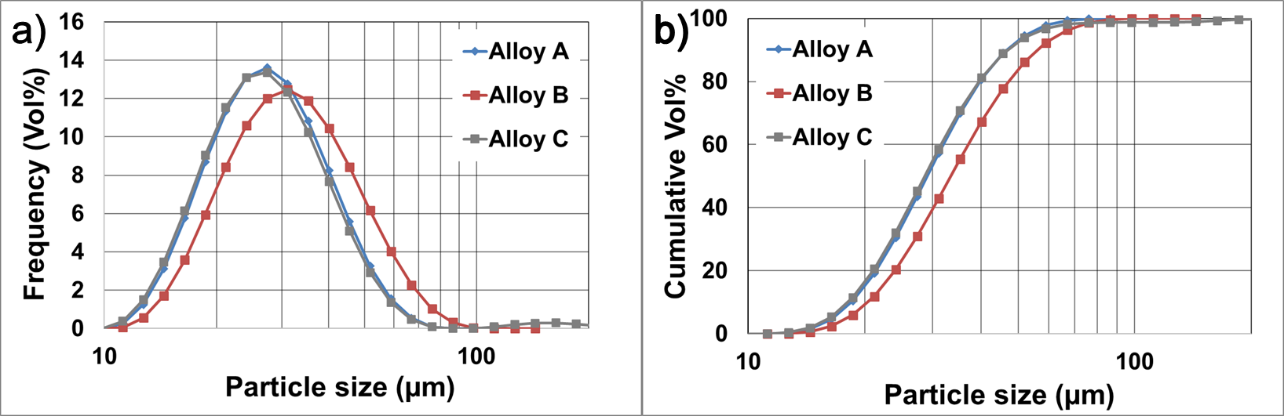
Figure S1 (a) Particle size (µm) vs volume % and (b) Particle size (µm) vs cumulative volume%.
Sample preparation
Sample were cut along all three planes of printing to remove uncertainties during printing process, as shown in Figure S2. Z axis is the build direction, X axis is the gas flow direction and Y axis is the third direction.
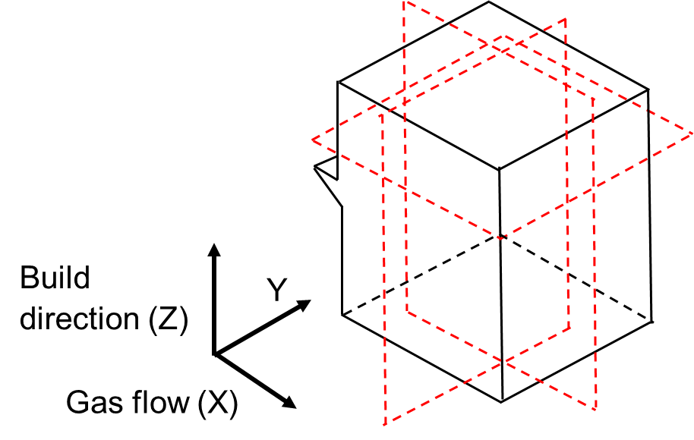
Figure S2 DOE cube design showing all three planes and the notch along X direction to mark gas flow direction; the three cutting planes used for sample preparation are marked in red.

Results
Alloy Design
Figure S3 shows the effect of Fe+Si on solidification behavior of alloy C. It is seen that when no Fe, Si is available, zero slope close to solidification is seen. This slope increase a little when 0.15wt% each Fe, Si is added but the solidification range is not affected much (~25-30 K close to solidification). It is only when 1wt% each Fe, Si is added that a significant slope is observed with a large solidification range (~110-120 K is observed) which is due to formation of Al-Fe-Si precipitates and can cause solidification cracking.
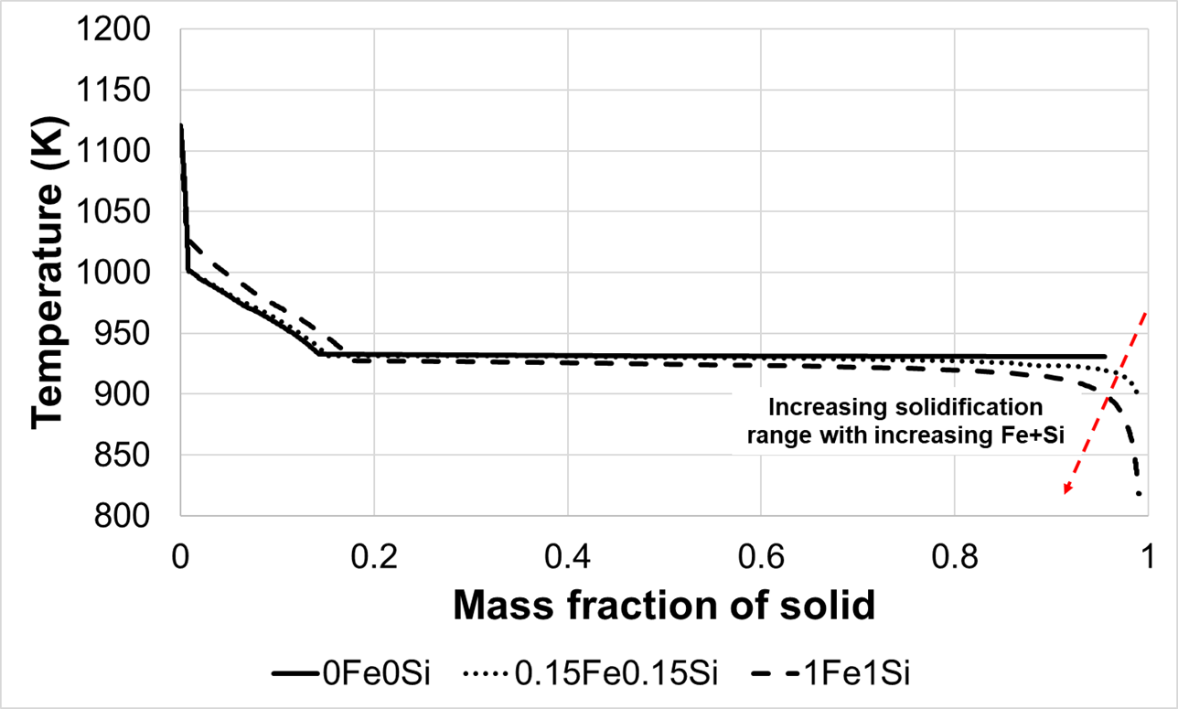
Figure S3 Scheil solidification simulations for Alloy C containing different amounts of Fe, Si each shown in legend (in wt%). Calculations done using ThermoCalc2021a with TCAL7 and MOBAL5 database.
Solidification cracking susceptibility
Solidification cracking susceptibility calculations are done by comparing two commonly used Al-grades namely 6061 and 7075 along with AlSi10Mg, which is a commercially available alloy for LB-PBF. These three alloys were benchmarked against alloy C and the results were compared using Scheil solidification curves to calculate the least slope close to solidification, thus indicating the solidification cracking susceptibility. Table S2 and Table S3 show the average composition of all four alloys and calculation for solidification cracking susceptibility for them respectively.
Table S2 Average composition of Al-alloys for which solidification cracking susceptibility is measured.
Note: All alloying elements <0.1 wt% are not accounted in ThermoCalc calculations
Alloy | Average Composition (wt%) [2, 3]
Al-6061 | 1% Mg, 0.7% Fe, 0.6% Si, 0.27% Cu, 0.25% Zn, 0.2% Cr, 0.15% Mn, 0.15% Ti
Al-7075 | 5.5% Zn, 2.5% Mg, 1.6% Cu, 0.5%Fe, 0.4%Si, 0.3% Mn, 0.23% Cr, 0.2% Ti
AlSi10Mg (EOS) | 10% Si, 0.55% Fe, 0.45% Mn, 0.32% Mg, 0.15% Ti
Alloy C | Al 5.0 Mn 0.8 Cr 0.60 Zr 0.16 Fe 0.17 Si
Table S3 Solidification cracking susceptibility of various Al-alloys, where low $\left|\frac{dT}{d({f_{s}}^{\frac{1}{2}})}\right|$ and low slope of tangent (when f_{s}^{1/2} ~1) reflects lower cracking susceptibility
Alloy | $\left|\frac{ΔT}{Δ{(f_{s})}^{\frac{1}{2}}}\right|$ when 0.8 < f_{s} < 1 | |Slope of tangent| around $\left({f_{s}}^{\frac{1}{2}}\right)$ close to 1
Al 6061 | 1229 | 2440
Al 7075 | 1148 | 1674
AlSi10Mg | 50 | 236
Alloy C (AlMnCrZr) | 190 | 250

Microscopy
Optical microscopy provided an overview of defects in as-printed samples and also try to find solidification cracks. The samples from DOE with very high or low energy density were seen to have different types of defects, typical to LB-PBF processing. As shown in Figure S4 a)-b), spherical pores are seen at the bottom of the melt pool which are a sign of gas porosity occurring due to very high energy density causing evaporation of elements. Figure S4 c)-d) shows lack of fusion pores, which are caused due to very low energy density causing incomplete melting of powder layers, thus leaving behind unmolten / partially melted powder behind.
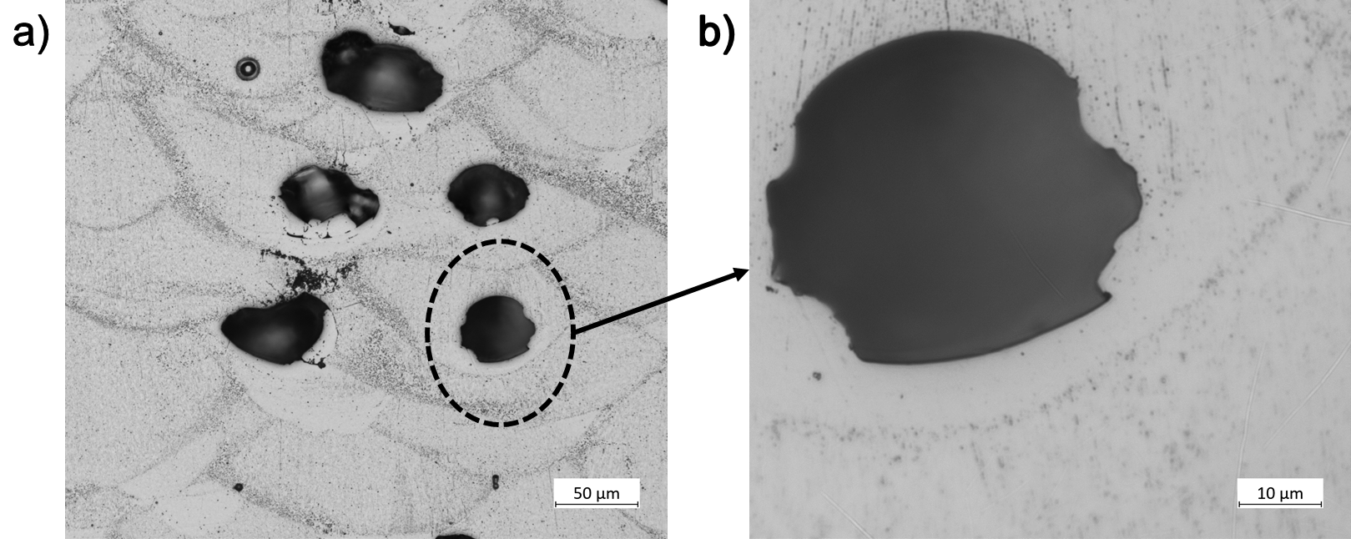
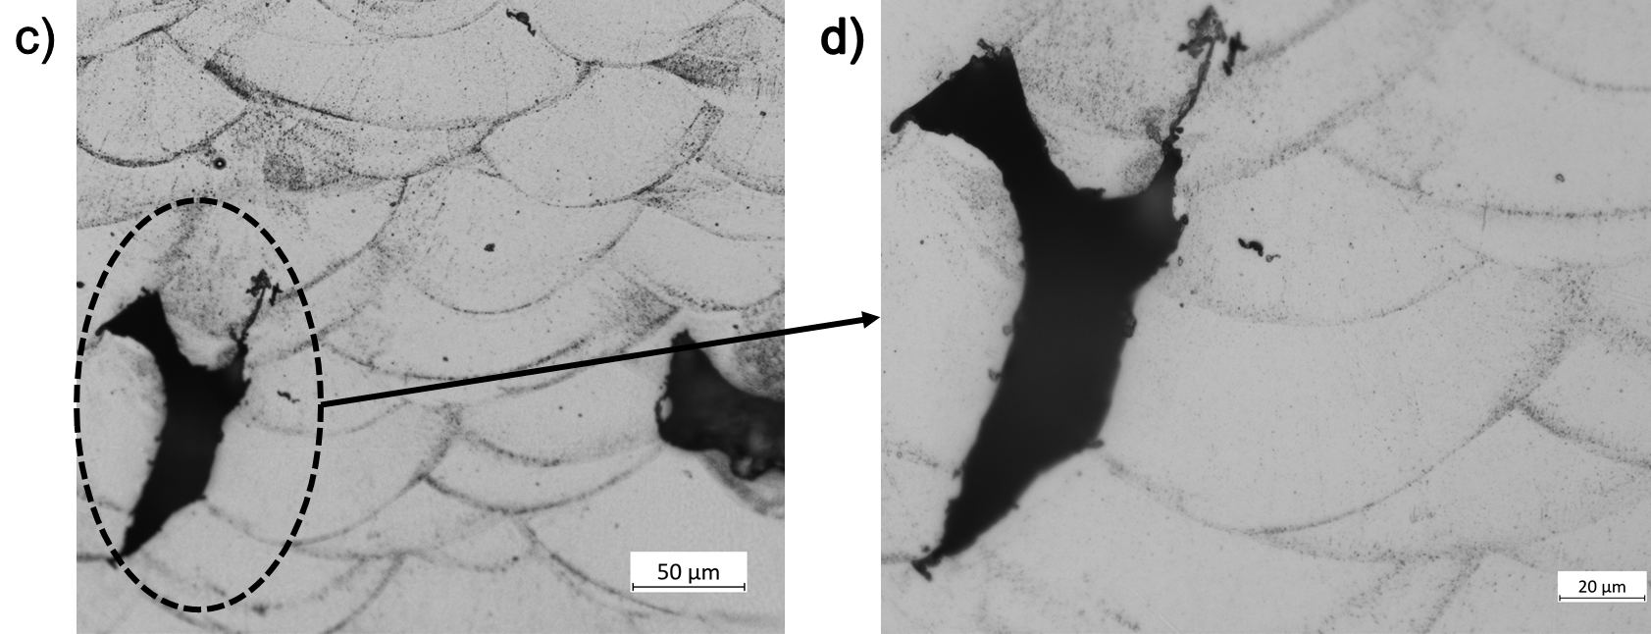
Figure S4 Two types of typical defects observed after printing of Al-alloys (illustrated for Alloy C2); The keyhole defects at low magnication shown in a) and close-up view in b); lack of fusion defects at low magnification shown in c) and close-up view in d).
Electron microscopy for the as-atomised powder was done to see if any segregations are caused during atomisation process. Negligible precipitation was seen, as shown in Figure S5. The precipitates seen (yellow) were found between dendritic regions of the atomised powder and their sizes were very small (<100 nm).
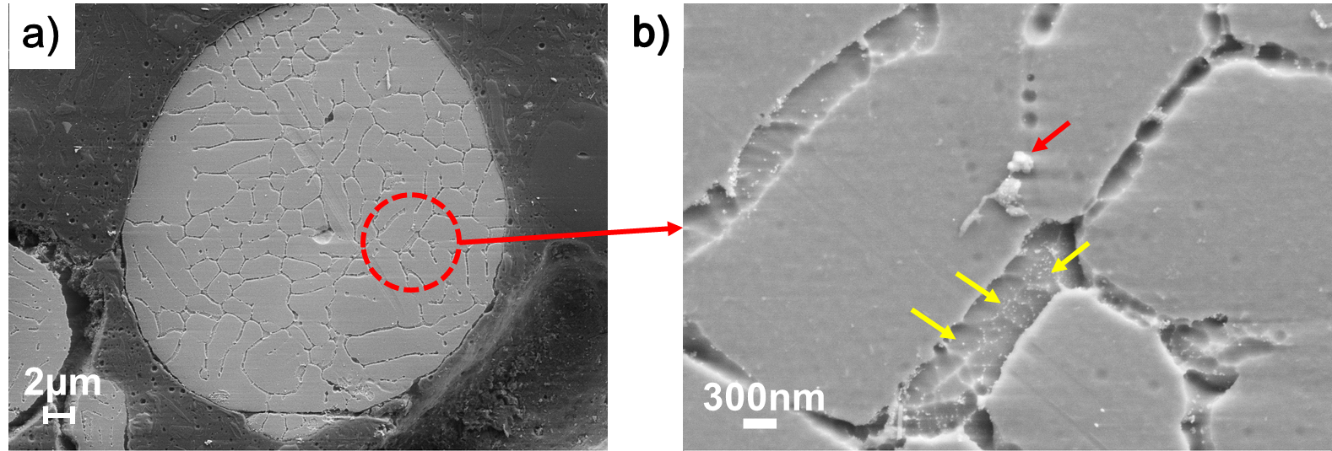
Figure S5 a) Electron microscopy image of as-atomised powder of Alloy C showing dendritic structure; magnified image (b) with nanometric particles inside dendritic regions (marked with yellow arrows). The particles marked with red arrow are left over silica from polishing with OP-S (to be ignored)
Alloy properties
Solid solution strengthening effect
Mn, Cr have more than two-three times the effect of Mg if higher amounts can be dissolved in solid solution. Higher solid solution effect can produce alloys which are medium strength with no precipitation. The solid solution strengthening effect of Mn, Cr and Mg based on first principle calculations is shown in Figure S6.
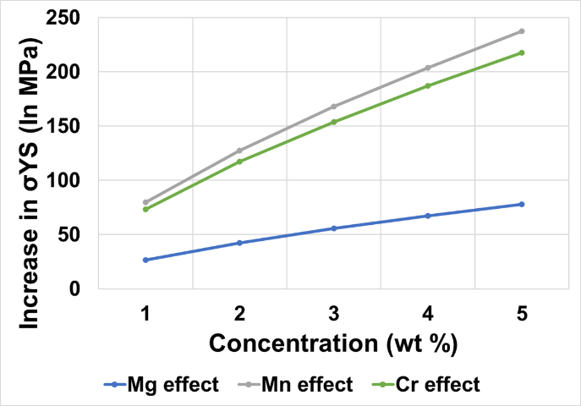
Figure S6 Expected solid solution effect on yield strength (σ_{YS}) of Mn, Cr and Mg in Al-binary alloys (based on first-principle calculations) (Uesugi et al., 2013)
X-Ray Diffraction
X-Ray diffraction was done on all the three alloys. To co-relate the amount of solutes dissolved, the effect of lattice parameter shift for the major Al peak was measured for Mn, Cr and Zr respectively, based on first-principle calculations and compared with experimental data. The simulated values were corrected by modifying the starting point assuming pure Al at 4.0478 Å instead of 4.016 Å. This was done by using PDF nr. 0040787 from DIFFRAC.EVA software and the data referred comes from the best quality source. Thus, the expected values from first principle calculations were offset linearly by approximately 0.0318 Å, as shown in Figure S7.
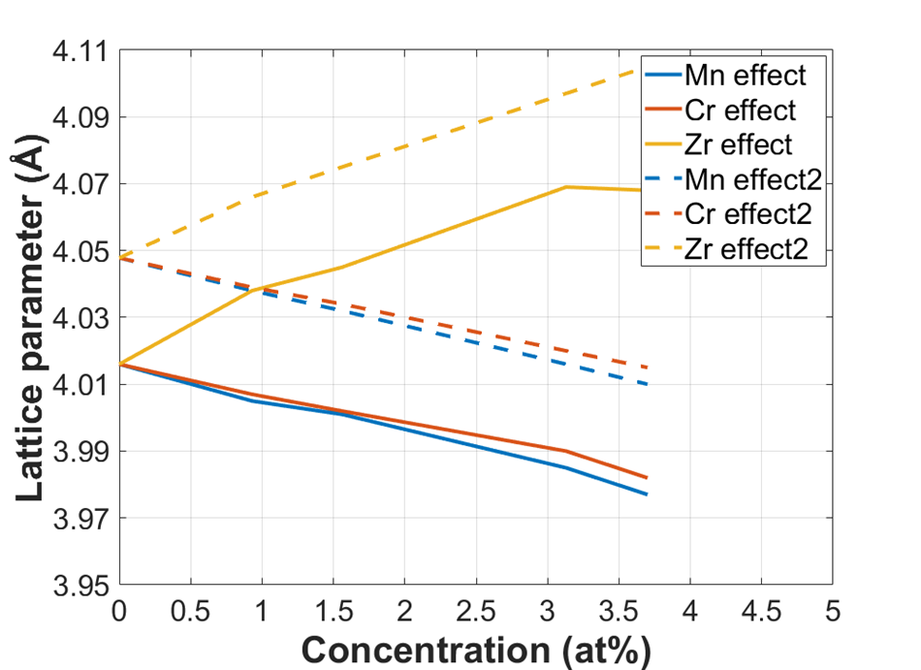
Figure S7 a) Effect on lattice parameters for Mn, Cr and Zr redrawn based on. Note that dotted lines represent intercept correction assuming pure Al= 4.0478 Å instead of Al = 4.016 Å (Uesugi et al., 2013)
Grain size effect
Grain size effect as mentioned in discussion section is illustrated for pure Al, Fe, Ni is shown in Figure S8.
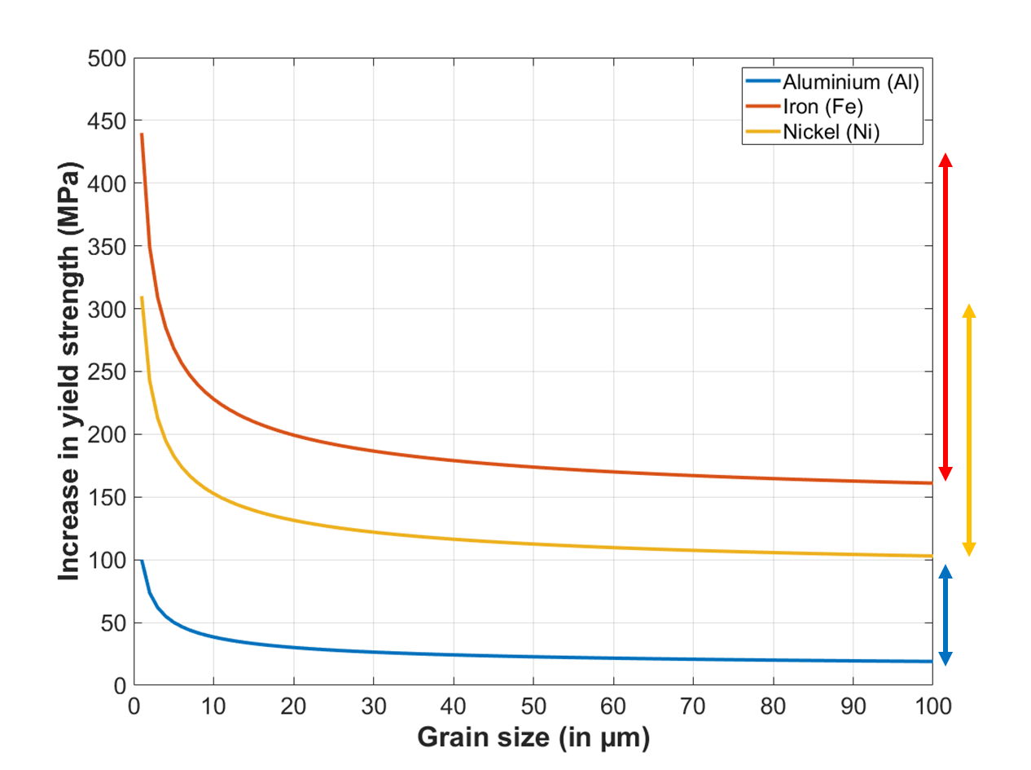
Figure S8 The grain size effect for pure Al, Fe, Ni showing that Hall-Petch effect is quite strong in Fe followed by Ni and Al. A representation of increase in yield strength from 100 µm 1 µm shown via length of arrows illustrated how Fe has a much bigger grain size effect than Al. (Cordero et al., 2016)

