Electronic Supplementary Material (ESI)

Insights into the decomposition of zirconium acetylacetonate using synchrotron radiation:
Routes to the formation of volatile Zr-intermediates

Sebastian Grimm^{a,b}*, Seung-Jin Baik^{b,c}, Patrick Hemberger^{d}, Tina Kasper^{b,e}, Andreas Kempf^{b,c} and Burak Atakan^{a,b}

ª IVG, Institute for Combustion and Gas Dynamics – Chair of Thermodynamics, University of Duisburg-Essen, 47057, Germany
^{b} CENIDE, Center for Nanointegration Duisburg-Essen, University of Duisburg-Essen, 47057, Germany
^{c} IVG, Institute for Combustion and Gas Dynamics - Chair of Fluid Dynamics, University of Duisburg-Essen, 47057, Germany
^{d} Laboratory for Synchrotron Radiation and Femtochemistry, Paul Scherrer Institute, CH-5232 Villigen-PSI, Switzerland
^{e} IVG, Institute for Combustion and Gas Dynamics – Mass Spectrometry in Reacting Flows, University of Duisburg-Essen, 47057, Germany

*Corresponding author. E-mail address: sebastian.grimm@uni-due.de (S. Grimm)
ORCID IDs:
0000-0002-7378-3224 (S. Grimm)
0000-0002-3362-5424 (S.-J. Baik)
0000-0002-1251-4549 (P. Hemberger)
0000-0003-3993-5316 (T. Kasper)
0000-0003-3627-4524 (Andreas M. Kempf)
0000-0002-1361-8315 (B. Atakan)

S 1 Numerical modelling of the microreactor

S 1.1 Governing equations
The Reynolds-averaged Navier-Stokes (RANS) equations contain mass and momentum conservations written as:
$\frac{∂ρ}{∂t}+\frac{∂}{∂x_{i}}\left(ρ{\overline{u}}_{i}\right)=0$ (E1)
$\frac{∂}{∂t}\left(ρ{\overline{u}}_{i}\right)+\frac{∂}{∂x_{j}}\left(ρ{\overline{u}}_{i}{\overline{u}}_{j}\right)=-\frac{∂p}{∂x_{j}}+\frac{∂}{∂x_{j}}\left[μ\left(\frac{∂u_{i}}{∂x_{j}}+\frac{∂u_{j}}{∂x_{i}}\right)-ρ\overline{u_{i}^{'}u_{j}^{'}}\right]$ (E2)
, where $μ$ is the dynamic viscosity. The velocity was decomposed with time-averaged component ${\overline{u}}_{i}$ and fluctuating component $u_{i}^{'}$, as $u_{i}={\overline{u}}_{i}+u_{i}^{'}$.
In the present work, based on the observed flow characteristic in the previous study [1], the RANS equations combined with a slip (boundary) condition were used to investigate the flow in the microreactor under the given conditions relevant to interpret the experimental data.
For the slip boundary implementation in the simulation, a simple model for the slip fluid velocity at the wall was used, which can be expressed as:
$V_{slip}={\left.l_{s}\frac{∂V}{∂n}\right|}_{at wall}$ (E3)
, where $l_{s}$ is the slip length and n denotes the normal vector to the wall. In the present work, the slip length $l_{s}$ is calculated using the approach suggested by Morris et al. [2]:
$l_{s}=α∙L·Kn$ (E4)
Where the local Knudsen number Kn is defined with the Mach number M and Reynolds number Re as: $Kn=(\sqrt{γπ}M)/(\sqrt{2}Re)$ [3]. The model constant $α$ in eq. E4 was suggested to be 1.15 [2] and the diameter of the microreactor was used as the characteristic length L.

S 1.2 Boundary conditions

Table S 1 Boundary conditions for the CFD simulation of the microreactor. Roman numerals are in accordance with Figure 1 in the main text.
Nr. | Boundary type | Pressure  mbar | Temperature  K
I | Inlet | 214 | 293
II | No-slip wall | - | 403
 |  | -
III | Slip wall | - | Helium: 423-903 (12 points) – Argon: 423, 671, 803
IV | Outlet | 5 x 10⁻⁵ | -

S 1.3 Local residence time and temperature distribution
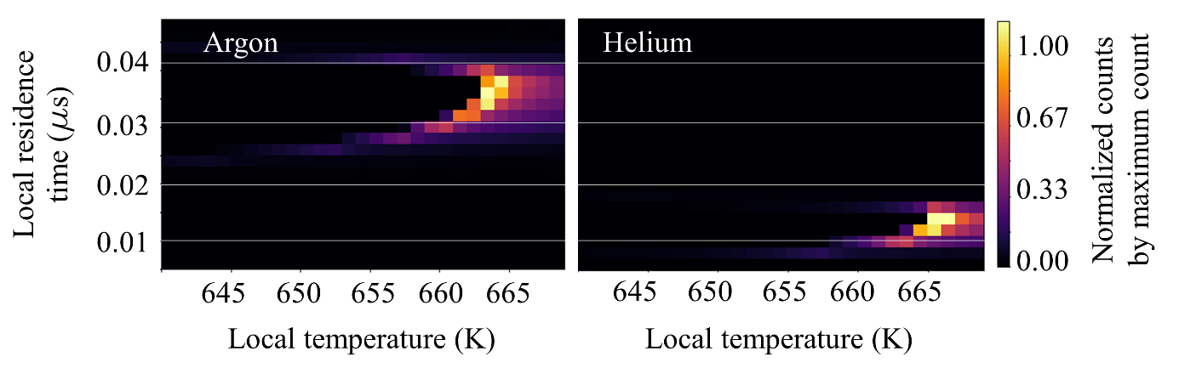
Figure S 1 Joint histogram between local residence time and temperature from each CFD cell from the simulation at a surface temperature of 671 K.

Figure S 1 shows a histogram of the combined local residence time and temperature in the heated area of the microreactor at a a surface temperature of 671 K. In the present study, an axisymmetric 2D simulation contains 50.000 equidistant cells (10 μm x 10 μm) within the heated area (x = 10 mm y = 0.5 mm). Therefore, the local residence time, which refers to how long the fluid stays in the specific computational cell, can be estimated easily from the cell width divided by the local axial velocity in the specific cell. As shown, the argon flow has a longer residence time in the heated zone, than helium. Furthermore, we can confirm that using helium as a dilution gas shows more plug-flow like conditions, which is also indicated in Figure 2 of the main text.

S 1.4 Comparison of the temperature profiles using different dilution gases

In order to correctly interpret the temperature onset of the formation of the detected intermediate species and interpret the chemical pathways to their formation more precisely, we performed two different simulation sets with the same boundary conditions, but using helium and argon as dilution gas. Considering the flow field, the main difference between helium and argon can be explained by a higher heat conductivity of helium, which in turn is responsible for more efficient heat transfer in the reactor by conduction and convection and therefore leads to a more plug-flow like temperature profile in the microreactor. Additionally, we found, that a lower inlet pressure (here ca. 214 mbar) leads to a more uniform temperature profile in comparison to the results obtained in our previous study (ca. 160 mbar), since the density of the gas is 6 times smaller [1]. This should lead to an increase in signal intensity, as well as an accurate interpretation of the temperature-dependence of the collected experimental data with respect to chemical mechanisms and kinetics.
Figure S 2 Contour plots of the reactor temperature field obtained from CFD calculations in helium (top side) and argon (bottom side) at surface temperatures of 671 and 803 K, where most of the intermediate species were observed upon pyrolysis of Zr(acac)₄.

S 1.5 Flow field in the microreactor
Figure S 3 Averaged pressure and residence time inside the heated area as a function of surface temperature using helium as dilution gas. The error bars indicate the maximum and minimum values along the axial centerline of the microreactor.
Figure S 3 shows the averaged pressure and residence time for the heated zone (10 mm length) from each simulation with surface temperatures ranging from 400 to 900 K, which correspond to the measured values in the experiment. Pressure and residence time profiles show an almost linear course upon a variation of the surface temperature. We report here average residence times of 10.5 ~ 14.5 μs in the case of helium used as dilution gas, which is in accordance with previous studies that hint on the beneficial properties of helium for the derivation of reaction kinetics in such small pyrolysis reactors [4–6].

S 2 Precursor stability at room temperature
S 2.1 Dissociative ionization
Figure S 4 (a) Mass-selected threshold photoelectron spectra (ms-TPES) recorded at room temperature in the 7.5–11.4 eV photon energy range. The main dissociative ionization product at m/z 387 is denoted in red, whereas the parent molecule Zr(C₅H₇O₂)₄ is shown in black along with the vertical ionization energies; (b) Breakdown diagram of C₅H₈O₂ at 403 K shows the dissociative ionization of acetylacetone.

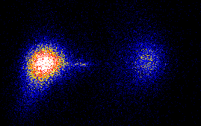
m/z 387
10 eV
RT
BG
DPI
Beam
Figure S 5 Room temperature ion image of m/z 387 at an evaporator temperature of 403 K and a photon energy of 10 eV. A broad kinetic energy distribution hints that m/z 387 (Zr(acac)₃⁺) is the main fragment formed by dissociative ionization of Zr(acac)₄.

S 2.2 Threshold photoelectron spectrum of acetic acid (m/z 60)

[7]
Figure S 6 Threshold photoelectron spectrum of m/z 60 at an evaporator temperature of 403 K (black symbols and line). The literature reference spectrum of C₂H₃O₂ (acetic acid) [7] is shown in red and is in good agreement with the bands observed here.

S 3 Species assignment of minor decomposition products
Figure S 7 ms-TPE spectra of minor decomposition products at a temperature of 803 K (a) and (b) and 776 K (c). Literature references in red are as follows: (a) m/z 15 Methyl radical (CH₃) [8]; (b) m/z 39 Propargyl radical (C₃H₃) [9] and (c) m/z 146 2,4,6-Trimethylstyrene (C₁₁H₁₄) [10].

Here 15 [8],39 [9], 146 [10] Figure S7

S4 Velocity map images of some of the detected Zr-species

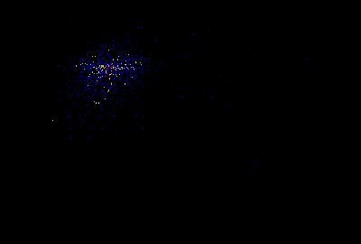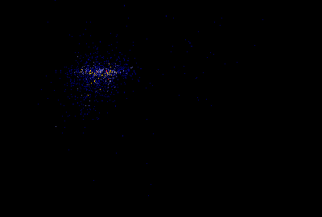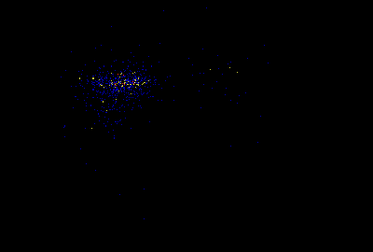
Beam
Beam
Beam
m/z 344
m/z 304
m/z 286
Figure S 8 Ion velocity map images of the most abundant Zr-species m/z 344, 304 and 286 at a temperature of 776 K, recorded at 8.5 eV.

References
[1] S. Grimm, S.-J. Baik, P. Hemberger, A. Bodi, A.M. Kempf, T. Kasper, B. Atakan, Physical chemistry chemical physics PCCP 23 (2021) 15059–15075.
[2] D.L. Morris, L. Hannon, A.L. Garcia, Physical review. A, Atomic, molecular, and optical physics 46 (1992) 5279–5281.
[3] G. Karniadakis, Microflows and nanoflows: Fundamentals and simulation, Springer, New York, NY, 2005.
[4] Q. Guan, K.N. Urness, T.K. Ormond, D.E. David, G. Barney Ellison, J.W. Daily, International Reviews in Physical Chemistry 33 (2014) 447–487.
[5] P.J. Weddle, C. Karakaya, H. Zhu, R. Sivaramakrishnan, K. Prozument, R.J. Kee, Int. J. Chem. Kinet. 50 (2018) 473–480.
[6] M.V. Zagidullin, R.I. Kaiser, D.P. Porfiriev, I.P. Zavershinskiy, M. Ahmed, V.N. Azyazov, A.M. Mebel, The journal of physical chemistry. A 122 (2018) 8819–8827.
[7] W. von Niessen, G. Bieri, L. Åsbrink, Journal of Electron Spectroscopy and Related Phenomena 21 (1980) 175–191.
[8] B.K. Cunha de Miranda, C. Alcaraz, M. Elhanine, B. Noller, P. Hemberger, I. Fischer, G.A. Garcia, H. Soldi-Lose, B. Gans, L.A.V. Mendes, S. Boyé-Péronne, S. Douin, J. Zabka, P. Botschwina, The journal of physical chemistry. A 114 (2010) 4818–4830.
[9] P. Hemberger, M. Lang, B. Noller, I. Fischer, C. Alcaraz, B.K. Cunha de Miranda, G.A. Garcia, H. Soldi-Lose, The journal of physical chemistry. A 115 (2011) 2225–2230.
[10] T. Kobayashi, S. Nagakura, Journal of Electron Spectroscopy and Related Phenomena 7 (1975) 488–491.

