Supporting information for

A Novel Iron(III)-Based MOF: Synthesis, Characterization, Biological, and Antimicrobial Activity Study
Sheta M. Sheta^{1, *}, Salem R. Salem², Said M. El-Sheikh ³
¹ Department of Inorganic Chemistry, National Research Centre, 33, El-Behouth St., Dokki, Giza, 12622, Egypt.
² Biochemistry Department, Egypt Centre for Research and Regenerative Medicine, Cairo, 11887, Egypt.
³ Nanomaterials and Nanotechnology Department, Central Metallurgical R & D Institute, Cairo, 11421, Egypt.

*Corresponding author
Sheta, M. Sheta, E-mail: dr.sheta.nrc@gmail.com, Tel.: +20 1009697356, Fax: +2-02-33370931.

Fig. S1: The proposed mechanism of the Fe(III)-MOF synthesis.

Fig. S2: The mass spectrum of the Fe(III)-MOF (Inside proposed fragmentation Scheme).

Fig. S3: The ¹H-NMR spectrum of the Fe(III)-MOF.

Fig. S4: The ¹³C-NMR spectrum of the Fe(III)-MOF.

Fig. S5: The X-ray photoelectron spectroscopic analysis (XPS) of Fe(III)-MOF: O 1s deconvolution fitting.

Fig. S6: The X-ray photoelectron spectroscopic analysis (XPS) of Fe(III)-MOF: N 1s deconvolution fitting.

Fig. S7: The X-ray photoelectron spectroscopic analysis (XPS) of Fe(III)-MOF: C 1s deconvolution fitting

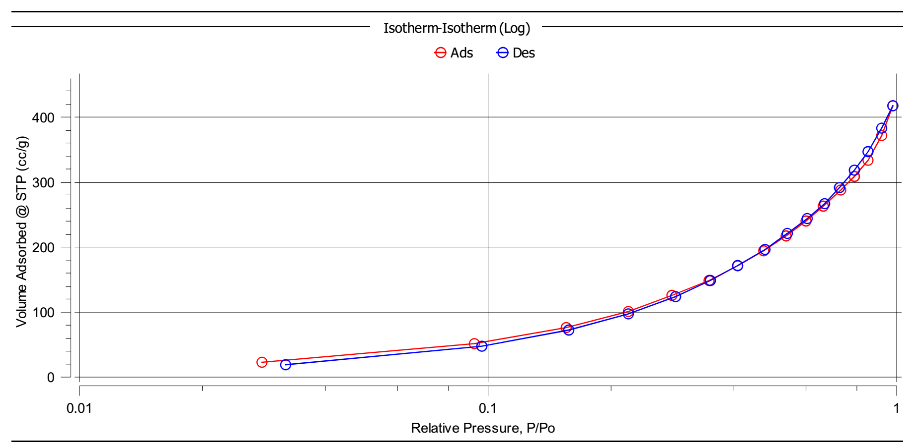 Fig. S8: The BET surface area analysis of Fe(III)-MOF: N2 adsorption/desorption isotherm.

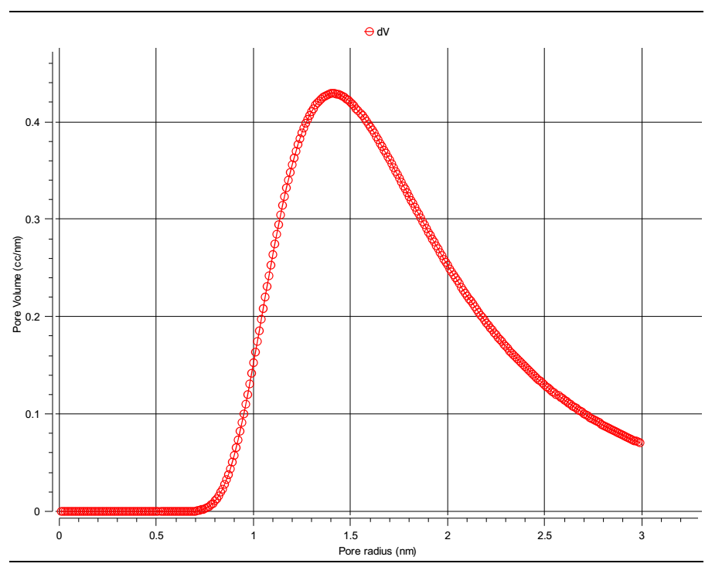
Fig. S9: The BET surface area analysis of Fe(III)-MOF: Changes in pore volume distribution in relation to pore radius.

Fig. S10: The photoluminescence spectrum emission band after excitation at 384 nm of the Fe(III)-MOF.
Fig. S11: The magnetization curve of the Fe(III)-MOF.

Table S1: EDX analysis of the Fe(III)-MOF.
Element | Weight % | Atomic % | Net Int. | Error %
C | 49.65 | 56.51 | 125.01 | 8.82
N | 9.18 | 8.96 | 12.32 | 17.86
O | 20.20 | 17.26 | 35.19 | 13.95
Fe | 20.97 | 17.27 | 10.89 | 4.11

Table S2: XPS Survey scans
Name | Peak BE | FWHM, eV | Area (P) CPS., eV | Atomic, %
C1s | 284.09 | 3.44 | 156525.1 | 56.27
O1s | 531.14 | 3.8 | 170091.3 | 17.12
N1s | 398.79 | 3.74 | 31509.33 | 8.61
Fe2p | 710.69 | 6.45 | 45405.55 | 18.00

