Supplementary material to:
Crack length estimations for small scale fracture experiments via image processing techniques

K. Schmuck a M. Alfreider a, D. Kiener a
a Department of Materials Science, Chair of Materials Physics, Montanuniversität Leoben, Jahnstraße 12, Leoben, Austria
The microstructure obtained after the high pressure torsion process consists of bi-modal grain size distribution, with larger inhomogenities which are statistically distributed and embedded in a nano-crystalline matrix, see Fig. S 1 and Fig. S 2. For the quantification of the nano-crystalline grain size from transmission electron microscopy several images were captured and evaluated.

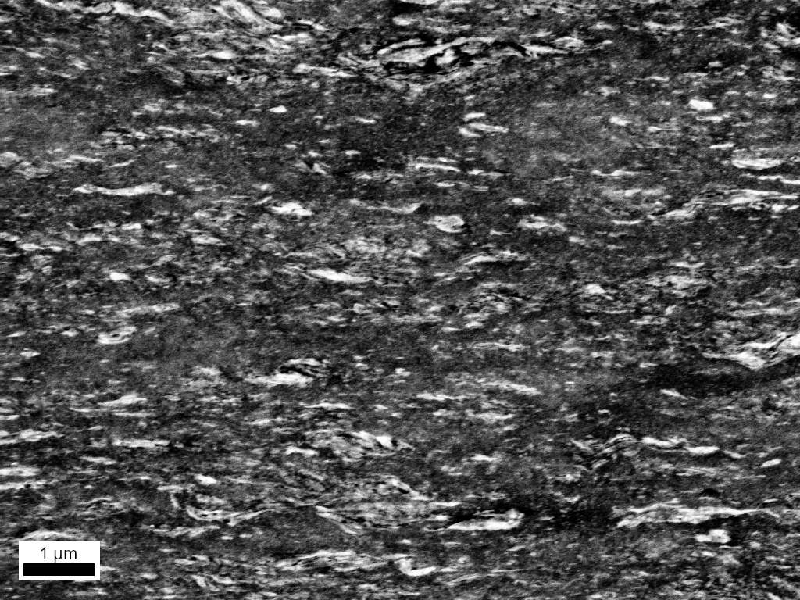
Fig. S 1 Obtained microstructure after the high pressure torsion process with elongated statistical distributed inhomogenities embedded in a nano-crystalline matrix. The image was acquired from backscatter electrons.
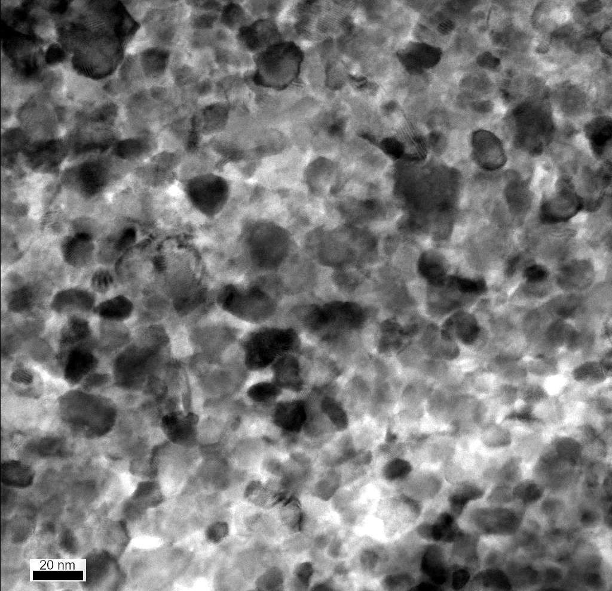
Fig. S 2 Embedding nano-crystalline matrix around statistical distributed inhomogenities, acquired by transmission electron microscopy.
Smoothed load-displacement data is depicted in Fig. S 3, Fig. S 4 and Fig. S 5 for the largest, medium and smallest cantilevers, respectively. Each diagram includes the fitted lines for unloading stiffness evaluation at every individual unloading step, drawn as dashed black lines. As can be seen in Fig. S 3, a load offset of about 2 mN occurred after the final unloading step for the largest cantilever. Thus, measured loads were corrected for this offset during all performed calculations. Measurement data of the smallest cantilever had a noticeable scatter, which is caused by the low measured forces. Thus, the measured data of the smallest cantilever was smoothed in two steps.
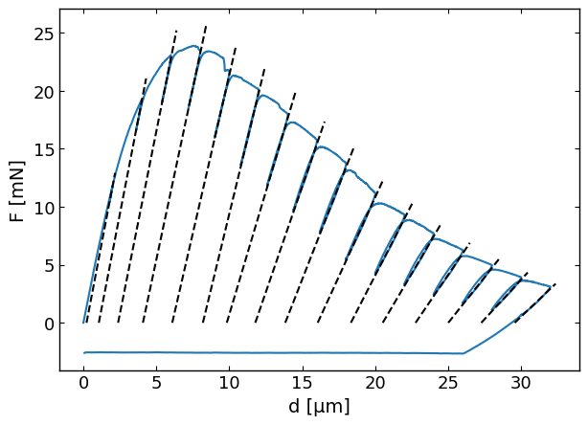
Fig. S 3 Load deflection data of the 34 x 31 µm² sized cantilever given by the blue solid line and the determined unloading stiffness as dashed black lines.
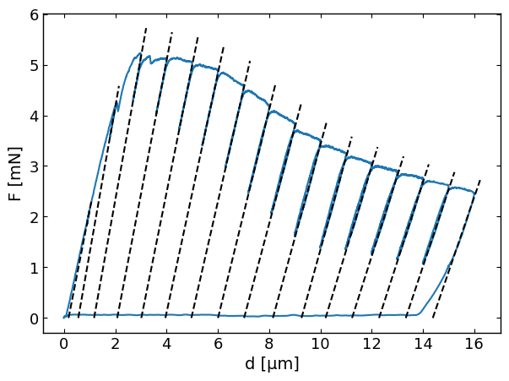
Fig. S 4Load deflection data of the 14 x 13 µm² sized cantilever given by the blue solid line, and the determined unloading stiffness as dashed black lines.
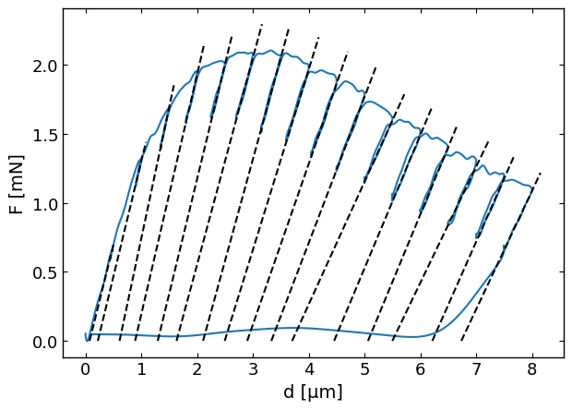
Fig. S 5 Load deflection data of the 6.5 x 4.3 µm² sized cantilever given by the blue solid line and the determined unloading stiffness as dashed black lines. Note that the load displacement curve is smoothed.

Corresponding author at: Department of Materials Physics, Montanuniversität Leoben, Leoben, Austria. E-Mail Address: klemens.schmuck@unileoben.ac.at (K. Schmuck)

