Supporting Information
Effect of structural iron on nanoscroll formation via exfoliation of a high-iron content kaolin

Balázs Zsirka¹*, Katalin Győrfi¹, Takahide Yamaguchi², Attila Táborosi³, Veronika Vágvölgyi¹, Clara Parameswary⁴, Zoltán Homonnay⁴, Ernő Kuzmann⁴, Erzsébet Horváth¹, János Kristóf¹

1 Research Group of Analytical Chemistry/Laboratory for Surfaces and Nanostructures, University of Pannonia, P.O. Box 158, Veszprém 8201, Hungary
2 Institute of Quantum Beam Science, Graduate School of Science and Engineering, Ibaraki University, 2-1-1, Bunkyo, Mito, Ibaraki 310-8512, Japan
3 Research Initiative for Supra-Materials, Faculty of Engineering, Shinshu University, 4-17-1, Wakasato, Nagano city, Nagano 380-8853, Japan
4 Institute of Chemistry, ELTE Eötvös Loránd University, Pázmány Péter s. 1/A, Budapest, 1117, Hungary

Table of Contents:
Figure S1. Resolved XRD patterns of nKao and 11M-nKao samples and of their oxidative surface treated derivatives. 2
Table S1. Full width at half maxima (FWHM), average crystallite size (d) and the average number adjoined TO layers (N) of kaolinite, as calculated by the Scherrer equation [1]. 3
Figure S2. FTIR-ATR spectra of Kao (a) and 11M-Kao (a2) samples, intercalated with (b) potassium acetate, (c) ethylene-glycol, (d) hexylamine, (e) toluene, and after surface cleaning with (f) 2-propanol, acetone and water, (g) hydrogen-peroxide in the 4000-400 cm⁻¹ range. 4
Table S2. Elemental composition determined by STEM-EDX from the designated areas of Figure 4. Values of Fe are highlighted. 5
Table S3. Mössbauer parameters of pristine sample Kao at room temperature and at 80 K. Fitted errors are given in brackets. 6
Figure S3. Fe K-edge XANES of Kao (solid line) compared to the simulated XANES by mixing Hematite and Goethite spectra (dashed lines). Mixing ratio of Hematite:Geothite were (A) 0.1:0.9, (B) 0.2:0.8, (C) 0.3:0.7, (D) 0.4:0.6, (E) 0.5:0.5, (F) 0.6:0.4, (G) 0.7:0.3, (H) 0.8:0.2, (I) 0.9:0.1. 7
Figure S4. The first derivative of Fe K-edge XANES region of the Kao (black), 5M-Kao (orange), 11M-Kao (red) samples compared to and the FeO (purple), hematite (blue), and goethite (green). 7
Figure S5. Fe K-edge EXAFS of Kao (black), 5M-Kao (orange), and 11M-Kao (red) clays compared to and the hematite (blue), and goethite (green) in k-space 8
Figure S6. Fe K-edge EXAFS of hematite (blue), goethite (green), and 11M-Kao with fitting curves (black, dashed) in R-space. 9
Figure S7. The Generation 2 (G₂) molecular cluster model for nano-kaolinite (A), the replacement positions of Al³⁺ to Fe³⁺/Fe²⁺, and the inner coordinates of Fe³⁺/Fe²⁺. The designations of sHO⁻, aO²⁻ and iHO⁻ indicates the surface-hydroxide, apical-oxide and inner-hydroxide groups, respectively. 10
Table S4. Comparison of the first and second shell distances and their averages of the three different positions (Figure S7. P1, P2, P3) for Al³⁺, Fe³⁺ and Fe²⁺ for both high and low spin states. 11
Table S5. Calculated energies (E), their comparison (ΔE) and the Boltzmann distribution values at 298K. 11
References 12

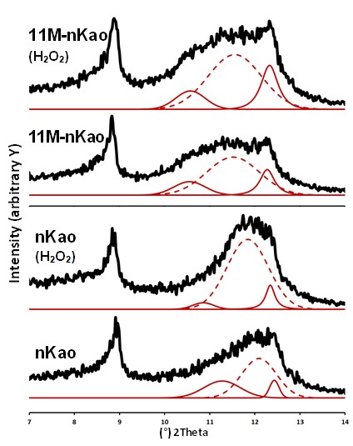

Figure S1. Resolved XRD patterns of nKao and 11M-nKao samples and of their oxidative surface treated derivatives.

Table S1. Full width at half maxima (FWHM), average crystallite size (d) and the average number adjoined TO layers (N) of kaolinite, as calculated by the Scherrer equation [1].
Sample | Kaolinite (001)
Sample | FWHM (°) | d(nm) | Number of TO layers
Kao | 0.186 | 345.6 | 480
nKao  (whole range, 1 peak) | 1.165 | 8.0 | 11
nKao  (deconvoluted, 3 peaks) | 0.951 | 10.1 | 14
nKao  (deconvoluted, 3 peaks) | 0.905 | 10.8 | 15
nKao  (deconvoluted, 3 peaks) | 0.246 | 95.9 | 133
nKao (H₂O₂)  (whole range, 1 peak) | 1.180 | 7.9 | 11
nKao (H₂O₂)  (deconvoluted, 3 peaks) | 0.552 | 20.5 | 28
nKao (H₂O₂)  (deconvoluted, 3 peaks) | 1.081 | 8.7 | 12
nKao (H₂O₂)  (deconvoluted, 3 peaks) | 0.239 | 105.5 | 146
11M-Kao | 0.186 | 340.5 | 473
11M-nKao  (whole range, 1 peak) | 1.848 | 4.7 | 7
11M-nKao  (deconvoluted, 3 peaks) | 0.822 | 12.1 | 17
11M-nKao  (deconvoluted, 3 peaks) | 1.371 | 6.6 | 9
11M-nKao  (deconvoluted, 3 peaks) | 0.375 | 37.8 | 52
11M-nKao (H₂O₂)  (whole range, 1 peak) | 1.864 | 4.7 | 7
11M-nKao (H₂O₂)  (deconvoluted, 3 peaks) | 0.770 | 13.1 | 18
11M-nKao (H₂O₂)  (deconvoluted, 3 peaks) | 1.391 | 6.5 | 9
11M-nKao (H₂O₂)  (deconvoluted, 3 peaks) | 0.434 | 29.5 | 41

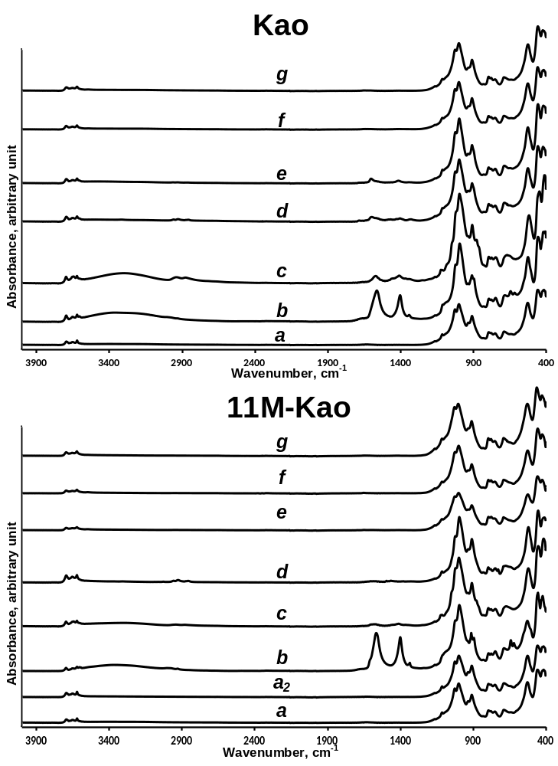

Figure S2. FTIR-ATR spectra of Kao (a) and 11M-Kao (a2) samples, intercalated with (b) potassium acetate, (c) ethylene-glycol, (d) hexylamine, (e) toluene, and after surface cleaning with (f) 2-propanol, acetone and water, (g) hydrogen-peroxide in the 4000-400 cm⁻¹ range.

Table S2. Elemental composition determined by STEM-EDX from the designated areas of Figure 4. Values of Fe are highlighted.
Sample |  | Element | Atom% | Mass%
nKao | Figure 4/a | O | 66.65 ± 6.44 | 50.01 ± 3.06
nKao | Figure 4/a | Al | 6.79 ± 1.49 | 8.59 ± 1.78
nKao | Figure 4/a | Si | 21.57 ± 4.64 | 28.42 ± 5.73
nKao | Figure 4/a | Ti | 0.2 ± 0.03 | 0.46 ± 0.07
nKao | Figure 4/a | Fe | 4.78 ± 0.78 | 12.53 ± 1.83
nKao | Figure 4/b | O | 70.11 ± 2.31 | 55.69 ± 0.77
nKao | Figure 4/b | Al | 12.94 ± 3.08 | 17.33 ± 3.38
nKao | Figure 4/b | Si | 14.54 ± 3.41 | 20.26 ± 3.87
nKao | Figure 4/b | Ti | 0.09 ± 0.02 | 0.21 ± 0.03
nKao | Figure 4/b | Fe | 2.34 ± 0.47 | 6.5 ± 0.96
11M-nKao | Figure 4/c | O | 69.23 ± 6.61 | 56.31 ± 3.42
11M-nKao | Figure 4/c | Al | 12.67 ± 2.78 | 17.38 ± 3.59
11M-nKao | Figure 4/c | Si | 17.75 ± 3.81 | 25.34 ± 5.11
11M-nKao | Figure 4/c | Ti | 0.11 ± 0.02 | 0.26 ± 0.04
11M-nKao | Figure 4/c | Fe | 0.25 ± 0.04 | 0.71 ± 0.1
11M-nKao | Figure 4/d | O | 70.58 ± 6.54 | 57.99 ± 3.45
11M-nKao | Figure 4/d | Al | 14.03 ± 3.06 | 19.44 ± 4
11M-nKao | Figure 4/d | Si | 15.11 ± 3.22 | 21.79 ± 4.38
11M-nKao | Figure 4/d | Ti | 0.06 ± 0.01 | 0.14 ± 0.02
11M-nKao | Figure 4/d | Fe | 0.22 ± 0.04 | 0.65 ± 0.09

Table S3. Mössbauer parameters of pristine sample Kao at room temperature and at 80 K. Fitted errors are given in brackets.
 | room temperature |  |  |  |  | 80K
Mössbauer parameters | hematite | goethite | Fe³⁺ | Fe²⁺ | hematite |  | goethite | Fe³⁺ | Fe²⁺
Relative area (%) | 28.7  (±0.7) | 58.1  (±6,5) | 11.6  (±0.5) | 1.6  (±0,4) | 18.2  (±2.6) |  | 73.8  (±3.6) | 5.7  (±0.7) | 2.4  (±1.1)
Isomer shift (mm/s) | 0.382 (±0.005) | 0.35 (±0.03) | 0.34 (±0.01) | 1.35 (±0.03) | 0.49 (±0.01) |  | 0.487 (±0.005) | 0.43 (±0.04) | 1.15 (±0.13)
Quadrupole splitting/shift (mm/s) | -0.217 (±0.009) | -0.27 (±0.05) | 0.59 (±0.02) | 2.31 (±0.35) | -0.14 (±0.02) |  | -0.23 (±0.01) | 0.68 (±0.06) | 2.76 (±0.26)
Hyperfine magnetic field (T) | 49.4 (±0.04) | 29.4 (±0.3) | N/A | N/A | 52.69 (±0.09) |  | 48.95 (±0.08) | N/A | N/A
Line width/range*  (mm/s) | 0.35-0.66 | 0.63-2.72 | 0.50 (±0.04) | 0.35 (±0.10) | 0.38-0.40 |  | 0.43-0.80 | 0.54 (±0.10) | 0.72 (±0.42)
*The sextets for goethite and hematite were analyzed with variable line widths for the 1-6, 2-5 and 3-4 pairs of lines. The observed line width ranges are given.

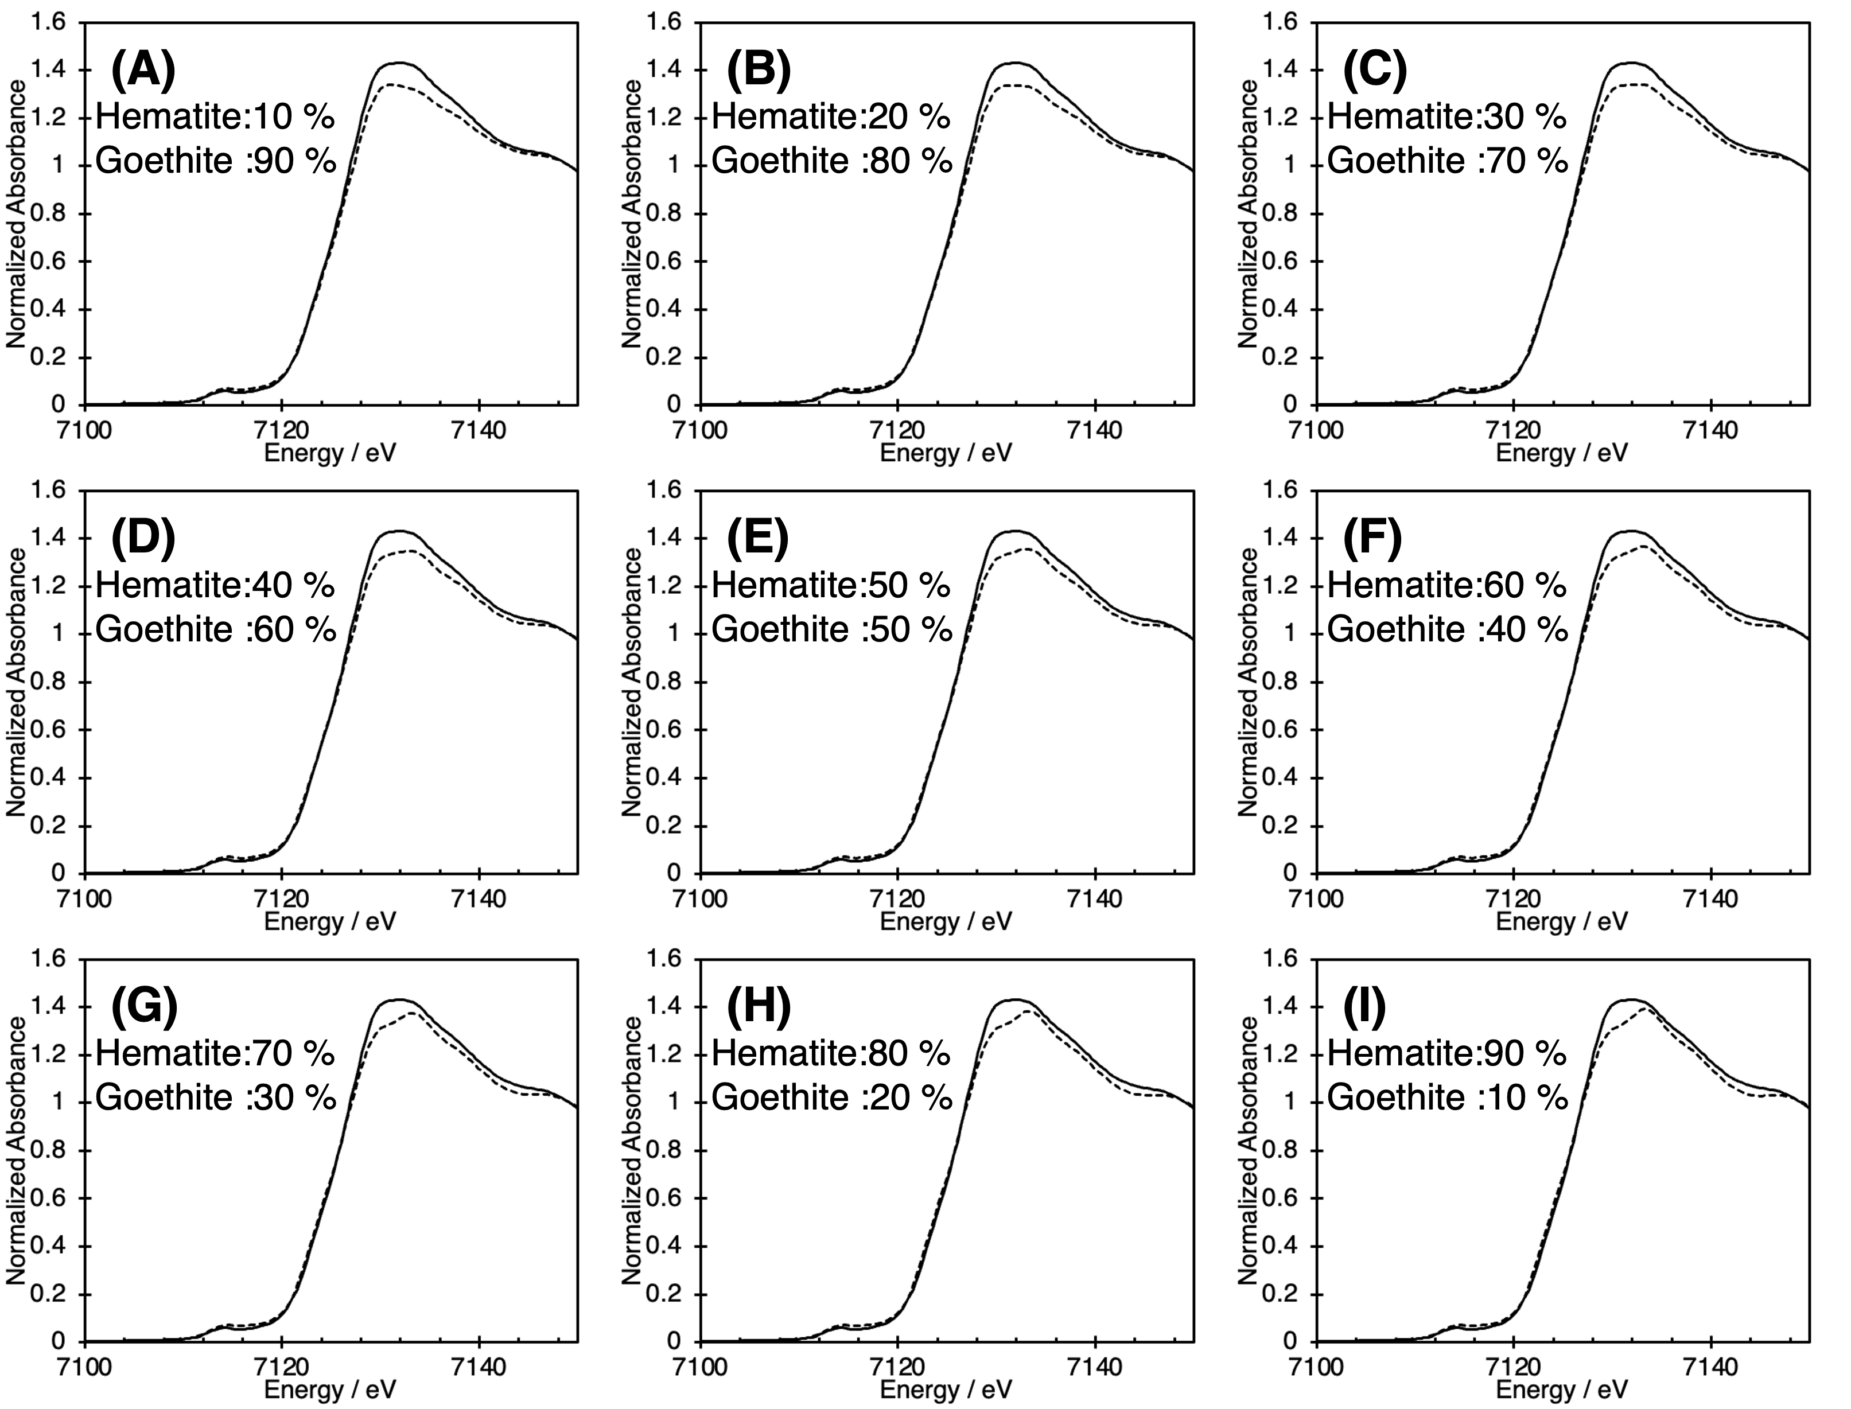

Figure S3. Fe K-edge XANES of Kao (solid line) compared to the simulated XANES by mixing Hematite and Goethite spectra (dashed lines). Mixing ratio of Hematite:Geothite were (A) 0.1:0.9, (B) 0.2:0.8, (C) 0.3:0.7, (D) 0.4:0.6, (E) 0.5:0.5, (F) 0.6:0.4, (G) 0.7:0.3, (H) 0.8:0.2, (I) 0.9:0.1.

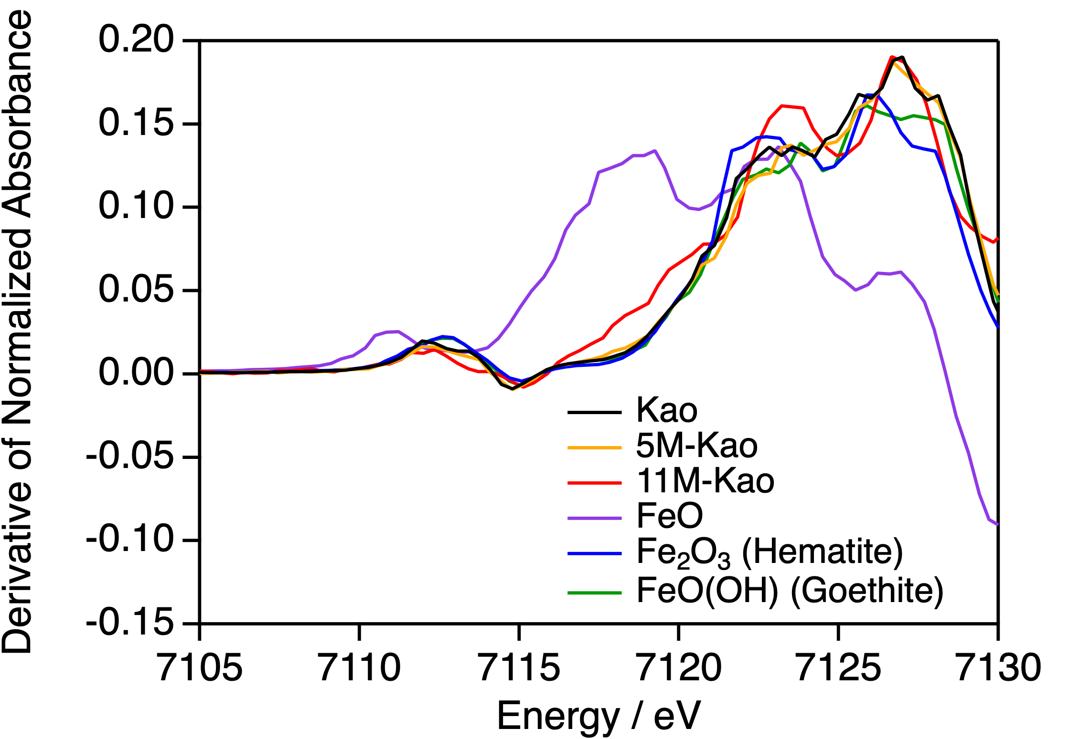

Figure S4. The first derivative of Fe K-edge XANES region of the Kao (black), 5M-Kao (orange), 11M-Kao (red) samples compared to and the FeO (purple), hematite (blue), and goethite (green).

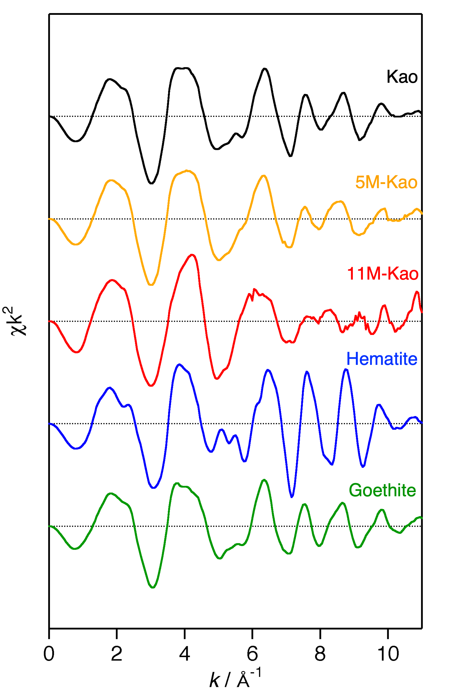

Figure S5. Fe K-edge EXAFS of Kao (black), 5M-Kao (orange), and 11M-Kao (red) clays compared to and the hematite (blue), and goethite (green) in k-space

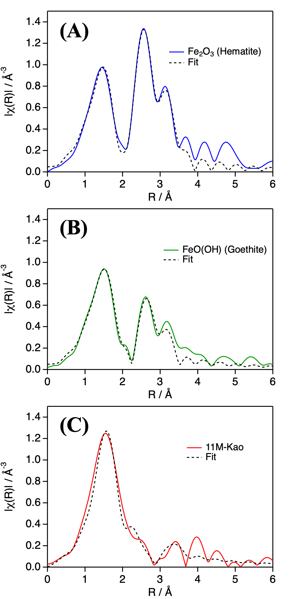

Figure S6. Fe K-edge EXAFS of hematite (blue), goethite (green), and 11M-Kao with fitting curves (black, dashed) in R-space.

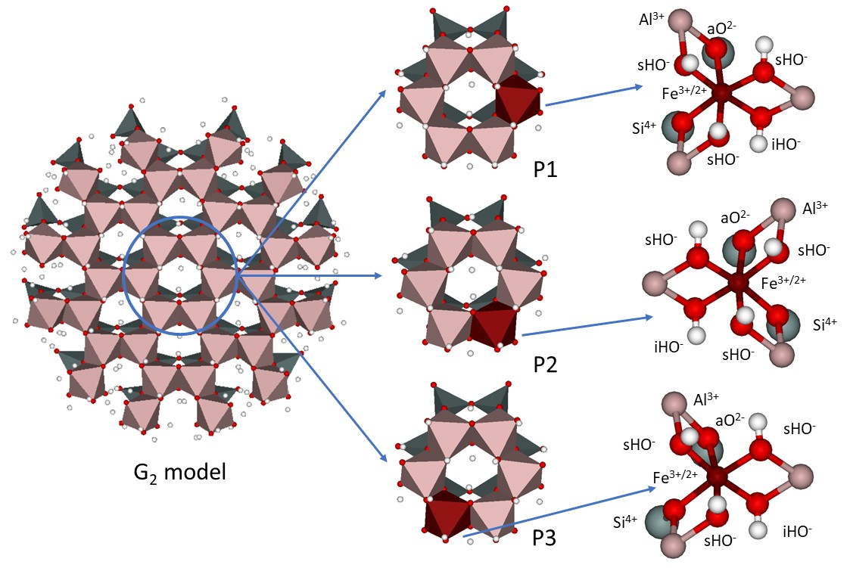

Figure S7. The Generation 2 (G₂) molecular cluster model for nano-kaolinite (A), the replacement positions of Al³⁺ to Fe³⁺/Fe²⁺, and the inner coordinates of Fe³⁺/Fe²⁺. The designations of sHO⁻, aO²⁻ and iHO⁻ indicates the surface-hydroxide, apical-oxide and inner-hydroxide groups, respectively.

Table S4. Comparison of the first and second shell distances and their averages of the three different positions (Figure S7. P1, P2, P3) for Al³⁺, Fe³⁺ and Fe²⁺ for both high and low spin states.
 |  | Al/Fe-O, Å |  |  |  | Al/Fe—Al,  Ave. Å | Al/Fe—Si,  Ave. Å
 |  | Al/Fe-sHO⁻ | Al/Fe-iHO⁻ | Al/Fe-aO²⁻ | Ave. | Al/Fe—Al,  Ave. Å | Al/Fe—Si,  Ave. Å
Al³⁺ | P1 | 1.89 | 1.92 | 1.97 | 1.92 | 2.93 | 3.25
Al³⁺ | P2 | 1.92 | 1.92 | 1.96 | 1.92 | 2.92 | 3.25
Al³⁺ | P3 | 1.92 | 1.91 | 1.95 | 1.92 | 2.91 | 3.25
Fe³⁺ | high spin
Fe³⁺ | P1 | 2.00 | 2.04 | 2.12 | 2.05 | 3.04 | 3.35
Fe³⁺ | P2 | 2.00 | 2.05 | 2.10 | 2.04 | 3.03 | 3.35
Fe³⁺ | P3 | 2.01 | 2.04 | 2.08 | 2.04 | 3.02 | 3.34
Fe³⁺ | low spin
Fe³⁺ | P1 | 1.92 | 1.96 | 2.01 | 1.95 | 2.95 | 3.24
Fe³⁺ | P2 | 1.91 | 1.97 | 1.99 | 1.95 | 2.95 | 3.24
Fe³⁺ | P3 | 1.92 | 1.96 | 1.98 | 1.95 | 2.94 | 3.24
Fe²⁺ | high spin
Fe²⁺ | P1 | 2.09 | 2.11 | 2.25 | 2.15 | 3.05 | 3.38
Fe²⁺ | P2 | 2.09 | 2.14 | 2.21 | 2.14 | 3.03 | 3.37
Fe²⁺ | P3 | 2.10 | 2.12 | 2.20 | 2.14 | 3.01 | 3.37
Fe²⁺ | low spin
Fe²⁺ | P1 | 2.06 | 2.02 | 2.11 | 2.06 | 2.95 | 3.25
Fe²⁺ | P2 | 2.01 | 2.02 | 2.06 | 2.03 | 2.91 | 3.21
Fe²⁺ | P3 | 2.01 | 2.02 | 2.04 | 2.02 | 2.90 | 3.22
*The inner coordinates result for Al³⁺ were taken from a previous study of nano kaolinite [2].

Table S5. Calculated energies (E), their comparison (ΔE) and the Boltzmann distribution values at 298K.
 |  |  | E, a.u. | ΔE, kJ/mol | Boltzmann %  (at 298K)
Fe³⁺ | high spin | P1 | -35146.0044 | 0 | 67%
Fe³⁺ | high spin | P2 | -35146.0031 | 3 | 16%
Fe³⁺ | high spin | P3 | -35146.0018 | 7 | 4%
Fe³⁺ | low spin | P1 | -35146.0017 | 7 | 3%
Fe³⁺ | low spin | P2 | -35146.0021 | 6 | 6%
Fe³⁺ | low spin | P3 | -35146.0019 | 7 | 4%
Fe²⁺ | high spin | P1 | -35146.1465 | 0 | 98%
Fe²⁺ | high spin | P2 | -35146.1426 | 10 | 1%
Fe²⁺ | high spin | P3 | -35146.1413 | 14 | 0%
Fe²⁺ | low spin | P1 | -35146.1204 | 68 | 0%
Fe²⁺ | low spin | P2 | -35146.1156 | 81 | 0%
Fe²⁺ | low spin | P3 | -35146.1151 | 82 | 0%

References

[1] Patterson AL. The Scherrer Formula for X-Ray Particle Size Determination. Phys Rev 1939;56:978–82. https://doi.org/10.1103/PhysRev.56.978.
[2] Táborosi A, Szilagyi RK, Zsirka B, Fónagy O, Horváth E, Kristóf J. Molecular treatment of nano-kaolinite generations. Inorg Chem 2018;57:7151–67. https://doi.org/10.1021/acs.inorgchem.8b00877.

