Supplementary Material

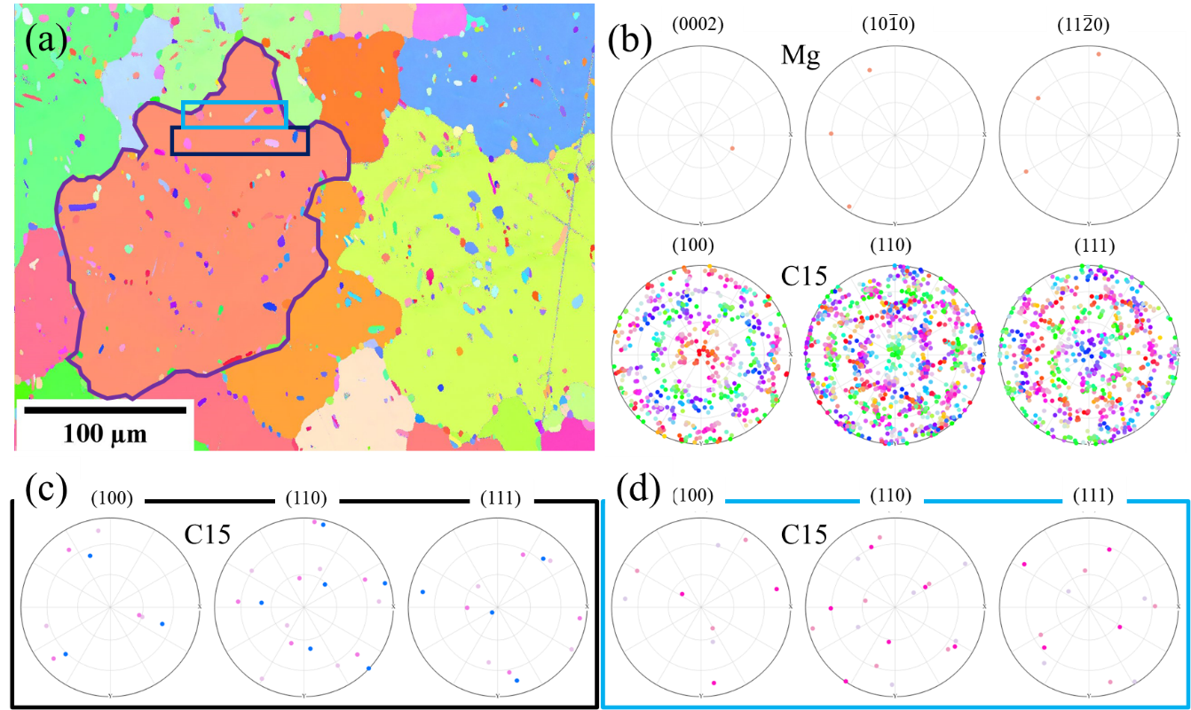
Figure SM 1. a) IPF map of heat-treated Mg-4.65Al-2.82Ca alloy (legend presented in figure 2), b) pole figures of Mg and C15 phase for Mg grain bounded by purple boundary, c) and d) depict different pole figures for C15 phase present in area bounded by black and blue rectangles.

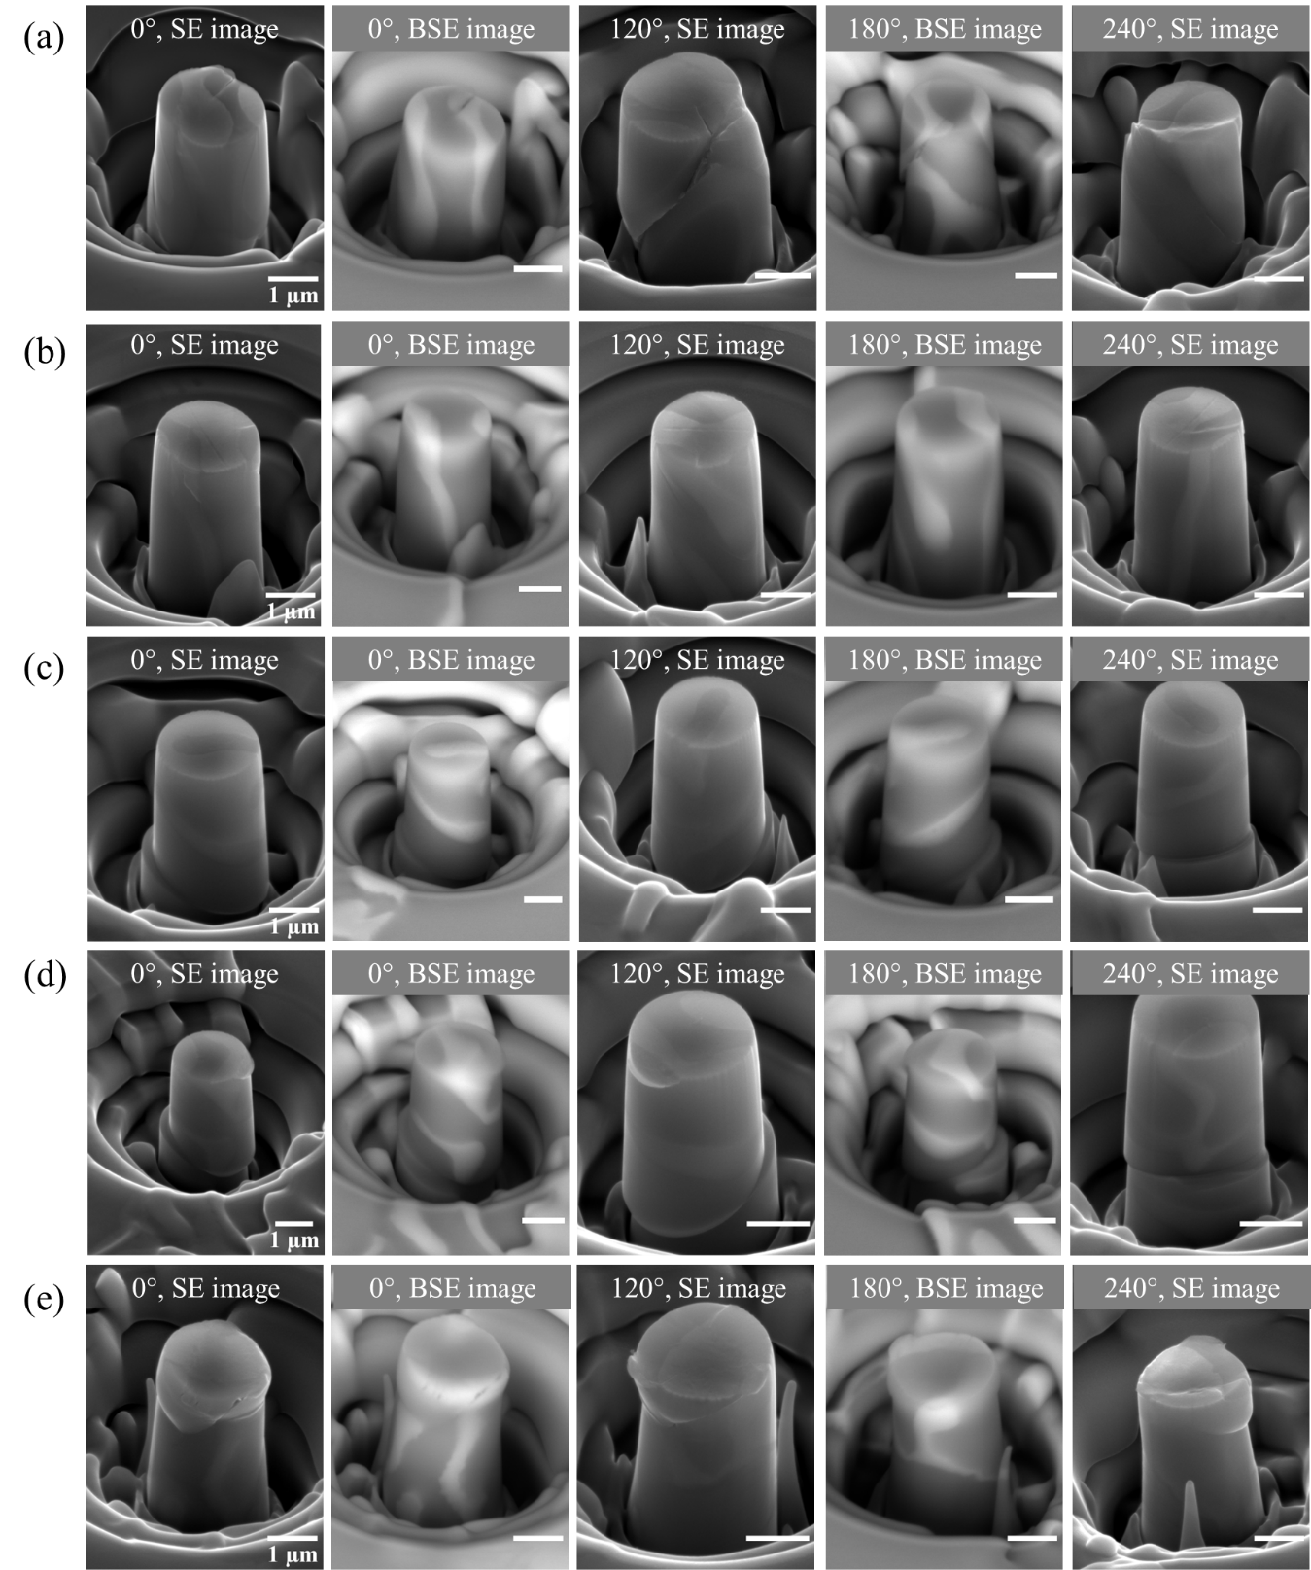
Figure SM 2.a) and b) contain the SE and BSE images of composite micropillars from different directions as specified by the rotation angle (the corresponding stress-strain curves are presented in Figure 5a); c) and d) show the SE and BSE images of composite micropillars for which the corresponding stress-strain curves are presented in Figure 5d; e) depicts the SE and BSE images of composite micropillar for which the corresponding stress-strain curve is presented in Figure 5g.

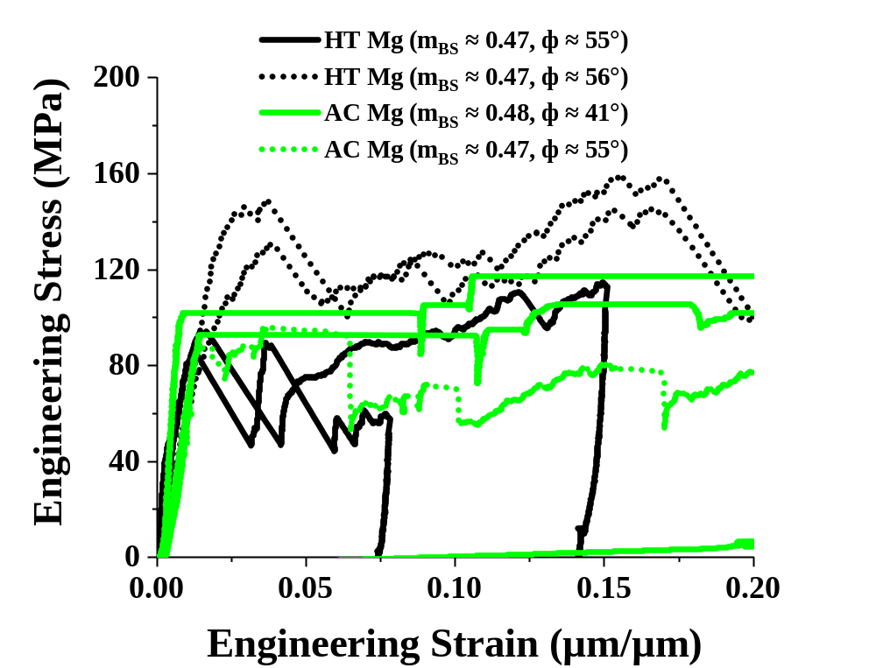
Figure SM 3. Mechanical response of α-Mg phase of similar orientation in both as-cast (AC) and heat-treated (HT) states

Estimation of volume fraction in the micropillar
The volume fraction of the Laves phase in a specific micropillar was assumed to be the same as area fraction of the Laves phase in the same micropillar. The area fraction of the Laves phase was measured as follows.
- The area of the top side of the pillar was measured. Then a shape which matched the dimensions of the pillars was drawn and the area enclosed by that shape was measured using imageJ (see area bounded by white circle in Figure SM 4 a).
- The area of the shape enclosing the Laves phase was computed (area bounded by yellow boundaries in Figure SM 4 a).
- Similarly, the region covering the front surface of the pillar was calculated (area bounded by white boundaries in Figure SM 4 b).
- The region enclosing the Laves phase on the front surface was then determined (area bounded by yellow boundaries in Figure SM 4 b).
- The same steps as mentioned in 3 and 4 were repeated for the other two sides (at rotations of 120° and 240°) of the pillars.
- The total area of the micropillars and that bounded by the Laves phase was then determined and later used to calculate area fraction of Laves phase in that respective micropillar.
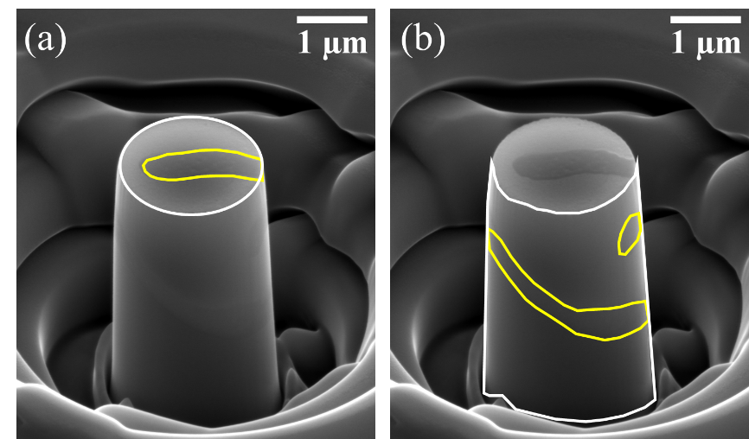
Figure SM 4. The white boundaries represent the total area of the top surface (a) and front surface (b) of the micropillar. The yellow boundaries show the geometry of the Laves phase on top surface (a) and the front surface (b).

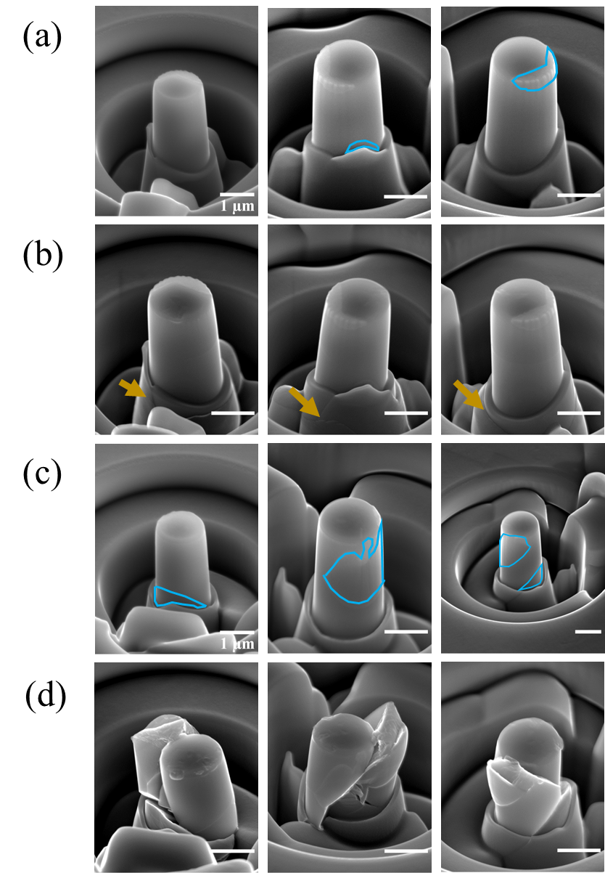
Figure SM 5. SE images of the undeformed (a and c) and deformed (b and d) Mg/C15 composite micropillars at rotation angles of 0°, 120°, and 240°. The Mg phase in the composite micropillars (Mg/C15) is highlighted using blue boundaries. The respective σ_{0.2} values for the two pillars are represented by blue dots (enclosed by dotted light blue rectangle) in Figure 10 a). Orange arrows in b) highlights that the pillar base rather than the actual Mg/C15 pillar has primarily deformed.

